**UNIVERSITY OF MUMBAI**



**Teacher’s Reference Manual**

**M. Sc (Information Technology)**

###### (Choice Based Credit System with effect from the academic year 2019 – 2020)

**PSIT1P2**

Data Science Practical

*Table of Contents*

|  |  |  |  |  |
| --- | --- | --- | --- | --- |
| **Sr.**  **No** | **Practical**  **No** | | **Name of the Practical** | **Page**  **No** |
| **1)** | **---** | | Prerequisites to Data Science Practical. | **01** |
| **2)** | **1** | | Creating Data Model using Cassandra. | **06** |
| **3)** | **2** | | **Conversion from different formats to**  **HOURS format.** | **13** |
| **4)** |  | **A.** | Text delimited csv format. |  |
| **5)** |  | **B.** | XML |  |
| **6)** |  | **C.** | JSON |  |
| **7)** |  | **D.** | MySQL Database |  |
| **8)** |  | **E.** | Picture (JPEG) |  |
| **9)** |  | **F.** | Video |  |
| **10)** |  | **G.** | Audio |  |
| **11)** | **3** | | **Utilities and Auditing** | **24** |
| **12)** | **4** | | **Retrieving Data** | **31** |
| **13)** | **5** | | **Assessing Data** | **65** |
| **14)** | **6** | | **Processing Data** | **139** |
| **15)** | **7** | | **Transforming Data** | **155** |
| **16)** | **8** | | **Organizing Data** | **168** |
| **17)** | **9** | | **Generating Reports** | **187** |
| **18)** | **10** | | **Data Visualization with Power BI** | **210** |

**~.~.~.~.~.~.~.~.~.~.~.~.~.~.~.~.~.~.~.~.~.~.~.~**

**PSIT1P2~~~~~** *Data Science Practical*

# Prerequisites to Data Science Practical

**Vermeulen-Krennwallner-Hillman-Clark Gro**up (VKHCG) is a hypothetical medium-size

**international company. It consists of four s**ubcompanies: Vermeulen PLC, Krennwallner AG,

**Hillman Ltd, and Clark Ltd.**

VKHC

Group

nnwallner

AG

Vermeulen PLC

Krennwallner AG

Hillman Ltd

Clark Ltd

|  |  |  |  |
| --- | --- | --- | --- |
| **Vermeulen PLC is a data processing company that processes all the data within thegroup companies. The company handles allthe information technology aspects of the business.** | **Krennwallner AG** is **an advertising and media company th**at **prepares advertisin**g **andmedia content f**or **the customers of th**e **group.** | **The Hillman** company is a supply chain and logistics company. | **The Clark** company is a venture capitalist and accounting company . |
| ***The company supplies***   * **Data science** * **Networks, servers, and communication systems** * **Internal and external web sites** * **Data analysis business activities** * **Decision science** * **Process automation** * **Management reporting** | ***The company supplies***   * **Advertising on billboards** * **Advertising and content manageme**nt **for online delivery** * **Event manageme**nt **for key customers** | *The Company provisions* a worldwide  supply chain solution to the businesses, including   * Third-party warehousing * International shipping * Door-to-door logistics | *The Company processes* the following financial responsibilities of the group:   * Financial insights * Venture capital management * Investments planning * Forex (foreign exchange) trading |

# Software requirements:

**- R-Console**

**3.XXX or Above**

* **R Studio**
* **Python**

**1.XXX or above**

**2.7 for Cassandra and 3.X**XX or above

1



**M. Sc. [*Information Technology*]**SEMESTER ~ ITeacher’s Reference Manual

* While installing Python check the option to Add Python to PATH Variable
* Open CMD in Administrative Mode
* Similarly install the following packages using pip

1. matplotlib
2. numpy
3. opencv-python
4. networkx
5. sys
6. uuid
7. pyspark

datetime json msgpack scipy geopy pysqlite3 openpyxl

sqlalchemy sql.connector geopandas quandl mlxtend folium

Packages can also be installed using Anaconda

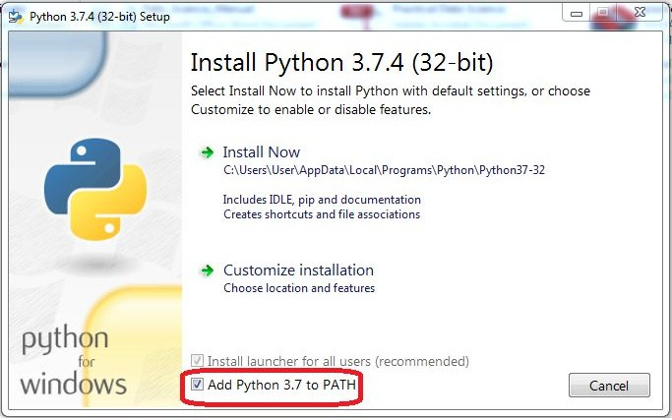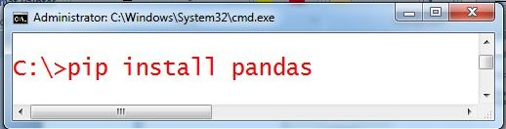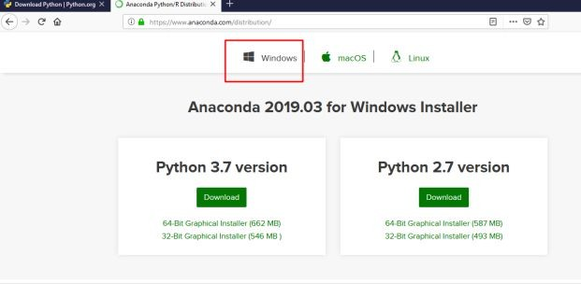

* + Download Anaconda from https://[www.anaconda.com](http://www.anaconda.com/) and visit downloads tab.
  + In the downloads page, scroll down until you see the download options for windows. **Click on the download button for python 3.7**. This will initiate a download for the **anaconda installer**.
  + Follow through the instructions for installing as shown in the next few images. Choose any destination folder according to your liking and uncheck “**Add anaconda to my PATH environment variable**.”
* Apache Cassandra https://downloads.datastax.com/#ddacs
* There is a dependency on the Visual C++ 2008 runtime (32bit), but Windows 7 and Windows 2008 Server R2 has it already installed. Download it from: <http://www.microsoft.com/download/en/details.aspx?displaylang=en&id=29>
* JDK 1.8
* Sypder

If Working on Windows OS, create a Directory C:/VKHCG.

#### R Packages

* + R- Studio

R – Studio:

Go to Tools → Install Packages OR

Select Install tab from Package Tab

Then type the package name in package text field

* + - Install following package
  + R – Console
* Data.Table Package
* ReadR Package
* JSONLite Package
* Ggplot2 Package
* Sparklyr Package
* Tibble package

Use the following command:

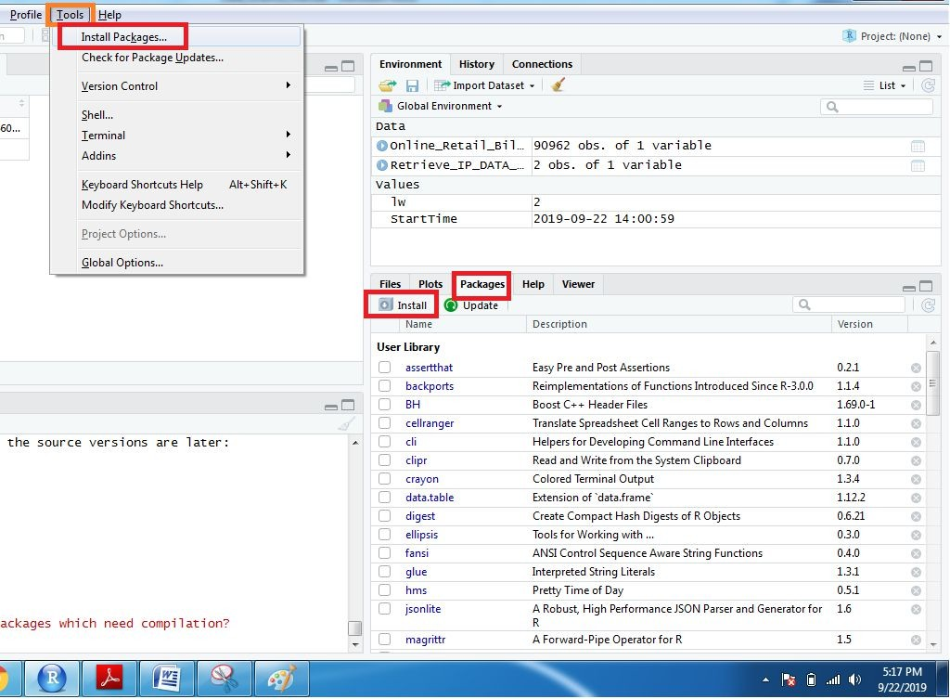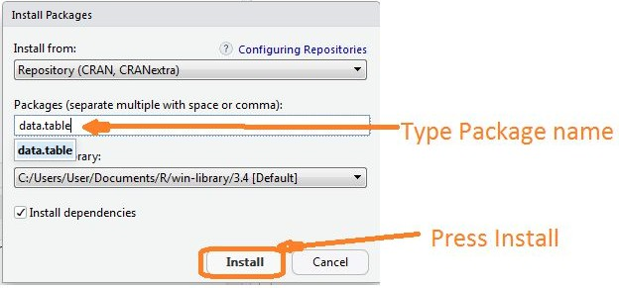

## Sample Data

* install.packages ("data.table")
* install.packages("readr")
* install.packages ("jsonlite")
* install.packages("ggplot2")
* install.packages("sparklyr")
* install.packages(“tibble”)

The following data is for the examples in

Type of file: Comma-separated values (CSV)

#### IP Addresses Data Sets

Location:VKHCG\01-Vermeulen\00-RawData

Data file: IP_DATA_C_VKHCG.csv Data file: IP_DATA_ALL.csv

Data file: IP_DATA_CORE.csv

#### Customer Data Sets

No. of Record: 255

No. of Records: 1,247,502 No. of Records: 3,562

Location: VKHCG\ 02-Krennwallner\00-RawData

Data file: DE_Billboard_Locations.csv

#### Logistics Data Sets

Location: VKHCG\03-Hillman\00-RawData Data file: GB_Postcode_Full.csv

Data file: GB_Postcode_Warehouse.csv Data file: GB_Postcodes_Shops.csv

###### Exchange Rate Data Set

Location: VKHCG\04-Clark\00-RawData Data file: Euro_ExchangeRates.csv

No. of Records: 8,873

No. of Records: 1,714,591 No. of Records: 3,005

No. of Records: 1,048,575

No. of Records: 4,697

###### Profit-and-Loss Statement Data Set

Location: VKHCG\04-Clark\00-RawData

Data file: Profit_And_Loss.csv No. of Records: 2,442

# Data Science Framework

Data science is a series of discoveries. Build a basic framework that can be used for your data processing. This

will

enable to

construct a

data

science

solution

and

then

easily

transfer

it to

your

data

engineering

environments.The layered framework is engineered with the following structures.

1. The Business Layer
2. The Utility Layer
3. The Operational Management Layer
4. The Audit, Balance, and Control Layer
5. The Functional Layer
   1. *Data models*
   2. *Processing algorithms*

Processing algorithm example is spread across six supersteps:

* + 1. ***Retrieve*:** This super step contains all the processing chains for retrieving data from the raw data lake via a more structured format.

***Assess*:**

This

superstep

contains

all

the

processing

chains

for

quality

assurance

and

additional data enhancements.

* + 1. ***Process*:** This superstep contains all the processing chains for building the data vault.

***Transform*:**

warehouse.

This

superstep

contains

all

the

processing

chains

for

building

the

data

* + 1. ***Organize*:** This superstep contains all the processing chains for building the data marts.

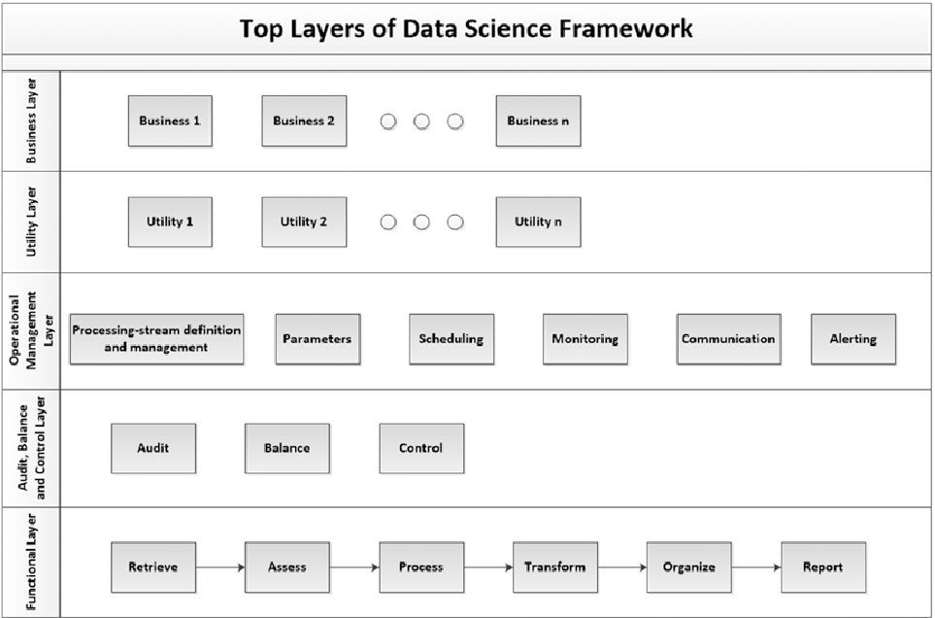

* + 1. ***Report*:** This superstep contains all the processing chains for building virtualization and reporting the actionable knowledge.
  1. *Provisioning of infrastructure.*

**Cluster**

## Practical 1:

**Creating Data Model using Cassandra.**

### Cassandra Data Model

**Cassandra**

**database is**

**distributed**

over

several

machines

that

operate

together.

The

**outermost container is known as th**e Cluster. For failure handling, every node contains

**a replica,**

**and in**

**case**

**of a**

**failur**e,

the

replica

takes

charge.

Cassandra

arranges

the

**nodes in a cluster, in a ring format**, and assigns data to them.

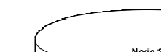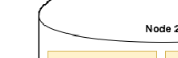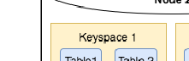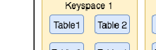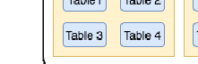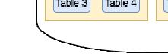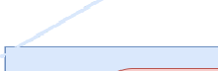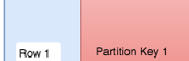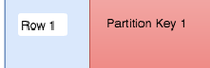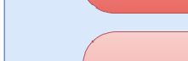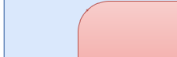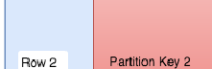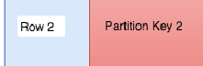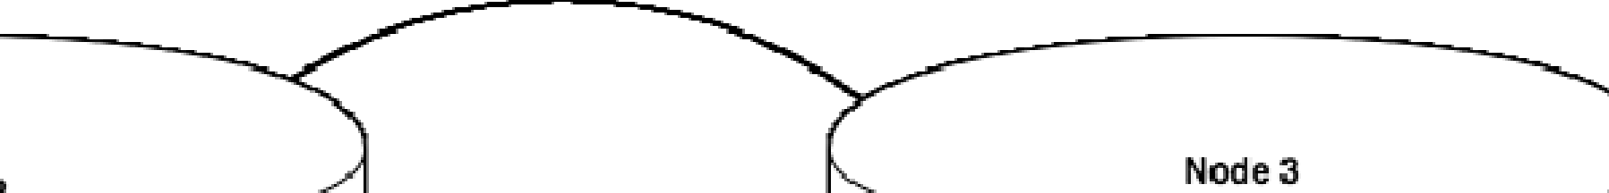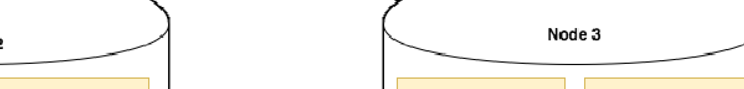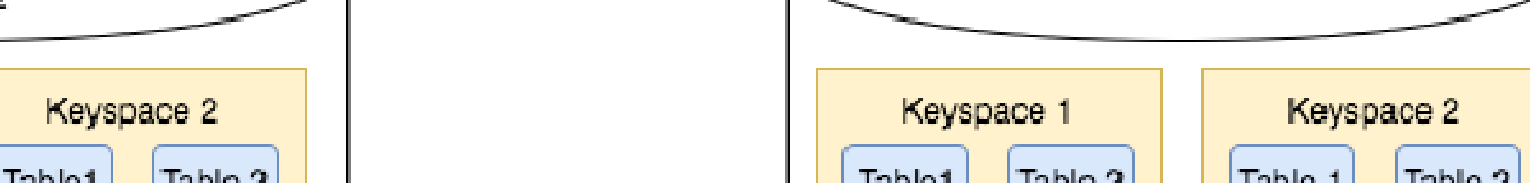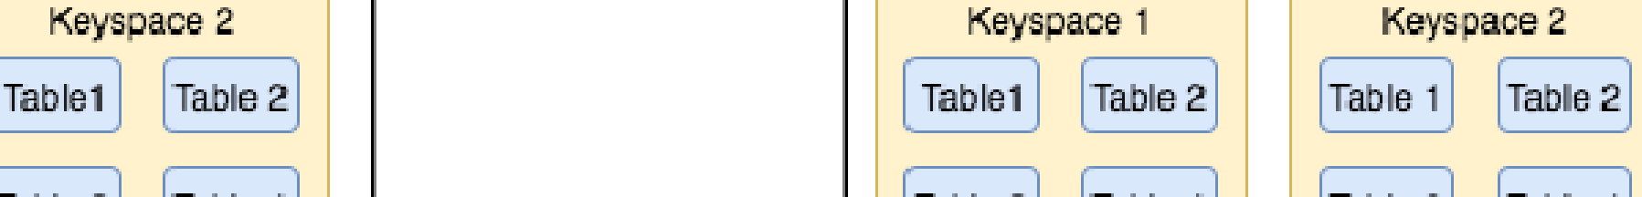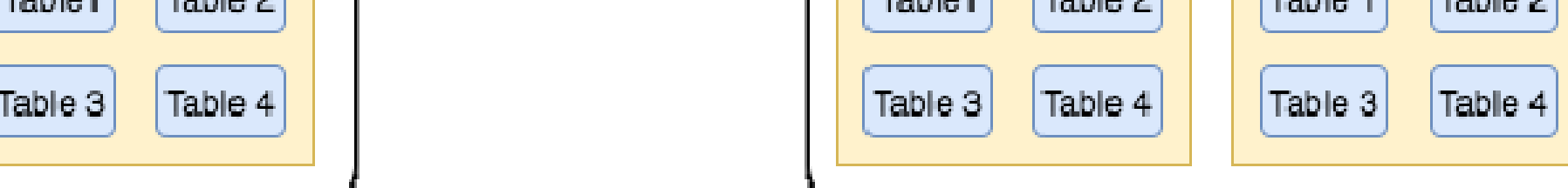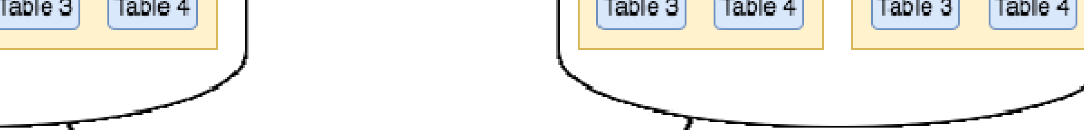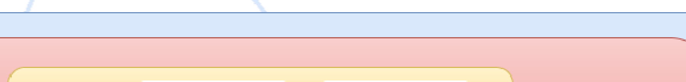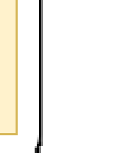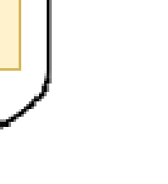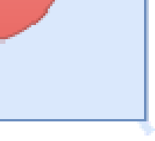

Keyspace

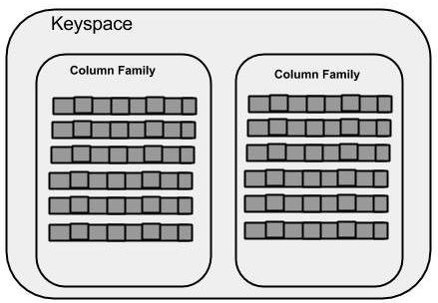

Keyspace is the outermost container for data in Cassandra. The basic attributes of a Keyspace in Cassandra are −

* **Replication factor** − It is the number of machines in the cluster that will receive copies of the same data.
* **Replica placement strategy** − It is nothing but the strategy to place replicas in the ring. We have strategies such as **simple strategy** (rack-aware strategy), **old**

**network topology strategy** (rack-aware strategy), and **network topology**

**strategy** (datacenter-shared strategy).

* **Column families** − Keyspace is a container for a list of one or more column

families. A column family, in turn, is a container of a collection of rows. Each row contains ordered columns. Column families represent the structure of your data. Each keyspace has at least one and often many column families.

Column Family

A column family is a container for an ordered collection of rows. Each row, in turn, is an ordered collection of columns. The following table lists the points that differentiate a column family from a table of relational databases.

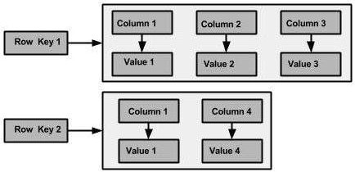

|  |  |
| --- | --- |
| **Relational Table** | **Cassandra column Family** |
| A schema in a relational model is fixed. Once we define certain columns for a table, while inserting data, in every row all the columns must be filled at least with a null value. | In Cassandra, although the column families are defined, the columns are not. You can freely add any column to any column family at any time. |
| Relational tables define only columns and the user fills in the table with values. | In Cassandra, a table contains columns, or can be defined as a super column family. |

Data Models of Cassandra and RDBMS

|  |  |
| --- | --- |
| **RDBMS** | **Cassandra** |
| RDBMS deals with structured data. | Cassandra deals with unstructured data. |
| It has a fixed schema. | Cassandra has a flexible schema. |
| In RDBMS, a table is an array of arrays. (ROW x COLUMN) | In Cassandra, a table is a list of “nested key-value pairs”. (ROW x COLUMN |

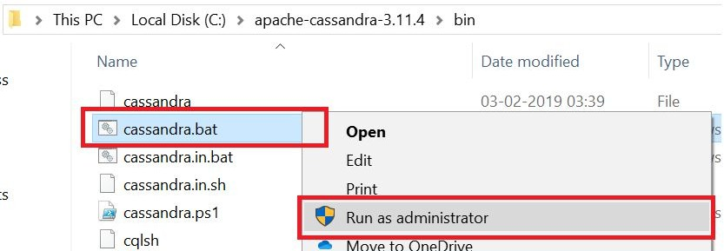

|  |  |
| --- | --- |
|  | key x COLUMN value) |
| Database is the outermost container that contains data corresponding to an application. | Keyspace is the outermost container that contains data corresponding to an application. |
| Tables are the entities of a database. | Tables or column families are the entity of a keyspace. |
| Row is an individual record in RDBMS. | Row is a unit of replication in Cassandra. |
| Column represents the attributes of a relation. | Column is a unit of storage in Cassandra. |
| RDBMS supports the concepts of foreign keys, joins. | Relationships are represented using collections. |

Go to Cassandra directory C:\apache-cassandra-3.11.4\bin

Run Cassandra.bat file

Open C:\apache-cassandra-3.11.4\bin\cqlsh.py with python 2.7 and run

Creating a Keyspace using Cqlsh

Create keyspace keyspace1 with replication = {‘class’:’SimpleStratergy’, ‘replication_factor’: 3};

Use keyspace1;

Create table dept ( dept_id int PRIMARY KEY, dept_name text, dept_loc text); Create table emp ( emp_id int PRIMARY KEY, emp_name text, dept_id int, email text, phone text );

Insert into dept (dept_id, dept_name, dept_loc) Insert into dept (dept_id, dept_name, dept_loc) Insert into dept (dept_id, dept_name, dept_loc)

values (1001, 'Accounts', 'Mumbai'); values (1002, 'Marketing', 'Delhi'); values (1003, 'HR', 'Chennai');

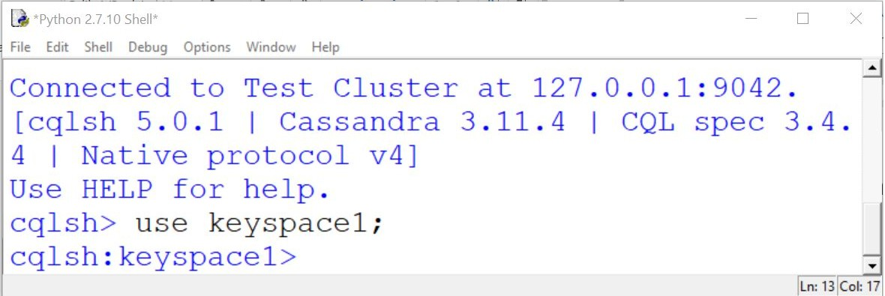

Insert into emp ( emp_id, emp_name, dept_id, email, phone ) values (1001, 'ABCD', 1001, ['abcd@company.com',](mailto:%27abcd@company.com) '1122334455');

Insert into emp ( emp_id, emp_name, dept_id, email, phone ) values (1002, 'DEFG', 1001, ['defg@company.com',](mailto:%27defg@company.com) '2233445566');

Insert into emp ( emp_id, emp_name, dept_id, email, phone ) values (1003, 'GHIJ', 1002, ['ghij@company.com',](mailto:%27ghij@company.com) '3344556677');

Insert into emp ( emp_id, emp_name, dept_id, email, phone ) values (1004, 'JKLM', 1002, ['jklm@company.com',](mailto:%27jklm@company.com) '4455667788');

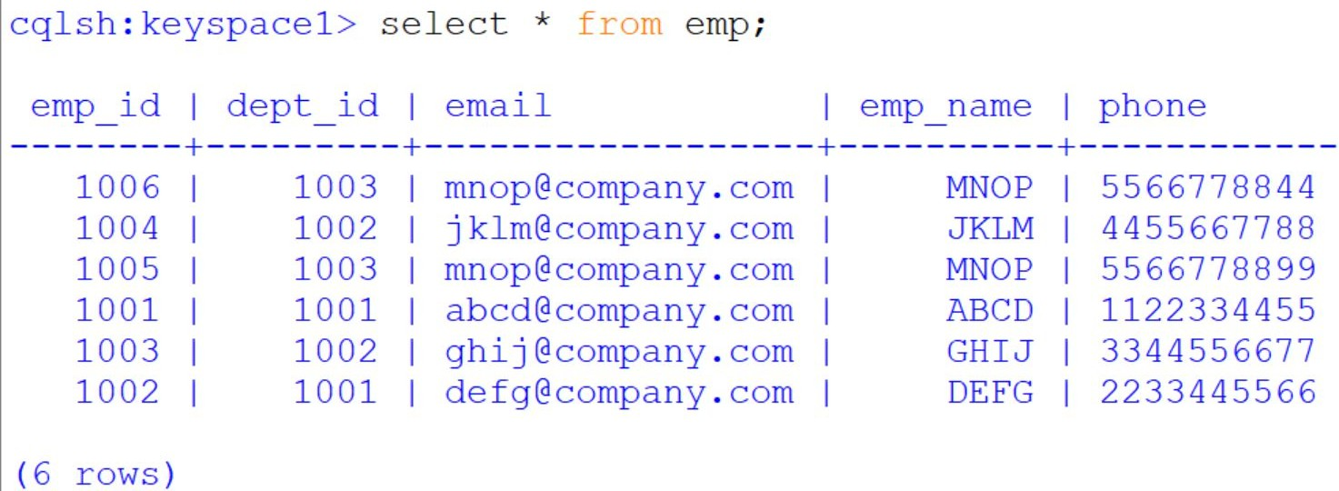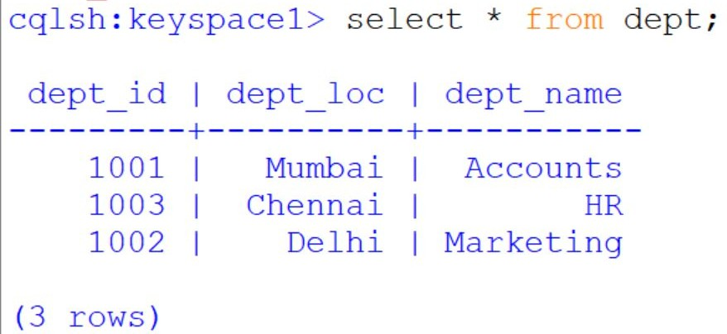

Insert into emp ( emp_id, emp_name, dept_id, email, phone ) values (1005, 'MNOP', 1003, ['mnop@company.com',](mailto:%27mnop@company.com) '5566778899');

Insert into emp ( emp_id, emp_name, dept_id, email, phone ) values (1006, 'MNOP', 1003, ['mnop@company.com',](mailto:%27mnop@company.com) '5566778844');

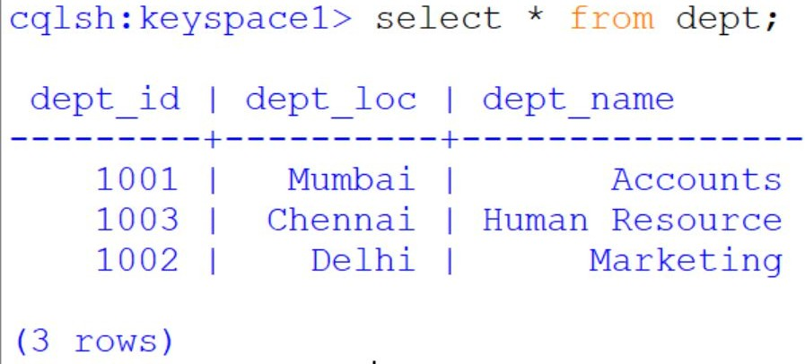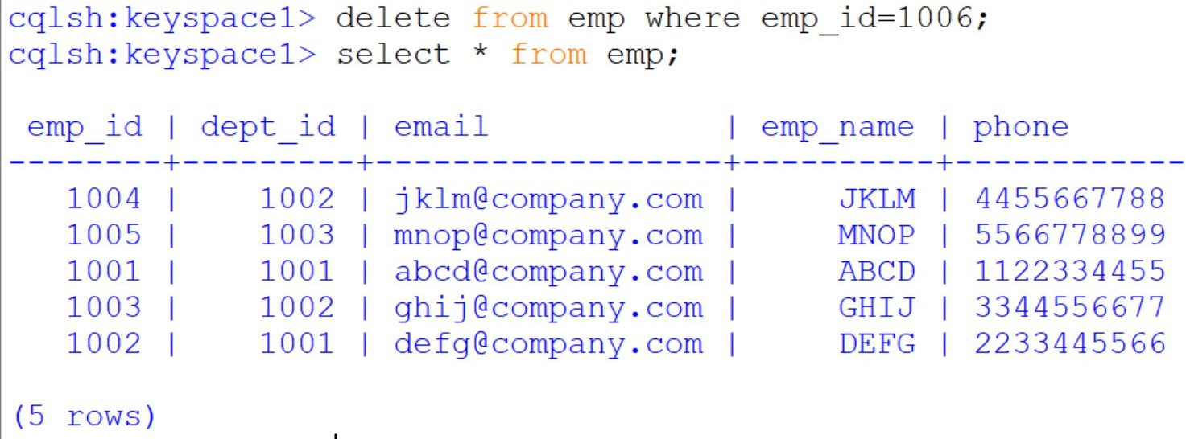

update dept set dept_name='Human Resource' where dept_id=1003;

## Practical 2:

The **Homogeneous Ontology for Recursive Uniform Schema (HORUS)** is used as an internal data format structure that enables the framework to reduce the permutations of transformations required by the framework. The use of HORUS methodology results in a hub-and-spoke data transformation approach. External data formats are converted to HORUS format, and then a HORUS format is transformed into any other external format. The basic concept is to take native raw data and then transform it first to a single format. That means that there is only one format for text files, one format for JSON or XML, one format for images and video. Therefore, to achieve any-to-any transformation coverage, the framework’s only requirements are a data- format-to-HORUS and HURUS-to- data-format converter.

**Sourc code is located in** C:\VKHCG\05-DS\9999-Data **directory**

**Write Python / R Program to convert from the following formats to HORUS format:**

1. **Text delimited CSVto HORUS format.**

**Code:**

# Utility Start CSV to HORUS =================================

# Standard Tools #=============================================================

import pandas as pd

# Input Agreement ============================================

sInputFileName='C:/VKHCG/05-DS/9999-Data/Country_Code.csv' InputData=pd.read_csv(sInputFileName,encoding="latin-1")

print('Input Data Values ===================================')

print(InputData) print('=====================================================') # Processing Rules ===========================================

ProcessData=InputData

# Remove columns ISO-2-Code and ISO-3-CODE ProcessData.drop('ISO-2-CODE', axis=1,inplace=True) ProcessData.drop('ISO-3-Code', axis=1,inplace=True) # Rename Country and ISO-M49

ProcessData.rename(columns={'Country': 'CountryName'}, inplace=True) ProcessData.rename(columns={'ISO-M49': 'CountryNumber'}, inplace=True) # Set new Index

ProcessData.set_index('CountryNumber', inplace=True) # Sort data by CurrencyNumber

ProcessData.sort_values('CountryName', axis=0, ascending=False, inplace=True)

print('Process Data Values =================================') print(ProcessData) print('=====================================================') # Output Agreement ===========================================

OutputData=ProcessData

sOutputFileName='C:/VKHCG/05-DS/9999-Data/HORUS-CSV-Country.csv' OutputData.to_csv(sOutputFileName, index = False)

print('CSV to HORUS - Done')

# Utility done ===============================================

**Output:**

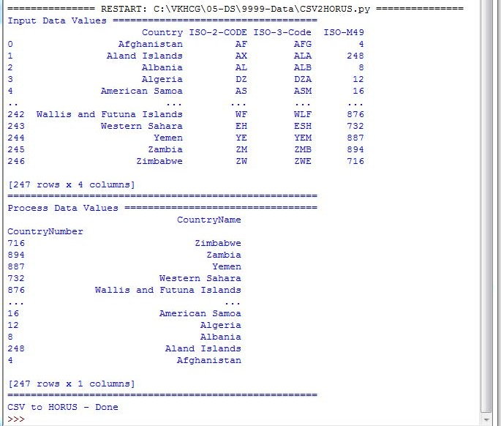

1. **XML to HORUS Format Code:**

# Utility Start XML to HORUS =================================

# Standard Tools import pandas as pd

import xml.etree.ElementTree as ET def df2xml(data):

header = data.columns root = ET.Element('root')

for row in range(data.shape[0]):

entry = ET.SubElement(root,'entry') for index in range(data.shape[1]):

schild=str(header[index])

child = ET.SubElement(entry, schild) if str(data[schild][row]) != 'nan':

child.text = str(data[schild][row]) else:

child.text = 'n/a' entry.append(child)

result = ET.tostring(root) return result

def xml2df(xml_data):

root = ET.XML(xml_data) all_records = []

for i, child in enumerate(root): record = {}

for subchild in child: record[subchild.tag] = subchild.text

all_records.append(record) return pd.DataFrame(all_records)

sInputFileName='C:/VKHCG/05-DS/9999-Data/Country_Code.xml'

InputData = open(sInputFileName).read() print('=====================================================') print('Input Data Values ===================================') print('=====================================================')

print(InputData) print('=====================================================') #============================================================= # Processing Rules =========================================== #=============================================================

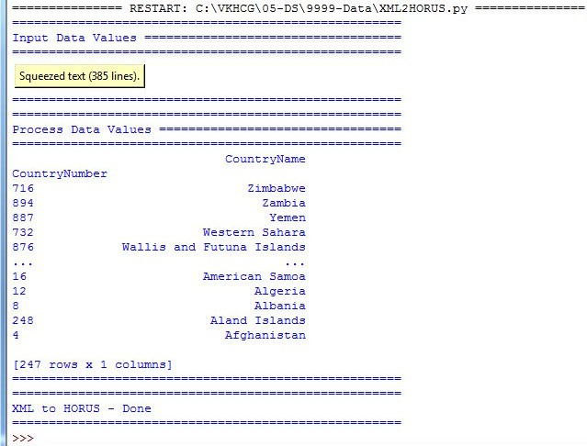

ProcessDataXML=InputData # XML to Data Frame

ProcessData=xml2df(ProcessDataXML)

# Remove columns ISO-2-Code and ISO-3-CODE ProcessData.drop('ISO-2-CODE', axis=1,inplace=True) ProcessData.drop('ISO-3-Code', axis=1,inplace=True) # Rename Country and ISO-M49

ProcessData.rename(columns={'Country': 'CountryName'}, inplace=True) ProcessData.rename(columns={'ISO-M49': 'CountryNumber'}, inplace=True) # Set new Index

ProcessData.set_index('CountryNumber', inplace=True) # Sort data by CurrencyNumber

ProcessData.sort_values('CountryName', axis=0, ascending=False, inplace=True) print('=====================================================')

print('Process Data Values =================================') print('=====================================================')

print(ProcessData) print('=====================================================')

OutputData=ProcessData

sOutputFileName='C:/VKHCG/05-DS/9999-Data/HORUS-XML-Country.csv' OutputData.to_csv(sOutputFileName, index = False) print('=====================================================')

print('XML to HORUS - Done') print('=====================================================') # Utility done ===============================================

**Output:**

1. **JSON to HORUS Format**

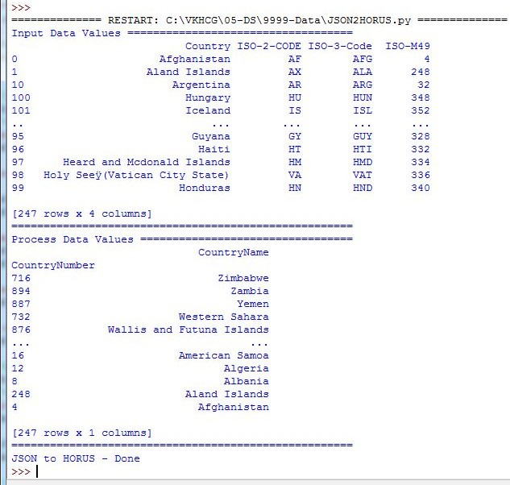

**Code:**

# Utility Start JSON to HORUS =================================

# Standard Tools #=============================================================

import pandas as pd

# Input Agreement ============================================

sInputFileName='C:/VKHCG/05-DS/9999-Data/Country_Code.json' InputData=pd.read_json(sInputFileName, orient='index', encoding="latin-1") print('Input Data Values ===================================')

print(InputData) print('=====================================================') # Processing Rules ===========================================

ProcessData=InputData

# Remove columns ISO-2-Code and ISO-3-CODE ProcessData.drop('ISO-2-CODE', axis=1,inplace=True) ProcessData.drop('ISO-3-Code', axis=1,inplace=True) # Rename Country and ISO-M49

ProcessData.rename(columns={'Country': 'CountryName'}, inplace=True) ProcessData.rename(columns={'ISO-M49': 'CountryNumber'}, inplace=True) # Set new Index

ProcessData.set_index('CountryNumber', inplace=True) # Sort data by CurrencyNumber

ProcessData.sort_values('CountryName', axis=0, ascending=False, inplace=True) print('Process Data Values =================================') print(ProcessData) print('=====================================================') # Output Agreement ===========================================

OutputData=ProcessData

sOutputFileName='c:/VKHCG/05-DS/9999-Data/HORUS-JSON-Country.csv' OutputData.to_csv(sOutputFileName, index = False)

print('JSON to HORUS - Done')

# Utility done ===============================================

**Output:**

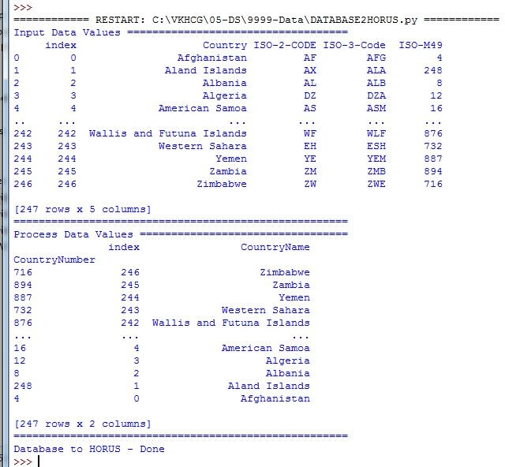

1. **MySql Database to HORUS Format**

**Code:**

# Utility Start Database to HORUS ================================= # Standard Tools

#=============================================================

import pandas as pd import sqlite3 as sq

# Input Agreement ============================================

sInputFileName='C:/VKHCG/05-DS/9999-Data/utility.db' sInputTable='Country_Code'

conn = sq.connect(sInputFileName) sSQL='select * FROM ' + sInputTable + ';' InputData=pd.read_sql_query(sSQL, conn)

print('Input Data Values ===================================')

print(InputData) print('=====================================================') # Processing Rules ===========================================

ProcessData=InputData

# Remove columns ISO-2-Code and ISO-3-CODE ProcessData.drop('ISO-2-CODE', axis=1,inplace=True) ProcessData.drop('ISO-3-Code', axis=1,inplace=True) # Rename Country and ISO-M49

ProcessData.rename(columns={'Country': 'CountryName'}, inplace=True) ProcessData.rename(columns={'ISO-M49': 'CountryNumber'}, inplace=True) # Set new Index

ProcessData.set_index('CountryNumber', inplace=True) # Sort data by CurrencyNumber

ProcessData.sort_values('CountryName', axis=0, ascending=False, inplace=True) print('Process Data Values =================================') print(ProcessData) print('=====================================================') # Output Agreement ===========================================

OutputData=ProcessData

sOutputFileName='C:/VKHCG/05-DS/9999-Data/HORUS-CSV-Country.csv' OutputData.to_csv(sOutputFileName, index = False)

print('Database to HORUS - Done')

# Utility done ===============================================

**Output:**

1. **Picture (JPEG) to HORUS Format**

**Code:**

**(Use SPYDER to run this program)**

# Utility Start Picture to HORUS ================================= # Standard Tools

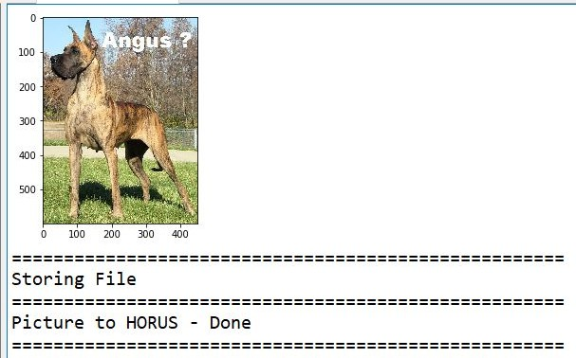

#=============================================================

from scipy.misc import imread import pandas as pd

import matplotlib.pyplot as plt import numpy as np

# Input Agreement ============================================

sInputFileName='C:/VKHCG/05-DS/9999-Data/Angus.jpg' InputData = imread(sInputFileName, flatten=False, mode='RGBA')

print('Input Data Values ===================================')

print('X: ',InputData.shape[0]) print('Y: ',InputData.shape[1]) print('RGBA: ', InputData.shape[2])

print('=====================================================') # Processing Rules ===========================================

ProcessRawData=InputData.flatten() y=InputData.shape[2] + 2 x=int(ProcessRawData.shape[0]/y)

ProcessData=pd.DataFrame(np.reshape(ProcessRawData, (x, y))) sColumns= ['XAxis','YAxis','Red', 'Green', 'Blue','Alpha'] ProcessData.columns=sColumns

ProcessData.index.names =['ID'] print('Rows: ',ProcessData.shape[0]) print('Columns :',ProcessData.shape[1])

print('=====================================================')

print('Process Data Values =================================') print('=====================================================')

plt.imshow(InputData) plt.show()

print('=====================================================') # Output Agreement ===========================================

OutputData=ProcessData print('Storing File')

sOutputFileName='C:/VKHCG/05-DS/9999-Data/HORUS-Picture.csv' OutputData.to_csv(sOutputFileName, index = False) print('=====================================================')

print('Picture to HORUS - Done') print('=====================================================')

**Output:**

1. **Video to HORUS Format**

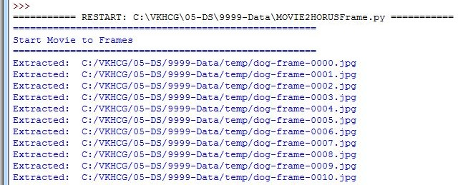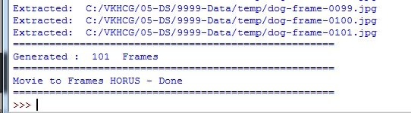

**Code:**

**Movie to Frames**

# Utility Start Movie to HORUS (Part 1) ====================== # Standard Tools

#=============================================================

import os import shutil import cv2

#=============================================================

sInputFileName='C:/VKHCG/05-DS/9999-Data/dog.mp4' sDataBaseDir='C:/VKHCG/05-DS/9999-Data/temp'

if os.path.exists(sDataBaseDir): shutil.rmtree(sDataBaseDir)

if not os.path.exists(sDataBaseDir): os.makedirs(sDataBaseDir)

print('=====================================================')

print('Start Movie to Frames') print('=====================================================')

vidcap = cv2.VideoCapture(sInputFileName) success,image = vidcap.read()

count = 0 while success:

success,image = vidcap.read()

sFrame=sDataBaseDir + str('/dog-frame-' + str(format(count, '04d'))+ '.jpg') print('Extracted: ', sFrame)

cv2.imwrite(sFrame, image)

if os.path.getsize(sFrame) == 0:

count += -1 os.remove(sFrame) print('Removed: ', sFrame)

if cv2.waitKey(10) == 27: # exit if Escape is hit break

count += 1 print('=====================================================')

print('Generated : ', count, ' Frames') print('=====================================================')

print('Movie to Frames HORUS - Done') print('=====================================================') # Utility done ===============================================

**Now frames are created and need to load them into HORUS.**

**Frames to Horus (Use SPYDER to run this program)**

# Utility Start Movie to HORUS (Part 2) ====================== # Standard Tools

#=============================================================

from scipy.misc import imread import pandas as pd

import matplotlib.pyplot as plt import numpy as np

import os

# Input Agreement ============================================

sDataBaseDir='C:/VKHCG/05-DS/9999-Data/temp' f=0

for file in os.listdir(sDataBaseDir):

if file.endswith(".jpg"):

f += 1

sInputFileName=os.path.join(sDataBaseDir, file) print('Process : ', sInputFileName)

InputData = imread(sInputFileName, flatten=False, mode='RGBA') print('Input Data Values ===================================')

print('X: ',InputData.shape[0]) print('Y: ',InputData.shape[1]) print('RGBA: ', InputData.shape[2])

print('=====================================================') # Processing Rules ===========================================

ProcessRawData=InputData.flatten() y=InputData.shape[2] + 2 x=int(ProcessRawData.shape[0]/y)

ProcessFrameData=pd.DataFrame(np.reshape(ProcessRawData, (x, y))) ProcessFrameData['Frame']=file print('=====================================================')

print('Process Data Values =================================') print('=====================================================')

plt.imshow(InputData) plt.show()

if f == 1:

ProcessData=ProcessFrameData else:

ProcessData=ProcessData.append(ProcessFrameData) if f > 0:

sColumns= ['XAxis','YAxis','Red', 'Green', 'Blue','Alpha','FrameName'] ProcessData.columns=sColumns print('=====================================================')

ProcessFrameData.index.names =['ID'] print('Rows: ',ProcessData.shape[0]) print('Columns :',ProcessData.shape[1])

print('=====================================================') # Output Agreement ===========================================

OutputData=ProcessData print('Storing File')

sOutputFileName='C:/VKHCG/05-DS/9999-Data/HORUS-Movie-Frame.csv' OutputData.to_csv(sOutputFileName, index = False) print('=====================================================')

print('Processed ; ', f,' frames')

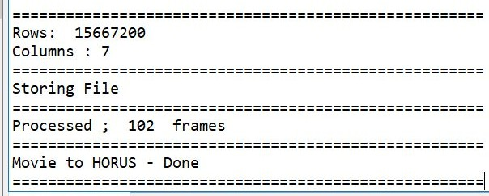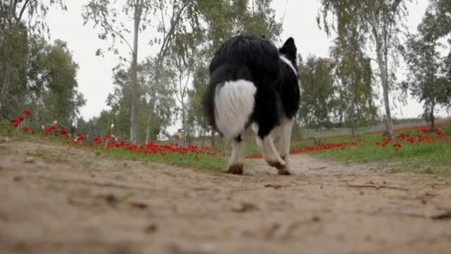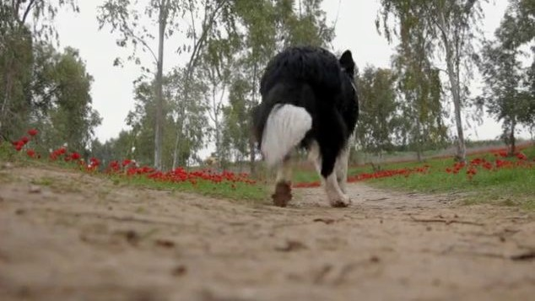

print('=====================================================')

print('Movie to HORUS - Done') print('=====================================================')

**Output:**

**dog-frame-0000.jpeg dog-frame-0001.jpeg**

**dog-frame-0100.jpeg dog-frame-0101.jpeg**

**Check the files from** C:\VKHCG\05-DS\9999-Data\temp

The movie clip is converted into 102 picture frames and then to HORUS format.

1. **Audio to HORUS Format Code:**

# Utility Start Audio to HORUS ===============================

# Standard Tools #=============================================================

from scipy.io import wavfile import pandas as pd

import matplotlib.pyplot as plt import numpy as np

#=============================================================

def show_info(aname, a,r):

print (' ')

print ("Audio:", aname)

print (' ')

print ("Rate:", r)

print (' ')

print ("shape:", a.shape)

print ("dtype:", a.dtype)

print ("min, max:", a.min(), a.max())

print (' ')

plot_info(aname, a,r) #=============================================================

def plot_info(aname, a,r):

sTitle= 'Signal Wave - '+ aname + ' at ' + str(r) + 'hz' plt.title(sTitle)

sLegend=[]

for c in range(a.shape[1]): sLabel = 'Ch' + str(c+1) sLegend=sLegend+[str(c+1)] plt.plot(a[:,c], label=sLabel)

plt.legend(sLegend) plt.show()

#=============================================================

sInputFileName='C:/VKHCG/05-DS/9999-Data/2ch-sound.wav' print('=====================================================')

print('Processing : ', sInputFileName) print('=====================================================')

InputRate, InputData = wavfile.read(sInputFileName) show_info("2 channel", InputData,InputRate) ProcessData=pd.DataFrame(InputData)

sColumns= ['Ch1','Ch2'] ProcessData.columns=sColumns OutputData=ProcessData

sOutputFileName='C:/VKHCG/05-DS/9999-Data/HORUS-Audio-2ch.csv' OutputData.to_csv(sOutputFileName, index = False) #=============================================================

sInputFileName='C:/VKHCG/05-DS/9999-Data/4ch-sound.wav' print('=====================================================')

print('Processing : ', sInputFileName) print('=====================================================')

InputRate, InputData = wavfile.read(sInputFileName) show_info("4 channel", InputData,InputRate) ProcessData=pd.DataFrame(InputData)

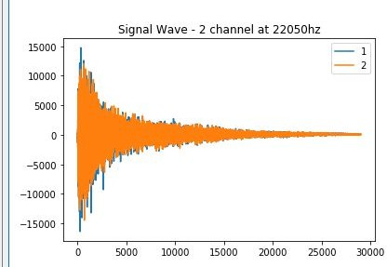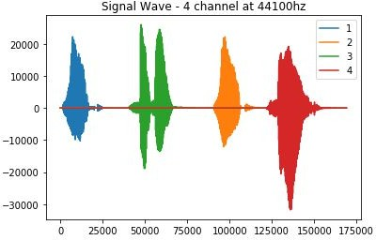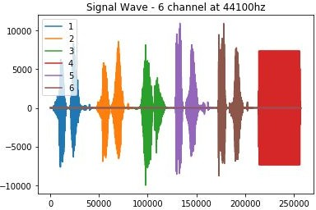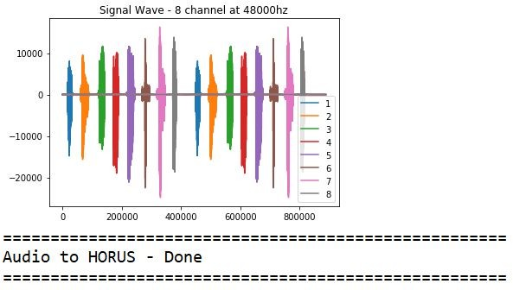

sColumns= ['Ch1','Ch2','Ch3', 'Ch4'] ProcessData.columns=sColumns OutputData=ProcessData

sOutputFileName='C:/VKHCG/05-DS/9999-Data/HORUS-Audio-4ch.csv' OutputData.to_csv(sOutputFileName, index = False) #=============================================================

sInputFileName='C:/VKHCG/05-DS/9999-Data/6ch-sound.wav' print('=====================================================')

print('Processing : ', sInputFileName) print('=====================================================')

InputRate, InputData = wavfile.read(sInputFileName) show_info("6 channel", InputData,InputRate) ProcessData=pd.DataFrame(InputData)

sColumns= ['Ch1','Ch2','Ch3', 'Ch4', 'Ch5','Ch6']

ProcessData.columns=sColumns OutputData=ProcessData

sOutputFileName='C:/VKHCG/05-DS/9999-Data/HORUS-Audio-6ch.csv' OutputData.to_csv(sOutputFileName, index = False) #=============================================================

sInputFileName='C:/VKHCG/05-DS/9999-Data/8ch-sound.wav' print('=====================================================')

print('Processing : ', sInputFileName) print('=====================================================')

InputRate, InputData = wavfile.read(sInputFileName) show_info("8 channel", InputData,InputRate) ProcessData=pd.DataFrame(InputData)

sColumns= ['Ch1','Ch2','Ch3', 'Ch4', 'Ch5','Ch6','Ch7','Ch8']

ProcessData.columns=sColumns OutputData=ProcessData

sOutputFileName='C:/VKHCG/05-DS/9999-Data/HORUS-Audio-8ch.csv' OutputData.to_csv(sOutputFileName, index = False) print('=====================================================')

print('Audio to HORUS - Done')

**Output:**

## Practical 3: Utilities and Auditing Basic Utility Design

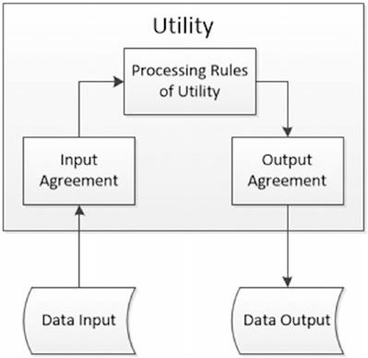

* 1. Load data as per input agreement.
  2. Apply processing rules of utility.
  3. Save data as per output agreement.

There are three types of utilities

* + - Data processing utilities
    - Maintenance utilities
    - Processing utilities

1. **Fixers Utilities:**

**Fixers enable your solution to take your existing data and fix a specific quality issue.**

#---------------------------- Program to Demonstrate Fixers utilities -------------------

import string

import datetime as dt

**# 1 Removing leading or lagging spaces from a data entry** print('#1 Removing leading or lagging spaces from a data entry'); baddata = " Data Science with too many spaces is bad!!! " print('>',baddata,'<')

cleandata=baddata.strip() print('>',cleandata,'<')

**# 2 Removing nonprintable characters from a data entry**

print('#2 Removing nonprintable characters from a data entry')

printable = set(string.printable)

baddata = "Data\x00Science with\x02 funny characters is \x10bad!!!" cleandata=''.join(filter(lambda x: x in string.printable,baddata))

print('Bad Data : ',baddata);

print('Clean Data : ',cleandata)

**# 3 Reformatting data entry to match specific formatting criteria**.

# Convert YYYY/MM/DD to DD Month YYYY

print('# 3 Reformatting data entry to match specific formatting criteria.') baddate = dt.date(2019, 10, 31)

baddata=format(baddate,'%Y-%m-%d')

gooddate = dt.datetime.strptime(baddata,'%Y-%m-%d') gooddata=format(gooddate,'%d %B %Y')

print('Bad Data : ',baddata)

print('Good Data : ',gooddata)

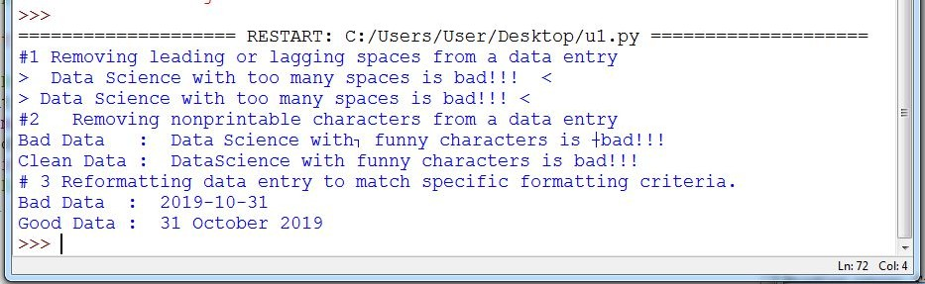

**Output:**

1. Data Binning or Bucketing

Binning is a data preprocessing technique used to reduce the effects of minor observation errors. Statistical data binning is a way to group a number of more or less continuous values into a smaller number of “bins.”

**Code :**

import numpy as np

import matplotlib.mlab as mlab import matplotlib.pyplot as plt import scipy.stats as stats

np.random.seed(0) # example data

mu = 90 # mean of distribution

sigma = 25 # standard deviation of distribution

x = mu + sigma * np.random.randn(5000) num_bins = 25

fig, ax = plt.subplots()

# the histogram of the data

n, bins, patches = ax.hist(x, num_bins, density=1)

# add a 'best fit' line

y = stats.norm.pdf(bins, mu, sigma) # mlab.normpdf(bins, mu, sigma) ax.plot(bins, y, '--') ax.set_xlabel('Example Data') ax.set_ylabel('Probability density')

sTitle=r'Histogram ' + str(len(x)) + ' entries into ' + str(num_bins) + ' Bins: $\mu=' + str(mu) + '$, $\sigma=' + str(sigma) + '$'

ax.set_title(sTitle)

fig.tight_layout()

sPathFig='C:/VKHCG/05-DS/4000-UL/0200-DU/DU-Histogram.png' fig.savefig(sPathFig)

plt.show()

**Output:**

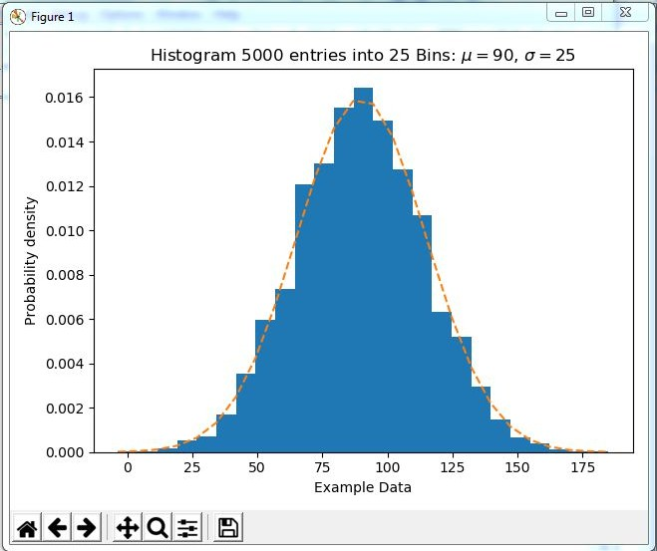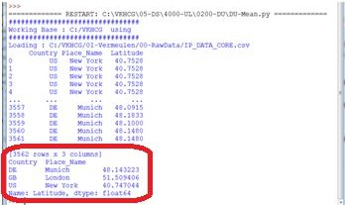

1. Averaging of Data

The use of averaging of features value enables the reduction of data volumes in a control fashion to improve effective data processing.

C:\VKHCG\05-DS\4000-UL\0200-DU\DU-Mean.py

**Code:**

import pandas as pd ################################################################

InputFileName='IP_DATA_CORE.csv' OutputFileName='Retrieve_Router_Location.csv' Base='C:/VKHCG' print('################################')

print('Working Base :',Base, ' using ') print('################################')

sFileName=Base + '/01-Vermeulen/00-RawData/' + InputFileName print('Loading :',sFileName) IP_DATA_ALL=pd.read_csv(sFileName,header=0,low_memory=False, usecols=['Country','Place Name','Latitude','Longitude'], encoding="latin-1") IP_DATA_ALL.rename(columns={'Place Name': 'Place_Name'}, inplace=True) AllData=IP_DATA_ALL[['Country', 'Place_Name','Latitude']]

print(AllData)

MeanData=AllData.groupby(['Country', 'Place_Name'])['Latitude'].mean() print(MeanData) ################################################################

**Output:**

1. Outlier Detection

Outliers are data that is so different from the rest of the data in the data set that it may be caused by an error in the data source. There is a technique called outlier detection that, with good data science, will identify these outliers.

C:\VKHCG\05-DS\4000-UL\0200-DU\DU-Outliers.py

**Code:**

################################################################

# -*- coding: utf-8 -*- ################################################################

import pandas as pd ################################################################

InputFileName='IP_DATA_CORE.csv' OutputFileName='Retrieve_Router_Location.csv' Base='C:/VKHCG' print('################################')

print('Working Base :',Base) print('################################')

################################################################

sFileName=Base + '/01-Vermeulen/00-RawData/' + InputFileName print('Loading :',sFileName) IP_DATA_ALL=pd.read_csv(sFileName,header=0,low_memory=False, usecols=['Country','Place Name','Latitude','Longitude'], encoding="latin-1") IP_DATA_ALL.rename(columns={'Place Name': 'Place_Name'}, inplace=True) LondonData=IP_DATA_ALL.loc[IP_DATA_ALL['Place_Name']=='London'] AllData=LondonData[['Country', 'Place_Name','Latitude']]

print('All Data') print(AllData)

MeanData=AllData.groupby(['Country', 'Place_Name'])['Latitude'].mean() StdData=AllData.groupby(['Country', 'Place_Name'])['Latitude'].std() print('Outliers')

UpperBound=float(MeanData+StdData) print('Higher than ', UpperBound)

OutliersHigher=AllData[AllData.Latitude>UpperBound] print(OutliersHigher)

LowerBound=float(MeanData-StdData) print('Lower than ', LowerBound)

OutliersLower=AllData[AllData.Latitude<LowerBound] print(OutliersLower)

print('Not Outliers')

OutliersNot=AllData[(AllData.Latitude>=LowerBound) & (AllData.Latitude<=UpperBound)] print(OutliersNot) ################################################################

**Output:**

=========== RESTART: C:\VKHCG\05-DS\4000-UL\0200-DU\DU-Outliers.py =========== ################################

Working Base : C:/VKHCG ################################

Loading : C:/VKHCG/01-Vermeulen/00-RawData/IP_DATA_CORE.csv All Data

Country Place_Name Latitude

1910

GB London

51.5130

|  |  |  |  |
| --- | --- | --- | --- |
| 1911 | GB | London | 51.5508 |
| 1912 | GB | London | 51.5649 |
| 1913 | GB | London | 51.5895 |
| 1914 | GB | London | 51.5232 |
| ... ... ... ...  3434 GB London | | | 51.5092 |
| 3435 GB London | | | 51.5092 |
| 3436 GB London | | | 51.5163 |
| 3437 GB London | | | 51.5085 |
| 3438 GB London | | | 51.5136 |

[1502 rows x 3 columns] Outliers

Higher than 51.51263550786781

Country Place_Name Latitude

|  |  |  |  |
| --- | --- | --- | --- |
| 1910 | GB | London | 51.5130 |
| 1911 | GB | London | 51.5508 |
| 1912 | GB | London | 51.5649 |
| 1913 | GB | London | 51.5895 |
| 1914 | GB | London | 51.5232 |
| 1916 | GB | London | 51.5491 |
| 1919 | GB | London | 51.5161 |
| 1920 | GB | London | 51.5198 |
| 1921 | GB | London | 51.5198 |
| 1923 | GB | London | 51.5237 |
| 1924 | GB | London | 51.5237 |
| 1925 | GB | London | 51.5237 |
| 1926 | GB | London | 51.5237 |
| 1927 | GB | London | 51.5232 |
| 3436 | GB | London | 51.5163 |
| 3438 | GB | London | 51.5136 |
| Lower than 51.50617687562166 Country Place_Name Latitude | | | |
| 1915 | GB | London | 51.4739 |
| Not Outliers  Country Place_Name | | | Latitude |
| 1917 GB London | | | 51.5085 |
| 1918 GB London | | | 51.5085 |
| 1922 GB London | | | 51.5085 |
| 1928 GB London | | | 51.5085 |
| 1929 GB London | | | 51.5085 |
| ... ... ... ... | | |  |
| 3432 GB London | | | 51.5092 |
| 3433 GB London | | | 51.5092 |
| 3434 GB London | | | 51.5092 |
| 3435 GB London | | | 51.5092 |
| 3437 GB London | | | 51.5085 |
| [1485 rows x 3 columns] | | | |

# Audit

The

audit,

balance,

and

control

layer is

the

area

from

which

you

can

observe

what

is currently

running within your data science environment. It records

* Process-execution statistics
* Balancing and controls
* Rejects and error-handling
* Codes management

*An audit is a systematic and independent examination of the ecosystem.*

The

audit

sublayer

records

the

processes

that

are

running at

any

specific

point

within

the

environment. This information is used by data scientists and engineers to understand and plan future improvements to the processing.

1. **Logging**

**Write a Python / R program for basic logging in data science.**

C:\VKHCG\77-Yoke\Yoke_Logging.py

**Code:**

import sys import os import logging import uuid import shutil import time

############################################################ Base='C:/VKHCG'

############################################################

sCompanies=['01-Vermeulen','02-Krennwallner','03-Hillman','04-Clark']

sLayers=['01-Retrieve','02-Assess','03-Process','04-Transform','05-Organise','06-Report'] sLevels=['debug','info','warning','error']

for sCompany in sCompanies: sFileDir=Base + '/' + sCompany if not os.path.exists(sFileDir):

os.makedirs(sFileDir) for sLayer in sLayers:

log = logging.getLogger() for hdlr in log.handlers[:]:

# root logger

# remove all old handlers

log.removeHandler(hdlr)

#

sFileDir=Base + '/' + sCompany + '/' + sLayer + '/Logging' if os.path.exists(sFileDir):

shutil.rmtree(sFileDir) time.sleep(2)

if not os.path.exists(sFileDir): os.makedirs(sFileDir)

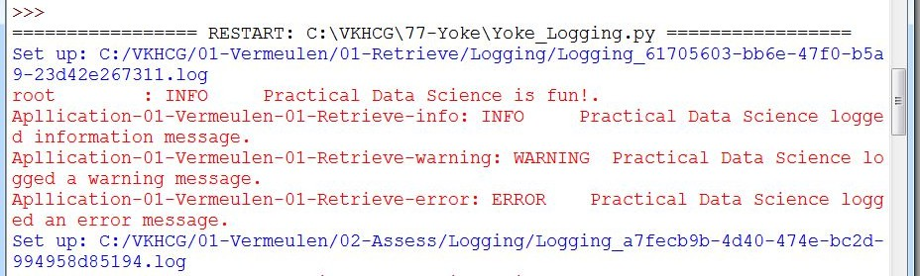

skey=str(uuid.uuid4())

sLogFile=Base + '/' + sCompany + '/' + sLayer + '/Logging/Logging_'+skey+'.log' print('Set up:',sLogFile)

# set up logging to file - see previous section for more details logging.basicConfig(level=logging.DEBUG,

format='%(asctime)s %(name)-12s %(levelname)-8s %(message)s', datefmt='%m-%d %H:%M',

filename=sLogFile, filemode='w')

# define a Handler which writes INFO messages or higher to the sys.stderr console = logging.StreamHandler()

console.setLevel(logging.INFO)

# set a format which is simpler for console use

formatter = logging.Formatter('%(name)-12s: %(levelname)-8s %(message)s') # tell the handler to use this format

console.setFormatter(formatter)

# add the handler to the root logger logging.getLogger('').addHandler(console)

# Now, we can log to the root logger, or any other logger. First the root... logging.info('Practical Data Science is fun!.')

for sLevel in sLevels:

sApp='Apllication-'+ sCompany + '-' + sLayer + '-' + sLevel logger = logging.getLogger(sApp)

if sLevel == 'debug':

logger.debug('Practical Data Science logged a debugging message.') if sLevel == 'info':

logger.info('Practical Data Science logged information message.') if sLevel == 'warning':

logger.warning('Practical Data Science logged a warning message.') if sLevel == 'error':

logger.error('Practical Data Science logged an error message.')

#

**Output:**

# Practical 4

**Retrieve Superstep**

The Retrieve superstep is a practical method for importing completely into the processing ecosystem a data lake consisting of various external data sources. The Retrieve superstep is the first contact between your data science and the source systems. I will guide you through a methodology of how to handle this discovery of the data up to the point you have all the data you need to evaluate the system you are working with, by deploying your data science skills. The successful retrieval of the data is a major stepping-stone to ensuring that you are performing good data science. Data lineage delivers the audit trail of the data elements at the lowest granular level, to ensure full data governance.

Data tagged in respective analytical models define the profile of the data that requires loading and guides the data scientist to what additional processing is required.

1. Perform the following data processing using R.

Use R-Studio for the following:

>library(readr)

Warning message:package ‘readr’ was built under R version 3.4.4

Load a table named IP_DATA_ALL.csv.

>IP_DATA_ALL <- read_csv("C:/VKHCG/01-Vermeulen/00-RawData/IP_DATA_ALL.csv") Parsed with column specification:

cols(

ID = col_double(), Country = col_character(),

`Place Name` = col_character(),

`Post Code` = col_double(), Latitude = col_double(), Longitude = col_double(),

`First IP Number` = col_double(),

`Last IP Number` = col_double()

)

>View(IP_DATA_ALL)

>spec(IP_DATA_ALL) cols(

ID = col_double(), Country = col_character(),

`Place Name` = col_character(),

`Post Code` = col_double(), Latitude = col_double(), Longitude = col_double(),

`First IP Number` = col_double(),

`Last IP Number` = col_double()

)

This informs you that you have the following eight columns:

* ID of type integer
* Place name of type character
* Post code of type character
* Latitude of type numeric double
* Longitude of type numeric double
* First IP number of type integer
* Last IP number of type integer

>library(tibble)

>set_tidy_names(IP_DATA_ALL, syntactic = TRUE, quiet = FALSE) New names:

Place Name -> Place.Name Post Code -> Post.Code

First IP Number -> First.IP.Number Last IP Number -> Last.IP.Number

This informs you that four of the field names are not valid and suggests new field names that are valid.You can fix any detected invalid column names by executing

IP_DATA_ALL_FIX=set_tidy_names(IP_DATA_ALL, syntactic = TRUE, quiet = TRUE)

By using command View(IP_DATA_ALL_FIX), you can check that you have fixed the columns. The new table IP_DATA_ALL_FIX.csv will fix the invalid column names with valid names.

>sapply(IP_DATA_ALL_FIX, typeof)

ID

"double"

Country "character"

Place.Name "character"

Post.Code "double"

Latitude "double"

Longitude First.IP.Number Last.IP.Number

"double"

"double"

"double"

>library(data.table)

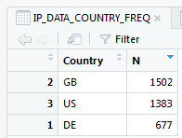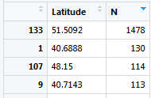

>hist_country=data.table(Country=unique(IP_DATA_ALL_FIX[is.na(IP_DATA_ALL_FIX ['Country']) == 0, ]$Country

))

>setorder(hist_country,'Country')

>hist_country_with_id=rowid_to_column(hist_country, var = "RowIDCountry")

>View(hist_country_fix)

>IP_DATA_COUNTRY_FREQ=data.table(with(IP_DATA_ALL_FIX, table(Country)))

>View(IP_DATA_COUNTRY_FREQ)

* The two biggest subset volumes are from the US and GB.
* The US has just over four times the data as GB.

hist_latitude =data.table(Latitude=unique(IP_DATA_ALL_FIX [is.na(IP_DATA_ALL_with_ID ['Latitude']) == 0, ]$Lati tude))

setkeyv(hist_latitude, 'Latitude') setorder(hist_latitude)

hist_latitude_with_id=rowid_to_column(hist_latitude, var = "RowID") View(hist_latitude_with_id) IP_DATA_Latitude_FREQ=data.table(with(IP_DATA_ALL_FIX,table(Latitude))) View(IP_DATA_Latitude_FREQ)

* The two biggest data volumes are from latitudes 51.5092 and 40.6888.
* The spread appears to be nearly equal between the top-two latitudes.

>sapply(IP_DATA_ALL_FIX[,'Latitude'], min, na.rm=TRUE) Latitude 40.6888

What does this tell you?

Fact: The range of latitude for the Northern Hemisphere is from 0 to 90. So, if you do not have any latitudes farther south than 40.6888, you can improve your retrieve routine.

>sapply(IP_DATA_ALL_FIX[,'Country'], min, na.rm=TRUE)

Country "DE"

Minimum business frequency is from DE – Denmark.

>sapply(IP_DATA_ALL_FIX[,'Latitude'], max, na.rm=TRUE) Latitude

51.5895

>sapply(IP_DATA_ALL_FIX[,'Country'], max, na.rm=TRUE)

Country "US"

The result is 51.5895. What does this tell you?

Fact: The range in latitude for the Northern Hemisphere is from 0 to 90. So, if you do not have any latitudes more northerly than 51.5895, you can improve your retrieve routine.

>sapply(IP_DATA_ALL_FIX [,'Latitude'], mean, na.rm=TRUE) Latitude

46.69097

>sapply(IP_DATA_ALL_FIX [,'Latitude'], median, na.rm=TRUE) Latitude

48.15

>sapply(IP_DATA_ALL_FIX [,'Latitude'], range, na.rm=TRUE)

Latitude [1,] 40.6888

[2,] 51.5895

>sapply(IP_DATA_ALL_FIX [,'Latitude'], quantile, na.rm=TRUE) Latitude

0%

25%

50%

75%

40.6888

40.7588

48.1500

51.5092

100% 51.5895

>sapply(IP_DATA_ALL_FIX [,'Latitude'], sd, na.rm=TRUE) Latitude

4.890387

>sapply(IP_DATA_ALL_FIX [,'Longitude'], sd, na.rm=TRUE) Longitude

38.01702

1. **Program to retrieve different attributes of data.**

##### **C:\ VKHCG\01-Vermeulen\01-Retrieve\Retrive_IP_DATA_ALL.py**### import sys

import os

import pandas as pd ################################################################ Base='C:/VKHCG' ################################################################

sFileName=Base + '/01-Vermeulen/00-RawData/IP_DATA_ALL.csv' print('Loading :',sFileName)

IP_DATA_ALL=pd.read_csv(sFileName,header=0,low_memory=False, encoding="latin-1") ################################################################

sFileDir=Base + '/01-Vermeulen/01-Retrieve/01-EDS/02-Python' if not os.path.exists(sFileDir):

os.makedirs(sFileDir)

print('Rows:', IP_DATA_ALL.shape[0]) print('Columns:', IP_DATA_ALL.shape[1])

print('### Raw Data Set #####################################')

for i in range(0,len(IP_DATA_ALL.columns)): print(IP_DATA_ALL.columns[i],type(IP_DATA_ALL.columns[i]))

print('### Fixed Data Set ###################################')

IP_DATA_ALL_FIX=IP_DATA_ALL

for i in range(0,len(IP_DATA_ALL.columns)):

cNameOld=IP_DATA_ALL_FIX.columns[i] + ' ' cNameNew=cNameOld.strip().replace(" ", ".")

IP_DATA_ALL_FIX.columns.values[i] = cNameNew print(IP_DATA_ALL.columns[i],type(IP_DATA_ALL.columns[i]))

################################################################

#print(IP_DATA_ALL_FIX.head()) ################################################################

print('Fixed Data Set with ID') IP_DATA_ALL_with_ID=IP_DATA_ALL_FIX IP_DATA_ALL_with_ID.index.names = ['RowID'] #print(IP_DATA_ALL_with_ID.head()) sFileName2=sFileDir + '/Retrieve_IP_DATA.csv'

IP_DATA_ALL_with_ID.to_csv(sFileName2, index = True, encoding="latin-1") ################################################################ print('### Done!! ############################################') ################################################################

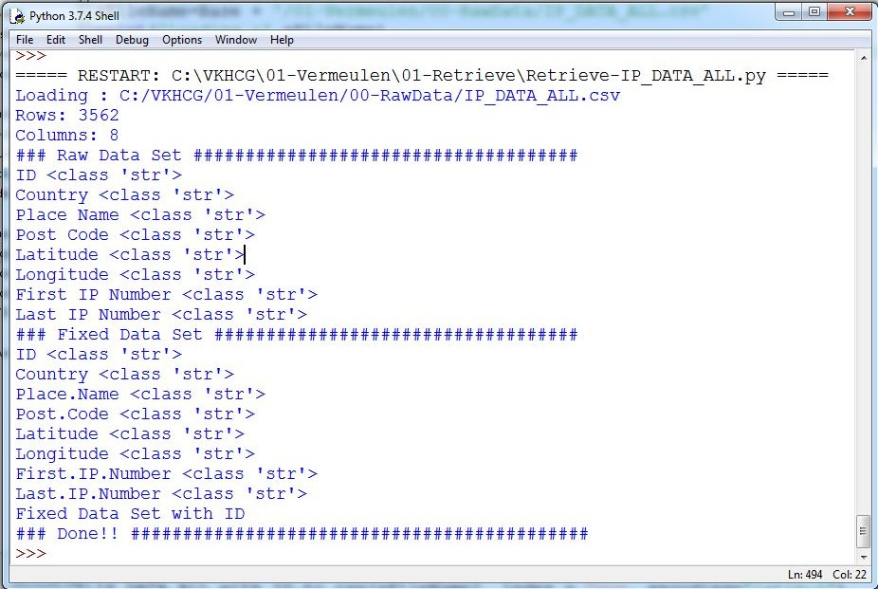

1. Data Pattern

To determine a pattern of the data values, Replace all alphabet values with an uppercase case *A*, all numbers with an uppercase *N*, and replace any spaces with a lowercase letter *b* and all other unknown characters with a lowercase *u*. As a result, “Good Book 101” becomes “AAAAbAAAAbNNNu.”This pattern creation is beneficial for designing any specific assess rules. This pattern view of data is a quick way to identify common patterns or determine standard layouts.

library(readr) library(data.table)

FileName=paste0('c:/VKHCG/01-Vermeulen/00-RawData/IP_DATA_ALL.csv') IP_DATA_ALL <- read_csv(FileName) hist_country=data.table(Country=unique(IP_DATA_ALL$Country)) pattern_country=data.table(Country=hist_country$Country,

PatternCountry=hist_country$Country) oldchar=c(letters,LETTERS) newchar=replicate(length(oldchar),"A")

for (r in seq(nrow(pattern_country))){ s=pattern_country[r,]$PatternCountry; for (c in seq(length(oldchar))){ s=chartr(oldchar[c],newchar[c],s)

};

for (n in seq(0,9,1)){ s=chartr(as.character(n),"N",s)

};

s=chartr(" ","b",s)

s=chartr(".","u",s) pattern_country[r,]$PatternCountry=s;

};

View(pattern_country)

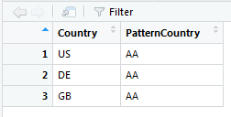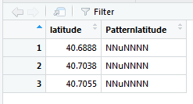

**Example 2:** This is a common use of patterns to separate common standards and structures. Pattern can be loaded in separate retrieve procedures. If the same two patterns, NNNNuNNuNN and uuNNuNNuNN, are found, you can send NNNNuNNuNN directly to be converted into a date, while uuNNuNNuNN goes through a quality-improvement process to then route back to the same queue as NNNNuNNuNN, once it complies.

library(readr) library(data.table) Base='C:/VKHCG'

FileName=paste0(Base,'/01-Vermeulen/00-RawData/IP_DATA_ALL.csv') IP_DATA_ALL <- read_csv(FileName) hist_latitude=data.table(Latitude=unique(IP_DATA_ALL$Latitude)) pattern_latitude=data.table(latitude=hist_latitude$Latitude,

Patternlatitude=as.character(hist_latitude$Latitude)) oldchar=c(letters,LETTERS)

newchar=replicate(length(oldchar),"A") for (r in seq(nrow(pattern_latitude))){ s=pattern_latitude[r,]$Patternlatitude; for (c in seq(length(oldchar))){

s=chartr(oldchar[c],newchar[c],s)

};

for (n in seq(0,9,1)){ s=chartr(as.character(n),"N",s)

};

s=chartr(" ","b",s)

s=chartr("+","u",s)

s=chartr("-","u",s)

s=chartr(".","u",s) pattern_latitude[r,]$Patternlatitude=s;

};

setorder(pattern_latitude,latitude) View(pattern_latitude[1:3])

###### Loading IP_DATA_ALL:

This data set contains all the IP address allocations in the world. It will help you to locateyour customers when interacting with them online.

Create a new Python script file and save it as Retrieve-IP_DATA_ALL.py in directory C:\VKHCG\01-Vermeulen\01-Retrieve.

##############Retrieve-IP_DATA_ALL.py########################

# -*- coding: utf-8 -*- ################################################################

import sys import os

import pandas as pd ################################################################ Base='C:/VKHCG' ################################################################

sFileName=Base + '/01-Vermeulen/00-RawData/IP_DATA_ALL.csv' print('Loading :',sFileName)

IP_DATA_ALL=pd.read_csv(sFileName,header=0,low_memory=False, encoding="latin-1") ################################################################

sFileDir=Base + '/01-Vermeulen/01-Retrieve/01-EDS/02-Python' if not os.path.exists(sFileDir):

os.makedirs(sFileDir)

print('Rows:', IP_DATA_ALL.shape[0]) print('Columns:', IP_DATA_ALL.shape[1])

print('### Raw Data Set #####################################')

for i in range(0,len(IP_DATA_ALL.columns)): print(IP_DATA_ALL.columns[i],type(IP_DATA_ALL.columns[i]))

print('### Fixed Data Set ###################################')

IP_DATA_ALL_FIX=IP_DATA_ALL

for i in range(0,len(IP_DATA_ALL.columns)):

cNameOld=IP_DATA_ALL_FIX.columns[i] + ' ' cNameNew=cNameOld.strip().replace(" ", ".")

IP_DATA_ALL_FIX.columns.values[i] = cNameNew print(IP_DATA_ALL.columns[i],type(IP_DATA_ALL.columns[i]))

################################################################

#print(IP_DATA_ALL_FIX.head()) ################################################################

print('Fixed Data Set with ID') IP_DATA_ALL_with_ID=IP_DATA_ALL_FIX IP_DATA_ALL_with_ID.index.names = ['RowID'] #print(IP_DATA_ALL_with_ID.head())

sFileName2=sFileDir + '/Retrieve_IP_DATA.csv' IP_DATA_ALL_with_ID.to_csv(sFileName2, index = True, encoding="latin-1") ################################################################ print('### Done!! ############################################') ################################################################

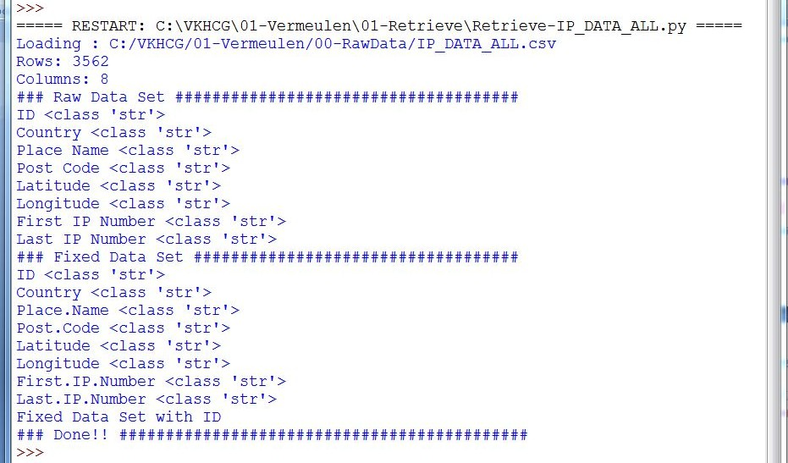

**Similarly execute the code for:**

###### Loading IP_DATA_C_VKHCG Loading IP_DATA_CORE Loading COUNTRY-CODES Loading DE_Billboard_Locations Loading GB_Postcode_Full Loading GB_Postcode_Warehouse Loading GB_Postcode_Shops Loading Euro_ExchangeRates Load: Profit_And_Loss

Assistinga company with its processing. The means are as follows:

* Identify the data sources required.
* Identify source data format (CSV, XML, JSON, or database).
* Data profile the data distribution (Skew, Histogram, Min, Max).
* Identify any loading characteristics (Columns Names, Data Types, Volumes).
* Determine the delivery format (CSV, XML, JSON, or database).

#### Vermeulen PLC

The company has two main jobs on which to focus your attention:

* Designing a routing diagram for company
* Planning a schedule of jobs to be performed for the router network

Start your Python editor and create a text file named Retrieve-IP_Routing.py in directory. C:\VKHCG\01-Vermeulen\01-Retrieve. ################################################################

# -*- coding: utf-8 -*- ################################################################

import sys import os

import pandas as pd

from math import radians, cos, sin, asin, sqrt ################################################################

def haversine(lon1, lat1, lon2, lat2,stype): """

Calculate the great circle distance between two points on the earth (specified in decimal degrees)

"""

# convert decimal degrees to radians

lon1, lat1, lon2, lat2 = map(radians, [lon1, lat1, lon2, lat2]) # haversine formula

dlon = lon2 - lon1 dlat = lat2 - lat1

a = sin(dlat/2)**2 + cos(lat1) * cos(lat2) * sin(dlon/2)**2 c = 2 * asin(sqrt(a))

if stype == 'km':

r = 6371 # Radius of earth in kilometers else:

r = 3956 # Radius of earth in miles d=round(c * r,3)

return d ################################################################ Base='C:/VKHCG' ################################################################

sFileName=Base + '/01-Vermeulen/00-RawData/IP_DATA_CORE.csv' print('Loading :',sFileName) IP_DATA_ALL=pd.read_csv(sFileName,header=0,low_memory=False, usecols=['Country','Place Name','Latitude','Longitude'], encoding="latin-1") ################################################################

sFileDir=Base + '/01-Vermeulen/01-Retrieve/01-EDS/02-Python' if not os.path.exists(sFileDir):

os.makedirs(sFileDir) ################################################################

IP_DATA = IP_DATA_ALL.drop_duplicates(subset=None, keep='first', inplace=False) IP_DATA.rename(columns={'Place Name': 'Place_Name'}, inplace=True)

IP_DATA1 = IP_DATA IP_DATA1.insert(0, 'K', 1)

IP_DATA2 = IP_DATA1 ################################################################

print(IP_DATA1.shape) ################################################################

IP_CROSS=pd.merge(right=IP_DATA1,left=IP_DATA2,on='K') IP_CROSS.drop('K', axis=1, inplace=True)

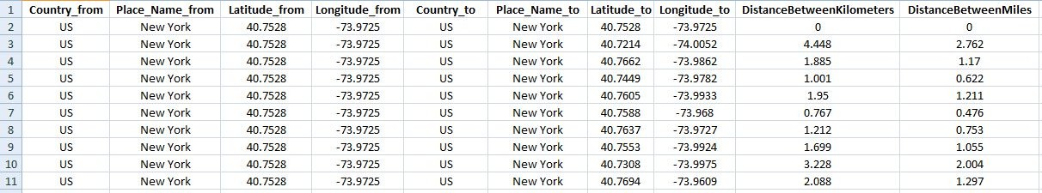

IP_CROSS.rename(columns={'Longitude_x': 'Longitude_from', 'Longitude_y': 'Longitude_to'}, inplace=True)

IP_CROSS.rename(columns={'Latitude_x': 'Latitude_from', 'Latitude_y': 'Latitude_to'}, inplace=True)

IP_CROSS.rename(columns={'Place_Name_x': 'Place_Name_from', 'Place_Name_y': 'Place_Name_to'}, inplace=True)

IP_CROSS.rename(columns={'Country_x': 'Country_from', 'Country_y': 'Country_to'}, inplace=True) ################################################################

IP_CROSS['DistanceBetweenKilometers'] = IP_CROSS.apply(lambda row: haversine(

row['Longitude_from'], row['Latitude_from'], row['Longitude_to'], row['Latitude_to'], 'km')

,axis=1) ################################################################

IP_CROSS['DistanceBetweenMiles'] = IP_CROSS.apply(lambda row: haversine(

row['Longitude_from'], row['Latitude_from'], row['Longitude_to'], row['Latitude_to'], 'miles')

,axis=1) print(IP_CROSS.shape)

sFileName2=sFileDir + '/Retrieve_IP_Routing.csv' IP_CROSS.to_csv(sFileName2, index = False, encoding="latin-1") ################################################################ print('### Done!! ############################################') ################################################################

**Output:**

See the file named Retrieve_IP_Routing.csv in C:\VKHCG\01-Vermeulen\01-Retrieve\01-EDS\02- Python.

**Total Records: 22501**

So, the distance between a router in New York (40.7528, -73.9725) to anoher router in New York (40.7214, -74.0052) is 4.448 kilometers, or 2.762 miles.

###### Building a Diagram for the Scheduling of Jobs

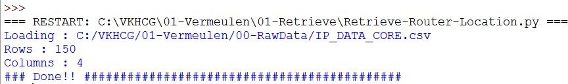

Start your Python editor and create a text file named Retrieve-Router-Location.py in directory. C:\VKHCG\01-Vermeulen\01-Retrieve.

################### Retrieve-Router-Location.py ###################### # -*- coding: utf-8 -*-

################################################################

import sys import os

import pandas as pd ################################################################

InputFileName='IP_DATA_CORE.csv' OutputFileName='Retrieve_Router_Location.csv' ################################################################ Base='C:/VKHCG' ################################################################

sFileName=Base + '/01-Vermeulen/00-RawData/' + InputFileName print('Loading :',sFileName) IP_DATA_ALL=pd.read_csv(sFileName,header=0,low_memory=False, usecols=['Country','Place Name','Latitude','Longitude'], encoding="latin-1") ################################################################

IP_DATA_ALL.rename(columns={'Place Name': 'Place_Name'}, inplace=True) ################################################################

sFileDir=Base + '/01-Vermeulen/01-Retrieve/01-EDS/02-Python' if not os.path.exists(sFileDir):

os.makedirs(sFileDir)

ROUTERLOC = IP_DATA_ALL.drop_duplicates(subset=None, keep='first', inplace=False)

print('Rows :',ROUTERLOC.shape[0]) print('Columns :',ROUTERLOC.shape[1])

sFileName2=sFileDir + '/' + OutputFileName ROUTERLOC.to_csv(sFileName2, index = False, encoding="latin-1") ################################################################ print('### Done!! ############################################') ################################################################

**Output:**

See the file named Retrieve_Router_Location.csv in C:\VKHCG\01-Vermeulen\01-Retrieve\01-EDS\02-Python.

#### Krennwallner AG

The company has two main jobs in need of your attention:

* *Picking content for billboards*: I will guide you through the data science required to pick advertisements for each billboard in the company.
* *Understanding your online visitor data*: I will guide you through the evaluation of the web traffic to the billboard’s online web servers.

###### Picking Content for Billboards

Start your Python editor and create a text file named Retrieve-DE-Billboard-Locations.py in directory.

C:\VKHCG\02-Krennwallner\01-Retrieve.

################# Retrieve-DE-Billboard-Locations.py # -*- coding: utf-8 -*-

###############

################################################################

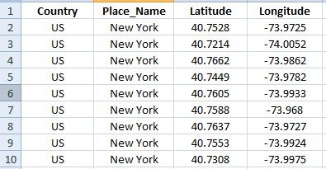

import sys import os

import pandas as pd ################################################################

InputFileName='DE_Billboard_Locations.csv' OutputFileName='Retrieve_DE_Billboard_Locations.csv' Company='02-Krennwallner'

################################################################ Base='C:/VKHCG'

print('################################')

print('Working Base :',Base, ' using ', sys.platform) print('################################') ################################################################ Base='C:/VKHCG'

sFileName=Base + '/' + Company + '/00-RawData/' + InputFileName print('Loading :',sFileName) IP_DATA_ALL=pd.read_csv(sFileName,header=0,low_memory=False, usecols=['Country','PlaceName','Latitude','Longitude'])

IP_DATA_ALL.rename(columns={'PlaceName': 'Place_Name'}, inplace=True) ################################################################

sFileDir=Base + '/' + Company + '/01-Retrieve/01-EDS/02-Python' if not os.path.exists(sFileDir):

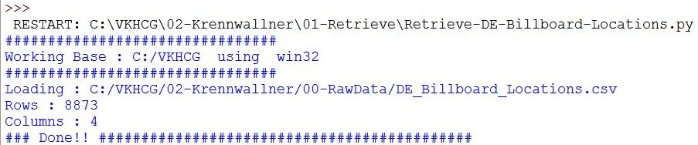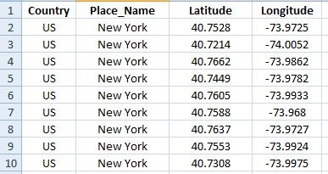

os.makedirs(sFileDir)

ROUTERLOC = IP_DATA_ALL.drop_duplicates(subset=None, keep='first', inplace=False)

print('Rows :',ROUTERLOC.shape[0]) print('Columns :',ROUTERLOC.shape[1])

sFileName2=sFileDir + '/' + OutputFileName ROUTERLOC.to_csv(sFileName2, index = False)

################################################################ print('### Done!! ############################################') ################################################################

See the file named Retrieve_Router_Location.csv in C:\VKHCG\02-Krennwallner\01-Retrieve\01-EDS\02-Python.

###### Understanding Your Online Visitor Data

Let’s retrieve the visitor data for the billboard we have in Germany.

Several times it was found that common and important information is buried somewhere in the

company’s various data sources. Investigating any direct suppliers or consumers’ upstream or

downstream data sources attached to the specific business process is necessary. That is part of your skills that you are applying to data science. Numerous insightful fragments of information was found in the data sources surrounding a customer’s business processes.

Start your Python editor and create a file named Retrieve-Online-Visitor.py in directory C:\VKHCG\02-Krennwallner\01-Retrieve. ################################################################

# -*- coding: utf-8 -*-

################################################################

import sys import os

import pandas as pd import gzip as gz

################################################################

InputFileName='IP_DATA_ALL.csv' OutputFileName='Retrieve_Online_Visitor' CompanyIn= '01-Vermeulen' CompanyOut= '02-Krennwallner'

################################################################ Base='C:/VKHCG'

print('################################')

print('Working Base :',Base, ' using ', sys.platform) print('################################') ################################################################ Base='C:/VKHCG'

sFileName=Base + '/' + CompanyIn + '/00-RawData/' + InputFileName print('Loading :',sFileName) IP_DATA_ALL=pd.read_csv(sFileName,header=0,low_memory=False,

usecols=['Country','Place Name','Latitude','Longitude','First IP Number','Last IP Number'])

IP_DATA_ALL.rename(columns={'Place Name': 'Place_Name'}, inplace=True) IP_DATA_ALL.rename(columns={'First IP Number': 'First_IP_Number'}, inplace=True) IP_DATA_ALL.rename(columns={'Last IP Number': 'Last_IP_Number'}, inplace=True) ################################################################

sFileDir=Base + '/' + CompanyOut + '/01-Retrieve/01-EDS/02-Python' if not os.path.exists(sFileDir):

os.makedirs(sFileDir)

visitordata = IP_DATA_ALL.drop_duplicates(subset=None, keep='first', inplace=False) visitordata10=visitordata.head(10)

print('Rows :',visitordata.shape[0]) print('Columns :',visitordata.shape[1])

print('Export CSV')

sFileName2=sFileDir + '/' + OutputFileName + '.csv' visitordata.to_csv(sFileName2, index = False) print('Store All:',sFileName2)

sFileName3=sFileDir + '/' + OutputFileName + '_10.csv' visitordata10.to_csv(sFileName3, index = False) print('Store 10:',sFileName3)

for z in ['gzip', 'bz2', 'xz']: if z == 'gzip':

sFileName4=sFileName2 + '.gz'

else:

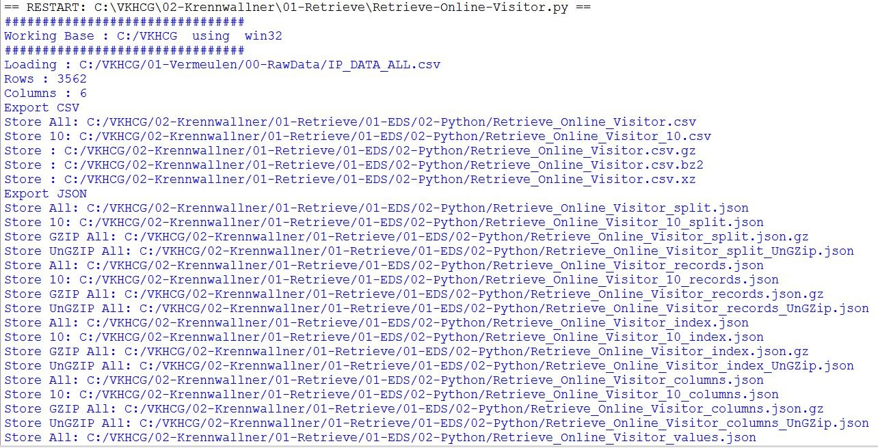

sFileName4=sFileName2 + '.' + z visitordata.to_csv(sFileName4, index = False, compression=z) print('Store :',sFileName4)

################################################################

print('Export JSON')

for sOrient in ['split','records','index', 'columns','values','table']: sFileName2=sFileDir + '/' + OutputFileName + '_' + sOrient + '.json' visitordata.to_json(sFileName2,orient=sOrient,force_ascii=True) print('Store All:',sFileName2)

sFileName3=sFileDir + '/' + OutputFileName + '_10_' + sOrient + '.json' visitordata10.to_json(sFileName3,orient=sOrient,force_ascii=True) print('Store 10:',sFileName3)

sFileName4=sFileName2 + '.gz' file_in = open(sFileName2, 'rb') file_out = gz.open(sFileName4, 'wb') file_out.writelines(file_in) file_in.close()

file_out.close()

print('Store GZIP All:',sFileName4)

sFileName5=sFileDir + '/' + OutputFileName + '_' + sOrient + '_UnGZip.json' file_in = gz.open(sFileName4, 'rb')

file_out = open(sFileName5, 'wb') file_out.writelines(file_in) file_in.close()

file_out.close()

print('Store UnGZIP All:',sFileName5) ################################################################ print('### Done!! ############################################') ################################################################

**Output:**

See the file named Retrieve_Online_Visitor.csv in

C:\VKHCG\02-Krennwallner\01-Retrieve\01-EDS\02-Python.

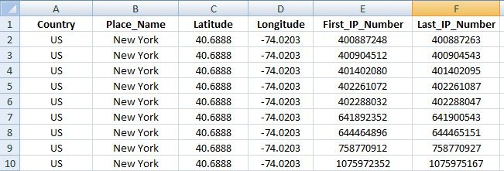

You can also see the following JSON files of only ten records.

###### XML processing.

Start Python editor and create a file named Retrieve-Online-Visitor-XML.py indirectory C:\VKHCG\02-Krennwallner\01-Retrieve. ################################################################

# -*- coding: utf-8 -*- ################################################################

import sys import os

import pandas as pd

import xml.etree.ElementTree as ET ################################################################

def df2xml(data):

header = data.columns root = ET.Element('root')

for row in range(data.shape[0]):

entry = ET.SubElement(root,'entry') for index in range(data.shape[1]):

schild=str(header[index])

child = ET.SubElement(entry, schild) if str(data[schild][row]) != 'nan':

child.text = str(data[schild][row]) else:

child.text = 'n/a' entry.append(child)

result = ET.tostring(root) return result

################################################################

def xml2df(xml_data):

root = ET.XML(xml_data) all_records = []

for i, child in enumerate(root): record = {}

for subchild in child:

record[subchild.tag] = subchild.text all_records.append(record)

return pd.DataFrame(all_records) ################################################################

InputFileName='IP_DATA_ALL.csv' OutputFileName='Retrieve_Online_Visitor.xml' CompanyIn= '01-Vermeulen'

CompanyOut= '02-Krennwallner' ################################################################

if sys.platform == 'linux': Base=os.path.expanduser('~') + '/VKHCG'

else:

Base='C:/VKHCG' ################################################################ print('################################')

print('Working Base :',Base, ' using ', sys.platform) print('################################') ################################################################

sFileName=Base + '/' + CompanyIn + '/00-RawData/' + InputFileName print('Loading :',sFileName) IP_DATA_ALL=pd.read_csv(sFileName,header=0,low_memory=False)

IP_DATA_ALL.rename(columns={'Place Name': 'Place_Name'}, inplace=True) IP_DATA_ALL.rename(columns={'First IP Number': 'First_IP_Number'}, inplace=True) IP_DATA_ALL.rename(columns={'Last IP Number': 'Last_IP_Number'}, inplace=True) IP_DATA_ALL.rename(columns={'Post Code': 'Post_Code'}, inplace=True) ################################################################

sFileDir=Base + '/' + CompanyOut + '/01-Retrieve/01-EDS/02-Python' if not os.path.exists(sFileDir):

os.makedirs(sFileDir)

visitordata = IP_DATA_ALL.head(10000)

print('Original Subset Data Frame') print('Rows :',visitordata.shape[0]) print('Columns :',visitordata.shape[1]) print(visitordata)

print('Export XML') sXML=df2xml(visitordata)

sFileName=sFileDir + '/' + OutputFileName file_out = open(sFileName, 'wb') file_out.write(sXML)

file_out.close()

print('Store XML:',sFileName)

xml_data = open(sFileName).read()

unxmlrawdata=xml2df(xml_data) print('Raw XML Data Frame') print('Rows :',unxmlrawdata.shape[0]) print('Columns :',unxmlrawdata.shape[1]) print(unxmlrawdata)

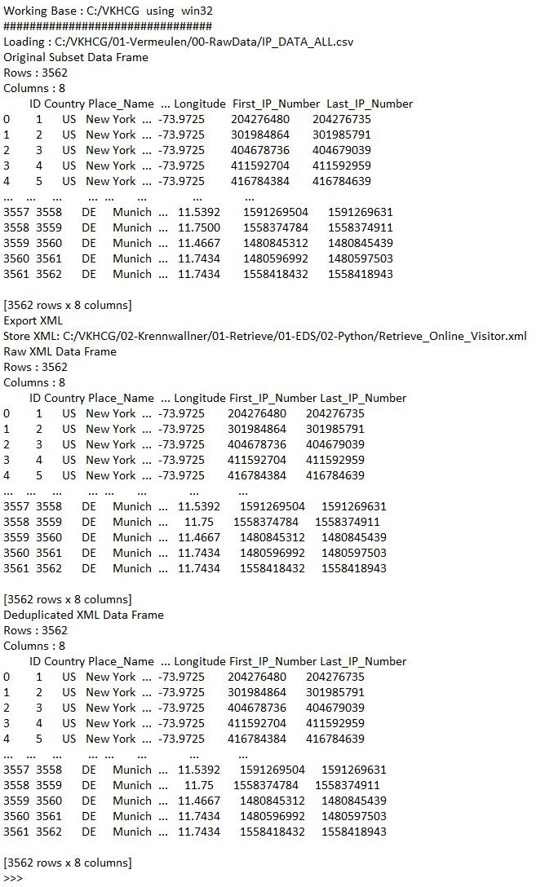

unxmldata = unxmlrawdata.drop_duplicates(subset=None, keep='first', inplace=False) print('Deduplicated XML Data Frame')

print('Rows :',unxmldata.shape[0]) print('Columns :',unxmldata.shape[1]) print(unxmldata)

################################################################# #print('### Done!! ############################################') #################################################################

**Output:**

See a file named Retrieve_Online_Visitor.xml in C:\VKHCG\02-Krennwallner\01-Retrieve\01-EDS\02-Python.

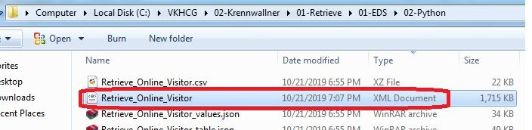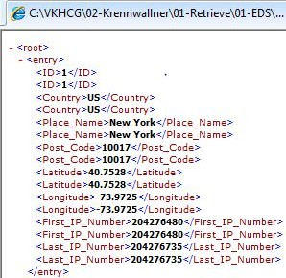

This enables you to deliver XML format data as part of the retrieve step.

#### Hillman Ltd

The company has four main jobs requiring your attention:

* *Planning the locations of the warehouses*: Hillman has countless UK warehouses, but owing to financial hardships, the business wants to shrink the quantity of warehouses by 20%.
* *Planning the shipping rules for best-fit international logistics*: At Hillman Global Logistics’ expense, the company has shipped goods from its international warehouses to its UK shops. This model is no longer sustainable. The co-owned shops now want more feasibility regarding shipping options.
* *Adopting the best packing option for shipping in containers*: Hillman has introduced a new

three-size-shipping-container solution. It needs a packing solution encompassing the

warehouses, shops, and customers.

* *Creating a delivery route*: Hillman needs to preplan a delivery route for each of its

warehouses to shops, to realize a 30% savings in shipping costs.

###### Planning Shipping Rules for Best-Fit International Logistics

*(Befor this Program, first understand the business terms explained in the reference book)*

**EXW—Ex Works (Named Place of Delivery)**

By this term, the seller makes the goods available at its premises or at another namedplace. This term places the maximum obligation on the buyer and minimum obligationson the seller.

Start yourPython editor and create a file named Retrieve-Incoterm-EXW.py in directory C:\VKHCG\03-Hillman\01-Retrieve. ################################################################

# -*- coding: utf-8 -*-

import os import sys

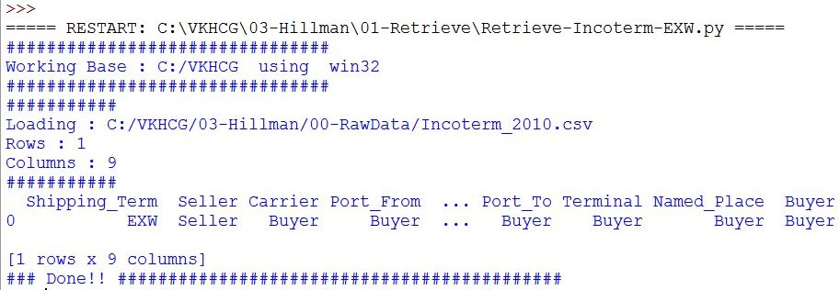

import pandas as pd IncoTerm='EXW' InputFileName='Incoterm_2010.csv'

OutputFileName='Retrieve_Incoterm_' + IncoTerm + '_RuleSet.csv' Company='03-Hillman' ################################################################ Base='C:/VKHCG'

print('################################')

print('Working Base :',Base, ' using ', sys.platform) print('################################')

sFileDir=Base + '/' + Company + '/01-Retrieve/01-EDS/02-Python' if not os.path.exists(sFileDir):

os.makedirs(sFileDir) ################################################################

### Import Incoterms ################################################################

sFileName=Base + '/' + Company + '/00-RawData/' + InputFileName print('###########')

print('Loading :',sFileName) IncotermGrid=pd.read_csv(sFileName,header=0,low_memory=False) IncotermRule=IncotermGrid[IncotermGrid.Shipping_Term == IncoTerm] print('Rows :',IncotermRule.shape[0])

print('Columns :',IncotermRule.shape[1]) print('###########')

print(IncotermRule)

sFileName=sFileDir + '/' + OutputFileName IncotermRule.to_csv(sFileName, index = False)

print('### Done!! ############################################')

**Output**

See the file named Retrieve_Incoterm_EXW.csv in C:\VKHCG\03-Hillman\01-Retrieve\01-EDS\02- Python. Open this file,

**FCA—Free Carrier (Named Place of Delivery)**

Under this condition, the seller delivers the goods, cleared for export, at a named place.

If I were to buy *Practical Data Science* at an overseas duty-free shop and then pick it up at the duty-free desk before taking it home, and the shop has shipped it FCA— Free Carrier—to the duty-free desk, the moment I pay at the register, the ownership is transferred to me, but if anything happens to the book between the shop and the duty-free desk, the shop will have to pay. It is only once I pick it up at the desk that I will have to pay, if anything happens. So, the moment I take the book, the transaction becomes EXW, so I have to pay any necessary import duties on arrival in my home country. Let’s see what the data science finds. Start your Python editor and create a text file named Retrieve-Incoterm-FCA.py in directory .\VKHCG\03-Hillman\01-Retrieve.

################################################################

# -*- coding: utf-8 -*- ################################################################

import os import sys

import pandas as pd ################################################################

IncoTerm='FCA' InputFileName='Incoterm_2010.csv'

OutputFileName='Retrieve_Incoterm_' + IncoTerm + '_RuleSet.csv' Company='03-Hillman' ################################################################ Base='C:/VKHCG'

print('################################')

print('Working Base :',Base, ' using ', sys.platform) print('################################') ################################################################

sFileDir=Base + '/' + Company + '/01-Retrieve/01-EDS/02-Python' if not os.path.exists(sFileDir):

os.makedirs(sFileDir) ################################################################

### Import Incoterms ################################################################

sFileName=Base + '/' + Company + '/00-RawData/' + InputFileName print('###########')

print('Loading :',sFileName) IncotermGrid=pd.read_csv(sFileName,header=0,low_memory=False) IncotermRule=IncotermGrid[IncotermGrid.Shipping_Term == IncoTerm] print('Rows :',IncotermRule.shape[0])

print('Columns :',IncotermRule.shape[1]) print('###########')

print(IncotermRule) ################################################################

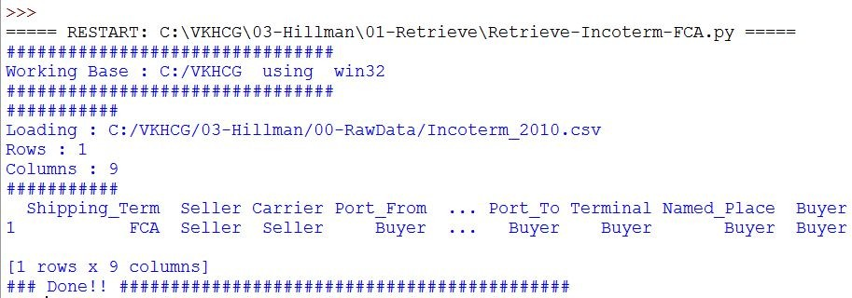

sFileName=sFileDir + '/' + OutputFileName IncotermRule.to_csv(sFileName, index = False)

################################################################ print('### Done!! ############################################') ################################################################

**Output:**

**CPT—Carriage Paid To (Named Place of Destination)**

The seller, under this term, pays for the carriage of the goods up to the named place of destination. However, the goods are considered to be delivered when they have been handed over to the first carrier, so that the risk transfers to the buyer upon handing the goods over to the carrier at the place of shipment in the country of export.

Start your Python editor and create a file named Retrieve-Incoterm-CPT.py in directory C:\VKHCG\03-Hillman\01-Retrieve.

**CIP—Carriage and Insurance Paid To (Named Place of Destination)**

This term is generally similar to the preceding CPT, with the exception that the seller is required to obtain insurance for the goods while in transit. Following is the data science version.

**DAT—Delivered at Terminal (Named Terminal at Port or Place of Destination)**

This Incoterm requires that the seller deliver the goods, unloaded, at the named terminal. The seller covers all the costs of transport (export fees, carriage, unloading from the main carrier at destination port, and destination port charges) and assumes all risks until arrival at the destination port or terminal.

**DAP—Delivered at Place (Named Place of Destination)**

According to Incoterm 2010’s definition, DAP—Delivered at Place—means that, at the disposal of the buyer, the seller delivers when the goods are placed on the arriving means of transport, ready for unloading at the

named place of destination. Under DAP terms, the risk passes from seller to buyer from the point of

destination mentioned in the contract of delivery.

**DDP—Delivered Duty Paid (Named Place of Destination)**

By this term, the seller is responsible for delivering the goods to the named place in the country of the buyer and pays all costs in bringing the goods to the destination, including import duties and taxes. The seller is not responsible for unloading. This term places the maximum obligations on the seller and minimum obligations

on the buyer. No risk or responsibility is transferred to the buyer until delivery of the goods at the named place of destination.

Possible Shipping Routes

There are numerous potential shipping routes available to the company. The retrieve step can generate the potential set, by using a route combination generator. This will give you a set of routes, but it is highly unlikely that you will ship along all of them. It is simply a population of routes that can be used by the data science to find the optimum solution.

Start your Python editor and create a file named Retrieve-Warehouse-Incoterm-Chains.py in directory

C:\VKHCG\03-Hillman\01-Retrieve.

##### Adopt New Shipping Containers

Adopting the best packing option for shipping in containers will require that I introduce a new concept. Shipping of containers is based on a concept reducing the packaging you use down to an optimum set of sizes having the following requirements:

* The product must fit within the box formed by the four sides of a cube.
* The product can be secured using packing foam, which will fill any void volume in the packaging.
* Packaging must fit in shipping containers with zero space gaps.
* Containers can only hold product that is shipped to a single warehouse, shop, or customer.

Start your Python editor and create a text file named Retrieve-Container-Plan.py in directory . C:\VKHCG\03-Hillman\01-Retrieve.

**\*\*\* Replace pd.DataFrame.from_items with pd.DataFrame.from_dict**

################################################################

# -*- coding: utf-8 -*- ################################################################

import sys import os

import pandas as pd ################################################################

ContainerFileName='Retrieve_Container.csv' BoxFileName='Retrieve_Box.csv' ProductFileName='Retrieve_Product.csv' Company='03-Hillman'

################################################################ Base='C:/VKHCG' ################################################################ print('################################')

print('Working Base :',Base, ' using ', sys.platform) print('################################') ################################################################

sFileDir=Base + '/' + Company + '/01-Retrieve/01-EDS/02-Python' if not os.path.exists(sFileDir):

os.makedirs(sFileDir) ################################################################

### Create the Containers ################################################################

containerLength=range(1,21) containerWidth=range(1,10) containerHeigth=range(1,6)

containerStep=1 c=0

for l in containerLength: for w in containerWidth:

for h in containerHeigth: containerVolume=(l/containerStep)*(w/containerStep)*(h/containerStep) c=c+1

ContainerLine=[('ShipType', ['Container']), ('UnitNumber', ('C'+format(c,"06d"))),

('Length',(format(round(l,3),".4f"))),

('Width',(format(round(w,3),".4f"))),

('Height',(format(round(h,3),".4f"))), ('ContainerVolume',(format(round(containerVolume,6),".6f")))]

if c==1:

ContainerFrame = pd.DataFrame.from_dict(ContainerLine) else:

ContainerRow = pd.DataFrame.from_dict(ContainerLine) ContainerFrame = ContainerFrame.append(ContainerRow)

ContainerFrame.index.name = 'IDNumber'

print('################')

print('## Container') print('################')

print('Rows :',ContainerFrame.shape[0]) print('Columns :',ContainerFrame.shape[1]) print('################')

################################################################

sFileContainerName=sFileDir + '/' + ContainerFileName ContainerFrame.to_csv(sFileContainerName, index = False) ################################################################

## Create valid Boxes with packing foam ################################################################

boxLength=range(1,21) boxWidth=range(1,21) boxHeigth=range(1,21) packThick=range(0,6) boxStep=10

b=0

for l in boxLength: for w in boxWidth:

for h in boxHeigth: for t in packThick:

boxVolume=round((l/boxStep)*(w/boxStep)*(h/boxStep),6) productVolume=round(((l-t)/boxStep)*((w-t)/boxStep)*((h-t)/boxStep),6) if productVolume > 0:

b=b+1

BoxLine=[('ShipType', ['Box']),

('UnitNumber', ('B'+format(b,"06d"))),

('Length',(format(round(l/10,6),".6f"))),

('Width',(format(round(w/10,6),".6f"))),

('Height',(format(round(h/10,6),".6f"))),

('Thickness',(format(round(t/5,6),".6f"))),

('BoxVolume',(format(round(boxVolume,9),".9f"))), ('ProductVolume',(format(round(productVolume,9),".9f")))]

if b==1:

BoxFrame = pd.DataFrame.from_dict(BoxLine) else:

BoxRow = pd.DataFrame.from_dict(BoxLine) BoxFrame = BoxFrame.append(BoxRow)

BoxFrame.index.name = 'IDNumber' print('#################')

print('## Box') print('#################')

print('Rows :',BoxFrame.shape[0]) print('Columns :',BoxFrame.shape[1]) print('#################')

################################################################

sFileBoxName=sFileDir + '/' + BoxFileName BoxFrame.to_csv(sFileBoxName, index = False) ################################################################

## Create valid Product ################################################################

productLength=range(1,21) productWidth=range(1,21) productHeigth=range(1,21) productStep=10

p=0

for l in productLength: for w in productWidth:

for h in productHeigth: productVolume=round((l/productStep)*(w/productStep)*(h/productStep),6) if productVolume > 0:

p=p+1

ProductLine=[('ShipType', ['Product']), ('UnitNumber', ('P'+format(p,"06d"))),

('Length',(format(round(l/10,6),".6f"))),

('Width',(format(round(w/10,6),".6f"))),

('Height',(format(round(h/10,6),".6f"))), ('ProductVolume',(format(round(productVolume,9),".9f")))]

if p==1:

ProductFrame = pd.DataFrame.from_dict(ProductLine) else:

ProductRow = pd.DataFrame.from_dict(ProductLine) ProductFrame = ProductFrame.append(ProductRow)

BoxFrame.index.name = 'IDNumber' print('#################')

print('## Product') print('#################')

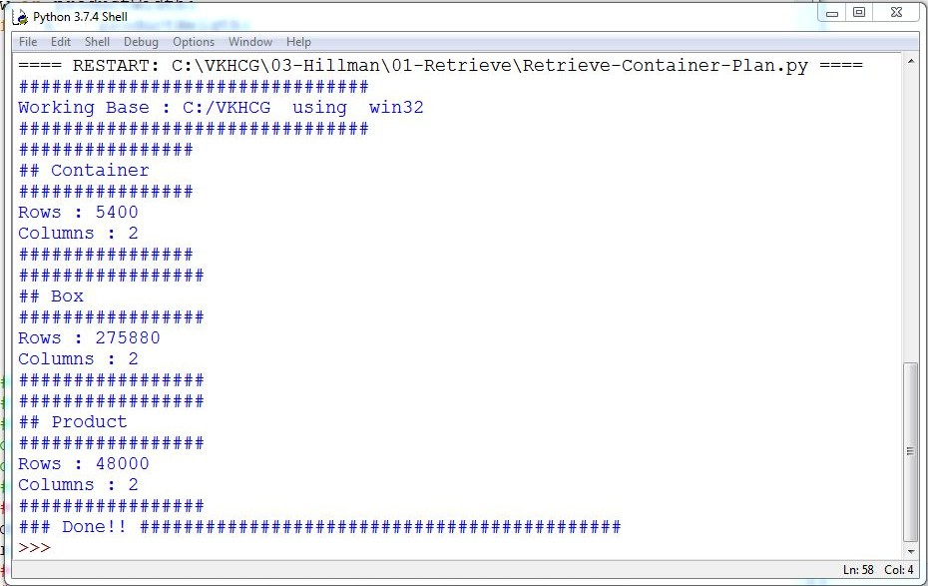

print('Rows :',ProductFrame.shape[0]) print('Columns :',ProductFrame.shape[1]) print('#################')

################################################################

sFileProductName=sFileDir + '/' + ProductFileName ProductFrame.to_csv(sFileProductName, index = False) ################################################################ ################################################################# print('### Done!! ############################################') #################################################################

**Output:**

Your second simulation is the cardboard boxes for the packing of the products. The requirement is for boxes having a dimension of 100 centimeters × 100 centimeters × 100 centimeters to 2.1 meters × 2.1 meters × 2.1 meters. You can also use between zero and 600 centimeters of packing foam to secure any product in the box.

See the container data file Retrieve_Container.csv and Retrieve_Box.csv in C:\VKHCG\03-Hillman\01-Retrieve\01-EDS\02-Python.

###### Create a Delivery Route

The model enables you to generate a complex routing plan for the shipping routes of the company. Start your Python editor and create a text file named Retrieve-Route-Plan.py in directory .

C:\VKHCG\03-Hillman\01-Retrieve.

################################################################

# -*- coding: utf-8 -*- ################################################################

import os import sys

import pandas as pd

from geopy.distance import vincenty ################################################################

InputFileName='GB_Postcode_Warehouse.csv' OutputFileName='Retrieve_GB_Warehouse.csv' Company='03-Hillman'

################################################################ Base='C:/VKHCG'

print('################################')

print('Working Base :',Base, ' using ', sys.platform) print('################################') ################################################################

sFileDir=Base + '/' + Company + '/01-Retrieve/01-EDS/02-Python' if not os.path.exists(sFileDir):

os.makedirs(sFileDir) ################################################################

sFileName=Base + '/' + Company + '/00-RawData/' + InputFileName print('###########')

print('Loading :',sFileName) Warehouse=pd.read_csv(sFileName,header=0,low_memory=False)

WarehouseClean=Warehouse[Warehouse.latitude != 0]

WarehouseGood=WarehouseClean[WarehouseClean.longitude != 0]

WarehouseGood.drop_duplicates(subset='postcode', keep='first', inplace=True)

WarehouseGood.sort_values(by='postcode', ascending=1) ################################################################

sFileName=sFileDir + '/' + OutputFileName WarehouseGood.to_csv(sFileName, index = False) ################################################################

WarehouseLoop = WarehouseGood.head(20)

for i in range(0,WarehouseLoop.shape[0]):

print('Run :',i,' =======>>>>>>>>>>',WarehouseLoop['postcode'][i]) WarehouseHold = WarehouseGood.head(10000) WarehouseHold['Transaction']=WarehouseHold.apply(lambda row:

'WH-to-WH'

,axis=1)

OutputLoopName='Retrieve_Route_' + 'WH-' + WarehouseLoop['postcode'][i] + '_Route.csv'

WarehouseHold['Seller']=WarehouseHold.apply(lambda row: 'WH-' + WarehouseLoop['postcode'][i]

,axis=1)

WarehouseHold['Seller_Latitude']=WarehouseHold.apply(lambda row: WarehouseHold['latitude'][i],axis=1)

WarehouseHold['Seller_Longitude']=WarehouseHold.apply(lambda row: WarehouseLoop['longitude'][i],axis=1)

WarehouseHold['Buyer']=WarehouseHold.apply(lambda row: 'WH-' + row['postcode'],axis=1)

WarehouseHold['Buyer_Latitude']=WarehouseHold.apply(lambda row: row['latitude'],axis=1)

WarehouseHold['Buyer_Longitude']=WarehouseHold.apply(lambda row: row['longitude'],axis=1)

WarehouseHold['Distance']=WarehouseHold.apply(lambda row: round( vincenty((WarehouseLoop['latitude'][i],WarehouseLoop['longitude'][i]),

(row['latitude'],row['longitude'])).miles,6),axis=1)

WarehouseHold.drop('id', axis=1, inplace=True) WarehouseHold.drop('postcode', axis=1, inplace=True) WarehouseHold.drop('latitude', axis=1, inplace=True) WarehouseHold.drop('longitude', axis=1, inplace=True) ################################################################

sFileLoopName=sFileDir + '/' + OutputLoopName WarehouseHold.to_csv(sFileLoopName, index = False)

################################################################# print('### Done!! ############################################') #################################################################

**Output:**

====== RESTART: C:\VKHCG\03-Hillman\01-Retrieve\Retrieve-Route-Plan.py ====== ################################

Working Base : C:/VKHCG using win32

################################ ###########

Loading : C:/VKHCG/03-Hillman/00-RawData/GB_Postcode_Warehouse.csv

Run : 0

Run : 1

Run : 2

Run : 3

Run : 4

Run : 5

Run : 6

Run : 7

Run : 8

Run : 9

=======>>>>>>>>>> AB10

=======>>>>>>>>>> AB11

=======>>>>>>>>>> AB12

=======>>>>>>>>>> AB13

=======>>>>>>>>>> AB14

=======>>>>>>>>>> AB15

=======>>>>>>>>>> AB16

=======>>>>>>>>>> AB21

=======>>>>>>>>>> AB22

=======>>>>>>>>>> AB23

Run : 10

Run : 11

Run : 12

=======>>>>>>>>>> AB24

=======>>>>>>>>>> AB25

=======>>>>>>>>>> AB30

Run : 13

Run : 14

Run : 15

Run : 16

Run : 17

Run : 18

Run : 19

=======>>>>>>>>>> AB31

=======>>>>>>>>>> AB32

=======>>>>>>>>>> AB33

=======>>>>>>>>>> AB34

=======>>>>>>>>>> AB35

=======>>>>>>>>>> AB36

=======>>>>>>>>>> AB37

### Done!! ############################################

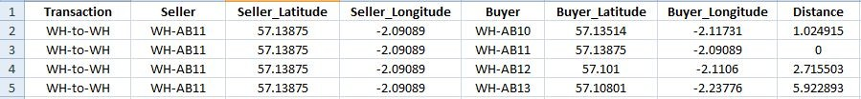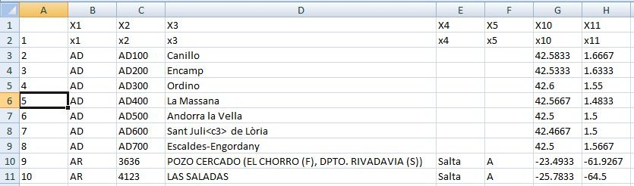

>>>

See the collection of files similar in format to Retrieve_Route_WH-AB11_Route.csv in C:\VKHCG\03-Hillman\01-Retrieve\01-EDS\02-Python.

###### Global Post Codes

Open RStudio and use R to process the following R script: Retrieve-Postcode-Global.r.

library(readr)

All_Countries <- read_delim("C:/VKHCG/03-Hillman/00-RawData/All_Countries.txt", "\t", col_names = FALSE,

col_types = cols( X12 = col_skip(), X6 = col_skip(), X7 = col_skip(), X8 = col_skip(), X9 = col_skip()),

na = "null", trim_ws = TRUE) write.csv(All_Countries,

file = "C:/VKHCG/03-Hillman/01-Retrieve/01-EDS/01-R/Retrieve_All_Countries.csv")

**Output:**

The program will successfully uploaded a new file named Retrieve_All_Countries.csv, after removing column No. 6, 7, 8, 9 and 12 from All_Countries.txt

#### Clark Ltd

Clark is the financial powerhouse of the group. It must process all the money-related data sources. **Forex**-The first financial duty of the company is to perform any foreign exchange trading. **Forex Base Data-**Previously, you found a single data source (Euro_ExchangeRates.csv) for forex rates in Clark. Earlier in the chapter, I helped you to create the load, as part of your R processing.

The relevant file is Retrieve_Retrieve_Euro_ExchangeRates.csv in directory C:\ VKHCG\04-Clark\01-Retrieve\01-EDS\01-R. So, that data is ready.

**Financials -** Clark generates the financial statements for all the group’s companies.

**Financial Base Data** - You found a single data source (Profit_And_Loss.csv) in Clark for

financials and, as mentioned previously, a single data source (Euro_ExchangeRates.csv) for forex rates. The file relevant file is Retrieve_Profit_And_Loss.csv in directory

C:\VKHCG\04-Clark\01-Retrieve\ 01-EDS\01-R.

Person Base Data

Start Python editor and create a file named Retrieve-PersonData.py in directory . C:\VKHCG\04-Clark\01-Retrieve.

################################################################

# -*- coding: utf-8 -*- ################################################################

import sys import os import shutil import zipfile

import pandas as pd ################################################################ Base='C:/VKHCG' ################################################################ print('################################')

print('Working Base :',Base, ' using ', sys.platform) print('################################') ################################################################

Company='04-Clark'

ZIPFiles=['Data_female-names','Data_male-names','Data_last-names'] for ZIPFile in ZIPFiles:

InputZIPFile=Base+'/'+Company+'/00-RawData/' + ZIPFile + '.zip' OutputDir=Base+'/'+Company+'/01-Retrieve/01-EDS/02-Python/' + ZIPFile OutputFile=Base+'/'+Company+'/01-Retrieve/01-EDS/02-Python/Retrieve-'+ZIPFile+'.csv' zip_file = zipfile.ZipFile(InputZIPFile, 'r')

zip_file.extractall(OutputDir) zip_file.close()

t=0

for dirname, dirnames, filenames in os.walk(OutputDir): for filename in filenames:

sCSVFile = dirname + '/' + filename t=t+1

if t==1:

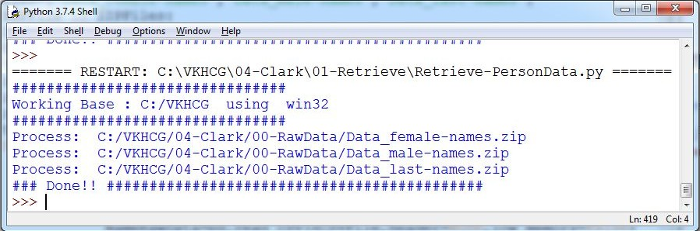

NameRawData=pd.read_csv(sCSVFile,header=None,low_memory=False)

NameData=NameRawData else:

NameRawData=pd.read_csv(sCSVFile,header=None,low_memory=False) NameData=NameData.append(NameRawData)

NameData.rename(columns={0 : 'NameValues'},inplace=True) NameData.to_csv(OutputFile, index = False) shutil.rmtree(OutputDir)

print('Process: ',InputZIPFile) ################################################################# print('### Done!! ############################################') #################################################################

This generates three files named Retrieve-Data_female-names.csv Retrieve-Data_male-names.csv Retrieve-Data_last-names.csv

### Connecting to other Data Sources

**A. Program to connect to different data sources.**

#### SQLite:

#########################################

# -*- coding: utf-8 -*-

#######################

################################################################

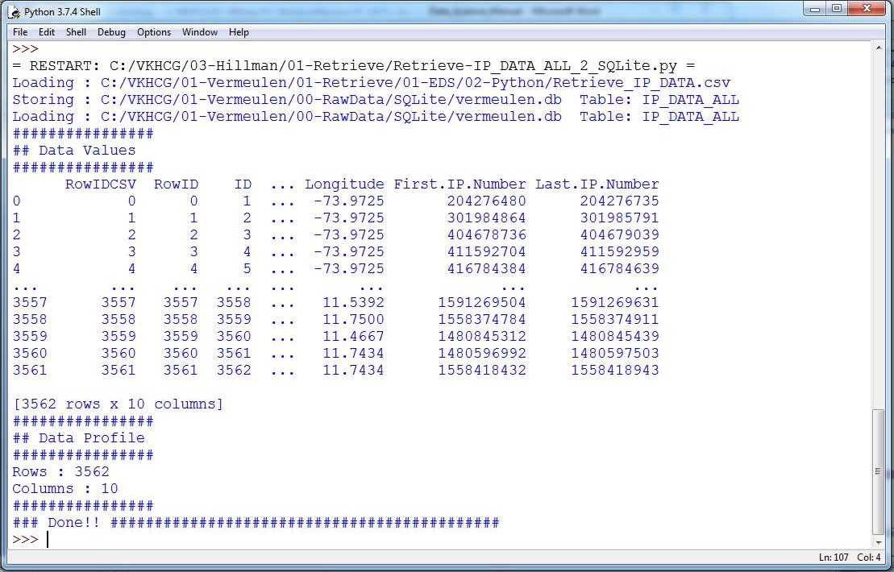

import sqlite3 as sq import pandas as pd

################################################################ Base='C:/VKHCG'

sDatabaseName=Base + '/01-Vermeulen/00-RawData/SQLite/vermeulen.db' conn = sq.connect(sDatabaseName) ################################################################

sFileName='C:/VKHCG/01-Vermeulen/01-Retrieve/01-EDS/02-Python/Retrieve_IP_DATA.csv' print('Loading :',sFileName) IP_DATA_ALL_FIX=pd.read_csv(sFileName,header=0,low_memory=False) IP_DATA_ALL_FIX.index.names = ['RowIDCSV']

sTable='IP_DATA_ALL'

print('Storing :',sDatabaseName,' Table:',sTable) IP_DATA_ALL_FIX.to_sql(sTable, conn, if_exists="replace") print('Loading :',sDatabaseName,' Table:',sTable) TestData=pd.read_sql_query("select * from IP_DATA_ALL;", conn) print('################')

print('## Data Values') print('################')

print(TestData) print('################')

print('## Data Profile') print('################')

print('Rows :',TestData.shape[0]) print('Columns :',TestData.shape[1]) print('################')

print('### Done!! ############################################')



**MySQL:**

Open MySql

Create a database “DataScience”

Create a python file and add the following code:

################ Connection With MySQL ######################

import mysql.connector

conn = mysql.connector.connect(host='localhost',

database='DataScience', user='root', password='root')

conn.connect if(conn.is_connected):

print('###### Connection With MySql Established Successfullly ##### ') else:

print('Not Connected -- Check Connection Properites')

#### Microsoft Excel

##################Retrieve-Country-Currency.py ################################################################

# -*- coding: utf-8 -*- ################################################################

import os

import pandas as pd ################################################################ Base='C:/VKHCG' ################################################################

sFileDir=Base + '/01-Vermeulen/01-Retrieve/01-EDS/02-Python' #if not os.path.exists(sFileDir):

#os.makedirs(sFileDir) ################################################################

CurrencyRawData = pd.read_excel('C:/VKHCG/01-Vermeulen/00-RawData/Country_Currency.xlsx') sColumns = ['Country or territory', 'Currency', 'ISO-4217']

CurrencyData = CurrencyRawData[sColumns] CurrencyData.rename(columns={'Country or territory': 'Country', 'ISO-4217': 'CurrencyCode'}, inplace=True) CurrencyData.dropna(subset=['Currency'],inplace=True) CurrencyData['Country'] = CurrencyData['Country'].map(lambda x: x.strip()) CurrencyData['Currency'] = CurrencyData['Currency'].map(lambda x: x.strip())

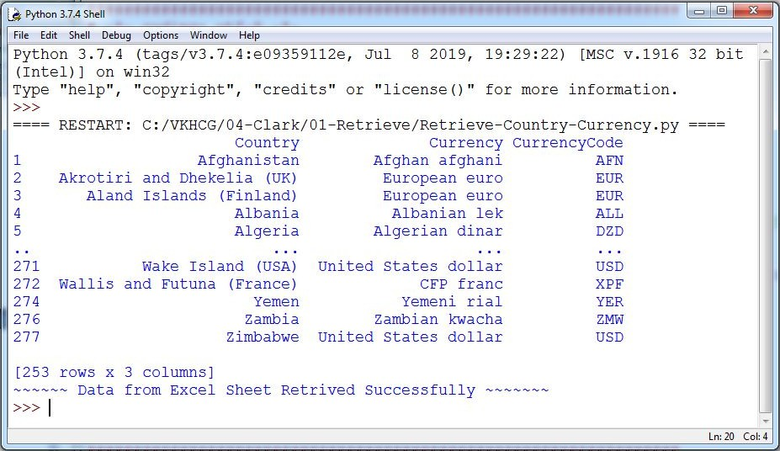

CurrencyData['CurrencyCode'] = CurrencyData['CurrencyCode'].map(lambda x: x.strip())

print(CurrencyData)

print('~~~~~~ Data from Excel Sheet Retrived Successfully ~~~~~~~ ') ################################################################

sFileName=sFileDir + '/Retrieve-Country-Currency.csv' CurrencyData.to_csv(sFileName, index = False) ################################################################

**OUTPUT:**

## Assess Superstep

Practical 5:

**Assessing Data**

Data

quality

refers to

the

condition of

a set of

qualitative

or quantitative

variables.

Dataquality is a

multidimensional measurement of the acceptability of specific data sets. Inbusiness, data quality is measured to determine whether data can be used as a basis forreliable intelligence extraction for supporting organizational decisions. Data profiling involves observing in your data sources all the viewpoints that theinformation offers.

The main

goal is

to determine if

individual

viewpoints

are

accurateand

complete.

The

Assess

superstep

determines what additional processing to apply tothe entries that are noncompliant.

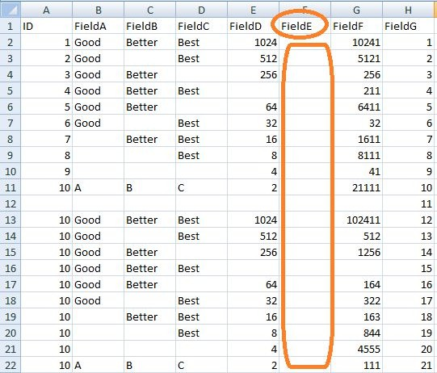

## Errors

Typically, one of four things can be done with an error to the data.

1. Accept the Error
2. Reject the Error
3. Correct the Error
4. Create a Default Value
   1. **Perform error management on the given data using pandas package.**

Python pandas package enables several automatic error-management features.

**File Location:** C:\VKHCG\01-Vermeulen\02-Assess

**Missing Values in Pandas:**

1. **Drop the Columns Where All Elements Are Missing Values**

**Code :**

################### Assess-Good-Bad-01.py########################

# -*- coding: utf-8 -*- ################################################################

import sys import os

import pandas as pd ################################################################ Base='C:/VKHCG' ################################################################ print('################################')

print('Working Base :',Base, ' using ', sys.platform) print('################################') ################################################################

sInputFileName='Good-or-Bad.csv' sOutputFileName='Good-or-Bad-01.csv' Company='01-Vermeulen'

################################################################ Base='C:/VKHCG' ################################################################

sFileDir=Base + '/' + Company + '/02-Assess/01-EDS/02-Python' if not os.path.exists(sFileDir):

os.makedirs(sFileDir) ################################################################

### Import Warehouse ################################################################

sFileName=Base + '/' + Company + '/00-RawData/' + sInputFileName print('Loading :',sFileName) RawData=pd.read_csv(sFileName,header=0) print('################################')

print('## Raw Data Values') print('################################')

print(RawData) print('################################')

print('## Data Profile') print('################################')

print('Rows :',RawData.shape[0]) print('Columns :',RawData.shape[1]) print('################################')

################################################################

sFileName=sFileDir + '/' + sInputFileName RawData.to_csv(sFileName, index = False)

################################################################

TestData=RawData.dropna(axis=1, how='all') ################################################################ print('################################')

print('## Test Data Values') print('################################')

print(TestData) print('################################')

print('## Data Profile') print('################################')

print('Rows :',TestData.shape[0]) print('Columns :',TestData.shape[1]) print('################################')

################################################################

sFileName=sFileDir + '/' + sOutputFileName TestData.to_csv(sFileName, index = False)

################################################################ print('################################')

print('### Done!! #####################') print('################################') ################################################################

**Output:**

>>>

======= RESTART: C:\VKHCG\01-Vermeulen\02-Assess\Assess-Good-Bad-01.py ======= ################################

Working Base : C:/VKHCG using win32 ################################

Loading : C:/VKHCG/01-Vermeulen/00-RawData/Good-or-Bad.csv ################################

## Raw Data Values ################################

ID FieldA FieldB FieldC FieldD FieldE FieldF FieldG

0 1.0

Good Better

Best 1024.0

NaN

10241.0 1

1 2.0

Good

NaN

Best

512.0

NaN

5121.0 2

2 3.0

3 4.0

4 5.0

Good Better Good Better Good Better

NaN Best NaN

256.0

NaN 64.0

NaN NaN NaN

256.0 3

211.0 4

6411.0 5

5 6.0

Good

NaN

Best

32.0

NaN

32.0 6

6 7.0

NaN Better

Best

16.0

NaN

1611.0 7

7 8.0

8 9.0

NaN NaN

NaN NaN

Best NaN

8.0

4.0

NaN NaN

8111.0 8

41.0 9

9 10.0 A B C 2.0 NaN 21111.0 10

* 1. NaN NaN NaN NaN NaN NaN NaN 11
  2. 10.0

Good Better

Best 1024.0

NaN 102411.0 12

|  |  |  |
| --- | --- | --- |
| 12 10.0 | Good NaN Best 512.0 NaN 512.0 | 13 |
| 13 10.0 | Good Better NaN 256.0 NaN 1256.0 | 14 |
| 14 10.0 | Good Better Best NaN NaN NaN | 15 |
| 15 10.0 | Good Better NaN 64.0 NaN 164.0 | 16 |
| 16 10.0 | Good NaN Best 32.0 NaN 322.0 | 17 |
| 17 10.0 | NaN Better Best 16.0 NaN 163.0 | 18 |
| 18 10.0 | NaN NaN Best 8.0 NaN 844.0 | 19 |
| 19 10.0 | NaN NaN NaN 4.0 NaN 4555.0 | 20 |
| 20 10.0 | A B C 2.0 NaN 111.0 21 |  |

################################

## Data Profile ################################

Rows : 21

Columns : 8 ################################ ################################

## Test Data Values ################################

ID FieldA FieldB FieldC FieldD

FieldF FieldG

0 1.0

Good Better

Best 1024.0

10241.0 1

1 2.0

Good

NaN

Best

512.0

5121.0 2

2 3.0

3 4.0

4 5.0

Good Better Good Better Good Better

NaN Best NaN

256.0

NaN 64.0

256.0 3

211.0 4

6411.0 5

5 6.0

Good

NaN

Best

32.0

32.0 6

6 7.0

NaN Better

Best

16.0

1611.0 7

7 8.0

8 9.0

NaN NaN

NaN NaN

Best NaN

8.0

4.0

8111.0 8

41.0 9

9 10.0

1. NaN

A B

NaN

C

NaN

2.0

NaN

21111.0

NaN

10

NaN 11

1. 10.0

Good Better

Best 1024.0 102411.0 12

1. 10.0

Good

NaN

Best

512.0

512.0 13

1. 10.0
2. 10.0
3. 10.0

Good Better Good Better Good Better

NaN Best NaN

256.0

NaN 64.0

1256.0 14

NaN 15

164.0 16

1. 10.0

Good

NaN

Best

32.0

322.0 17

1. 10.0

NaN Better

Best

16.0

163.0 18

1. 10.0
2. 10.0

NaN NaN

NaN NaN

Best NaN

8.0

4.0

844.0 19

4555.0 20

1. 10.0 A B

C 2.0

111.0 21

################################

## Data Profile ################################

Rows : 21

Columns : 7 ################################ ################################ ### Done!! ##################### ################################

**>>>**

All of column E has been deleted, owing to the fact that all values in that column were missing values/errors.

1. **Drop the Columns Where Any of the Elements Is Missing Values**

################## Assess-Good-Bad-02.py###########################

# -*- coding: utf-8 -*- ################################################################

import sys import os

import pandas as pd ################################################################ Base='C:/VKHCG'

sInputFileName='Good-or-Bad.csv' sOutputFileName='Good-or-Bad-02.csv' Company='01-Vermeulen'

################################################################ Base='C:/VKHCG' ################################################################ print('################################')

print('Working Base :',Base, ' using ', sys.platform) print('################################') ################################################################

sFileDir=Base + '/' + Company + '/02-Assess/01-EDS/02-Python' if not os.path.exists(sFileDir):

os.makedirs(sFileDir) ################################################################

### Import Warehouse ################################################################

sFileName=Base + '/' + Company + '/00-RawData/' + sInputFileName print('Loading :',sFileName) RawData=pd.read_csv(sFileName,header=0)

print('################################')

print('## Raw Data Values') print('################################')

print(RawData) print('################################')

print('## Data Profile') print('################################')

print('Rows :',RawData.shape[0]) print('Columns :',RawData.shape[1]) print('################################')

################################################################

sFileName=sFileDir + '/' + sInputFileName RawData.to_csv(sFileName, index = False)

################################################################

TestData=RawData.dropna(axis=1, how='any') ################################################################ print('################################')

print('## Test Data Values') print('################################')

print(TestData) print('################################')

print('## Data Profile') print('################################')

print('Rows :',TestData.shape[0]) print('Columns :',TestData.shape[1]) print('################################')

################################################################

sFileName=sFileDir + '/' + sOutputFileName TestData.to_csv(sFileName, index = False)

################################################################ print('################################')

print('### Done!! #####################') print('################################') ################################################################

>>>

======= RESTART: C:\VKHCG\01-Vermeulen\02-Assess\Assess-Good-Bad-02.py ======= ################################

Working Base : C:/VKHCG

using

win32

################################

Loading : C:/VKHCG/01-Vermeulen/00-RawData/Good-or-Bad.csv ################################

## Raw Data Values

|  |  |  |  |  |  |  |  |
| --- | --- | --- | --- | --- | --- | --- | --- |
| ################################  ID FieldA FieldB FieldC FieldD FieldE FieldF FieldG | | | | | | | |
| 0 1.0 | Good | Better | Best 1024.0 | | NaN | 10241.0 | 1 |
| 1 2.0 | Good | NaN | Best 512.0 | | NaN | 5121.0 | 2 |
| 2 3.0 | Good | Better | NaN 256.0 | | NaN | 256.0 | 3 |
| 3 4.0 | Good | Better | Best NaN | | NaN | 211.0 | 4 |
| 4 5.0 | Good | Better | NaN 64.0 | | NaN | 6411.0 | 5 |
| 5 6.0 | Good | NaN | Best 32.0 | | NaN | 32.0 | 6 |
| 6 7.0 | NaN | Better | Best 16.0 | | NaN | 1611.0 | 7 |
| 7 8.0 | NaN | NaN | Best 8.0 | | NaN | 8111.0 | 8 |
| 8 9.0 | NaN | NaN | NaN 4.0 | | NaN | 41.0 | 9 |
| 9 10.0 A B C 2.0 NaN 21111.0 10  10 NaN NaN NaN NaN NaN NaN NaN 11 | | | | | | | |
| 11 10.0 | Good | Better | Best | 1024.0 | NaN | 102411.0 | 12 |
| 12 10.0 | Good | NaN | Best | 512.0 | NaN | 512.0 | 13 |
| 13 10.0 | Good | Better | NaN | 256.0 | NaN | 1256.0 | 14 |
| 14 10.0 | Good | Better | Best | NaN | NaN | NaN | 15 |
| 15 10.0 | Good | Better | NaN | 64.0 | NaN | 164.0 | 16 |
| 16 10.0 | Good | NaN | Best | 32.0 | NaN | 322.0 | 17 |
| 17 10.0 | NaN | Better | Best | 16.0 | NaN | 163.0 | 18 |

18 10.0

19 10.0

NaN NaN

NaN NaN

Best NaN

8.0

4.0

NaN NaN

844.0 19

4555.0 20

20 10.0 A B

C 2.0

NaN

111.0 21

################################

## Data Profile ################################

Rows : 21

Columns : 8 ################################ ################################

## Test Data Values ################################

FieldG

|  |  |
| --- | --- |
| 0 | 1 |
| 1 | 2 |
| 2 | 3 |
| 3 | 4 |
| 4 | 5 |
| 5 | 6 |
| 6 | 7 |
| 7 | 8 |
| 8 | 9 |
| 9 | 10 |
| 10 | 11 |
| 11 | 12 |
| 12 | 13 |
| 13 | 14 |
| 14 | 15 |
| 15 | 16 |
| 16 | 17 |
| 17 | 18 |
| 18 | 19 |
| 19 | 20 |
| 20 | 21 |

################################

## Data Profile ################################

Rows : 21

Columns : 1 ################################ ################################ ### Done!! ##################### ################################

>>>

1. **Keep Only the Rows That Contain a Maximum of Two Missing Values**

#####################

# -*- coding: utf-8 -*-

Assess-Good-Bad-03.py

################

################################################################

import sys import os

import pandas as pd ################################################################

sInputFileName='Good-or-Bad.csv' sOutputFileName='Good-or-Bad-03.csv' Company='01-Vermeulen' Base='C:/VKHCG'

################################################################ print('################################')

print('Working Base :',Base, ' using Windows ~~~~') print('################################') ################################################################

sFileDir=Base + '/' + Company + '/02-Assess/01-EDS/02-Python' if not os.path.exists(sFileDir):

os.makedirs(sFileDir) ################################################################

### Import Warehouse ################################################################

sFileName=Base + '/' + Company + '/00-RawData/' + sInputFileName print('Loading :',sFileName) RawData=pd.read_csv(sFileName,header=0)

print('################################')

print('## Raw Data Values') print('################################')

print(RawData) print('################################')

print('## Data Profile') print('################################')

print('Rows :',RawData.shape[0]) print('Columns :',RawData.shape[1]) print('################################')

################################################################

sFileName=sFileDir + '/' + sInputFileName RawData.to_csv(sFileName, index = False)

################################################################

TestData=RawData.dropna(thresh=2)

print('################################')

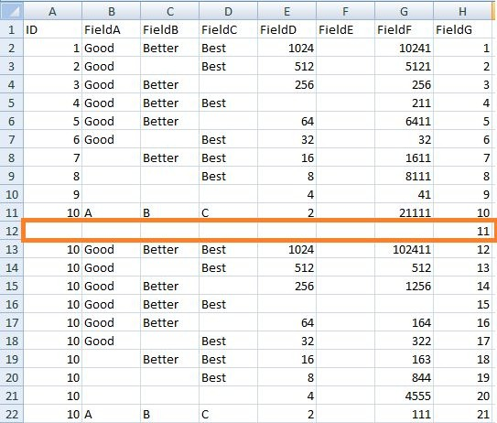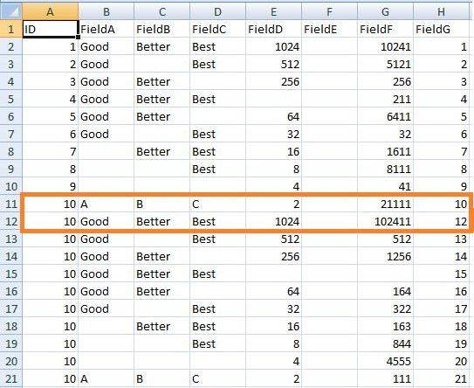

print('## Test Data Values') print('################################')

print(TestData) print('################################')

print('## Data Profile') print('################################')

print('Rows :',TestData.shape[0]) print('Columns :',TestData.shape[1]) print('################################')

sFileName=sFileDir + '/' + sOutputFileName TestData.to_csv(sFileName, index = False)

################################################################ print('################################')

print('### Done!! #####################') print('################################') ################################################################

**Before**

**After**

Row with more than two missing values got deleted.

The next step along the route is to generate a full network routing solution for the company, to resolve the data issues in the retrieve data.

* 1. **Write Python / R program to create the network routing diagram from the given data onrouters.**

########## Assess-Network-Routing-Company.py ##################### import sys

import os

import pandas as pd ################################################################

pd.options.mode.chained_assignment = None ################################################################ Base='C:/VKHCG' ################################################################ print('################################')

print('Working Base :',Base, ' using Windows') print('################################') ################################################################

sInputFileName1='01-Retrieve/01-EDS/01-R/Retrieve_Country_Code.csv' sInputFileName2='01-Retrieve/01-EDS/02-Python/Retrieve_Router_Location.csv' sInputFileName3='01-Retrieve/01-EDS/01-R/Retrieve_IP_DATA.csv' ################################################################

sOutputFileName='Assess-Network-Routing-Company.csv' Company='01-Vermeulen'

################################################################ ################################################################

### Import Country Data ################################################################

sFileName=Base + '/' + Company + '/' + sInputFileName1 print('################################')

print('Loading :',sFileName) print('################################')

CountryData=pd.read_csv(sFileName,header=0,low_memory=False, encoding="latin-1") print('Loaded Country:',CountryData.columns.values) print('################################') ################################################################

## Assess Country Data ################################################################ print('################################')

print('Changed :',CountryData.columns.values) CountryData.rename(columns={'Country': 'Country_Name'}, inplace=True) CountryData.rename(columns={'ISO-2-CODE': 'Country_Code'}, inplace=True) CountryData.drop('ISO-M49', axis=1, inplace=True)

CountryData.drop('ISO-3-Code', axis=1, inplace=True) CountryData.drop('RowID', axis=1, inplace=True) print('To :',CountryData.columns.values) print('################################')

################################################################ ################################################################

### Import Company Data ################################################################

sFileName=Base + '/' + Company + '/' + sInputFileName2 print('################################')

print('Loading :',sFileName) print('################################')

CompanyData=pd.read_csv(sFileName,header=0,low_memory=False, encoding="latin-1") print('Loaded Company :',CompanyData.columns.values) print('################################') ################################################################

## Assess Company Data ################################################################ print('################################')

print('Changed :',CompanyData.columns.values) CompanyData.rename(columns={'Country': 'Country_Code'}, inplace=True) print('To :',CompanyData.columns.values) print('################################') ################################################################ ################################################################

### Import Customer Data ################################################################

sFileName=Base + '/' + Company + '/' + sInputFileName3 print('################################')

print('Loading :',sFileName) print('################################')

CustomerRawData=pd.read_csv(sFileName,header=0,low_memory=False, encoding="latin-1") print('################################')

print('Loaded Customer :',CustomerRawData.columns.values) print('################################') ################################################################

CustomerData=CustomerRawData.dropna(axis=0, how='any') print('################################')

print('Remove Blank Country Code')

print('Reduce Rows from', CustomerRawData.shape[0],' to ', CustomerData.shape[0]) print('################################') ################################################################ print('################################')

print('Changed :',CustomerData.columns.values) CustomerData.rename(columns={'Country': 'Country_Code'}, inplace=True) print('To :',CustomerData.columns.values) print('################################') ################################################################ print('################################')

print('Merge Company and Country Data') print('################################')

CompanyNetworkData=pd.merge(

CompanyData, CountryData, how='inner', on='Country_Code'

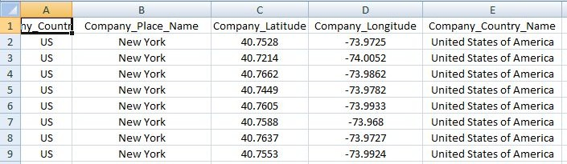

) ################################################################ print('################################')

print('Change ',CompanyNetworkData.columns.values) for i in CompanyNetworkData.columns.values:

j='Company_'+i

CompanyNetworkData.rename(columns={i: j}, inplace=True) print('To ', CompanyNetworkData.columns.values) print('################################')

################################################################ ################################################################

sFileDir=Base + '/' + Company + '/02-Assess/01-EDS/02-Python' if not os.path.exists(sFileDir):

os.makedirs(sFileDir) ################################################################

sFileName=sFileDir + '/' + sOutputFileName print('################################')

print('Storing :', sFileName) print('################################')

CompanyNetworkData.to_csv(sFileName, index = False, encoding="latin-1") ################################################################ ################################################################ print('################################')

print('### Done!! #####################') print('################################') ################################################################

**Output:**

**Go to C:\VKHCG\01-Vermeulen\02-Assess\01-EDS\02-Python folder and open Assess-Network-Routing-Company.csv**

Next, Access the the customers location using network router location.

####################Assess-Network-Routing-Customer.py ###################### import sys

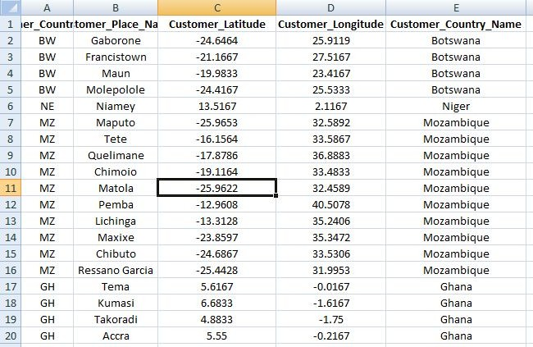

import os

import pandas as pd ################################################################

pd.options.mode.chained_assignment = None ################################################################ Base='C:/VKHCG'

print('################################')

print('Working Base :',Base, ' using ', sys.platform) print('################################') ################################################################

sInputFileName=Base+'/01-Vermeulen/02-Assess/01-EDS/02-Python/Assess-Network-Routing- Customer.csv'

################################################################

sOutputFileName='Assess-Network-Routing-Customer.gml' Company='01-Vermeulen'

################################################################

### Import Country Data ################################################################

sFileName=sInputFileName print('################################')

print('Loading :',sFileName) print('################################')

CustomerData=pd.read_csv(sFileName,header=0,low_memory=False, encoding="latin-1") print('Loaded Country:',CustomerData.columns.values) print('################################')

print(CustomerData.head()) print('################################') print('### Done!! #####################') print('################################')

################################################################

**Output**

**Assess-Network-Routing-Customer.csv**

**Assess-Network-Routing-Node.py**

################################################################

import sys import os

import pandas as pd ################################################################

pd.options.mode.chained_assignment = None ################################################################ Base='C:/VKHCG' ################################################################ print('################################')

print('Working Base :',Base, ' using ', sys.platform) print('################################') ################################################################

sInputFileName='01-Retrieve/01-EDS/02-Python/Retrieve_IP_DATA.csv' ################################################################

sOutputFileName='Assess-Network-Routing-Node.csv' Company='01-Vermeulen'

################################################################

### Import IP Data ################################################################

sFileName=Base + '/' + Company + '/' + sInputFileName print('################################')

print('Loading :',sFileName) print('################################')

IPData=pd.read_csv(sFileName,header=0,low_memory=False, encoding="latin-1") print('Loaded IP :', IPData.columns.values) print('################################') ################################################################ print('################################')

print('Changed :',IPData.columns.values) IPData.drop('RowID', axis=1, inplace=True) IPData.drop('ID', axis=1, inplace=True)

IPData.rename(columns={'Country': 'Country_Code'}, inplace=True) IPData.rename(columns={'Place.Name': 'Place_Name'}, inplace=True) IPData.rename(columns={'Post.Code': 'Post_Code'}, inplace=True) IPData.rename(columns={'First.IP.Number': 'First_IP_Number'}, inplace=True) IPData.rename(columns={'Last.IP.Number': 'Last_IP_Number'}, inplace=True) print('To :',IPData.columns.values) print('################################') ################################################################ print('################################')

print('Change ',IPData.columns.values) for i in IPData.columns.values:

j='Node_'+i

IPData.rename(columns={i: j}, inplace=True) print('To ', IPData.columns.values) print('################################')

################################################################

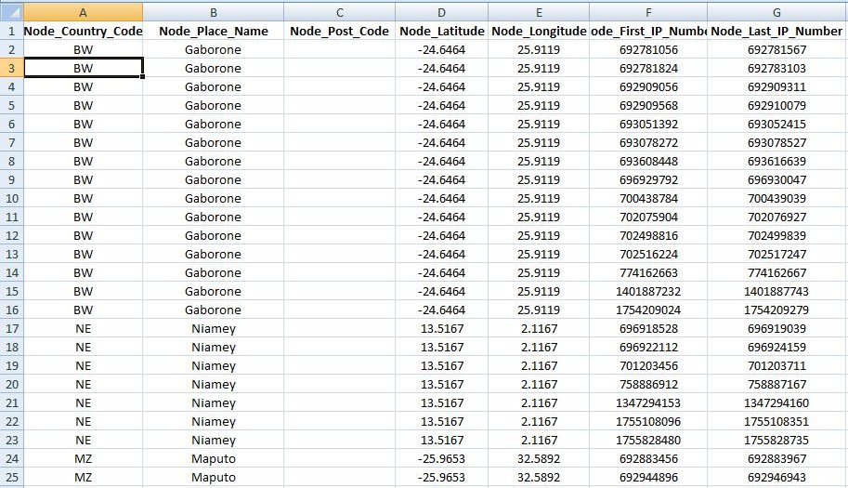

sFileDir=Base + '/' + Company + '/02-Assess/01-EDS/02-Python' if not os.path.exists(sFileDir):

os.makedirs(sFileDir) ################################################################

sFileName=sFileDir + '/' + sOutputFileName print('################################')

print('Storing :', sFileName) print('################################')

IPData.to_csv(sFileName, index = False, encoding="latin-1") ################################################################ print('################################')

print('### Done!! #####################') print('################################') ################################################################

**Output:**

**C:/VKHCG/01-Vermeulen/02-Assess/01-EDS/02-Python/Assess-Network-Routing-Node.csv**

Directed Acyclic Graph (DAG)

A directed acyclic graph is a specific graph that only has one path through the graph.

* 1. **Write a Python / R program to build directed acyclic graph.**

Open your python editor and create a file named Assess-DAG-Location.py in directory C:\VKHCG\01-Vermeulen\02-Assess

################################################################

import networkx as nx

import matplotlib.pyplot as plt import sys

import os

import pandas as pd ################################################################ Base='C:/VKHCG' ################################################################ print('################################')

print('Working Base :',Base, ' using ', sys.platform) print('################################') ################################################################

sInputFileName='01-Retrieve/01-EDS/02-Python/Retrieve_Router_Location.csv' sOutputFileName1='Assess-DAG-Company-Country.png' sOutputFileName2='Assess-DAG-Company-Country-Place.png'

Company='01-Vermeulen' ################################################################

### Import Company Data ################################################################

sFileName=Base + '/' + Company + '/' + sInputFileName print('################################')

print('Loading :',sFileName) print('################################')

CompanyData=pd.read_csv(sFileName,header=0,low_memory=False, encoding="latin-1") print('Loaded Company :',CompanyData.columns.values) print('################################') ################################################################

print(CompanyData) print('################################')

print('Rows : ',CompanyData.shape[0]) print('################################') ################################################################

G1=nx.DiGraph() G2=nx.DiGraph()

################################################################

for i in range(CompanyData.shape[0]): G1.add_node(CompanyData['Country'][i])

sPlaceName= CompanyData['Place_Name'][i] + '-' + CompanyData['Country'][i] G2.add_node(sPlaceName)

print('################################')

for n1 in G1.nodes(): for n2 in G1.nodes():

if n1 != n2:

print('Link :',n1,' to ', n2) G1.add_edge(n1,n2)

print('################################')

print('################################')

print("Nodes of graph: ") print(G1.nodes()) print("Edges of graph: ") print(G1.edges())

print('################################') ################################################################

sFileDir=Base + '/' + Company + '/02-Assess/01-EDS/02-Python' if not os.path.exists(sFileDir):

os.makedirs(sFileDir) ################################################################

sFileName=sFileDir + '/' + sOutputFileName1 print('################################')

print('Storing :', sFileName) print('################################')

nx.draw(G1,pos=nx.spectral_layout(G1), nodecolor='r',edge_color='g', with_labels=True,node_size=8000, font_size=12)

plt.savefig(sFileName) # save as png plt.show() # display

################################################################ print('################################')

for n1 in G2.nodes(): for n2 in G2.nodes():

if n1 != n2:

print('Link :',n1,' to ', n2) G2.add_edge(n1,n2)

print('################################')

print('################################')

print("Nodes of graph: ") print(G2.nodes()) print("Edges of graph: ") print(G2.edges())

print('################################') ################################################################

sFileDir=Base + '/' + Company + '/02-Assess/01-EDS/02-Python' if not os.path.exists(sFileDir):

os.makedirs(sFileDir) ################################################################

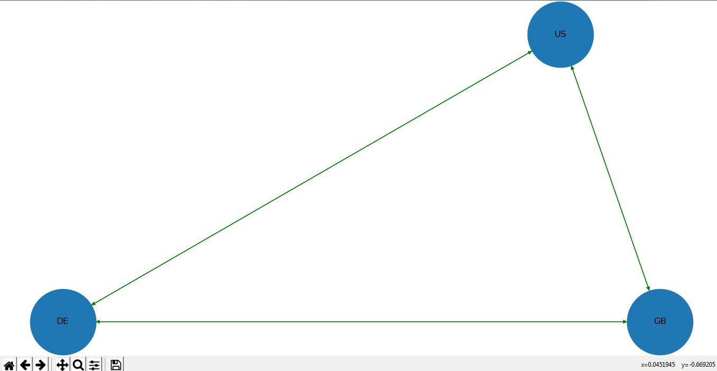

sFileName=sFileDir + '/' + sOutputFileName2 print('################################')

print('Storing :', sFileName) print('################################')

nx.draw(G2,pos=nx.spectral_layout(G2), nodecolor='r',edge_color='b', with_labels=True,node_size=8000, font_size=12)

plt.savefig(sFileName) # save as png plt.show() # display

################################################################

**Output: ################################**

**Rows : 150 ################################ ################################**

**Link : US to DE Link : US to GB Link : DE to US Link : DE to GB Link : GB to US Link : GB to DE**

**################################ ################################**

**Nodes of graph:**

**['US', 'DE', 'GB']**

**Edges of graph:**

**[('US', 'DE'), ('US', 'GB'), ('DE', 'US'), ('DE', 'GB'), ('GB', 'US'), ('GB', 'DE')] ################################**

**Customer Location DAG**

################### **Assess-DAG-Location.py**###################

import networkx as nx

import matplotlib.pyplot as plt import sys

import os

import pandas as pd ################################################################ Base='C:/VKHCG' ################################################################ print('################################')

print('Working Base :',Base, ' using ', sys.platform) print('################################') ################################################################

sInputFileName='01-Retrieve/01-EDS/02-Python/Retrieve_Router_Location.csv' sOutputFileName1='Assess-DAG-Company-Country.png' sOutputFileName2='Assess-DAG-Company-Country-Place.png'

Company='01-Vermeulen' ################################################################

### Import Company Data ################################################################

sFileName=Base + '/' + Company + '/' + sInputFileName print('################################')

print('Loading :',sFileName) print('################################')

CompanyData=pd.read_csv(sFileName,header=0,low_memory=False, encoding="latin-1") print('Loaded Company :',CompanyData.columns.values) print('################################') ################################################################

print(CompanyData) print('################################')

print('Rows : ',CompanyData.shape[0]) print('################################') ################################################################

G1=nx.DiGraph() G2=nx.DiGraph()

################################################################

for i in range(CompanyData.shape[0]): G1.add_node(CompanyData['Country'][i])

sPlaceName= CompanyData['Place_Name'][i] + '-' + CompanyData['Country'][i] G2.add_node(sPlaceName)

print('################################')

for n1 in G1.nodes(): for n2 in G1.nodes():

if n1 != n2:

print('Link :',n1,' to ', n2) G1.add_edge(n1,n2)

print('################################')

print('################################')

print("Nodes of graph: ") print(G1.nodes()) print("Edges of graph: ") print(G1.edges())

print('################################') ################################################################

sFileDir=Base + '/' + Company + '/02-Assess/01-EDS/02-Python' if not os.path.exists(sFileDir):

os.makedirs(sFileDir) ################################################################

sFileName=sFileDir + '/' + sOutputFileName1 print('################################')

print('Storing :', sFileName) print('################################')

nx.draw(G1,pos=nx.spectral_layout(G1), nodecolor='r',edge_color='g', with_labels=True,node_size=8000, font_size=12)

plt.savefig(sFileName) # save as png plt.show() # display

################################################################ print('################################')

for n1 in G2.nodes(): for n2 in G2.nodes():

if n1 != n2:

print('Link :',n1,' to ', n2) G2.add_edge(n1,n2)

print('################################')

print('################################')

print("Nodes of graph: ") print(G2.nodes()) print("Edges of graph: ") print(G2.edges())

print('################################') ################################################################

sFileDir=Base + '/' + Company + '/02-Assess/01-EDS/02-Python' if not os.path.exists(sFileDir):

os.makedirs(sFileDir) ################################################################

sFileName=sFileDir + '/' + sOutputFileName2 print('################################')

print('Storing :', sFileName) print('################################')

nx.draw(G2,pos=nx.spectral_layout(G2),

nodecolor='r',edge_color='b', with_labels=True,node_size=8000, font_size=12)

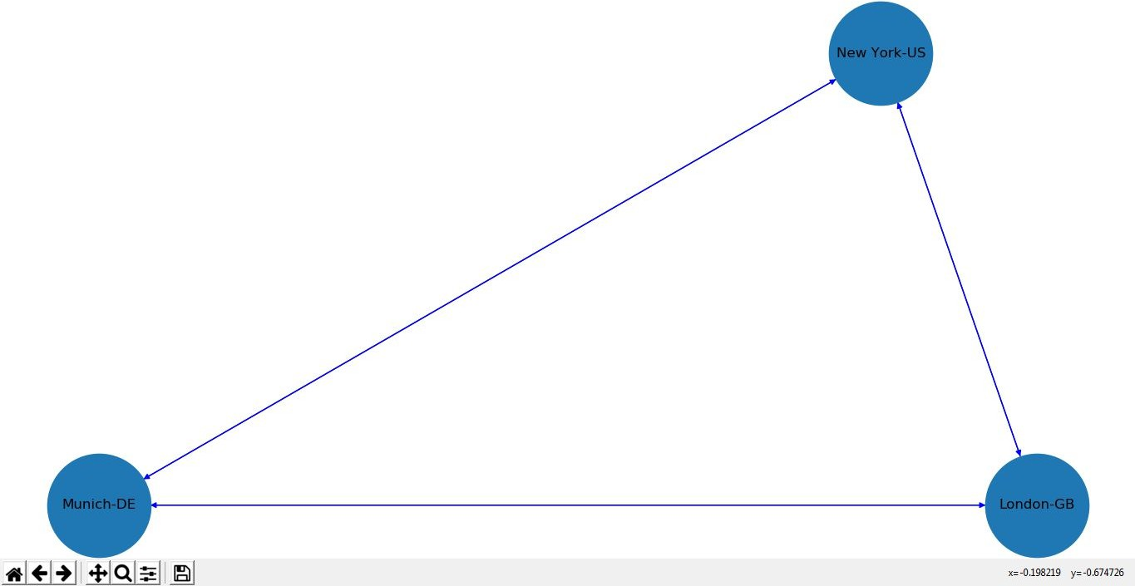

plt.savefig(sFileName) # save as png plt.show() # display

################################################################

**Output:**

################################

Link : New York-US to Munich-DE Link : New York-US to London-GB Link : Munich-DE to New York-US Link : Munich-DE to London-GB Link : London-GB to New York-US Link : London-GB to Munich-DE ################################ ################################

Nodes of graph:

['New York-US', 'Munich-DE', 'London-GB'] Edges of graph:

[('New York-US', 'Munich-DE'), ('New York-US', 'London-GB'), ('Munich-DE', 'New York-US'),

('Munich-DE', 'London-GB'), ('London-GB', 'New York-US'), ('London-GB', 'Munich-DE')]

Open your Python editor and create a file named Assess-DAG-GPS.py in directory C:\VKHCG\01-Vermeulen\02-Assess.

import networkx as nx

import matplotlib.pyplot as plt import sys

import os

import pandas as pd

Base='C:/VKHCG' print('################################')

print('Working Base :',Base, ' using ', sys.platform) print('################################')

sInputFileName='01-Retrieve/01-EDS/02-Python/Retrieve_Router_Location.csv' sOutputFileName='Assess-DAG-Company-GPS.png'

Company='01-Vermeulen' ### Import Company Data

sFileName=Base + '/' + Company + '/' + sInputFileName print('################################')

print('Loading :',sFileName) print('################################')

CompanyData=pd.read_csv(sFileName,header=0,low_memory=False, encoding="latin-1") print('Loaded Company :',CompanyData.columns.values) print('################################')

print(CompanyData) print('################################')

print('Rows : ',CompanyData.shape[0]) print('################################')

G=nx.Graph()

for i in range(CompanyData.shape[0]): nLatitude=round(CompanyData['Latitude'][i],2) nLongitude=round(CompanyData['Longitude'][i],2)

if nLatitude < 0:

sLatitude = str(nLatitude*-1) + ' S' else:

sLatitude = str(nLatitude) + ' N'

if nLongitude < 0:

sLongitude = str(nLongitude*-1) + ' W' else:

sLongitude = str(nLongitude) + ' E'

sGPS= sLatitude + '-' + sLongitude G.add_node(sGPS)

print('################################')

for n1 in G.nodes(): for n2 in G.nodes():

if n1 != n2:

print('Link :',n1,' to ', n2) G.add_edge(n1,n2)

print('################################')

print('################################')

print("Nodes of graph: ") print(G.number_of_nodes())

**print("Edges of graph: ") print(G.number_of_edges()) print('################################')**

**Output:**

**=== RESTART: C:\VKHCG\01-Vermeulen\02-**Assess\Assess-DAG-GPS-unsmoothed.py === **################################**

**Working Base : C:/VKHCG**

**using**

**win32**

**################################**

**Loading : C:/VKHCG/01-Vermeulen/01-Retriev**e/01-EDS/02-Python/Retrieve_Router_Location.csv **################################**

**Loaded Company : ['Country' 'Place_Name' 'Lat**itude' 'Longitude'] **################################**

**Country Place_Name**

**Latitude**

**Longitude**

1. **US**
2. **US**

**-**

**-**

**-**

**New York New York**

**40.7528**

**40.7214**

**-73.9725**

**-74.0052**

**Link : 48.15 N-11.74 E to Link : 48.15 N-11.74 E to Link : 48.15 N-11.74 E to Link : 48.15 N-11.74 E to**

**48.15 N-11.46 E**

**48.09 N-11.54 E**

**48.18 N-11.75 E**

**48.1 N-11.47 E**

**################################**

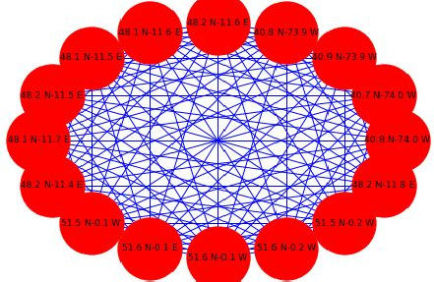

**Nodes of graph:**

**117**

**Edges of graph:**

**6786 ################################**

**>>>**

* 1. **Write a Python / R program to pick the content for Bill Boards from the given data.**

**Picking Content for Billboards**

The basic process required is to combine two sets of data and then calculate the number of visitors per day from the range of IP addresses that access the billboards in Germany.

**Bill Board Location: Rows - 8873 Access Visitors: Rows - 75999**

**Access Location Record: Rows – 1,81,235**

Open Python editor and create a file named **Assess-DE-Billboard.py** in directory C:\VKHCG\02-Krennwallner\02-Assess

################# **Assess-DE-Billboard.py**######################

import sys import os

import sqlite3 as sq import pandas as pd

################################################################ Base='C:/VKHCG'

print('################################')

print('Working Base :',Base, ' using ', sys.platform) print('################################') ################################################################

sInputFileName1='01-Retrieve/01-EDS/02-Python/Retrieve_DE_Billboard_Locations.csv' sInputFileName2='01-Retrieve/01-EDS/02-Python/Retrieve_Online_Visitor.csv' sOutputFileName='Assess-DE-Billboard-Visitor.csv'

Company='02-Krennwallner' ################################################################

sDataBaseDir=Base + '/' + Company + '/02-Assess/SQLite' if not os.path.exists(sDataBaseDir):

os.makedirs(sDataBaseDir) ################################################################

sDatabaseName=sDataBaseDir + '/krennwallner.db' conn = sq.connect(sDatabaseName)

################################################################

### Import Billboard Data ################################################################

sFileName=Base + '/' + Company + '/' + sInputFileName1 print('################################')

print('Loading :',sFileName) print('################################')

BillboardRawData=pd.read_csv(sFileName,header=0,low_memory=False, encoding="latin-1") BillboardRawData.drop_duplicates(subset=None, keep='first', inplace=True)

BillboardData=BillboardRawData

print('Loaded Company :',BillboardData.columns.values) print('################################') ################################################################ print('################')

sTable='Assess_BillboardData'

print('Storing :',sDatabaseName,' Table:',sTable)

BillboardData.to_sql(sTable, conn, if_exists="replace") print('################') ################################################################

print(BillboardData.head()) print('################################')

print('Rows : ',BillboardData.shape[0]) print('################################') ################################################################

### Import Billboard Data ################################################################

sFileName=Base + '/' + Company + '/' + sInputFileName2 print('################################')

print('Loading :',sFileName) print('################################')

VisitorRawData=pd.read_csv(sFileName,header=0,low_memory=False, encoding="latin-1") VisitorRawData.drop_duplicates(subset=None, keep='first', inplace=True) VisitorData=VisitorRawData[VisitorRawData.Country=='DE']

print('Loaded Company :',VisitorData.columns.values) print('################################') ################################################################ print('################')

sTable='Assess_VisitorData'

print('Storing :',sDatabaseName,' Table:',sTable) VisitorData.to_sql(sTable, conn, if_exists="replace") print('################')

################################################################

print(VisitorData.head()) print('################################')

print('Rows : ',VisitorData.shape[0]) print('################################') ################################################################ print('################')

sTable='Assess_BillboardVisitorData' print('Loading :',sDatabaseName,' Table:',sTable) sSQL="select distinct"

sSQL=sSQL+ " A.Country AS BillboardCountry," sSQL=sSQL+ " A.Place_Name AS BillboardPlaceName," sSQL=sSQL+ " A.Latitude AS BillboardLatitude, " sSQL=sSQL+ " A.Longitude AS BillboardLongitude," sSQL=sSQL+ " B.Country AS VisitorCountry," sSQL=sSQL+ " B.Place_Name AS VisitorPlaceName," sSQL=sSQL+ " B.Latitude AS VisitorLatitude, " sSQL=sSQL+ " B.Longitude AS VisitorLongitude,"

sSQL=sSQL+ " (B.Last_IP_Number - B.First_IP_Number) * 365.25 * 24 * 12 AS VisitorYearRate" sSQL=sSQL+ " from"

sSQL=sSQL+ " Assess_BillboardData as A" sSQL=sSQL+ " JOIN "

sSQL=sSQL+ " Assess_VisitorData as B"

sSQL=sSQL+ " ON "

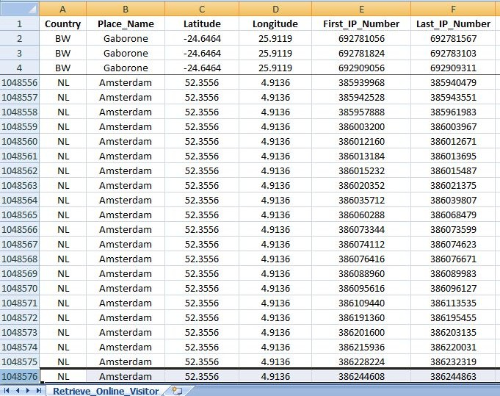

sSQL=sSQL+ " A.Country = B.Country" sSQL=sSQL+ " AND "

sSQL=sSQL+ " A.Place_Name = B.Place_Name;" BillboardVistorsData=pd.read_sql_query(sSQL, conn) print('################') ################################################################ print('################')

sTable='Assess_BillboardVistorsData' print('Storing :',sDatabaseName,' Table:',sTable)

BillboardVistorsData.to_sql(sTable, conn, if_exists="replace") print('################') ################################################################

print(BillboardVistorsData.head()) print('################################')

print('Rows : ',BillboardVistorsData.shape[0]) print('################################') ################################################################

sFileDir=Base + '/' + Company + '/02-Assess/01-EDS/02-Python' if not os.path.exists(sFileDir):

os.makedirs(sFileDir) ################################################################ print('################################')

print('Storing :', sFileName) print('################################')

sFileName=sFileDir + '/' + sOutputFileName BillboardVistorsData.to_csv(sFileName, index = False) print('################################') ################################################################ print('### Done!! ############################################') ################################################################

**Output:**

C:\VKHCG\02-Krennwallner\01-Retrieve\01-EDS\02-Python\Retrieve_Online_Visitor.csv containing, 10,48,576**(Ten lack Forty Eight Thousand Five Hundred and Seventy Six )**rows.

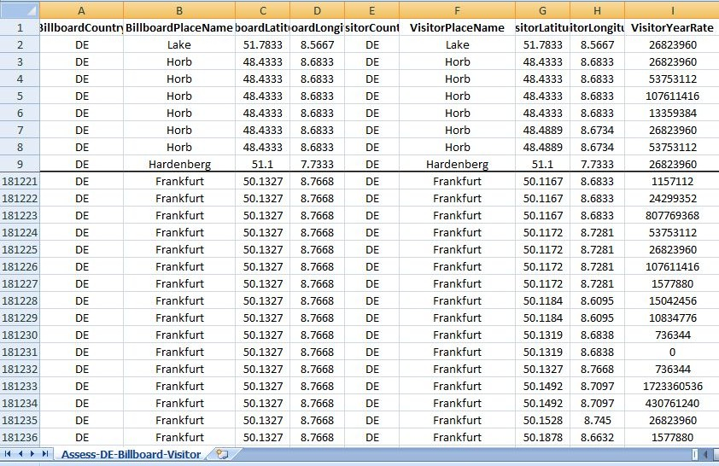

**SQLite Visitor’s Database**

C:/VKHCG/02-Krennwallner/02-Assess/SQLite/krennwallner.db Table:

BillboardCountry BillboardPlaceName ... VisitorLongitude VisitorYearRate

|  |  |  |  |
| --- | --- | --- | --- |
| 0 | DE | Lake ... 8.5667 | 26823960.0 |
| 1 | DE | Horb ... 8.6833 | 26823960.0 |
| 2 | DE | Horb ... 8.6833 | 53753112.0 |
| 3 | DE | Horb ... 8.6833 | 107611416.0 |
| 4 | DE | Horb ... 8.6833 | 13359384.0 |

* 1. **Write a Python / R program to generate GML file from the given csv file.**

**Understanding Your Online Visitor Data**

Online visitors have to be mapped to their closest billboard, to ensure we understand where and what they can access.

Open your Python editor and create a file called Assess-Billboard_2_Visitor.py in directory C:\VKHCG\ 02-Krennwallner\02-Assess. ################################################################

# -*- coding: utf-8 -*- ################################################################

import networkx as nx

import sys import os

import sqlite3 as sq import pandas as pd

from geopy.distance import vincenty ################################################################ Base='C:/VKHCG'

print('################################')

print('Working Base :',Base, ' using ', sys.platform) print('################################') ################################################################

Company='02-Krennwallner' sTable='Assess_BillboardVisitorData' sOutputFileName='Assess-DE-Billboard-Visitor.gml'

################################################################

sDataBaseDir=Base + '/' + Company + '/02-Assess/SQLite' if not os.path.exists(sDataBaseDir):

os.makedirs(sDataBaseDir) ################################################################

sDatabaseName=sDataBaseDir + '/krennwallner.db' conn = sq.connect(sDatabaseName)

################################################################ print('################')

print('Loading :',sDatabaseName,' Table:',sTable) sSQL="select "

sSQL=sSQL+ " A.BillboardCountry," sSQL=sSQL+ " A.BillboardPlaceName,"

sSQL=sSQL+ " ROUND(A.BillboardLatitude,3) AS BillboardLatitude, " sSQL=sSQL+ " ROUND(A.BillboardLongitude,3) AS BillboardLongitude,"

sSQL=sSQL+ " (CASE WHEN A.BillboardLatitude < 0 THEN "

sSQL=sSQL+ " 'S' || ROUND(ABS(A.BillboardLatitude),3)"

sSQL=sSQL+ " ELSE "

sSQL=sSQL+ " 'N' || ROUND(ABS(A.BillboardLatitude),3)"

sSQL=sSQL+ " END ) AS sBillboardLatitude,"

sSQL=sSQL+ " (CASE WHEN A.BillboardLongitude < 0 THEN "

sSQL=sSQL+ " 'W' || ROUND(ABS(A.BillboardLongitude),3)"

sSQL=sSQL+ " ELSE "

sSQL=sSQL+ " 'E' || ROUND(ABS(A.BillboardLongitude),3)"

sSQL=sSQL+ " END ) AS sBillboardLongitude,"

sSQL=sSQL+ " A.VisitorCountry," sSQL=sSQL+ " A.VisitorPlaceName,"

sSQL=sSQL+ " ROUND(A.VisitorLatitude,3) AS VisitorLatitude, " sSQL=sSQL+ " ROUND(A.VisitorLongitude,3) AS VisitorLongitude,"

sSQL=sSQL+ " (CASE WHEN A.VisitorLatitude < 0 THEN "

sSQL=sSQL+ " 'S' || ROUND(ABS(A.VisitorLatitude),3)"

sSQL=sSQL+ " ELSE "

sSQL=sSQL+ " 'N' ||ROUND(ABS(A.VisitorLatitude),3)"

sSQL=sSQL+ " END ) AS sVisitorLatitude,"

sSQL=sSQL+ " (CASE WHEN A.VisitorLongitude < 0 THEN "

sSQL=sSQL+ " 'W' || ROUND(ABS(A.VisitorLongitude),3)"

sSQL=sSQL+ " ELSE "

sSQL=sSQL+ " 'E' || ROUND(ABS(A.VisitorLongitude),3)"

sSQL=sSQL+ " END ) AS sVisitorLongitude,"

sSQL=sSQL+ " A.VisitorYearRate" sSQL=sSQL+ " from"

sSQL=sSQL+ " Assess_BillboardVistorsData AS A;" BillboardVistorsData=pd.read_sql_query(sSQL, conn) print('################') ################################################################

BillboardVistorsData['Distance']=BillboardVistorsData.apply(lambda row: round(

vincenty((row['BillboardLatitude'],row['BillboardLongitude']), (row['VisitorLatitude'],row['VisitorLongitude'])).miles

,4)

,axis=1) ################################################################

G=nx.Graph() ################################################################

for i in range(BillboardVistorsData.shape[0]):

sNode0='MediaHub-' + BillboardVistorsData['BillboardCountry'][i]

sNode1='B-'+ BillboardVistorsData['sBillboardLatitude'][i] + '-' sNode1=sNode1 + BillboardVistorsData['sBillboardLongitude'][i] G.add_node(sNode1,

Nodetype='Billboard', Country=BillboardVistorsData['BillboardCountry'][i], PlaceName=BillboardVistorsData['BillboardPlaceName'][i], Latitude=round(BillboardVistorsData['BillboardLatitude'][i],3), Longitude=round(BillboardVistorsData['BillboardLongitude'][i],3))

sNode2='M-'+ BillboardVistorsData['sVisitorLatitude'][i] + '-' sNode2=sNode2 + BillboardVistorsData['sVisitorLongitude'][i] G.add_node(sNode2,

Nodetype='Mobile', Country=BillboardVistorsData['VisitorCountry'][i], PlaceName=BillboardVistorsData['VisitorPlaceName'][i], Latitude=round(BillboardVistorsData['VisitorLatitude'][i],3), Longitude=round(BillboardVistorsData['VisitorLongitude'][i],3))

print('Link Media Hub :',sNode0,' to Billboard : ', sNode1) G.add_edge(sNode0,sNode1)

print('Link Post Code :',sNode1,' to GPS : ', sNode2) G.add_edge(sNode1,sNode2,distance=round(BillboardVistorsData['Distance'][i]))

################################################################ print('################################')

print("Nodes of graph: ",nx.number_of_nodes(G)) print("Edges of graph: ",nx.number_of_edges(G)) print('################################')

################################################################

sFileDir=Base + '/' + Company + '/02-Assess/01-EDS/02-Python' if not os.path.exists(sFileDir):

os.makedirs(sFileDir) ################################################################

sFileName=sFileDir + '/' + sOutputFileName print('################################')

print('Storing :', sFileName) print('################################')

nx.write_gml(G,sFileName) sFileName=sFileName +'.gz' nx.write_gml(G,sFileName)

################################################################ ################################################################ print('### Done!! ############################################') ################################################################

**Output:**

**This will produce a set of demonstrated values onscreen, plus a graph data file named Assess-DE-Billboard-Visitor.gml.**

(It takes a long time to complete the process, after completion the gml file can be viewed in text editor)

Hence, we have applied formulae to extract features, such as the distance between the billboard and the visitor.

###### Planning an Event for Top-Ten Customers

Open Python editor and create a file named Assess-Visitors.py in directory C:\VKHCG\02-Krennwallner\02-Assess ################################################################

import sys import os

import sqlite3 as sq import pandas as pd

from pandas.io import sql ################################################################ Base='C:/VKHCG'

print('################################')

print('Working Base :',Base, ' using ', sys.platform) print('################################') ################################################################

Company='02-Krennwallner'

sInputFileName='01-Retrieve/01-EDS/02-Python/Retrieve_Online_Visitor.csv' ################################################################

sDataBaseDir=Base + '/' + Company + '/02-Assess/SQLite' if not os.path.exists(sDataBaseDir):

os.makedirs(sDataBaseDir) ################################################################

sDatabaseName=sDataBaseDir + '/krennwallner.db' conn = sq.connect(sDatabaseName)

################################################################

### Import Country Data ################################################################

sFileName=Base + '/' + Company + '/' + sInputFileName print('################################')

print('Loading :',sFileName) print('################################')

VisitorRawData=pd.read_csv(sFileName, header=0, low_memory=False, encoding="latin-1", skip_blank_lines=True)

VisitorRawData.drop_duplicates(subset=None, keep='first', inplace=True)

VisitorData=VisitorRawData

print('Loaded Company :',VisitorData.columns.values) print('################################') ################################################################ print('################')

sTable='Assess_Visitor'

print('Storing :',sDatabaseName,' Table:',sTable) VisitorData.to_sql(sTable, conn, if_exists="replace") print('################')

################################################################

print(VisitorData.head()) print('################################')

print('Rows : ',VisitorData.shape[0]) print('################################') ################################################################ print('################')

sView='Assess_Visitor_UseIt'

print('Creating :',sDatabaseName,' View:',sView) sSQL="DROP VIEW IF EXISTS " + sView + ";"

sql.execute(sSQL,conn)

sSQL="CREATE VIEW " + sView + " AS"

sSQL=sSQL+ " SELECT"

sSQL=sSQL+ " A.Country," sSQL=sSQL+ " A.Place_Name," sSQL=sSQL+ " A.Latitude," sSQL=sSQL+ " A.Longitude,"

sSQL=sSQL+ " (A.Last_IP_Number - A.First_IP_Number) AS UsesIt" sSQL=sSQL+ " FROM"

sSQL=sSQL+ " Assess_Visitor as A" sSQL=sSQL+ " WHERE"

sSQL=sSQL+ " Country is not null" sSQL=sSQL+ " AND"

sSQL=sSQL+ " Place_Name is not null;" sql.execute(sSQL,conn)

################################################################# print('################')

sView='Assess_Total_Visitors_Location' print('Creating :',sDatabaseName,' View:',sView) sSQL="DROP VIEW IF EXISTS " + sView + ";"

sql.execute(sSQL,conn)

sSQL="CREATE VIEW " + sView + " AS" sSQL=sSQL+ " SELECT"

sSQL=sSQL+ " Country," sSQL=sSQL+ " Place_Name,"

sSQL=sSQL+ " SUM(UsesIt) AS TotalUsesIt" sSQL=sSQL+ " FROM"

sSQL=sSQL+ " Assess_Visitor_UseIt" sSQL=sSQL+ " GROUP BY"

sSQL=sSQL+ " Country," sSQL=sSQL+ " Place_Name" sSQL=sSQL+ " ORDER BY"

sSQL=sSQL+ " TotalUsesIt DESC" sSQL=sSQL+ " LIMIT 10;"

sql.execute(sSQL,conn) ################################################################# print('################')

sView='Assess_Total_Visitors_GPS' print('Creating :',sDatabaseName,' View:',sView) sSQL="DROP VIEW IF EXISTS " + sView + ";"

sql.execute(sSQL,conn)

sSQL="CREATE VIEW " + sView + " AS" sSQL=sSQL+ " SELECT"

sSQL=sSQL+ " Latitude," sSQL=sSQL+ " Longitude,"

sSQL=sSQL+ " SUM(UsesIt) AS TotalUsesIt" sSQL=sSQL+ " FROM"

sSQL=sSQL+ " Assess_Visitor_UseIt"

sSQL=sSQL+ " GROUP BY"

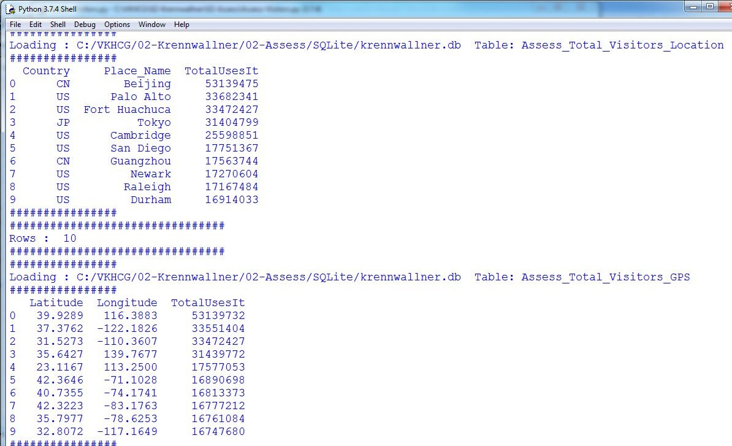

sSQL=sSQL+ " Latitude," sSQL=sSQL+ " Longitude" sSQL=sSQL+ " ORDER BY"

sSQL=sSQL+ " TotalUsesIt DESC" sSQL=sSQL+ " LIMIT 10;"

sql.execute(sSQL,conn) #################################################################

sTables=['Assess_Total_Visitors_Location', 'Assess_Total_Visitors_GPS'] for sTable in sTables:

print('################')

print('Loading :',sDatabaseName,' Table:',sTable) sSQL=" SELECT "

sSQL=sSQL+ " *" sSQL=sSQL+ " FROM"

sSQL=sSQL+ " " + sTable + ";" TopData=pd.read_sql_query(sSQL, conn) print('################')

print(TopData) print('################')

print('################################')

print('Rows : ',TopData.shape[0]) print('################################')

################################################################ print('### Done!! ############################################') ################################################################

Output:

* 1. **Write a Python / R program to plan the locations of the warehouses from the given data.**

###### Planning the Locations of the Warehouses

Planning the location of the warehouses requires the assessment of the GPS locations of these warehouses against the requirements for Hillman’s logistics needs.

Open your editor and create a file named Assess-Warehouse-Address.py in directory C:\VKHCG\03-Hillman\02-Assess.

################## Assess-Warehouse-Address.py ################### # -*- coding: utf-8 -*- ################################################################

import os

import pandas as pd

from geopy.geocoders import Nominatim geolocator = Nominatim()

################################################################

InputDir='01-Retrieve/01-EDS/01-R' InputFileName='Retrieve_GB_Postcode_Warehouse.csv' EDSDir='02-Assess/01-EDS'

OutputDir=EDSDir + '/02-Python' OutputFileName='Assess_GB_Warehouse_Address.csv' Company='03-Hillman'

################################################################ Base='C:/VKHCG'

print('################################')

print('Working Base :',Base, ' using Windows') print('################################') ################################################################

sFileDir=Base + '/' + Company + '/' + EDSDir if not os.path.exists(sFileDir):

os.makedirs(sFileDir) ################################################################

sFileDir=Base + '/' + Company + '/' + OutputDir if not os.path.exists(sFileDir):

os.makedirs(sFileDir) ################################################################

sFileName=Base + '/' + Company + '/' + InputDir + '/' + InputFileName print('###########')

print('Loading :',sFileName) Warehouse=pd.read_csv(sFileName,header=0,low_memory=False) Warehouse.sort_values(by='postcode', ascending=1) ################################################################

## Limited to 10 due to service limit on Address Service. ################################################################

WarehouseGoodHead=Warehouse[Warehouse.latitude != 0].head(5) WarehouseGoodTail=Warehouse[Warehouse.latitude != 0].tail(5) ################################################################

WarehouseGoodHead['Warehouse_Point']=WarehouseGoodHead.apply(lambda row: (str(row['latitude'])+','+str(row['longitude']))

,axis=1) WarehouseGoodHead['Warehouse_Address']=WarehouseGoodHead.apply(lambda row:

geolocator.reverse(row['Warehouse_Point']).address

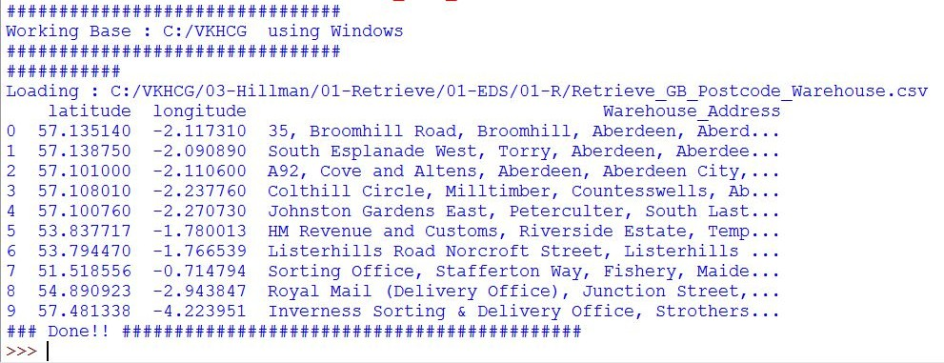

,axis=1)

WarehouseGoodHead.drop('Warehouse_Point', axis=1, inplace=True) WarehouseGoodHead.drop('id', axis=1, inplace=True) WarehouseGoodHead.drop('postcode', axis=1, inplace=True) ################################################################

WarehouseGoodTail['Warehouse_Point']=WarehouseGoodTail.apply(lambda row: (str(row['latitude'])+','+str(row['longitude']))

,axis=1) WarehouseGoodTail['Warehouse_Address']=WarehouseGoodTail.apply(lambda row:

geolocator.reverse(row['Warehouse_Point']).address

,axis=1)

WarehouseGoodTail.drop('Warehouse_Point', axis=1, inplace=True) WarehouseGoodTail.drop('id', axis=1, inplace=True) WarehouseGoodTail.drop('postcode', axis=1, inplace=True) ################################################################

WarehouseGood=WarehouseGoodHead.append(WarehouseGoodTail, ignore_index=True) print(WarehouseGood) ################################################################

sFileName=sFileDir + '/' + OutputFileName WarehouseGood.to_csv(sFileName, index = False)

################################################################# print('### Done!! ############################################') #################################################################

**Output:**

* 1. **Write a Python / R program using data science via clustering to determine new warehouses using the given data.**

**Global New Warehouse:**Hillman wants to add extra global warehouses, and you are required to assess wherethey should be located. We only have to collect the possible locations for warehouses.

The following example will show you how to modify the data columns you read in that are totally ambiguous. Open Python editor and create a file named Assess-Warehouse-Global.py in directory

C:\VKHCG\03-Hillman\02-Assess

#################

# -*- coding: utf-8 -*-

Assess-Warehouse-Global.py##############

################################################################

import sys import os

import pandas as pd ################################################################ Base='C:/VKHCG' ################################################################ print('################################')

print('Working Base :',Base, ' using ', sys.platform) print('################################') ################################################################

Company='03-Hillman'

InputDir='01-Retrieve/01-EDS/01-R' InputFileName='Retrieve_All_Countries.csv' EDSDir='02-Assess/01-EDS' OutputDir=EDSDir + '/02-Python' OutputFileName='Assess_All_Warehouse.csv'

################################################################

sFileDir=Base + '/' + Company + '/' + EDSDir if not os.path.exists(sFileDir):

os.makedirs(sFileDir) ################################################################

sFileDir=Base + '/' + Company + '/' + OutputDir if not os.path.exists(sFileDir):

os.makedirs(sFileDir) ################################################################

sFileName=Base + '/' + Company + '/' + InputDir + '/' + InputFileName print('###########')

print('Loading :',sFileName) Warehouse=pd.read_csv(sFileName,header=0,low_memory=False, encoding="latin-1") ################################################################

sColumns={'X1' : 'Country', 'X2' : 'PostCode',

'X3' : 'PlaceName',

'X4' : 'AreaName',

'X5' : 'AreaCode',

'X10' : 'Latitude',

'X11' : 'Longitude'} Warehouse.rename(columns=sColumns,inplace=True) WarehouseGood=Warehouse ################################################################

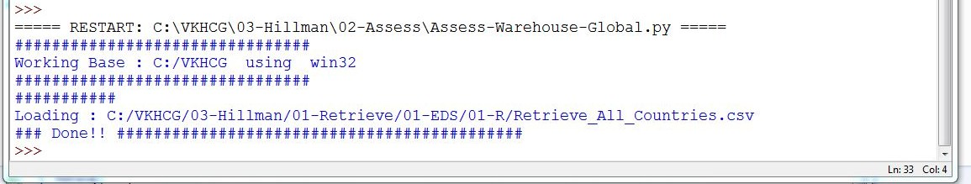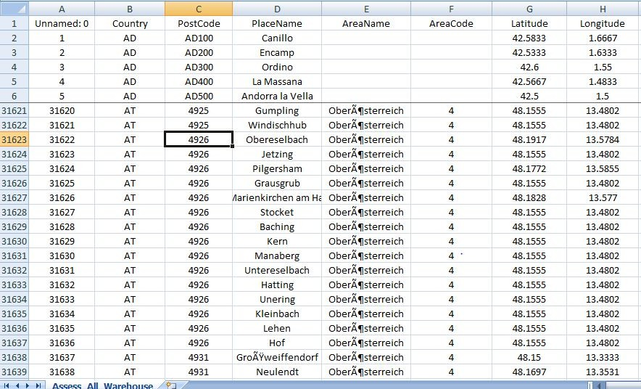

sFileName=sFileDir + '/' + OutputFileName WarehouseGood.to_csv(sFileName, index = False)

################################################################# print('### Done!! ############################################') #################################################################

This will produce a set of demonstrated values onscreen, plus a graph data file named Assess_All_Warehouse.csv.

**Output:**

Open Assess0_All_Warehose.csv from C:\VKHCG\03-Hillman\02-Assess\01-EDS\02-Python

* 1. **Using the given data, write a Python / R program to plan the shipping routes for best-fit international logistics.**

Hillman requires an international logistics solution to support all the required shippingroutes.

Open Python editor and create a file named Assess-Best-Fit-Logistics.py in directory C:\VKHCG\03-Hillman\02-Assess

################################################################

# -*- coding: utf-8 -*- ################################################################

import sys import os

import pandas as pd import networkx as nx

from geopy.distance import vincenty import sqlite3 as sq

from pandas.io import sql ################################################################

if sys.platform == 'linux': Base=os.path.expanduser('~') + '/VKHCG'

else:

Base='C:/VKHCG' print('################################')

print('Working Base :',Base, ' using ', sys.platform) print('################################') ################################################################

Company='03-Hillman'

InputDir='01-Retrieve/01-EDS/01-R' InputFileName='Retrieve_All_Countries.csv' EDSDir='02-Assess/01-EDS' OutputDir=EDSDir + '/02-Python' OutputFileName='Assess_Best_Logistics.gml'

################################################################

sFileDir=Base + '/' + Company + '/' + EDSDir if not os.path.exists(sFileDir):

os.makedirs(sFileDir) ################################################################

sFileDir=Base + '/' + Company + '/' + OutputDir if not os.path.exists(sFileDir):

os.makedirs(sFileDir) ################################################################

sDataBaseDir=Base + '/' + Company + '/02-Assess/SQLite' if not os.path.exists(sDataBaseDir):

os.makedirs(sDataBaseDir) ################################################################

sDatabaseName=sDataBaseDir + '/Hillman.db' conn = sq.connect(sDatabaseName)

################################################################

sFileName=Base + '/' + Company + '/' + InputDir + '/' + InputFileName print('###########')

print('Loading :',sFileName) Warehouse=pd.read_csv(sFileName,header=0,low_memory=False, encoding="latin-1") ################################################################

sColumns={'X1' : 'Country', 'X2' : 'PostCode',

'X3' : 'PlaceName',

'X4' : 'AreaName',

'X5' : 'AreaCode',

'X10' : 'Latitude',

'X11' : 'Longitude'} Warehouse.rename(columns=sColumns,inplace=True) WarehouseGood=Warehouse #print(WarehouseGood.head())

################################################################

RoutePointsCountry=pd.DataFrame(WarehouseGood.groupby(['Country'])[['Latitude','Longitude'

]].mean()) #print(RoutePointsCountry.head()) print('################')

sTable='Assess_RoutePointsCountry' print('Storing :',sDatabaseName,' Table:',sTable)

RoutePointsCountry.to_sql(sTable, conn, if_exists="replace") print('################') ################################################################

RoutePointsPostCode=pd.DataFrame(WarehouseGood.groupby(['Country', 'PostCode'])[['Latitude','Longitude']].mean()) #print(RoutePointsPostCode.head())

print('################')

sTable='Assess_RoutePointsPostCode' print('Storing :',sDatabaseName,' Table:',sTable)

RoutePointsPostCode.to_sql(sTable, conn, if_exists="replace") print('################') ################################################################

RoutePointsPlaceName=pd.DataFrame(WarehouseGood.groupby(['Country', 'PostCode','PlaceName'])[['Latitude','Longitude']].mean()) #print(RoutePointsPlaceName.head())

print('################')

sTable='Assess_RoutePointsPlaceName' print('Storing :',sDatabaseName,' Table:',sTable)

RoutePointsPlaceName.to_sql(sTable, conn, if_exists="replace") print('################') ################################################################

### Fit Country to Country ################################################################ print('################')

sView='Assess_RouteCountries'

print('Creating :',sDatabaseName,' View:',sView)

sSQL="DROP VIEW IF EXISTS " + sView + ";"

sql.execute(sSQL,conn)

sSQL="CREATE VIEW " + sView + " AS" sSQL=sSQL+ " SELECT DISTINCT"

sSQL=sSQL+ " sSQL=sSQL+ " sSQL=sSQL+ " sSQL=sSQL+ " sSQL=sSQL+ " sSQL=sSQL+ "

S.Country AS SourceCountry," S.Latitude AS SourceLatitude," S.Longitude AS SourceLongitude," T.Country AS TargetCountry," T.Latitude AS TargetLatitude," T.Longitude AS TargetLongitude"

sSQL=sSQL+ " FROM"

sSQL=sSQL+ " sSQL=sSQL+ " sSQL=sSQL+ "

Assess_RoutePointsCountry AS S"

,"

Assess_RoutePointsCountry AS T"

sSQL=sSQL+ " WHERE S.Country <> T.Country" sSQL=sSQL+ " AND"

sSQL=sSQL+ " S.Country in ('GB','DE','BE','AU','US','IN')" sSQL=sSQL+ " AND"

sSQL=sSQL+ " T.Country in ('GB','DE','BE','AU','US','IN');"

sql.execute(sSQL,conn)

print('################')

print('Loading :',sDatabaseName,' Table:',sView) sSQL=" SELECT "

sSQL=sSQL+ " *" sSQL=sSQL+ " FROM" sSQL=sSQL+ " " + sView + ";"

RouteCountries=pd.read_sql_query(sSQL, conn)

RouteCountries['Distance']=RouteCountries.apply(lambda row: round( vincenty((row['SourceLatitude'],row['SourceLongitude']),

(row['TargetLatitude'],row['TargetLongitude'])).miles,4),axis=1)

print(RouteCountries.head(5)) ################################################################

### Fit Country to Post Code ################################################################ print('################')

sView='Assess_RoutePostCode'

print('Creating :',sDatabaseName,' View:',sView) sSQL="DROP VIEW IF EXISTS " + sView + ";"

sql.execute(sSQL,conn)

sSQL="CREATE VIEW " + sView + " AS" sSQL=sSQL+ " SELECT DISTINCT"

sSQL=sSQL+ " S.Country AS SourceCountry,"

sSQL=sSQL+ " sSQL=sSQL+ " sSQL=sSQL+ " sSQL=sSQL+ " sSQL=sSQL+ " sSQL=sSQL+ "

S.Latitude AS SourceLatitude," S.Longitude AS SourceLongitude," T.Country AS TargetCountry," T.PostCode AS TargetPostCode," T.Latitude AS TargetLatitude," T.Longitude AS TargetLongitude"

sSQL=sSQL+ " FROM"

sSQL=sSQL+ " sSQL=sSQL+ " sSQL=sSQL+ "

Assess_RoutePointsCountry AS S"

,"

Assess_RoutePointsPostCode AS T"

sSQL=sSQL+ " WHERE S.Country = T.Country" sSQL=sSQL+ " AND"

sSQL=sSQL+ " S.Country in ('GB','DE','BE','AU','US','IN')" sSQL=sSQL+ " AND"

sSQL=sSQL+ " T.Country in ('GB','DE','BE','AU','US','IN');"

sql.execute(sSQL,conn)

print('################')

print('Loading :',sDatabaseName,' Table:',sView) sSQL=" SELECT "

sSQL=sSQL+ " *" sSQL=sSQL+ " FROM" sSQL=sSQL+ " " + sView + ";"

RoutePostCode=pd.read_sql_query(sSQL, conn)

RoutePostCode['Distance']=RoutePostCode.apply(lambda row: round( vincenty((row['SourceLatitude'],row['SourceLongitude']),

(row['TargetLatitude'],row['TargetLongitude'])).miles

,4)

,axis=1)

print(RoutePostCode.head(5)) ################################################################

### Fit Post Code to Place Name ################################################################ print('################')

sView='Assess_RoutePlaceName' print('Creating :',sDatabaseName,' View:',sView)

sSQL="DROP VIEW IF EXISTS " + sView + ";"

sql.execute(sSQL,conn)

sSQL="CREATE VIEW " + sView + " AS" sSQL=sSQL+ " SELECT DISTINCT"

sSQL=sSQL+ " sSQL=sSQL+ " sSQL=sSQL+ " sSQL=sSQL+ "

S.Country AS SourceCountry," S.PostCode AS SourcePostCode," S.Latitude AS SourceLatitude," S.Longitude AS SourceLongitude,"

sSQL=sSQL+ " sSQL=sSQL+ " sSQL=sSQL+ " sSQL=sSQL+ " sSQL=sSQL+ "

T.Country AS TargetCountry," T.PostCode AS TargetPostCode," T.PlaceName AS TargetPlaceName," T.Latitude AS TargetLatitude," T.Longitude AS TargetLongitude"

sSQL=sSQL+ " FROM"

sSQL=sSQL+ " sSQL=sSQL+ " sSQL=sSQL+ "

Assess_RoutePointsPostCode AS S"

,"

Assess_RoutePointsPLaceName AS T"

sSQL=sSQL+ " WHERE"

sSQL=sSQL+ " S.Country = T.Country" sSQL=sSQL+ " AND"

sSQL=sSQL+ " S.PostCode = T.PostCode" sSQL=sSQL+ " AND"

sSQL=sSQL+ " S.Country in ('GB','DE','BE','AU','US','IN')" sSQL=sSQL+ " AND"

sSQL=sSQL+ " T.Country in ('GB','DE','BE','AU','US','IN');"

sql.execute(sSQL,conn)

print('################')

print('Loading :',sDatabaseName,' Table:',sView) sSQL=" SELECT "

sSQL=sSQL+ " *" sSQL=sSQL+ " FROM" sSQL=sSQL+ " " + sView + ";"

RoutePlaceName=pd.read_sql_query(sSQL, conn)

RoutePlaceName['Distance']=RoutePlaceName.apply(lambda row: round( vincenty((row['SourceLatitude'],row['SourceLongitude']),

(row['TargetLatitude'],row['TargetLongitude'])).miles

,4)

,axis=1)

print(RoutePlaceName.head(5)) ################################################################

G=nx.Graph() ################################################################

print('Countries:',RouteCountries.shape) for i in range(RouteCountries.shape[0]):

sNode0='C-' + RouteCountries['SourceCountry'][i] G.add_node(sNode0,

Nodetype='Country', Country=RouteCountries['SourceCountry'][i], Latitude=round(RouteCountries['SourceLatitude'][i],4), Longitude=round(RouteCountries['SourceLongitude'][i],4))

sNode1='C-' + RouteCountries['TargetCountry'][i]

G.add_node(sNode1,

Nodetype='Country', Country=RouteCountries['TargetCountry'][i], Latitude=round(RouteCountries['TargetLatitude'][i],4), Longitude=round(RouteCountries['TargetLongitude'][i],4))

G.add_edge(sNode0,sNode1,distance=round(RouteCountries['Distance'][i],3)) #print(sNode0,sNode1)

################################################################

print('Post Code:',RoutePostCode.shape) for i in range(RoutePostCode.shape[0]):

sNode0='C-' + RoutePostCode['SourceCountry'][i] G.add_node(sNode0,

Nodetype='Country', Country=RoutePostCode['SourceCountry'][i], Latitude=round(RoutePostCode['SourceLatitude'][i],4), Longitude=round(RoutePostCode['SourceLongitude'][i],4))

sNode1='P-' + RoutePostCode['TargetPostCode'][i] G.add_node(sNode1,

Nodetype='PostCode', Country=RoutePostCode['TargetCountry'][i],

+ '-' + RoutePostCode['TargetCountry'][i]

PostCode=RoutePostCode['TargetPostCode'][i], Latitude=round(RoutePostCode['TargetLatitude'][i],4), Longitude=round(RoutePostCode['TargetLongitude'][i],4))

G.add_edge(sNode0,sNode1,distance=round(RoutePostCode['Distance'][i],3)) #print(sNode0,sNode1)

################################################################

print('Place Name:',RoutePlaceName.shape) for i in range(RoutePlaceName.shape[0]):

sNode0='P-' + RoutePlaceName['TargetPostCode'][i] + '-'

sNode0=sNode0 + RoutePlaceName['TargetCountry'][i] G.add_node(sNode0,

Nodetype='PostCode', Country=RoutePlaceName['SourceCountry'][i], PostCode=RoutePlaceName['TargetPostCode'][i], Latitude=round(RoutePlaceName['SourceLatitude'][i],4), Longitude=round(RoutePlaceName['SourceLongitude'][i],4))

sNode1='L-' + RoutePlaceName['TargetPlaceName'][i] + '-'

sNode1=sNode1 + RoutePlaceName['TargetPostCode'][i] sNode1=sNode1 + RoutePlaceName['TargetCountry'][i] G.add_node(sNode1,

Nodetype='PlaceName', Country=RoutePlaceName['TargetCountry'][i], PostCode=RoutePlaceName['TargetPostCode'][i],

+ '-'

PlaceName=RoutePlaceName['TargetPlaceName'][i], Latitude=round(RoutePlaceName['TargetLatitude'][i],4), Longitude=round(RoutePlaceName['TargetLongitude'][i],4))

G.add_edge(sNode0,sNode1,distance=round(RoutePlaceName['Distance'][i],3)) #print(sNode0,sNode1)

################################################################

sFileName=sFileDir + '/' + OutputFileName print('################################')

print('Storing :', sFileName) print('################################')

nx.write_gml(G,sFileName) sFileName=sFileName +'.gz' nx.write_gml(G,sFileName)

################################################################ print('################################')

print('Path:', nx.shortest_path(G,source='P-SW1-GB',target='P-01001-US',weight='distance')) print('Path length:', nx.shortest_path_length(G,source='P-SW1-GB',target='P-01001- US',weight='distance'))

print('Path length (1):', nx.shortest_path_length(G,source='P-SW1-GB',target='C- GB',weight='distance'))

print('Path length (2):', nx.shortest_path_length(G,source='C-GB',target='C- US',weight='distance'))

print('Path length (3):', nx.shortest_path_length(G,source='C-US',target='P-01001- US',weight='distance'))

print('################################')

print('Routes from P-SW1-GB < 2: ', nx.single_source_shortest_path(G,source='P-SW1-GB'

,cutoff=1))

print('Routes from P-01001-US < 2: ', nx.single_source_shortest_path(G,source='P-01001-US'

,cutoff=1)) print('################################')

################################################################ print('################')

print('Vacuum Database') sSQL="VACUUM;"

sql.execute(sSQL,conn) print('################')

################################################################ print('### Done!! ############################################') ################################################################

**Output:**

You can now query features out of a graph, such as shortage pathsbetween locations and paths from a given location, using Assess_Best_Logistics.gml with appropirate application.

1. **Write a Python / R program to decide the best packing option to ship in container from the given data.**

Hillman wants to introduce new shipping containers into its logistics strategy. This program will through a process of assessing the possible container sizes.This example introduces features with ranges or tolerances.

Open Python editor and create a file named Assess-Shipping-Containers.py in directory C:\VKHCG\03-Hillman\02-Assess

################################################################

# -*- coding: utf-8 -*- ################################################################

import sys import os

import pandas as pd import sqlite3 as sq

from pandas.io import sql ################################################################ Base='C:/VKHCG'

print('################################')

print('Working Base :',Base, ' using ', sys.platform) print('################################') ################################################################

Company='03-Hillman'

InputDir='01-Retrieve/01-EDS/02-Python' InputFileName1='Retrieve_Product.csv' InputFileName2='Retrieve_Box.csv' InputFileName3='Retrieve_Container.csv' EDSDir='02-Assess/01-EDS' OutputDir=EDSDir + '/02-Python'

OutputFileName='Assess_Shipping_Containers.csv' ################################################################

sFileDir=Base + '/' + Company + '/' + EDSDir if not os.path.exists(sFileDir):

os.makedirs(sFileDir) ################################################################

sFileDir=Base + '/' + Company + '/' + OutputDir if not os.path.exists(sFileDir):

os.makedirs(sFileDir) ################################################################

sDataBaseDir=Base + '/' + Company + '/02-Assess/SQLite' if not os.path.exists(sDataBaseDir):

os.makedirs(sDataBaseDir) ################################################################

sDatabaseName=sDataBaseDir + '/hillman.db' conn = sq.connect(sDatabaseName)

################################################################

################################################################

### Import Product Data ################################################################

sFileName=Base + '/' + Company + '/' + InputDir + '/' + InputFileName1 print('###########')

print('Loading :',sFileName) ProductRawData=pd.read_csv(sFileName,

header=0, low_memory=False, encoding="latin-1"

)

ProductRawData.drop_duplicates(subset=None, keep='first', inplace=True) ProductRawData.index.name = 'IDNumber' ProductData=ProductRawData[ProductRawData.Length <= 0.5].head(10) print('Loaded Product :',ProductData.columns.values) print('################################') ################################################################ print('################')

sTable='Assess_Product'

print('Storing :',sDatabaseName,' Table:',sTable) ProductData.to_sql(sTable, conn, if_exists="replace") print('################')

################################################################

print(ProductData.head()) print('################################')

print('Rows : ',ProductData.shape[0]) print('################################') ################################################################ ################################################################

### Import Box Data ################################################################

sFileName=Base + '/' + Company + '/' + InputDir + '/' + InputFileName2 print('###########')

print('Loading :',sFileName) BoxRawData=pd.read_csv(sFileName,

header=0, low_memory=False, encoding="latin-1"

)

BoxRawData.drop_duplicates(subset=None, keep='first', inplace=True) BoxRawData.index.name = 'IDNumber' BoxData=BoxRawData[BoxRawData.Length <= 1].head(1000) print('Loaded Product :',BoxData.columns.values) print('################################')

################################################################ print('################')

sTable='Assess_Box'

print('Storing :',sDatabaseName,' Table:',sTable)

BoxData.to_sql(sTable, conn, if_exists="replace") print('################')

################################################################

print(BoxData.head()) print('################################')

print('Rows : ',BoxData.shape[0]) print('################################') ################################################################ ################################################################

### Import Container Data ################################################################

sFileName=Base + '/' + Company + '/' + InputDir + '/' + InputFileName3 print('###########')

print('Loading :',sFileName) ContainerRawData=pd.read_csv(sFileName,

header=0, low_memory=False, encoding="latin-1"

)

ContainerRawData.drop_duplicates(subset=None, keep='first', inplace=True) ContainerRawData.index.name = 'IDNumber' ContainerData=ContainerRawData[ContainerRawData.Length <= 2].head(10) print('Loaded Product :',ContainerData.columns.values) print('################################') ################################################################ print('################')

sTable='Assess_Container'

print('Storing :',sDatabaseName,' Table:',sTable) BoxData.to_sql(sTable, conn, if_exists="replace") print('################')

################################################################

print(ContainerData.head()) print('################################')

print('Rows : ',ContainerData.shape[0]) print('################################') ################################################################ ################################################################

### Fit Product in Box ################################################################ print('################')

sView='Assess_Product_in_Box'

print('Creating :',sDatabaseName,' View:',sView) sSQL="DROP VIEW IF EXISTS " + sView + ";"

sql.execute(sSQL,conn)

sSQL="CREATE VIEW " + sView + " AS" sSQL=sSQL+ " SELECT"

sSQL=sSQL+ " P.UnitNumber AS ProductNumber,"

sSQL=sSQL+ " B.UnitNumber AS BoxNumber," sSQL=sSQL+ " (B.Thickness * 1000) AS PackSafeCode,"

sSQL=sSQL+ " (B.BoxVolume - P.ProductVolume) AS PackFoamVolume," sSQL=sSQL+ " ((B.Length*10) * (B.Width*10) * (B.Height*10)) * 167 AS Air_Dimensional_Weight,"

sSQL=sSQL+ " ((B.Length*10) * (B.Width*10) * (B.Height*10)) * 333 AS Road_Dimensional_Weight,"

sSQL=sSQL+ " ((B.Length*10) * (B.Width*10) * (B.Height*10)) * 1000 AS Sea_Dimensional_Weight,"

sSQL=sSQL+ " P.Length AS Product_Length," sSQL=sSQL+ " P.Width AS Product_Width," sSQL=sSQL+ " P.Height AS Product_Height,"

sSQL=sSQL+ " P.ProductVolume AS Product_cm_Volume,"

sSQL=sSQL+ " ((P.Length*10) * (P.Width*10) * (P.Height*10)) AS Product_ccm_Volume," sSQL=sSQL+ " (B.Thickness * 0.95) AS Minimum_Pack_Foam,"

sSQL=sSQL+ " (B.Thickness * 1.05) AS Maximum_Pack_Foam,"

sSQL=sSQL+ " B.Length - (B.Thickness * 1.10) AS Minimum_Product_Box_Length," sSQL=sSQL+ " B.Length - (B.Thickness * 0.95) AS Maximum_Product_Box_Length," sSQL=sSQL+ " B.Width - (B.Thickness * 1.10) AS Minimum_Product_Box_Width," sSQL=sSQL+ " B.Width - (B.Thickness * 0.95) AS Maximum_Product_Box_Width," sSQL=sSQL+ " B.Height - (B.Thickness * 1.10) AS Minimum_Product_Box_Height," sSQL=sSQL+ " B.Height - (B.Thickness * 0.95) AS Maximum_Product_Box_Height," sSQL=sSQL+ " B.Length AS Box_Length,"

sSQL=sSQL+ " B.Width AS Box_Width," sSQL=sSQL+ " B.Height AS Box_Height," sSQL=sSQL+ " B.BoxVolume AS Box_cm_Volume,"

sSQL=sSQL+ " ((B.Length*10) * (B.Width*10) * (B.Height*10)) AS Box_ccm_Volume," sSQL=sSQL+ " (2 * B.Length * B.Width) + (2 * B.Length * B.Height) + (2 * B.Width * B.Height) AS Box_sqm_Area,"

sSQL=sSQL+ " ((B.Length*10) * (B.Width*10) * (B.Height*10)) * Box_A_Max_Kg_Weight,"

sSQL=sSQL+ " ((B.Length*10) * (B.Width*10) * (B.Height*10)) * Box_B_Max_Kg_Weight,"

3.5 AS

7.7 AS

sSQL=sSQL+ " ((B.Length*10) * (B.Width*10) * (B.Height*10)) * 10.0 AS

Box_C_Max_Kg_Weight" sSQL=sSQL+ " FROM"

sSQL=sSQL+ " Assess_Product as P" sSQL=sSQL+ " ,"

sSQL=sSQL+ " Assess_Box as B" sSQL=sSQL+ " WHERE"

sSQL=sSQL+ " P.Length >= (B.Length - (B.Thickness * 1.10))" sSQL=sSQL+ " AND"

sSQL=sSQL+ " P.Width >= (B.Width - (B.Thickness * 1.10))" sSQL=sSQL+ " AND"

sSQL=sSQL+ " P.Height >= (B.Height - (B.Thickness * 1.10))" sSQL=sSQL+ " AND"

sSQL=sSQL+ " P.Length <= (B.Length - (B.Thickness * 0.95))" sSQL=sSQL+ " AND"

sSQL=sSQL+ " P.Width <= (B.Width - (B.Thickness * 0.95))" sSQL=sSQL+ " AND"

sSQL=sSQL+ " P.Height <= (B.Height - (B.Thickness * 0.95))" sSQL=sSQL+ " AND"

sSQL=sSQL+ " (B.Height - B.Thickness) >= 0" sSQL=sSQL+ " AND"

sSQL=sSQL+ " (B.Width - B.Thickness) >= 0" sSQL=sSQL+ " AND"

sSQL=sSQL+ " (B.Height - B.Thickness) >= 0" sSQL=sSQL+ " AND"

sSQL=sSQL+ " B.BoxVolume >= P.ProductVolume;" sql.execute(sSQL,conn)

################################################################

### Fit Box in Pallet ################################################################

t=0

for l in range(2,8):

for w in range(2,8): for h in range(4):

t += 1

PalletLine=[('IDNumber',[t]),

('ShipType', ['Pallet']),

('UnitNumber', ('L-'+format(t,"06d"))),

('Box_per_Length',(format(2**l,"4d"))),

('Box_per_Width',(format(2**w,"4d"))),

('Box_per_Height',(format(2**h,"4d")))] if t==1:

PalletFrame = pd.DataFrame.from_items(PalletLine) else:

PalletRow = pd.DataFrame.from_items(PalletLine) PalletFrame = PalletFrame.append(PalletRow)

PalletFrame.set_index(['IDNumber'],inplace=True) ################################################################

PalletFrame.head() print('################################')

print('Rows : ',PalletFrame.shape[0]) print('################################') ################################################################

### Fit Box on Pallet ################################################################ print('################')

sView='Assess_Box_on_Pallet'

print('Creating :',sDatabaseName,' View:',sView) sSQL="DROP VIEW IF EXISTS " + sView + ";"

sql.execute(sSQL,conn)

sSQL="CREATE VIEW " + sView + " AS" sSQL=sSQL+ " SELECT DISTINCT"

sSQL=sSQL+ " P.UnitNumber AS PalletNumber," sSQL=sSQL+ " B.UnitNumber AS BoxNumber,"

sSQL=sSQL+ " round(B.Length*P.Box_per_Length,3) AS Pallet_Length," sSQL=sSQL+ " round(B.Width*P.Box_per_Width,3) AS Pallet_Width," sSQL=sSQL+ " round(B.Height*P.Box_per_Height,3) AS Pallet_Height,"

sSQL=sSQL+ " P.Box_per_Length * P.Box_per_Width * P.Box_per_Height AS Pallet_Boxes" sSQL=sSQL+ " FROM"

sSQL=sSQL+ " Assess_Box as B" sSQL=sSQL+ " ,"

sSQL=sSQL+ " Assess_Pallet as P" sSQL=sSQL+ " WHERE"

sSQL=sSQL+ " round(B.Length*P.Box_per_Length,3) <= 20" sSQL=sSQL+ " AND"

sSQL=sSQL+ " round(B.Width*P.Box_per_Width,3) <= 9" sSQL=sSQL+ " AND"

sSQL=sSQL+ " round(B.Height*P.Box_per_Height,3) <= 5;" sql.execute(sSQL,conn) ################################################################

sTables=['Assess_Product_in_Box','Assess_Box_on_Pallet'] for sTable in sTables:

print('################')

print('Loading :',sDatabaseName,' Table:',sTable) sSQL=" SELECT "

sSQL=sSQL+ " *" sSQL=sSQL+ " FROM"

sSQL=sSQL+ " " + sTable + ";" SnapShotData=pd.read_sql_query(sSQL, conn) print('################')

sTableOut=sTable + '_SnapShot'

print('Storing :',sDatabaseName,' Table:',sTable) SnapShotData.to_sql(sTableOut, conn, if_exists="replace") print('################')

################################################################

### Fit Pallet in Container ################################################################

sTables=['Length','Width','Height'] for sTable in sTables:

sView='Assess_Pallet_in_Container_' + sTable print('Creating :',sDatabaseName,' View:',sView) sSQL="DROP VIEW IF EXISTS " + sView + ";"

sql.execute(sSQL,conn)

sSQL="CREATE VIEW " + sView + " AS" sSQL=sSQL+ " SELECT DISTINCT"

sSQL=sSQL+ " C.UnitNumber AS ContainerNumber," sSQL=sSQL+ " P.PalletNumber,"

sSQL=sSQL+ " P.BoxNumber,"

sSQL=sSQL+ " round(C." + sTable + "/P.Pallet_" + sTable + ",0)" sSQL=sSQL+ " AS Pallet_per_" + sTable + ","

sSQL=sSQL+ " round(C." + sTable + "/P.Pallet_" + sTable + ",0)" sSQL=sSQL+ " * P.Pallet_Boxes AS Pallet_" + sTable + "_Boxes," sSQL=sSQL+ " P.Pallet_Boxes"

sSQL=sSQL+ " FROM"

sSQL=sSQL+ " Assess_Container as C" sSQL=sSQL+ " ,"

sSQL=sSQL+ " Assess_Box_on_Pallet_SnapShot as P" sSQL=sSQL+ " WHERE"

sSQL=sSQL+ " round(C.Length/P.Pallet_Length,0) > 0" sSQL=sSQL+ " AND"

sSQL=sSQL+ " round(C.Width/P.Pallet_Width,0) > 0" sSQL=sSQL+ " AND"

sSQL=sSQL+ " round(C.Height/P.Pallet_Height,0) > 0;" sql.execute(sSQL,conn)

print('################')

print('Loading :',sDatabaseName,' Table:',sView) sSQL=" SELECT "

sSQL=sSQL+ " *" sSQL=sSQL+ " FROM" sSQL=sSQL+ " " + sView + ";"

SnapShotData=pd.read_sql_query(sSQL, conn) print('################')

sTableOut= sView + '_SnapShot'

print('Storing :',sDatabaseName,' Table:',sTableOut) SnapShotData.to_sql(sTableOut, conn, if_exists="replace") print('################')

################################################################ print('################')

sView='Assess_Pallet_in_Container' print('Creating :',sDatabaseName,' View:',sView) sSQL="DROP VIEW IF EXISTS " + sView + ";"

sql.execute(sSQL,conn)

sSQL="CREATE VIEW " + sView + " AS" sSQL=sSQL+ " SELECT"

sSQL=sSQL+ " CL.ContainerNumber," sSQL=sSQL+ " CL.PalletNumber," sSQL=sSQL+ " CL.BoxNumber,"

sSQL=sSQL+ " CL.Pallet_Boxes AS Boxes_per_Pallet," sSQL=sSQL+ " CL.Pallet_per_Length,"

sSQL=sSQL+ " CW.Pallet_per_Width," sSQL=sSQL+ " CH.Pallet_per_Height,"

sSQL=sSQL+ " CL.Pallet_Length_Boxes * CW.Pallet_Width_Boxes * CH.Pallet_Height_Boxes AS Container_Boxes"

sSQL=sSQL+ " FROM"

sSQL=sSQL+ " Assess_Pallet_in_Container_Length_SnapShot as CL" sSQL=sSQL+ " JOIN"

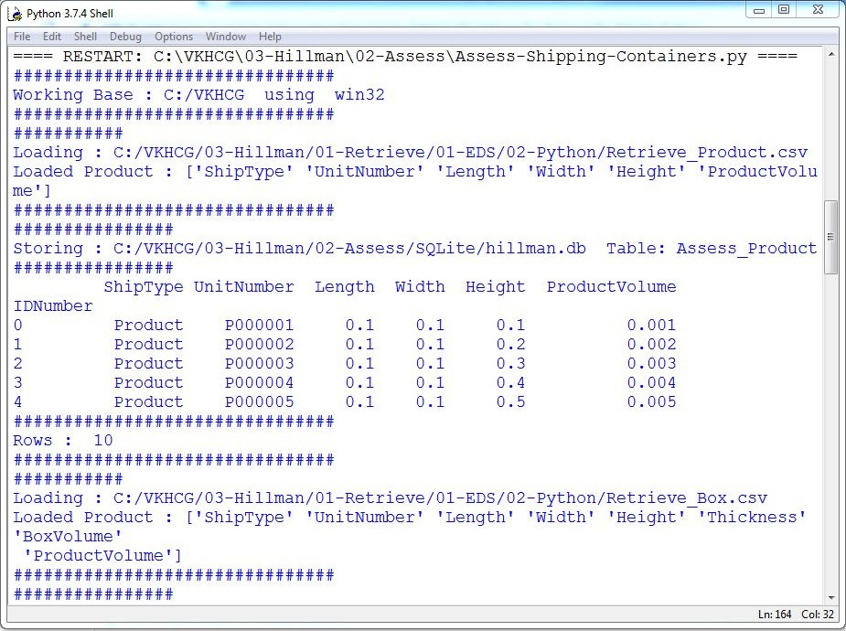

sSQL=sSQL+ " Assess_Pallet_in_Container_Width_SnapShot as CW" sSQL=sSQL+ " ON"

sSQL=sSQL+ " CL.ContainerNumber = CW.ContainerNumber" sSQL=sSQL+ " AND"

sSQL=sSQL+ " CL.PalletNumber = CW.PalletNumber" sSQL=sSQL+ " AND"

sSQL=sSQL+ " CL.BoxNumber = CW.BoxNumber" sSQL=sSQL+ " JOIN"

sSQL=sSQL+ " Assess_Pallet_in_Container_Height_SnapShot as CH" sSQL=sSQL+ " ON"

sSQL=sSQL+ " CL.ContainerNumber = CH.ContainerNumber" sSQL=sSQL+ " AND"

sSQL=sSQL+ " CL.PalletNumber = CH.PalletNumber" sSQL=sSQL+ " AND"

sSQL=sSQL+ " CL.BoxNumber = CH.BoxNumber;" sql.execute(sSQL,conn)

################################################################

sTables=['Assess_Product_in_Box','Assess_Pallet_in_Container'] for sTable in sTables:

print('################')

print('Loading :',sDatabaseName,' Table:',sTable) sSQL=" SELECT "

sSQL=sSQL+ " *" sSQL=sSQL+ " FROM"

sSQL=sSQL+ " " + sTable + ";" PackData=pd.read_sql_query(sSQL, conn) print('################')

print(PackData) print('################')

print('################################')

print('Rows : ',PackData.shape[0]) print('################################')

sFileName=sFileDir + '/' + sTable + '.csv' print(sFileName) PackData.to_csv(sFileName, index = False)

print('### Done!! ############################################') ################################################################

1. **Write a Python program to create a delivery route using the given data.**

###### Creating a Delivery Route

Hillman requires the complete grid plan of the delivery routes for the company, to ensure the suppliers, warehouses, shops, and customers can be reached by its new strategy. This new plan will enable the optimum routes between suppliers, warehouses, shops, and customers.

Open Python editor and create a file named Assess-Shipping-Routes.py in directory C:\VKHCG\03-Hillman\02-Assess.

################################################################

# -*- coding: utf-8 -*- ################################################################

import sys import os

import pandas as pd import sqlite3 as sq

from pandas.io import sql import networkx as nx

from geopy.distance import vincenty ################################################################

nMax=3 nMaxPath=10 nSet=False nVSet=False

################################################################ Base='C:/VKHCG' ################################################################ print('################################')

print('Working Base :',Base, ' using ', sys.platform) print('################################') ################################################################

Company='03-Hillman'

InputDir1='01-Retrieve/01-EDS/01-R' InputDir2='01-Retrieve/01-EDS/02-Python'

InputFileName1='Retrieve_GB_Postcode_Warehouse.csv' InputFileName2='Retrieve_GB_Postcodes_Shops.csv' EDSDir='02-Assess/01-EDS'

OutputDir=EDSDir + '/02-Python' OutputFileName1='Assess_Shipping_Routes.gml' OutputFileName2='Assess_Shipping_Routes.txt' ################################################################

sFileDir=Base + '/' + Company + '/' + EDSDir if not os.path.exists(sFileDir):

os.makedirs(sFileDir) ################################################################

sFileDir=Base + '/' + Company + '/' + OutputDir if not os.path.exists(sFileDir):

os.makedirs(sFileDir) ################################################################

sDataBaseDir=Base + '/' + Company + '/02-Assess/SQLite' if not os.path.exists(sDataBaseDir):

os.makedirs(sDataBaseDir) ################################################################

sDatabaseName=sDataBaseDir + '/hillman.db' conn = sq.connect(sDatabaseName)

################################################################ ################################################################

### Import Warehouse Data ################################################################

sFileName=Base + '/' + Company + '/' + InputDir1 + '/' + InputFileName1 print('###########')

print('Loading :',sFileName) WarehouseRawData=pd.read_csv(sFileName,

header=0, low_memory=False, encoding="latin-1"

)

WarehouseRawData.drop_duplicates(subset=None, keep='first', inplace=True) WarehouseRawData.index.name = 'IDNumber' WarehouseData=WarehouseRawData.head(nMax) WarehouseData=WarehouseData.append(WarehouseRawData.tail(nMax))

WarehouseData=WarehouseData.append(WarehouseRawData[WarehouseRawData.postcode=='KA13']) if nSet==True:

WarehouseData=WarehouseData.append(WarehouseRawData[WarehouseRawData.postcode=='SW1W']) WarehouseData.drop_duplicates(subset=None, keep='first', inplace=True)

print('Loaded Warehouses :',WarehouseData.columns.values) print('################################') ################################################################ print('################')

sTable='Assess_Warehouse_UK'

print('Storing :',sDatabaseName,' Table:',sTable) WarehouseData.to_sql(sTable, conn, if_exists="replace") print('################') ################################################################

print(WarehouseData.head()) print('################################')

print('Rows : ',WarehouseData.shape[0]) print('################################') ################################################################

### Import Shop Data ################################################################

sFileName=Base + '/' + Company + '/' + InputDir1 + '/' + InputFileName2 print('###########')

print('Loading :',sFileName) ShopRawData=pd.read_csv(sFileName,

header=0, low_memory=False, encoding="latin-1"

)

ShopRawData.drop_duplicates(subset=None, keep='first', inplace=True) ShopRawData.index.name = 'IDNumber'

ShopData=ShopRawData

print('Loaded Shops :',ShopData.columns.values)

print('################################') ################################################################ print('################')

sTable='Assess_Shop_UK'

print('Storing :',sDatabaseName,' Table:',sTable) ShopData.to_sql(sTable, conn, if_exists="replace") print('################')

################################################################

print(ShopData.head()) print('################################')

print('Rows : ',ShopData.shape[0]) print('################################') ################################################################

### Connect HQ ################################################################ print('################')

sView='Assess_HQ'

print('Creating :',sDatabaseName,' View:',sView) sSQL="DROP VIEW IF EXISTS " + sView + ";"

sql.execute(sSQL,conn)

sSQL="CREATE VIEW " + sView + " AS" sSQL=sSQL+ " SELECT"

sSQL=sSQL+ " W.postcode AS HQ_PostCode," sSQL=sSQL+ " 'HQ-' || W.postcode AS HQ_Name," sSQL=sSQL+ " round(W.latitude,6) AS HQ_Latitude," sSQL=sSQL+ " round(W.longitude,6) AS HQ_Longitude" sSQL=sSQL+ " FROM"

sSQL=sSQL+ " Assess_Warehouse_UK as W" sSQL=sSQL+ " WHERE"

sSQL=sSQL+ " TRIM(W.postcode) in ('KA13','SW1W');"

sql.execute(sSQL,conn) ################################################################

### Connect Warehouses ################################################################ print('################')

sView='Assess_Warehouse'

print('Creating :',sDatabaseName,' View:',sView) sSQL="DROP VIEW IF EXISTS " + sView + ";"

sql.execute(sSQL,conn)

sSQL="CREATE VIEW " + sView + " AS" sSQL=sSQL+ " SELECT"

sSQL=sSQL+ " W.postcode AS Warehouse_PostCode," sSQL=sSQL+ " 'WH-' || W.postcode AS Warehouse_Name," sSQL=sSQL+ " round(W.latitude,6) AS Warehouse_Latitude," sSQL=sSQL+ " round(W.longitude,6) AS Warehouse_Longitude" sSQL=sSQL+ " FROM"

sSQL=sSQL+ " Assess_Warehouse_UK as W;" sql.execute(sSQL,conn)

################################################################

### Connect Warehouse to Shops by PostCode

-################################################################

print('################')

sView='Assess_Shop'

print('Creating :',sDatabaseName,' View:',sView) sSQL="DROP VIEW IF EXISTS " + sView + ";"

sql.execute(sSQL,conn)

sSQL="CREATE VIEW " + sView + " AS" sSQL=sSQL+ " SELECT"

sSQL=sSQL+ " TRIM(S.postcode) AS Shop_PostCode,"

sSQL=sSQL+ " 'SP-' || TRIM(S.FirstCode) || '-' || TRIM(S.SecondCode) AS Shop_Name," sSQL=sSQL+ " TRIM(S.FirstCode) AS Warehouse_PostCode,"

sSQL=sSQL+ " round(S.latitude,6) AS Shop_Latitude," sSQL=sSQL+ " round(S.longitude,6) AS Shop_Longitude" sSQL=sSQL+ " FROM"

sSQL=sSQL+ " Assess_Warehouse_UK as W" sSQL=sSQL+ " JOIN"

sSQL=sSQL+ " Assess_Shop_UK as S" sSQL=sSQL+ " ON"

sSQL=sSQL+ " TRIM(W.postcode) = TRIM(S.FirstCode);" sql.execute(sSQL,conn) ################################################################ ################################################################

G=nx.Graph() ################################################################ print('################')

sTable = 'Assess_HQ'

print('Loading :',sDatabaseName,' Table:',sTable) sSQL=" SELECT DISTINCT"

sSQL=sSQL+ " *" sSQL=sSQL+ " FROM"

sSQL=sSQL+ " " + sTable + ";" RouteData=pd.read_sql_query(sSQL, conn) print('################')

################################################################

print(RouteData.head()) print('################################')

print('HQ Rows : ',RouteData.shape[0]) print('################################') ################################################################

for i in range(RouteData.shape[0]): sNode0=RouteData['HQ_Name'][i] G.add_node(sNode0,

Nodetype='HQ', PostCode=RouteData['HQ_PostCode'][i], Latitude=round(RouteData['HQ_Latitude'][i],6), Longitude=round(RouteData['HQ_Longitude'][i],6))

################################################################ print('################')

sTable = 'Assess_Warehouse'

print('Loading :',sDatabaseName,' Table:',sTable) sSQL=" SELECT DISTINCT"

sSQL=sSQL+ " *" sSQL=sSQL+ " FROM"

sSQL=sSQL+ " " + sTable + ";" RouteData=pd.read_sql_query(sSQL, conn) print('################')

################################################################

print(RouteData.head()) print('################################')

print('Warehouse Rows : ',RouteData.shape[0]) print('################################')

for i in range(RouteData.shape[0]): sNode0=RouteData['Warehouse_Name'][i] G.add_node(sNode0,

Nodetype='Warehouse', PostCode=RouteData['Warehouse_PostCode'][i], Latitude=round(RouteData['Warehouse_Latitude'][i],6), Longitude=round(RouteData['Warehouse_Longitude'][i],6))

print('################')

sTable = 'Assess_Shop'

print('Loading :',sDatabaseName,' Table:',sTable) sSQL=" SELECT DISTINCT"

sSQL=sSQL+ " *" sSQL=sSQL+ " FROM"

sSQL=sSQL+ " " + sTable + ";" RouteData=pd.read_sql_query(sSQL, conn) print('################')

print(RouteData.head()) print('################################')

print('Shop Rows : ',RouteData.shape[0]) print('################################')

for i in range(RouteData.shape[0]): sNode0=RouteData['Shop_Name'][i] G.add_node(sNode0,

Nodetype='Shop', PostCode=RouteData['Shop_PostCode'][i], WarehousePostCode=RouteData['Warehouse_PostCode'][i], Latitude=round(RouteData['Shop_Latitude'][i],6), Longitude=round(RouteData['Shop_Longitude'][i],6))

################################################################

## Create Edges ################################################################ print('################################')

print('Loading Edges') print('################################')

for sNode0 in nx.nodes_iter(G): for sNode1 in nx.nodes_iter(G):

if G.node[sNode0]['Nodetype']=='HQ' and \ G.node[sNode1]['Nodetype']=='HQ' and \ sNode0 != sNode1:

distancemeters=round(\

vincenty(\

(\

G.node[sNode0]['Latitude'],\ G.node[sNode0]['Longitude']\

,0)

),\ (\

G.node[sNode1]['Latitude']\

,\ G.node[sNode1]['Longitude']\

)\

).meters\

distancemiles=round(\

vincenty(\

(\

G.node[sNode0]['Latitude'],\ G.node[sNode0]['Longitude']\

),\ (\

G.node[sNode1]['Latitude']\

,\ G.node[sNode1]['Longitude']\

)\

).miles\

,3)

if distancemiles >= 0.05:

cost = round(150+(distancemiles * 2.5),6) vehicle='V001'

else:

cost = round(2+(distancemiles * 0.10),6) vehicle='ForkLift'

G.add_edge(sNode0,sNode1,DistanceMeters=distancemeters, \ DistanceMiles=distancemiles, \ Cost=cost,Vehicle=vehicle)

if nVSet==True:

print('Edge-H-H:',sNode0,' to ', sNode1, \ ' Distance:',distancemeters,'meters',\

distancemiles,'miles','Cost', cost,'Vehicle',vehicle)

if G.node[sNode0]['Nodetype']=='HQ' and \ G.node[sNode1]['Nodetype']=='Warehouse' and \ sNode0 != sNode1:

distancemeters=round(\

vincenty(\

(\

G.node[sNode0]['Latitude'],\ G.node[sNode0]['Longitude']\

),\ (\

G.node[sNode1]['Latitude']\

,\ G.node[sNode1]['Longitude']\

)\

).meters\

,0)

distancemiles=round(\

vincenty(\

(\

G.node[sNode0]['Latitude'],\ G.node[sNode0]['Longitude']\

),\ (\

G.node[sNode1]['Latitude']\

,\ G.node[sNode1]['Longitude']\

)\

).miles\

,3)

if distancemiles >= 10:

cost = round(50+(distancemiles * 2),6) vehicle='V002'

else:

cost = round(5+(distancemiles * 1.5),6) vehicle='V003'

if distancemiles <= 50: G.add_edge(sNode0,sNode1,DistanceMeters=distancemeters, \

DistanceMiles=distancemiles, \ Cost=cost,Vehicle=vehicle)

if nVSet==True:

print('Edge-H-W:',sNode0,' to ', sNode1, \ ' Distance:',distancemeters,'meters',\

distancemiles,'miles','Cost', cost,'Vehicle',vehicle)

if nSet==True and \ G.node[sNode0]['Nodetype']=='Warehouse' and \ G.node[sNode1]['Nodetype']=='Warehouse' and \ sNode0 != sNode1:

distancemeters=round(\

vincenty(\

(\

G.node[sNode0]['Latitude'],\ G.node[sNode0]['Longitude']\

),\ (\

G.node[sNode1]['Latitude']\

,\ G.node[sNode1]['Longitude']\

)\

).meters\

,0)

distancemiles=round(\

vincenty(\

(\

G.node[sNode0]['Latitude'],\ G.node[sNode0]['Longitude']\

),\ (\

G.node[sNode1]['Latitude']\

,3)

,\ G.node[sNode1]['Longitude']\

)\

).miles\

if distancemiles >= 10:

cost = round(50+(distancemiles * 1.10),6) vehicle='V004'

else:

cost = round(5+(distancemiles * 1.05),6) vehicle='V005'

if distancemiles <= 20: G.add_edge(sNode0,sNode1,DistanceMeters=distancemeters, \

DistanceMiles=distancemiles, \ Cost=cost,Vehicle=vehicle)

if nVSet==True:

print('Edge-W-W:',sNode0,' to ', sNode1, \ ' Distance:',distancemeters,'meters',\

distancemiles,'miles','Cost', cost,'Vehicle',vehicle)

if G.node[sNode0]['Nodetype']=='Warehouse' and \ G.node[sNode1]['Nodetype']=='Shop' and \ G.node[sNode0]['PostCode']==G.node[sNode1]['WarehousePostCode'] and \ sNode0 != sNode1:

distancemeters=round(\

vincenty(\

(\

G.node[sNode0]['Latitude'],\ G.node[sNode0]['Longitude']\

),\ (\

G.node[sNode1]['Latitude']\

,\ G.node[sNode1]['Longitude']\

)\

).meters\

,0)

distancemiles=round(\

vincenty(\

(\

G.node[sNode0]['Latitude'],\ G.node[sNode0]['Longitude']\

),\ (\

G.node[sNode1]['Latitude']\

,\ G.node[sNode1]['Longitude']\

)\

).miles\

,3)

if distancemiles >= 10:

cost = round(50+(distancemiles * 1.50),6) vehicle='V006'

else:

cost = round(5+(distancemiles * 0.75),6) vehicle='V007'

if distancemiles <= 10: G.add_edge(sNode0,sNode1,DistanceMeters=distancemeters, \

DistanceMiles=distancemiles, \ Cost=cost,Vehicle=vehicle)

if nVSet==True:

print('Edge-W-S:',sNode0,' to ', sNode1, \ ' Distance:',distancemeters,'meters',\

distancemiles,'miles','Cost', cost,'Vehicle',vehicle)

if nSet==True and \ G.node[sNode0]['Nodetype']=='Shop' and \ G.node[sNode1]['Nodetype']=='Shop' and \

G.node[sNode0]['WarehousePostCode']==G.node[sNode1]['WarehousePostCode'] and \ sNode0 != sNode1:

distancemeters=round(\

vincenty(\

(\

G.node[sNode0]['Latitude'],\ G.node[sNode0]['Longitude']\

),\ (\

G.node[sNode1]['Latitude']\

,\ G.node[sNode1]['Longitude']\

)\

).meters\

,0)

distancemiles=round(\

vincenty(\

(\

G.node[sNode0]['Latitude'],\ G.node[sNode0]['Longitude']\

),\ (\

G.node[sNode1]['Latitude']\

,\ G.node[sNode1]['Longitude']\

)\

).miles\

,3)

if distancemiles >= 0.05:

cost = round(5+(distancemiles * 0.5),6) vehicle='V008'

else:

cost = round(1+(distancemiles * 0.1),6) vehicle='V009'

if distancemiles <= 0.075: G.add_edge(sNode0,sNode1,DistanceMeters=distancemeters, \

DistanceMiles=distancemiles, \ Cost=cost,Vehicle=vehicle)

if nVSet==True:

print('Edge-S-S:',sNode0,' to ', sNode1, \ ' Distance:',distancemeters,'meters',\

distancemiles,'miles','Cost', cost,'Vehicle',vehicle)

if nSet==True and \ G.node[sNode0]['Nodetype']=='Shop' and \ G.node[sNode1]['Nodetype']=='Shop' and \

G.node[sNode0]['WarehousePostCode']!=G.node[sNode1]['WarehousePostCode'] and \ sNode0 != sNode1:

distancemeters=round(\

vincenty(\

(\

G.node[sNode0]['Latitude'],\ G.node[sNode0]['Longitude']\

),\ (\

G.node[sNode1]['Latitude']\

,\ G.node[sNode1]['Longitude']\

)\

).meters\

,0)

distancemiles=round(\

vincenty(\

(\

G.node[sNode0]['Latitude'],\ G.node[sNode0]['Longitude']\

),\ (\

G.node[sNode1]['Latitude']\

,\ G.node[sNode1]['Longitude']\

)\

).miles\

,3)

cost = round(1+(distancemiles * 0.1),6) vehicle='V010'

if distancemiles <= 0.025: G.add_edge(sNode0,sNode1,DistanceMeters=distancemeters, \

DistanceMiles=distancemiles, \ Cost=cost,Vehicle=vehicle)

if nVSet==True:

print('Edge-S-S:',sNode0,' to ', sNode1, \ ' Distance:',distancemeters,'meters',\

distancemiles,'miles','Cost', cost,'Vehicle',vehicle) sFileName=sFileDir + '/' + OutputFileName1 print('################################')

print('Storing :', sFileName) print('################################')

nx.write_gml(G,sFileName) sFileName=sFileName +'.gz' nx.write_gml(G,sFileName) print('Nodes:',nx.number_of_nodes(G)) print('Edges:',nx.number_of_edges(G)) sFileName=sFileDir + '/' + OutputFileName2 print('################################')

print('Storing :', sFileName) print('################################')

## Create Paths print('################################')

print('Loading Paths') print('################################')

f = open(sFileName,'w') l=0

sline = 'ID|Cost|StartAt|EndAt|Path|Measure' if nVSet==True: print ('0', sline) f.write(sline+ '\n')

for sNode0 in nx.nodes_iter(G): for sNode1 in nx.nodes_iter(G):

if sNode0 != sNode1 and \

nx.has_path(G, sNode0, sNode1)==True and \ nx.shortest_path_length(G, \

source=sNode0, \ target=sNode1, \

weight='DistanceMiles') < nMaxPath: l+=1

sID='{:.0f}'.format(l)

spath = ','.join(nx.shortest_path(G, \ source=sNode0, \

target=sNode1, \ weight='DistanceMiles')) slength= '{:.6f}'.format(\ nx.shortest_path_length(G, \ source=sNode0, \ target=sNode1, \ weight='DistanceMiles'))

sline = sID + '|"DistanceMiles"|"' + sNode0 + '"|"' \

+ sNode1 + '"|"' + spath + '"|' + slength if nVSet==True: print (sline) f.write(sline + '\n')

l+=1

sID='{:.0f}'.format(l)

spath = ','.join(nx.shortest_path(G, \ source=sNode0, \

target=sNode1, \ weight='DistanceMeters')) slength= '{:.6f}'.format(\

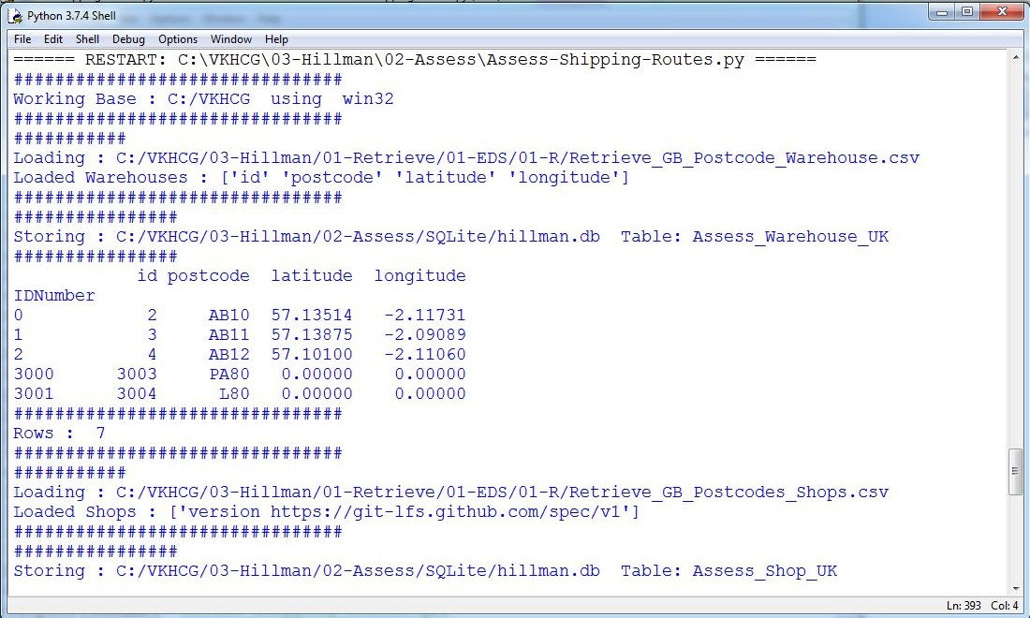

nx.shortest_path_length(G, \ source=sNode0, \ target=sNode1, \ weight='DistanceMeters'))

sline = sID + '|"DistanceMeters"|"' + sNode0 + '"|"' \

+ sNode1 + '"|"' + spath + '"|' + slength if nVSet==True: print (sline) f.write(sline + '\n')

l+=1

sID='{:.0f}'.format(l)

spath = ','.join(nx.shortest_path(G, \ source=sNode0, \

target=sNode1, \ weight='Cost'))

slength= '{:.6f}'.format(\ nx.shortest_path_length(G, \ source=sNode0, \ target=sNode1, \ weight='Cost'))

sline = sID + '|"Cost"|"' + sNode0 + '"|"' \

+ sNode1 + '"|"' + spath + '"|' + slength if nVSet==True: print (sline) f.write(sline + '\n')

f.close()

print('Nodes:',nx.number_of_nodes(G)) print('Edges:',nx.number_of_edges(G)) print('Paths:',sID) print('################')

print('Vacuum Database') sSQL="VACUUM;"

sql.execute(sSQL,conn) print('################')

print('### Done!! ############################################'

#### Clark Ltd

Clark

Ltd

is the

accountancy

company

that

handles

everything

related

to the

VKHCG’s

finances

and

personnel. Let’s investigate Clark with new knowledge.

**K. Write a Python program to create Simple forex trading planner from the given data.**

###### Simple Forex Trading Planner

Clark requires the assessment of the group’s forex data, for processing and data qualityissues. I will guide you through an example of a forex solution.

Open your Python editor and create a file named Assess-Forex.py in directory C:\VKHCG\04-Clark\02-Assess.

################################################################

import sys import os

import sqlite3 as sq import pandas as pd

################################################################ Base='C:/VKHCG'

print('################################')

print('Working Base :',Base, ' using ', sys.platform) print('################################') ################################################################

Company='04-Clark'

sInputFileName1='01-Vermeulen/01-Retrieve/01-EDS/02-Python/Retrieve-Country-Currency.csv' sInputFileName2='04-Clark/01-Retrieve/01-EDS/01-R/Retrieve_Euro_EchangeRates.csv' ################################################################

sDataBaseDir=Base + '/' + Company + '/02-Assess/SQLite' if not os.path.exists(sDataBaseDir):

os.makedirs(sDataBaseDir) ################################################################

sDatabaseName=sDataBaseDir + '/clark.db' conn = sq.connect(sDatabaseName)

################################################################

### Import Country Data ################################################################

sFileName1=Base + '/' + sInputFileName1 print('################################')

print('Loading :',sFileName1) print('################################')

CountryRawData=pd.read_csv(sFileName1,header=0,low_memory=False, encoding="latin-1") CountryRawData.drop_duplicates(subset=None, keep='first', inplace=True)

CountryData=CountryRawData

print('Loaded Company :',CountryData.columns.values) print('################################') ################################################################ print('################')

sTable='Assess_Country'

print('Storing :',sDatabaseName,' Table:',sTable) CountryData.to_sql(sTable, conn, if_exists="replace")

print('################') ################################################################

print(CountryData.head()) print('################################')

print('Rows : ',CountryData.shape[0]) print('################################') ################################################################

### Import Forex Data ################################################################

sFileName2=Base + '/' + sInputFileName2 print('################################')

print('Loading :',sFileName2) print('################################')

ForexRawData=pd.read_csv(sFileName2,header=0,low_memory=False, encoding="latin-1") ForexRawData.drop_duplicates(subset=None, keep='first', inplace=True) ForexData=ForexRawData.head(5)

print('Loaded Company :',ForexData.columns.values) print('################################') ################################################################ print('################')

sTable='Assess_Forex'

print('Storing :',sDatabaseName,' Table:',sTable) ForexData.to_sql(sTable, conn, if_exists="replace") print('################')

################################################################

print(ForexData.head()) print('################################')

print('Rows : ',ForexData.shape[0]) print('################################') ################################################################ print('################')

sTable='Assess_Forex'

print('Loading :',sDatabaseName,' Table:',sTable) sSQL="select distinct"

sSQL=sSQL+ " A.CodeIn" sSQL=sSQL+ " from"

sSQL=sSQL+ " Assess_Forex as A;" CodeData=pd.read_sql_query(sSQL, conn) print('################')

################################################################

for c in range(CodeData.shape[0]): print('################')

sTable='Assess_Forex & 2x Country > ' + CodeData['CodeIn'][c] print('Loading :',sDatabaseName,' Table:',sTable)

sSQL="select distinct" sSQL=sSQL+ " A.Date," sSQL=sSQL+ " A.CodeIn,"

sSQL=sSQL+ " B.Country as CountryIn," sSQL=sSQL+ " B.Currency as CurrencyNameIn," sSQL=sSQL+ " A.CodeOut,"

sSQL=sSQL+ " C.Country as CountryOut," sSQL=sSQL+ " C.Currency as CurrencyNameOut,"

sSQL=sSQL+ " A.Rate"

sSQL=sSQL+ " from" sSQL=sSQL+ " Assess_Forex as A" sSQL=sSQL+ " JOIN"

sSQL=sSQL+ " Assess_Country as B" sSQL=sSQL+ " ON A.CodeIn = B.CurrencyCode" sSQL=sSQL+ " JOIN"

sSQL=sSQL+ " Assess_Country as C" sSQL=sSQL+ " ON A.CodeOut = C.CurrencyCode" sSQL=sSQL+ " WHERE"

sSQL=sSQL+ " A.CodeIn ='" + CodeData['CodeIn'][c] + "';" ForexData=pd.read_sql_query(sSQL, conn).head(1000) print('################')

print(ForexData) print('################')

sTable='Assess_Forex_' + CodeData['CodeIn'][c] print('Storing :',sDatabaseName,' Table:',sTable) ForexData.to_sql(sTable, conn, if_exists="replace") print('################') print('################################')

print('Rows : ',ForexData.shape[0]) print('################################')

################################################################ print('### Done!! ############################################') ################################################################

**Output:**

This will produce a set of demonstrated values onscreen by removing duplicate records and other related data processing.

**L. Write a Python program to process the balance sheet to ensure that only good data is processing.**

###### Financials

Clark requires you to process the balance sheet for the VKHCG group companies. Go through a sample balance sheet data assessment, to ensure that only the good data is processed.

Open Python editor and create a file named Assess-Financials.py in directory C:\VKHCG\04-Clark\02-Assess. ################################################################

import sys import os

import sqlite3 as sq import pandas as pd

################################################################

if sys.platform == 'linux': Base=os.path.expanduser('~') + '/VKHCG'

else:

Base='C:/VKHCG' print('################################')

print('Working Base :',Base, ' using ', sys.platform) print('################################') ################################################################

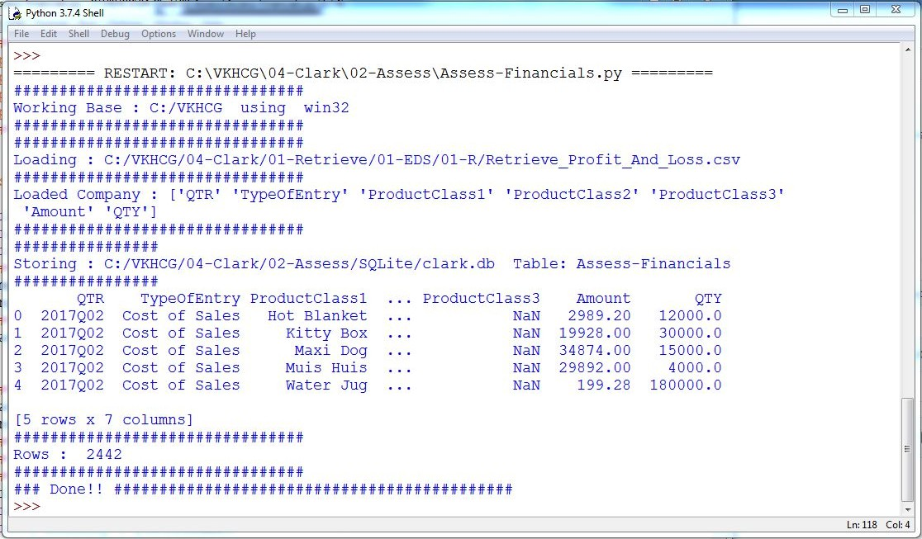

Company='04-Clark'

sInputFileName='01-Retrieve/01-EDS/01-R/Retrieve_Profit_And_Loss.csv' ################################################################

sDataBaseDir=Base + '/' + Company + '/02-Assess/SQLite' if not os.path.exists(sDataBaseDir):

os.makedirs(sDataBaseDir) ################################################################

sDatabaseName=sDataBaseDir + '/clark.db' conn = sq.connect(sDatabaseName)

################################################################

### Import Financial Data ################################################################

sFileName=Base + '/' + Company + '/' + sInputFileName print('################################')

print('Loading :',sFileName) print('################################')

FinancialRawData=pd.read_csv(sFileName,header=0,low_memory=False, encoding="latin-1")

FinancialData=FinancialRawData

print('Loaded Company :',FinancialData.columns.values) print('################################') ################################################################ print('################')

sTable='Assess-Financials'

print('Storing :',sDatabaseName,' Table:',sTable) FinancialData.to_sql(sTable, conn, if_exists="replace") print('################')

################################################################

print(FinancialData.head()) print('################################')

print('Rows : ',FinancialData.shape[0]) print('################################') ################################################################ ################################################################ print('### Done!! ############################################') ################################################################

**Write a Python program to store all master records for the financial calendar**

###### Financial Calendar

Clark stores all the master records for the financial calendar. So we import thecalendar from the retrieve step’s data storage.

Open Python editor and create a file named Assess-Calendar.py in directory C:\VKHCG\04-Clark\02-Assess.

################################################################

import sys import os

import sqlite3 as sq import pandas as pd

################################################################

if sys.platform == 'linux': Base=os.path.expanduser('~') + '/VKHCG'

else:

Base='C:/VKHCG' print('################################')

print('Working Base :',Base, ' using ', sys.platform) print('################################') ################################################################

Company='04-Clark' ################################################################

sDataBaseDirIn=Base + '/' + Company + '/01-Retrieve/SQLite' if not os.path.exists(sDataBaseDirIn):

os.makedirs(sDataBaseDirIn) sDatabaseNameIn=sDataBaseDirIn + '/clark.db' connIn = sq.connect(sDatabaseNameIn)

################################################################

sDataBaseDirOut=Base + '/' + Company + '/01-Retrieve/SQLite' if not os.path.exists(sDataBaseDirOut):

os.makedirs(sDataBaseDirOut) sDatabaseNameOut=sDataBaseDirOut + '/clark.db' connOut = sq.connect(sDatabaseNameOut)

################################################################

sTableIn='Retrieve_Date'

sSQL='select * FROM ' + sTableIn + ';' print('################')

sTableOut='Assess_Time'

print('Loading :',sDatabaseNameIn,' Table:',sTableIn) dateRawData=pd.read_sql_query(sSQL, connIn) dateData=dateRawData

################################################################ print('################################')

print('Load Rows : ',dateRawData.shape[0], ' records') print('################################')

dateData.drop_duplicates(subset='FinDate', keep='first', inplace=True) ################################################################ print('################')

sTableOut='Assess_Date'

print('Storing :',sDatabaseNameOut,' Table:',sTableOut)

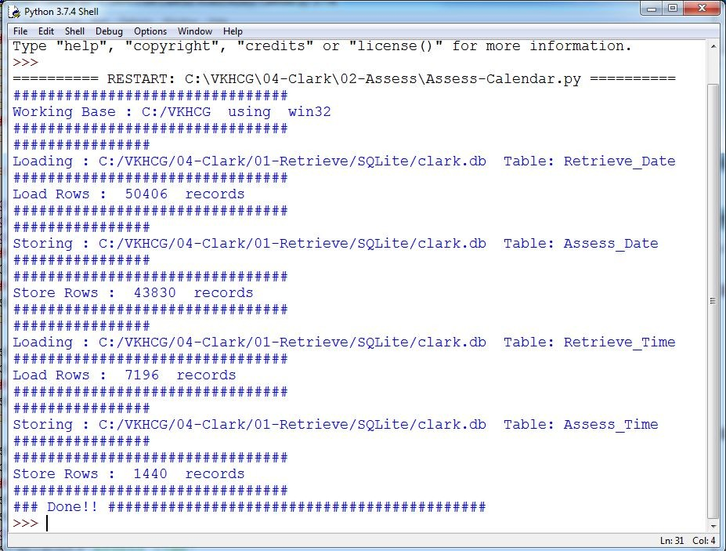

dateData.to_sql(sTableOut, connOut, if_exists="replace") print('################') ################################################################ print('################################')

print('Store Rows : ',dateData.shape[0], ' records') print('################################') ################################################################ ################################################################

sTableIn='Retrieve_Time' sSQL='select * FROM ' + sTableIn + ';' print('################')

sTableOut='Assess_Time'

print('Loading :',sDatabaseNameIn,' Table:',sTableIn) timeRawData=pd.read_sql_query(sSQL, connIn) timeData=timeRawData

################################################################ print('################################')

print('Load Rows : ',timeData.shape[0], ' records') print('################################')

timeData.drop_duplicates(subset=None, keep='first', inplace=True) ################################################################ print('################')

sTableOut='Assess_Time'

print('Storing :',sDatabaseNameOut,' Table:',sTableOut) timeData.to_sql(sTableOut, connOut, if_exists="replace") print('################') ################################################################ print('################################')

print('Store Rows : ',timeData.shape[0], ' records') print('################################') ################################################################ print('### Done!! ############################################') ################################################################

**M. Write a Python program to generate payroll from the given data.**

###### People

Clark Ltd generates the payroll, so it holds all the staff records. Clark also handles all payments to suppliers and receives payments from customers’ details on all companies.

Open Python editor and create a file named Assess-People.py in directory C:\VKHCG\04-Clark\02-Assess.

################################################################

import sys import os

import sqlite3 as sq import pandas as pd

################################################################ Base='C:/VKHCG'

print('################################')

print('Working Base :',Base, ' using ', sys.platform) print('################################') ################################################################

Company='04-Clark'

sInputFileName1='01-Retrieve/01-EDS/02-Python/Retrieve-Data_female-names.csv' sInputFileName2='01-Retrieve/01-EDS/02-Python/Retrieve-Data_male-names.csv' sInputFileName3='01-Retrieve/01-EDS/02-Python/Retrieve-Data_last-names.csv' sOutputFileName1='Assess-Staff.csv'

sOutputFileName2='Assess-Customers.csv' ################################################################

sDataBaseDir=Base + '/' + Company + '/02-Assess/SQLite' if not os.path.exists(sDataBaseDir):

os.makedirs(sDataBaseDir) ################################################################

sDatabaseName=sDataBaseDir + '/clark.db' conn = sq.connect(sDatabaseName)

################################################################

### Import Female Data ################################################################

sFileName=Base + '/' + Company + '/' + sInputFileName1 print('################################')

print('Loading :',sFileName) print('################################')

print(sFileName)

FemaleRawData=pd.read_csv(sFileName,header=0,low_memory=False, encoding="latin-1") FemaleRawData.rename(columns={'NameValues' : 'FirstName'},inplace=True) FemaleRawData.drop_duplicates(subset=None, keep='first', inplace=True) FemaleData=FemaleRawData.sample(100)

print('################################') ################################################################ print('################')

sTable='Assess_FemaleName'

print('Storing :',sDatabaseName,' Table:',sTable)

FemaleData.to_sql(sTable, conn, if_exists="replace") print('################') print('################################')

print('Rows : ',FemaleData.shape[0], ' records') print('################################') ################################################################

### Import Male Data

sFileName=Base + '/' + Company + '/' + sInputFileName2 print('################################')

print('Loading :',sFileName) print('################################')

MaleRawData=pd.read_csv(sFileName,header=0,low_memory=False, encoding="latin-1") MaleRawData.rename(columns={'NameValues' : 'FirstName'},inplace=True) MaleRawData.drop_duplicates(subset=None, keep='first', inplace=True) MaleData=MaleRawData.sample(100)

print('################################')

sTable='Assess_MaleName'

print('Storing :',sDatabaseName,' Table:',sTable) MaleData.to_sql(sTable, conn, if_exists="replace") print('################')

################################################################ print('################################')

print('Rows : ',MaleData.shape[0], ' records') print('################################') ################################################################

### Import Surname Data

sFileName=Base + '/' + Company + '/' + sInputFileName3 print('################################')

print('Loading :',sFileName) print('################################')

SurnameRawData=pd.read_csv(sFileName,header=0,low_memory=False, encoding="latin-1") SurnameRawData.rename(columns={'NameValues' : 'LastName'},inplace=True) SurnameRawData.drop_duplicates(subset=None, keep='first', inplace=True) SurnameData=SurnameRawData.sample(200)

print('################')

sTable='Assess_Surname'

print('Storing :',sDatabaseName,' Table:',sTable) SurnameData.to_sql(sTable, conn, if_exists="replace") print('################') print('################################')

print('Rows : ',SurnameData.shape[0], ' records') print('################################') print('################')

sTable='Assess_FemaleName & Assess_MaleName' print('Loading :',sDatabaseName,' Table:',sTable) sSQL="select distinct"

sSQL=sSQL+ " A.FirstName," sSQL=sSQL+ " 'Female' as Gender"

sSQL=sSQL+ " from"

sSQL=sSQL+ " Assess_FemaleName as A" sSQL=sSQL+ " UNION"

sSQL=sSQL+ " select distinct" sSQL=sSQL+ " A.FirstName," sSQL=sSQL+ " 'Male' as Gender" sSQL=sSQL+ " from"

sSQL=sSQL+ " Assess_MaleName as A;" FirstNameData=pd.read_sql_query(sSQL, conn) print('################')

################################################################# #print('################')

sTable='Assess_FirstName'

print('Storing :',sDatabaseName,' Table:',sTable) FirstNameData.to_sql(sTable, conn, if_exists="replace") print('################')

################################################################ ################################################################ print('################')

sTable='Assess_FirstName x2 & Assess_Surname' print('Loading :',sDatabaseName,' Table:',sTable) sSQL="select distinct"

sSQL=sSQL+ " A.FirstName,"

sSQL=sSQL+ " B.FirstName AS SecondName," sSQL=sSQL+ " C.LastName,"

sSQL=sSQL+ " A.Gender" sSQL=sSQL+ " from"

sSQL=sSQL+ " Assess_FirstName as A" sSQL=sSQL+ " ,"

sSQL=sSQL+ " Assess_FirstName as B" sSQL=sSQL+ " ,"

sSQL=sSQL+ " Assess_Surname as C" sSQL=sSQL+ " WHERE"

sSQL=sSQL+ " A.Gender = B.Gender" sSQL=sSQL+ " AND"

sSQL=sSQL+ " A.FirstName <> B.FirstName;" PeopleRawData=pd.read_sql_query(sSQL, conn) People1Data=PeopleRawData.sample(10000)

sTable='Assess_FirstName & Assess_Surname' print('Loading :',sDatabaseName,' Table:',sTable) sSQL="select distinct"

sSQL=sSQL+ " A.FirstName," sSQL=sSQL+ " '' AS SecondName," sSQL=sSQL+ " B.LastName," sSQL=sSQL+ " A.Gender" sSQL=sSQL+ " from"

sSQL=sSQL+ " Assess_FirstName as A"

sSQL=sSQL+ " ,"

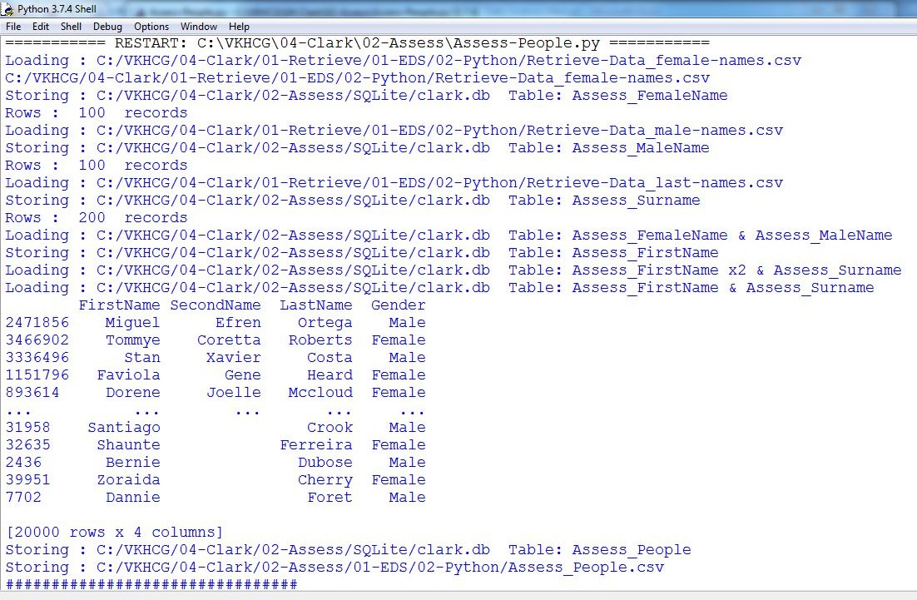

sSQL=sSQL+ " Assess_Surname as B;" PeopleRawData=pd.read_sql_query(sSQL, conn) People2Data=PeopleRawData.sample(10000) PeopleData=People1Data.append(People2Data) print(PeopleData)

print('################') ################################################################# #print('################')

sTable='Assess_People'

print('Storing :',sDatabaseName,' Table:',sTable) PeopleData.to_sql(sTable, conn, if_exists="replace") print('################')

################################################################

sFileDir=Base + '/' + Company + '/02-Assess/01-EDS/02-Python' if not os.path.exists(sFileDir):

os.makedirs(sFileDir) ################################################################

sOutputFileName = sTable+'.csv' sFileName=sFileDir + '/' + sOutputFileName print('################################')

print('Storing :', sFileName) print('################################')

PeopleData.to_csv(sFileName, index = False) print('################################') ################################################################ print('### Done!! ############################################') ################################################################

**OUTPUT:**

## Practical 6:

**Processing Data**

**A. Build the time hub, links, and satellites.**

Open your Python editor and create a file named Process_Time.py. Save it into directory C:\VKHCG\01-Vermeulen\03-Process. ################################################################

# -*- coding: utf-8 -*- ################################################################

import sys import os

from datetime import datetime from datetime import timedelta

from pytz import timezone, all_timezones import pandas as pd

import sqlite3 as sq

from pandas.io import sql import uuid

pd.options.mode.chained_assignment = None ################################################################

if sys.platform == 'linux': Base=os.path.expanduser('~') + '/VKHCG'

else:

Base='C:/VKHCG' print('################################')

print('Working Base :',Base, ' using ', sys.platform) print('################################') ################################################################

Company='01-Vermeulen' InputDir='00-RawData' InputFileName='VehicleData.csv'

################################################################

sDataBaseDir=Base + '/' + Company + '/03-Process/SQLite' if not os.path.exists(sDataBaseDir):

os.makedirs(sDataBaseDir) ################################################################

sDatabaseName=sDataBaseDir + '/Hillman.db' conn1 = sq.connect(sDatabaseName)

################################################################

sDataVaultDir=Base + '/88-DV'

if not os.path.exists(sDataBaseDir): os.makedirs(sDataBaseDir)

################################################################

sDatabaseName=sDataVaultDir + '/datavault.db' conn2 = sq.connect(sDatabaseName)

################################################################

base = datetime(2018,1,1,0,0,0)

numUnits=10*365*24 ################################################################

date_list = [base - timedelta(hours=x) for x in range(0, numUnits)] t=0

for i in date_list: now_utc=i.replace(tzinfo=timezone('UTC'))

sDateTime=now_utc.strftime("%Y-%m-%d %H:%M:%S") print(sDateTime)

sDateTimeKey=sDateTime.replace(' ','-').replace(':','-') t+=1

IDNumber=str(uuid.uuid4()) TimeLine=[('ZoneBaseKey', ['UTC']),

('IDNumber', [IDNumber]), ('nDateTimeValue', [now_utc]), ('DateTimeValue', [sDateTime]), ('DateTimeKey', [sDateTimeKey])]

if t==1:

TimeFrame = pd.DataFrame.from_items(TimeLine) else:

TimeRow = pd.DataFrame.from_items(TimeLine) TimeFrame = TimeFrame.append(TimeRow)

################################################################

TimeHub=TimeFrame[['IDNumber','ZoneBaseKey','DateTimeKey','DateTimeValue']] TimeHubIndex=TimeHub.set_index(['IDNumber'],inplace=False) ################################################################

TimeFrame.set_index(['IDNumber'],inplace=True) ################################################################

sTable = 'Process-Time'

print('Storing :',sDatabaseName,' Table:',sTable) TimeHubIndex.to_sql(sTable, conn1, if_exists="replace")

################################################################

sTable = 'Hub-Time'

print('Storing :',sDatabaseName,' Table:',sTable) TimeHubIndex.to_sql(sTable, conn2, if_exists="replace")

################################################################

active_timezones=all_timezones z=0

for zone in active_timezones: t=0

for j in range(TimeFrame.shape[0]): now_date=TimeFrame['nDateTimeValue'][j] DateTimeKey=TimeFrame['DateTimeKey'][j] now_utc=now_date.replace(tzinfo=timezone('UTC')) sDateTime=now_utc.strftime("%Y-%m-%d %H:%M:%S") now_zone = now_utc.astimezone(timezone(zone)) sZoneDateTime=now_zone.strftime("%Y-%m-%d %H:%M:%S") print(sZoneDateTime)

t+=1

z+=1

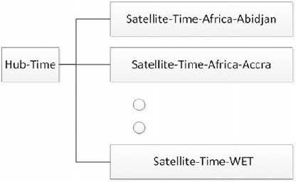

IDZoneNumber=str(uuid.uuid4()) TimeZoneLine=[('ZoneBaseKey', ['UTC']),

('IDZoneNumber', [IDZoneNumber]), ('DateTimeKey', [DateTimeKey]), ('UTCDateTimeValue', [sDateTime]), ('Zone', [zone]),

('DateTimeValue', [sZoneDateTime])]

if t==1:

TimeZoneFrame = pd.DataFrame.from_items(TimeZoneLine) else:

TimeZoneRow = pd.DataFrame.from_items(TimeZoneLine) TimeZoneFrame = TimeZoneFrame.append(TimeZoneRow)

TimeZoneFrameIndex=TimeZoneFrame.set_index(['IDZoneNumber'],inplace=False) sZone=zone.replace('/','-').replace(' ','') #############################################################

sTable = 'Process-Time-'+sZone

print('Storing :',sDatabaseName,' Table:',sTable) TimeZoneFrameIndex.to_sql(sTable, conn1, if_exists="replace")

################################################################# #############################################################

sTable = 'Satellite-Time-'+sZone

print('Storing :',sDatabaseName,' Table:',sTable) TimeZoneFrameIndex.to_sql(sTable, conn2, if_exists="replace")

################################################################# print('################')

print('Vacuum Databases') sSQL="VACUUM;"

sql.execute(sSQL,conn1) sql.execute(sSQL,conn2) print('################')

################################################################# print('### Done!! ############################################') #################################################################

You have built your first hub and satellites for time in the data vault.

The data vault has been built in directory ..\ VKHCG\88-DV\datavault.db. You can access it with your SQLite tools

###### Golden Nominal

A golden nominal record is a single person’s record, with distinctive references for use by all systems. This gives the system a single view of the person. I use first name, other names, last name, and birth date as my golden nominal. The data we have in the assess directory requires a birth date to become a golden nominal. The proram will generate a golden nominal using our sample data set.

Open your Python editor and create a file called Process-People.py in the .. C:\VKHCG\04-Clark\03-Process directory.

################################################################

import sys import os

import sqlite3 as sq import pandas as pd

from pandas.io import sql

from datetime import datetime, timedelta from pytz import timezone, all_timezones from random import randint

import uuid ################################################################

if sys.platform == 'linux': Base=os.path.expanduser('~') + '/VKHCG'

else:

Base='C:/VKHCG' print('################################')

print('Working Base :',Base, ' using ', sys.platform) print('################################') ################################################################

Company='04-Clark'

sInputFileName='02-Assess/01-EDS/02-Python/Assess_People.csv' ################################################################

sDataBaseDir=Base + '/' + Company + '/03-Process/SQLite' if not os.path.exists(sDataBaseDir):

os.makedirs(sDataBaseDir) ################################################################

sDatabaseName=sDataBaseDir + '/clark.db' conn1 = sq.connect(sDatabaseName)

################################################################

sDataVaultDir=Base + '/88-DV'

if not os.path.exists(sDataBaseDir): os.makedirs(sDataBaseDir)

################################################################

sDatabaseName=sDataVaultDir + '/datavault.db' conn2 = sq.connect(sDatabaseName)

################################################################

### Import Female Data ################################################################

sFileName=Base + '/' + Company + '/' + sInputFileName print('################################')

print('Loading :',sFileName) print('################################')

print(sFileName)

RawData=pd.read_csv(sFileName,header=0,low_memory=False, encoding="latin-1")

RawData.drop_duplicates(subset=None, keep='first', inplace=True)

start_date = datetime(1900,1,1,0,0,0) start_date_utc=start_date.replace(tzinfo=timezone('UTC'))

HoursBirth=100*365*24 RawData['BirthDateUTC']=RawData.apply(lambda row:

(start_date_utc + timedelta(hours=randint(0, HoursBirth)))

,axis=1) zonemax=len(all_timezones)-1

RawData['TimeZone']=RawData.apply(lambda row: (all_timezones[randint(0, zonemax)])

,axis=1) RawData['BirthDateISO']=RawData.apply(lambda row:

row["BirthDateUTC"].astimezone(timezone(row['TimeZone']))

,axis=1) RawData['BirthDateKey']=RawData.apply(lambda row:

row["BirthDateUTC"].strftime("%Y-%m-%d %H:%M:%S")

,axis=1) RawData['BirthDate']=RawData.apply(lambda row:

row["BirthDateISO"].strftime("%Y-%m-%d %H:%M:%S")

,axis=1) RawData['PersonID']=RawData.apply(lambda row:

str(uuid.uuid4())

,axis=1)

################################################################

Data=RawData.copy() Data.drop('BirthDateUTC', axis=1,inplace=True) Data.drop('BirthDateISO', axis=1,inplace=True) indexed_data = Data.set_index(['PersonID'])

print('################################') ################################################################# print('################')

sTable='Process_Person'

print('Storing :',sDatabaseName,' Table:',sTable) indexed_data.to_sql(sTable, conn1, if_exists="replace") print('################')

################################################################

PersonHubRaw=Data[['PersonID','FirstName','SecondName','LastName','BirthDateKey']] PersonHubRaw['PersonHubID']=RawData.apply(lambda row:

str(uuid.uuid4())

,axis=1)

PersonHub=PersonHubRaw.drop_duplicates(subset=None, \

keep='first',\ inplace=False)

indexed_PersonHub = PersonHub.set_index(['PersonHubID']) sTable = 'Hub-Person'

print('Storing :',sDatabaseName,' Table:',sTable) indexed_PersonHub.to_sql(sTable, conn2, if_exists="replace") ################################################################

PersonSatelliteGenderRaw=Data[['PersonID','FirstName','SecondName','LastName'\

,'BirthDateKey','Gender']] PersonSatelliteGenderRaw['PersonSatelliteID']=RawData.apply(lambda row:

str(uuid.uuid4())

,axis=1)

PersonSatelliteGender=PersonSatelliteGenderRaw.drop_duplicates(subset=None, \

keep='first', \ inplace=False)

indexed_PersonSatelliteGender = PersonSatelliteGender.set_index(['PersonSatelliteID']) sTable = 'Satellite-Person-Gender'

print('Storing :',sDatabaseName,' Table:',sTable) indexed_PersonSatelliteGender.to_sql(sTable, conn2, if_exists="replace") ################################################################

PersonSatelliteBirthdayRaw=Data[['PersonID','FirstName','SecondName','LastName',\ 'BirthDateKey','TimeZone','BirthDate']]

PersonSatelliteBirthdayRaw['PersonSatelliteID']=RawData.apply(lambda row: str(uuid.uuid4())

,axis=1)

PersonSatelliteBirthday=PersonSatelliteBirthdayRaw.drop_duplicates(subset=None, \

keep='first',\ inplace=False)

indexed_PersonSatelliteBirthday = PersonSatelliteBirthday.set_index(['PersonSatelliteID']) sTable = 'Satellite-Person-Names'

print('Storing :',sDatabaseName,' Table:',sTable) indexed_PersonSatelliteBirthday.to_sql(sTable, conn2, if_exists="replace") ################################################################

sFileDir=Base + '/' + Company + '/03-Process/01-EDS/02-Python' if not os.path.exists(sFileDir):

os.makedirs(sFileDir) ################################################################

sOutputFileName = sTable + '.csv' sFileName=sFileDir + '/' + sOutputFileName print('################################')

print('Storing :', sFileName) print('################################')

RawData.to_csv(sFileName, index = False) print('################################') ################################################################# print('################')

print('Vacuum Databases') sSQL="VACUUM;"

sql.execute(sSQL,conn1) sql.execute(sSQL,conn2) print('################')

################################################################# print('### Done!! ############################################') #################################################################

**Output :**

It will apply golden nominal rules by assuming nobody born before January 1, 1900, droping to two ISO complex date time structures, as the code does not translate into SQLite’s data types and saves your new golden nominal to a CSV file.

Load the person into the data vault

========== RESTART: C:\VKHCG\04-Clark\03-Process\Process-People.py ========== ################################

Working Base : C:/VKHCG using win32

################################ ################################

Loading : C:/VKHCG/04-Clark/02-Assess/01-EDS/02-Python/Assess_People.csv ################################

C:/VKHCG/04-Clark/02-Assess/01-EDS/02-Python/Assess_People.csv ################################

################

Storing : C:/VKHCG/88-DV/datavault.db ################

Storing : C:/VKHCG/88-DV/datavault.db Storing : C:/VKHCG/88-DV/datavault.db ################################

Table: Process_Person

Table: Satellite-Person-Gender Table: Satellite-Person-Names

Storing : C:/VKHCG/04-Clark/03-Process/01-EDS/02-Python/Satellite-Person-Names.csv ################################

################################ ################

Vacuum Databases ################

### Done!! ############################################

###### Vehicles

The international classification of vehicles is a complex process. There are standards, but these are not

universally applied or similar between groups or countries.

Let’s load the vehicle data for Hillman Ltd into the data vault, as we will need it later. Create a new file named Process-Vehicle-Logistics.py in the Python editor in directory ..\VKHCG\03-Hillman\03-Process. ################################################################

# -*- coding: utf-8 -*- ################################################################

import sys import os

import pandas as pd import sqlite3 as sq

from pandas.io import sql import uuid

pd.options.mode.chained_assignment = None ################################################################

if sys.platform == 'linux': Base=os.path.expanduser('~') + '/VKHCG'

else:

Base='C:/VKHCG' print('################################')

print('Working Base :',Base, ' using ', sys.platform)

print('################################') ################################################################

Company='03-Hillman' InputDir='00-RawData' InputFileName='VehicleData.csv'

################################################################

sDataBaseDir=Base + '/' + Company + '/03-Process/SQLite' if not os.path.exists(sDataBaseDir):

os.makedirs(sDataBaseDir) ################################################################

sDatabaseName=sDataBaseDir + '/Hillman.db' conn1 = sq.connect(sDatabaseName)

################################################################

sDataVaultDir=Base + '/88-DV'

if not os.path.exists(sDataBaseDir): os.makedirs(sDataBaseDir)

################################################################

sDatabaseName=sDataVaultDir + '/datavault.db' conn2 = sq.connect(sDatabaseName)

################################################################

sFileName=Base + '/' + Company + '/' + InputDir + '/' + InputFileName print('###########')

print('Loading :',sFileName) VehicleRaw=pd.read_csv(sFileName,header=0,low_memory=False, encoding="latin-1") ################################################################

sTable='Process_Vehicles'

print('Storing :',sDatabaseName,' Table:',sTable) VehicleRaw.to_sql(sTable, conn1, if_exists="replace")

################################################################

VehicleRawKey=VehicleRaw[['Make','Model']].copy() VehicleKey=VehicleRawKey.drop_duplicates() ################################################################

VehicleKey['ObjectKey']=VehicleKey.apply(lambda row:

str('('+ str(row['Make']).strip().replace(' ', '-').replace('/', '-').lower() +

')-(' + (str(row['Model']).strip().replace(' ', '-').replace(' ', '-').lower())

+')')

,axis=1) ################################################################

VehicleKey['ObjectType']=VehicleKey.apply(lambda row: 'vehicle'

,axis=1) ################################################################

VehicleKey['ObjectUUID']=VehicleKey.apply(lambda row: str(uuid.uuid4())

,axis=1) ################################################################

### Vehicle Hub ################################################################

#

VehicleHub=VehicleKey[['ObjectType','ObjectKey','ObjectUUID']].copy() VehicleHub.index.name='ObjectHubID'

sTable = 'Hub-Object-Vehicle'

print('Storing :',sDatabaseName,' Table:',sTable) VehicleHub.to_sql(sTable, conn2, if_exists="replace")

################################################################

### Vehicle Satellite ################################################################ #

VehicleSatellite=VehicleKey[['ObjectType','ObjectKey','ObjectUUID','Make','Model']].copy() VehicleSatellite.index.name='ObjectSatelliteID'

sTable = 'Satellite-Object-Make-Model' print('Storing :',sDatabaseName,' Table:',sTable)

VehicleSatellite.to_sql(sTable, conn2, if_exists="replace")

################################################################

### Vehicle Dimension ################################################################

sView='Dim-Object'

print('Storing :',sDatabaseName,' View:',sView) sSQL="CREATE VIEW IF NOT EXISTS [" + sView + "] AS" sSQL=sSQL+ " SELECT DISTINCT"

sSQL=sSQL+ " sSQL=sSQL+ " sSQL=sSQL+ " sSQL=sSQL+ "

H.ObjectType,"

H.ObjectKey AS VehicleKey," TRIM(S.Make) AS VehicleMake," TRIM(S.Model) AS VehicleModel"

sSQL=sSQL+ " FROM"

sSQL=sSQL+ " [Hub-Object-Vehicle] AS H"

sSQL=sSQL+ " JOIN"

sSQL=sSQL+ " [Satellite-Object-Make-Model] AS S"

sSQL=sSQL+ " ON"

sSQL=sSQL+ " H.ObjectType=S.ObjectType"

sSQL=sSQL+ " AND"

sSQL=sSQL+ " H.ObjectUUID=S.ObjectUUID;" sql.execute(sSQL,conn2)

print('################')

print('Loading :',sDatabaseName,' Table:',sView) sSQL=" SELECT DISTINCT"

sSQL=sSQL+ " VehicleMake," sSQL=sSQL+ " VehicleModel" sSQL=sSQL+ " FROM" sSQL=sSQL+ " [" + sView + "]" sSQL=sSQL+ " ORDER BY"

sSQL=sSQL+ " VehicleMake" sSQL=sSQL+ " AND"

sSQL=sSQL+ " VehicleMake;" DimObjectData=pd.read_sql_query(sSQL, conn2)

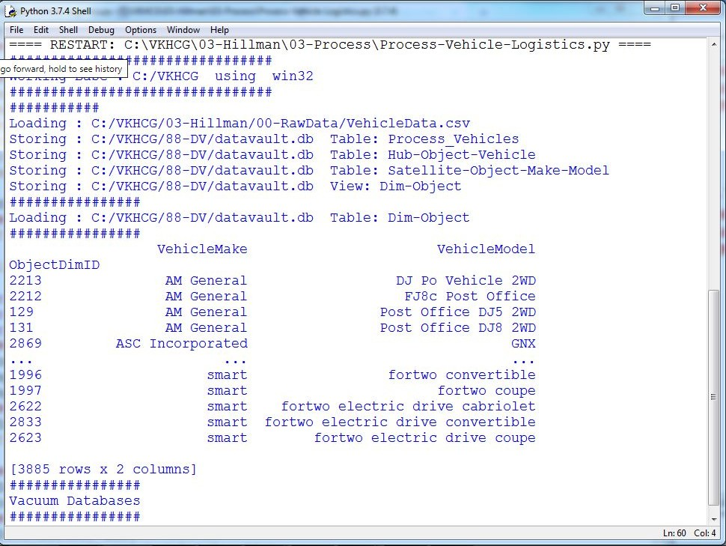

DimObjectData.index.name='ObjectDimID' DimObjectData.sort_values(['VehicleMake','VehicleModel'],inplace=True, ascending=True) print('################')

print(DimObjectData) ################################################################# print('################')

print('Vacuum Databases') sSQL="VACUUM;"

sql.execute(sSQL,conn1) sql.execute(sSQL,conn2) print('################')

#################################################################

conn1.close() conn2.close()

################################################################# #print('### Done!! ############################################') #################################################################

Human-Environment Interaction

The interaction of humans with their environment is a major relationship that guides people’s behavior and the characteristics of the location. Activities such as mining and other industries, roads, and landscaping at a location create both positive and negative effects on the environment, but also on humans. A location earmarked as a green belt, to assist in reducing the carbon footprint, or a new interstate change its current and future characteristics. The location is a main data source for the data science, and, normally, we find unknown or unexpected effects on the data insights. In the Python editor, open a new file named Process_Location.py in directory ..\VKHCG\01-Vermeulen\03-Process.

################################################################

# -*- coding: utf-8 -*- ################################################################

import sys import os

import pandas as pd import sqlite3 as sq

from pandas.io import sql import uuid

################################################################ Base='C:/VKHCG'

print('################################')

print('Working Base :',Base, ' using ', sys.platform) print('################################') ################################################################

Company='01-Vermeulen' InputAssessGraphName='Assess_All_Animals.gml' EDSAssessDir='02-Assess/01-EDS' InputAssessDir=EDSAssessDir + '/02-Python'

################################################################

sFileAssessDir=Base + '/' + Company + '/' + InputAssessDir if not os.path.exists(sFileAssessDir):

os.makedirs(sFileAssessDir) ################################################################

sDataBaseDir=Base + '/' + Company + '/03-Process/SQLite' if not os.path.exists(sDataBaseDir):

os.makedirs(sDataBaseDir) ################################################################

sDatabaseName=sDataBaseDir + '/Vermeulen.db' conn1 = sq.connect(sDatabaseName)

################################################################

sDataVaultDir=Base + '/88-DV'

if not os.path.exists(sDataBaseDir): os.makedirs(sDataBaseDir)

################################################################

sDatabaseName=sDataVaultDir + '/datavault.db' conn2 = sq.connect(sDatabaseName)

t=0 tMax=360*180

################################################################

for Longitude in range(-180,180,10): for Latitude in range(-90,90,10):

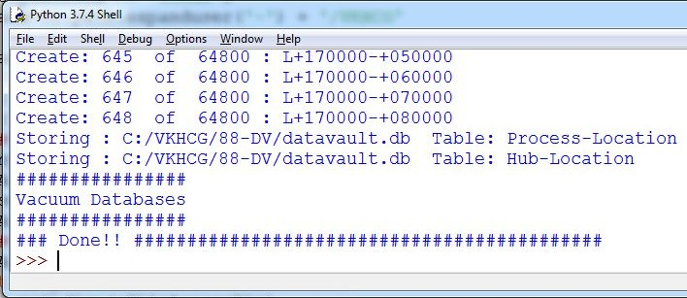

t+=1

IDNumber=str(uuid.uuid4())

LocationName='L'+format(round(Longitude,3)*1000, '+07d') +\ '-'+format(round(Latitude,3)*1000, '+07d')

print('Create:',t,' of ',tMax,':',LocationName) LocationLine=[('ObjectBaseKey', ['GPS']),

('IDNumber', [IDNumber]),

('LocationNumber', [str(t)]), ('LocationName', [LocationName]), ('Longitude', [Longitude]),

('Latitude', [Latitude])]

if t==1:

LocationFrame = pd.DataFrame.from_items(LocationLine) else:

LocationRow = pd.DataFrame.from_items(LocationLine) LocationFrame = LocationFrame.append(LocationRow)

################################################################

LocationHubIndex=LocationFrame.set_index(['IDNumber'],inplace=False) ################################################################

sTable = 'Process-Location'

print('Storing :',sDatabaseName,' Table:',sTable) LocationHubIndex.to_sql(sTable, conn1, if_exists="replace") #################################################################

sTable = 'Hub-Location'

print('Storing :',sDatabaseName,' Table:',sTable) LocationHubIndex.to_sql(sTable, conn2, if_exists="replace") ################################################################# print('################')

print('Vacuum Databases') sSQL="VACUUM;"

sql.execute(sSQL,conn1) sql.execute(sSQL,conn2) print('################')

################################################################ print('### Done!! ############################################') ################################################################

#### Forecasting

Forecasting is the ability to project a possible future, by looking at historical data. The datavault enables these types of investigations, owing to the complete history it collects as itprocesses the source’s systems data. A data scientist supply answers to such questions as the following:

* What should we buy?
* What should we sell?
* Where will our next business come from?

People want to know what you calculate to determine what is about to happen.

Open a new file in your Python editor and save it as Process-Shares-Data.py in directory C: \VKHCG\04-Clark\03-Process. I will guide you through this

process. You will require a library called quandl

**type pip install quandl in cmd**

################################################################

import sys import os

import sqlite3 as sq import quandl import pandas as pd

################################################################ Base='C:/VKHCG'

print('################################')

print('Working Base :',Base, ' using ', sys.platform) print('################################') ################################################################

Company='04-Clark'

sInputFileName='00-RawData/VKHCG_Shares.csv' sOutputFileName='Shares.csv' ################################################################

sDataBaseDir=Base + '/' + Company + '/03-Process/SQLite' if not os.path.exists(sDataBaseDir):

os.makedirs(sDataBaseDir) ################################################################

sFileDir1=Base + '/' + Company + '/01-Retrieve/01-EDS/02-Python' if not os.path.exists(sFileDir1):

os.makedirs(sFileDir1) ################################################################

sFileDir2=Base + '/' + Company + '/02-Assess/01-EDS/02-Python' if not os.path.exists(sFileDir2):

os.makedirs(sFileDir2) ################################################################

sFileDir3=Base + '/' + Company + '/03-Process/01-EDS/02-Python' if not os.path.exists(sFileDir3):

os.makedirs(sFileDir3) ################################################################

sDatabaseName=sDataBaseDir + '/clark.db' conn = sq.connect(sDatabaseName)

################################################################

### Import Share Names Data

################################################################

sFileName=Base + '/' + Company + '/' + sInputFileName print('################################')

print('Loading :',sFileName) print('################################')

RawData=pd.read_csv(sFileName,header=0,low_memory=False, encoding="latin-1") RawData.drop_duplicates(subset=None, keep='first', inplace=True)

print('Rows :',RawData.shape[0])

print('Columns:',RawData.shape[1]) print('################')

################################################################

sFileName=sFileDir1 + '/Retrieve_' + sOutputFileName print('################################')

print('Storing :', sFileName) print('################################')

RawData.to_csv(sFileName, index = False) print('################################') ################################################################

sFileName=sFileDir2 + '/Assess_' + sOutputFileName print('################################')

print('Storing :', sFileName) print('################################')

RawData.to_csv(sFileName, index = False) print('################################') ################################################################

sFileName=sFileDir3 + '/Process_' + sOutputFileName print('################################')

print('Storing :', sFileName) print('################################')

RawData.to_csv(sFileName, index = False) print('################################') ################################################################

### Import Shares Data Details nShares=RawData.shape[0] #nShares=6

for sShare in range(nShares): sShareName=str(RawData['Shares'][sShare]) ShareData = quandl.get(sShareName) UnitsOwn=RawData['Units'][sShare]

ShareData['UnitsOwn']=ShareData.apply(lambda row:(UnitsOwn),axis=1) ShareData['ShareCode']=ShareData.apply(lambda row:(sShareName),axis=1) print('################')

print('Share :',sShareName)

print('Rows :',ShareData.shape[0])

print('Columns:',ShareData.shape[1]) print('################')

################################################################# print('################')

sTable=str(RawData['sTable'][sShare]) print('Storing :',sDatabaseName,' Table:',sTable) ShareData.to_sql(sTable, conn, if_exists="replace") print('################')

################################################################

sOutputFileName = sTable.replace("/","-") + '.csv' sFileName=sFileDir1 + '/Retrieve_' + sOutputFileName print('################################')

print('Storing :', sFileName) print('################################')

ShareData.to_csv(sFileName, index = False) print('################################') ################################################################

sOutputFileName = sTable.replace("/","-") + '.csv' sFileName=sFileDir2 + '/Assess_' + sOutputFileName print('################################')

print('Storing :', sFileName) print('################################')

ShareData.to_csv(sFileName, index = False) print('################################') ################################################################

sOutputFileName = sTable.replace("/","-") + '.csv' sFileName=sFileDir3 + '/Process_' + sOutputFileName print('################################')

print('Storing :', sFileName) print('################################')

ShareData.to_csv(sFileName, index = False) print('################################')

print('### Done!! ############################################') ################################################################

##### Output:

======== RESTART: C:\VKHCG\04-Clark\03-Process\Process-Shares-Data.py ======== Working Base : C:/VKHCG using win32

Loading : C:/VKHCG/04-Clark/00-RawData/VKHCG_Shares.csv

Rows : 10

Columns: 3

Storing : C:/VKHCG/04-Clark/01-Retrieve/01-EDS/02-Python/Retrieve_Shares.csv Storing : C:/VKHCG/04-Clark/02-Assess/01-EDS/02-Python/Assess_Shares.csv Storing : C:/VKHCG/04-Clark/03-Process/01-EDS/02-Python/Process_Shares.csv Share : WIKI/GOOGL

Rows : 3424

Columns: 14

Storing : C:/VKHCG/04-Clark/03-Process/SQLite/clark.db Table: WIKI_Google

Storing : C:/VKHCG/04-Clark/01-Retrieve/01-EDS/02-Python/Retrieve_WIKI_Google.csv Storing : C:/VKHCG/04-Clark/02-Assess/01-EDS/02-Python/Assess_WIKI_Google.csv Storing : C:/VKHCG/04-Clark/03-Process/01-EDS/02-Python/Process_WIKI_Google.csv Share : WIKI/MSFT

Rows : 8076

Columns: 14

Storing : C:/VKHCG/04-Clark/03-Process/SQLite/clark.db Table: WIKI_Microsoft

Storing : C:/VKHCG/04-Clark/01-Retrieve/01-EDS/02-Python/Retrieve_WIKI_Microsoft.csv Storing : C:/VKHCG/04-Clark/02-Assess/01-EDS/02-Python/Assess_WIKI_Microsoft.csv

Storing : C:/VKHCG/04-Clark/03-Process/01-EDS/02-Python/Process_WIKI_Microsoft.csv Share : WIKI/UPS

Rows : 4622

Columns: 14

Storing : C:/VKHCG/04-Clark/03-Process/SQLite/clark.db Table: WIKI_UPS

Storing : C:/VKHCG/04-Clark/01-Retrieve/01-EDS/02-Python/Retrieve_WIKI_UPS.csv Storing : C:/VKHCG/04-Clark/02-Assess/01-EDS/02-Python/Assess_WIKI_UPS.csv Storing : C:/VKHCG/04-Clark/03-Process/01-EDS/02-Python/Process_WIKI_UPS.csv Share : WIKI/AMZN

Rows : 5248

Columns: 14

Storing : C:/VKHCG/04-Clark/03-Process/SQLite/clark.db Table: WIKI_Amazon

Storing : C:/VKHCG/04-Clark/01-Retrieve/01-EDS/02-Python/Retrieve_WIKI_Amazon.csv Storing : C:/VKHCG/04-Clark/02-Assess/01-EDS/02-Python/Assess_WIKI_Amazon.csv Storing : C:/VKHCG/04-Clark/03-Process/01-EDS/02-Python/Process_WIKI_Amazon.csv Share : LOCALBTC/USD

Rows : 1863

Columns: 6

Storing : C:/VKHCG/04-Clark/03-Process/SQLite/clark.db Table: LOCALBTC_USD

Storing : C:/VKHCG/04-Clark/01-Retrieve/01-EDS/02-Python/Retrieve_LOCALBTC_USD.csv Storing : C:/VKHCG/04-Clark/02-Assess/01-EDS/02-Python/Assess_LOCALBTC_USD.csv Storing : C:/VKHCG/04-Clark/03-Process/01-EDS/02-Python/Process_LOCALBTC_USD.csv Share : PERTH/AUD_USD_M

Rows : 340

Columns: 8

Storing : C:/VKHCG/04-Clark/03-Process/SQLite/clark.db Table: PERTH_AUD_USD_M

Storing : C:/VKHCG/04-Clark/01-Retrieve/01-EDS/02-Python/Retrieve_PERTH_AUD_USD_M.csv Storing : C:/VKHCG/04-Clark/02-Assess/01-EDS/02-Python/Assess_PERTH_AUD_USD_M.csv Storing : C:/VKHCG/04-Clark/03-Process/01-EDS/02-Python/Process_PERTH_AUD_USD_M.csv Share : PERTH/AUD_USD_D

Rows : 7989

Columns: 8

Storing : C:/VKHCG/04-Clark/03-Process/SQLite/clark.db Table: PERTH_AUD_USD_D

Storing : C:/VKHCG/04-Clark/01-Retrieve/01-EDS/02-Python/Retrieve_PERTH_AUD_USD_D.csv Storing : C:/VKHCG/04-Clark/02-Assess/01-EDS/02-Python/Assess_PERTH_AUD_USD_D.csv Storing : C:/VKHCG/04-Clark/03-Process/01-EDS/02-Python/Process_PERTH_AUD_USD_D.csv Share : FRED/GDP

Rows : 290

Columns: 3

Storing : C:/VKHCG/04-Clark/03-Process/SQLite/clark.db Table: FRED/GDP

Storing : C:/VKHCG/04-Clark/01-Retrieve/01-EDS/02-Python/Retrieve_FRED-GDP.csv Storing : C:/VKHCG/04-Clark/02-Assess/01-EDS/02-Python/Assess_FRED-GDP.csv Storing : C:/VKHCG/04-Clark/03-Process/01-EDS/02-Python/Process_FRED-GDP.csv Share : FED/RXI_US_N_A_UK

Rows : 49

Columns: 3

Storing : C:/VKHCG/04-Clark/03-Process/SQLite/clark.db Table: FED_RXI_US_N_A_UK

Storing : C:/VKHCG/04-Clark/01-Retrieve/01-EDS/02-Python/Retrieve_FED_RXI_US_N_A_UK.csv Storing : C:/VKHCG/04-Clark/02-Assess/01-EDS/02-Python/Assess_FED_RXI_US_N_A_UK.csv Storing : C:/VKHCG/04-Clark/03-Process/01-EDS/02-Python/Process_FED_RXI_US_N_A_UK.csv Share : FED/RXI_N_A_CA

Rows : 49

Columns: 3

Storing : C:/VKHCG/04-Clark/03-Process/SQLite/clark.db Table: FED_RXI_N_A_CA

Storing : C:/VKHCG/04-Clark/01-Retrieve/01-EDS/02-Python/Retrieve_FED_RXI_N_A_CA.csv Storing : C:/VKHCG/04-Clark/02-Assess/01-EDS/02-Python/Assess_FED_RXI_N_A_CA.csv Storing : C:/VKHCG/04-Clark/03-Process/01-EDS/02-Python/Process_FED_RXI_N_A_CA.csv ### Done!! ############################################

## Practical 7:

**Transforming Data**

Transform Superstep

The Transform superstep allows you, as a data scientist, to take data from the data vault and formulate answers to questions raised by your investigations. The transformation step is the data science process that converts results into insights. It takes standard data science techniques and methods to attain insight and knowledge about the data that then can be transformed into actionable decisions, which, through storytelling, you can explain to non-data scientists what you have discovered in the data lake.

To illustrate the consolidation process,

the example show

a person being borne.

Open a new file in

the Python editor and save it as Transform-Gunnarsson_is_Born.py in directory C: \VKHCG\01-Vermeulen\04-Transform.

################################################################

# -*- coding: utf-8 -*- ################################################################

import sys import os

from datetime import datetime from pytz import timezone import pandas as pd

import sqlite3 as sq import uuid

pd.options.mode.chained_assignment = None ################################################################ Base='C:/VKHCG'

print('################################')

print('Working Base :',Base, ' using ', sys.platform) print('################################') ################################################################

Company='01-Vermeulen' InputDir='00-RawData' InputFileName='VehicleData.csv'

################################################################

sDataBaseDir=Base + '/' + Company + '/04-Transform/SQLite' if not os.path.exists(sDataBaseDir):

os.makedirs(sDataBaseDir) ################################################################

sDatabaseName=sDataBaseDir + '/Vermeulen.db' conn1 = sq.connect(sDatabaseName)

################################################################

sDataVaultDir=Base + '/88-DV'

if not os.path.exists(sDataVaultDir): os.makedirs(sDataVaultDir)

################################################################

sDatabaseName=sDataVaultDir + '/datavault.db' conn2 = sq.connect(sDatabaseName)

################################################################

sDataWarehouseDir=Base + '/99-DW'

if not os.path.exists(sDataWarehouseDir): os.makedirs(sDataWarehouseDir)

################################################################

sDatabaseName=sDataWarehouseDir + '/datawarehouse.db' conn3 = sq.connect(sDatabaseName)

################################################################ print('\n#################################')

print('Time Category') print('UTC Time')

BirthDateUTC = datetime(1960,12,20,10,15,0) BirthDateZoneUTC=BirthDateUTC.replace(tzinfo=timezone('UTC')) BirthDateZoneStr=BirthDateZoneUTC.strftime("%Y-%m-%d %H:%M:%S") BirthDateZoneUTCStr=BirthDateZoneUTC.strftime("%Y-%m-%d %H:%M:%S (%Z) (%z)") print(BirthDateZoneUTCStr)

print('#################################')

print('Birth Date in Reykjavik :') BirthZone = 'Atlantic/Reykjavik'

BirthDate = BirthDateZoneUTC.astimezone(timezone(BirthZone)) BirthDateStr=BirthDate.strftime("%Y-%m-%d %H:%M:%S (%Z) (%z)") BirthDateLocal=BirthDate.strftime("%Y-%m-%d %H:%M:%S") print(BirthDateStr)

print('#################################') ################################################################

IDZoneNumber=str(uuid.uuid4()) sDateTimeKey=BirthDateZoneStr.replace(' ','-').replace(':','-') TimeLine=[('ZoneBaseKey', ['UTC']),

('IDNumber', [IDZoneNumber]), ('DateTimeKey', [sDateTimeKey]), ('UTCDateTimeValue', [BirthDateZoneUTC]), ('Zone', [BirthZone]),

('DateTimeValue', [BirthDateStr])] TimeFrame = pd.DataFrame.from_items(TimeLine)

################################################################

TimeHub=TimeFrame[['IDNumber','ZoneBaseKey','DateTimeKey','DateTimeValue']] TimeHubIndex=TimeHub.set_index(['IDNumber'],inplace=False) ################################################################

sTable = 'Hub-Time-Gunnarsson' print('\n#################################')

print('Storing :',sDatabaseName,'\n Table:',sTable) print('\n#################################')

TimeHubIndex.to_sql(sTable, conn2, if_exists="replace") sTable = 'Dim-Time-Gunnarsson' TimeHubIndex.to_sql(sTable, conn3, if_exists="replace")

################################################################

TimeSatellite=TimeFrame[['IDNumber','DateTimeKey','Zone','DateTimeValue']] TimeSatelliteIndex=TimeSatellite.set_index(['IDNumber'],inplace=False) ################################################################

BirthZoneFix=BirthZone.replace(' ','-').replace('/','-') sTable = 'Satellite-Time-' + BirthZoneFix + '-Gunnarsson' print('\n#################################')

print('Storing :',sDatabaseName,'\n Table:',sTable) print('\n#################################')

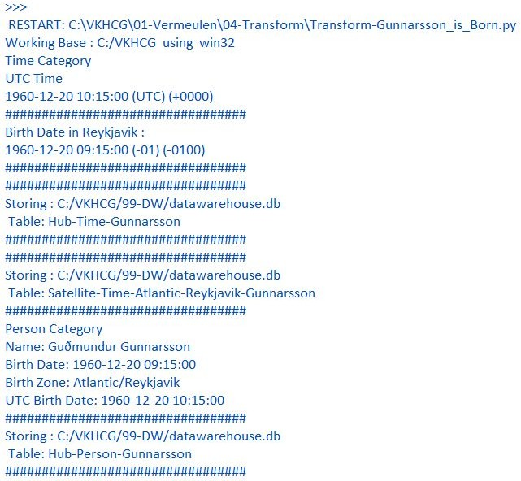

TimeSatelliteIndex.to_sql(sTable, conn2, if_exists="replace") sTable = 'Dim-Time-' + BirthZoneFix + '-Gunnarsson' TimeSatelliteIndex.to_sql(sTable, conn3, if_exists="replace")

################################################################ print('\n#################################')

print('Person Category') FirstName = 'Guðmundur' LastName = 'Gunnarsson'

print('Name:',FirstName,LastName) print('Birth Date:',BirthDateLocal) print('Birth Zone:',BirthZone)

print('UTC Birth Date:',BirthDateZoneStr) print('#################################') ###############################################################

IDPersonNumber=str(uuid.uuid4()) PersonLine=[('IDNumber', [IDPersonNumber]),

('FirstName', [FirstName]),

('LastName', [LastName]),

('Zone', ['UTC']),

('DateTimeValue', [BirthDateZoneStr])] PersonFrame = pd.DataFrame.from_items(PersonLine)

################################################################

TimeHub=PersonFrame TimeHubIndex=TimeHub.set_index(['IDNumber'],inplace=False) ################################################################

sTable = 'Hub-Person-Gunnarsson' print('\n#################################')

print('Storing :',sDatabaseName,'\n Table:',sTable) print('\n#################################')

TimeHubIndex.to_sql(sTable, conn2, if_exists="replace") sTable = 'Dim-Person-Gunnarsson' TimeHubIndex.to_sql(sTable, conn3, if_exists="replace")

################################################################

**Output :** Guðmundur Gunnarsson was born on December 20, 1960, at 9:15 in Landspítali,Hringbraut 101, 101 Reykjavík, Iceland.

You must build three items: **dimension Person**, **dimension Time**, and **factPersonBornAtTime**. Open your Python editor and create a file named Transform-Gunnarsson-Sun-Model.py in directory C:\VKHCG\01-Vermeulen\04-Transform.

################################################################

# -*- coding: utf-8 -*- ################################################################

import sys import os

from datetime import datetime from pytz import timezone import pandas as pd

import sqlite3 as sq import uuid

pd.options.mode.chained_assignment = None ################################################################

if sys.platform == 'linux': Base=os.path.expanduser('~') + '/VKHCG'

else:

Base='C:/VKHCG' print('################################')

print('Working Base :',Base, ' using ', sys.platform) print('################################') ################################################################

Company='01-Vermeulen' ################################################################

sDataBaseDir=Base + '/' + Company + '/04-Transform/SQLite' if not os.path.exists(sDataBaseDir):

os.makedirs(sDataBaseDir) ################################################################

sDatabaseName=sDataBaseDir + '/Vermeulen.db' conn1 = sq.connect(sDatabaseName)

################################################################

sDataWarehousetDir=Base + '/99-DW'

if not os.path.exists(sDataWarehousetDir): os.makedirs(sDataWarehousetDir)

################################################################

sDatabaseName=sDataWarehousetDir + '/datawarehouse.db' conn2 = sq.connect(sDatabaseName)

################################################################ print('\n#################################')

print('Time Dimension') BirthZone = 'Atlantic/Reykjavik'

BirthDateUTC = datetime(1960,12,20,10,15,0) BirthDateZoneUTC=BirthDateUTC.replace(tzinfo=timezone('UTC')) BirthDateZoneStr=BirthDateZoneUTC.strftime("%Y-%m-%d %H:%M:%S") BirthDateZoneUTCStr=BirthDateZoneUTC.strftime("%Y-%m-%d %H:%M:%S (%Z) (%z)") BirthDate = BirthDateZoneUTC.astimezone(timezone(BirthZone))

BirthDateStr=BirthDate.strftime("%Y-%m-%d %H:%M:%S (%Z) (%z)") BirthDateLocal=BirthDate.strftime("%Y-%m-%d %H:%M:%S") ################################################################

IDTimeNumber=str(uuid.uuid4()) TimeLine=[('TimeID', [IDTimeNumber]),

('UTCDate', [BirthDateZoneStr]), ('LocalTime', [BirthDateLocal]), ('TimeZone', [BirthZone])]

TimeFrame = pd.DataFrame.from_items(TimeLine) ################################################################

DimTime=TimeFrame DimTimeIndex=DimTime.set_index(['TimeID'],inplace=False) ################################################################

sTable = 'Dim-Time' print('\n#################################')

print('Storing :',sDatabaseName,'\n Table:',sTable) print('\n#################################')

DimTimeIndex.to_sql(sTable, conn1, if_exists="replace") DimTimeIndex.to_sql(sTable, conn2, if_exists="replace") ################################################################ print('\n#################################')

print('Dimension Person') print('\n#################################')

FirstName = 'Guðmundur' LastName = 'Gunnarsson'

###############################################################

IDPersonNumber=str(uuid.uuid4()) PersonLine=[('PersonID', [IDPersonNumber]),

('FirstName', [FirstName]),

('LastName', [LastName]),

('Zone', ['UTC']),

('DateTimeValue', [BirthDateZoneStr])] PersonFrame = pd.DataFrame.from_items(PersonLine)

################################################################

DimPerson=PersonFrame DimPersonIndex=DimPerson.set_index(['PersonID'],inplace=False) ################################################################

sTable = 'Dim-Person' print('\n#################################')

print('Storing :',sDatabaseName,'\n Table:',sTable) print('\n#################################')

DimPersonIndex.to_sql(sTable, conn1, if_exists="replace") DimPersonIndex.to_sql(sTable, conn2, if_exists="replace") ################################################################ print('\n#################################')

print('Fact - Person - time') print('\n#################################')

IDFactNumber=str(uuid.uuid4())

PersonTimeLine=[('IDNumber', [IDFactNumber]), ('IDPersonNumber', [IDPersonNumber]), ('IDTimeNumber', [IDTimeNumber])]

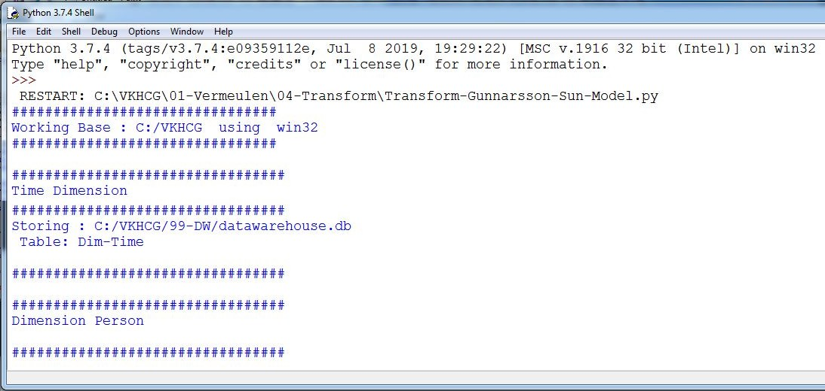

PersonTimeFrame = pd.DataFrame.from_items(PersonTimeLine) ################################################################

FctPersonTime=PersonTimeFrame FctPersonTimeIndex=FctPersonTime.set_index(['IDNumber'],inplace=False) ################################################################

sTable = 'Fact-Person-Time' print('\n#################################')

print('Storing :',sDatabaseName,'\n Table:',sTable) print('\n#################################')

FctPersonTimeIndex.to_sql(sTable, conn1, if_exists="replace") FctPersonTimeIndex.to_sql(sTable, conn2, if_exists="replace") ################################################################

**Output:**

## Building a Data Warehouse

Open the Transform-Sun-Models.py file from directory C:\VKHCG\01-Vermeulen\04-Transform.

################################################################

# -*- coding: utf-8 -*- ################################################################

import sys import os

from datetime import datetime from pytz import timezone import pandas as pd

import sqlite3 as sq import uuid

pd.options.mode.chained_assignment = None ################################################################

if sys.platform == 'linux': Base=os.path.expanduser('~') + '/VKHCG'

else:

Base='C:/VKHCG' print('################################')

print('Working Base :',Base, ' using ', sys.platform) print('################################') ################################################################

Company='01-Vermeulen' ################################################################

sDataBaseDir=Base + '/' + Company + '/04-Transform/SQLite' if not os.path.exists(sDataBaseDir):

os.makedirs(sDataBaseDir) ################################################################

sDatabaseName=sDataBaseDir + '/Vermeulen.db' conn1 = sq.connect(sDatabaseName)

################################################################

sDataVaultDir=Base + '/88-DV'

if not os.path.exists(sDataVaultDir): os.makedirs(sDataVaultDir)

################################################################

sDatabaseName=sDataVaultDir + '/datavault.db' conn2 = sq.connect(sDatabaseName)

################################################################

sDataWarehouseDir=Base + '/99-DW'

if not os.path.exists(sDataWarehouseDir): os.makedirs(sDataWarehouseDir)

################################################################

sDatabaseName=sDataWarehouseDir + '/datawarehouse.db' conn3 = sq.connect(sDatabaseName)

################################################################

sSQL=" SELECT DateTimeValue FROM [Hub-Time];" DateDataRaw=pd.read_sql_query(sSQL, conn2) DateData=DateDataRaw.head(1000)

print(DateData) ################################################################ print('\n#################################')

print('Time Dimension') print('\n#################################')

t=0 mt=DateData.shape[0] for i in range(mt):

BirthZone = ('Atlantic/Reykjavik','Europe/London','UCT') for j in range(len(BirthZone)):

t+=1

print(t,mt*3)

BirthDateUTC = datetime.strptime(DateData['DateTimeValue'][i],"%Y-%m-%d %H:%M:%S") BirthDateZoneUTC=BirthDateUTC.replace(tzinfo=timezone('UTC')) BirthDateZoneStr=BirthDateZoneUTC.strftime("%Y-%m-%d %H:%M:%S") BirthDateZoneUTCStr=BirthDateZoneUTC.strftime("%Y-%m-%d %H:%M:%S (%Z) (%z)")

BirthDate = BirthDateZoneUTC.astimezone(timezone(BirthZone[j])) BirthDateStr=BirthDate.strftime("%Y-%m-%d %H:%M:%S (%Z) (%z)") BirthDateLocal=BirthDate.strftime("%Y-%m-%d %H:%M:%S") ################################################################

IDTimeNumber=str(uuid.uuid4()) TimeLine=[('TimeID', [str(IDTimeNumber)]),

('UTCDate', [str(BirthDateZoneStr)]), ('LocalTime', [str(BirthDateLocal)]), ('TimeZone', [str(BirthZone)])]

if t==1:

TimeFrame = pd.DataFrame.from_items(TimeLine) else:

TimeRow = pd.DataFrame.from_items(TimeLine) TimeFrame=TimeFrame.append(TimeRow)

################################################################

DimTime=TimeFrame DimTimeIndex=DimTime.set_index(['TimeID'],inplace=False) ################################################################

sTable = 'Dim-Time' print('\n#################################')

print('Storing :',sDatabaseName,'\n Table:',sTable) print('\n#################################')

DimTimeIndex.to_sql(sTable, conn1, if_exists="replace") DimTimeIndex.to_sql(sTable, conn3, if_exists="replace") ################################################################ sSQL=" SELECT " + \

" FirstName," + \

" SecondName," + \ " LastName," + \

" BirthDateKey " + \

" FROM [Hub-Person];" PersonDataRaw=pd.read_sql_query(sSQL, conn2) PersonData=PersonDataRaw.head(1000)

################################################################ print('\n#################################')

print('Dimension Person') print('\n#################################')

t=0 mt=DateData.shape[0] for i in range(mt):

t+=1

print(t,mt)

FirstName = str(PersonData["FirstName"]) SecondName = str(PersonData["SecondName"]) if len(SecondName) > 0:

SecondName=""

LastName = str(PersonData["LastName"]) BirthDateKey = str(PersonData["BirthDateKey"])

###############################################################

IDPersonNumber=str(uuid.uuid4()) PersonLine=[('PersonID', [str(IDPersonNumber)]),

('FirstName', [FirstName]), ('SecondName', [SecondName]), ('LastName', [LastName]), ('Zone', [str('UTC')]),

('BirthDate', [BirthDateKey])]

if t==1:

PersonFrame = pd.DataFrame.from_items(PersonLine) else:

PersonRow = pd.DataFrame.from_items(PersonLine) PersonFrame = PersonFrame.append(PersonRow)

################################################################

DimPerson=PersonFrame print(DimPerson)

DimPersonIndex=DimPerson.set_index(['PersonID'],inplace=False) ################################################################

sTable = 'Dim-Person' print('\n#################################')

print('Storing :',sDatabaseName,'\n Table:',sTable) print('\n#################################')

DimPersonIndex.to_sql(sTable, conn1, if_exists="replace") DimPersonIndex.to_sql(sTable, conn3, if_exists="replace") ###############################################################

Output:

You have successfully performed data vault to data warehouse transformation.

#### Simple Linear Regression

Linear regression is used if there is a relationship or significant association between the variables. This can be checked by scatterplots. If no linear association appears between the variables, fitting a linear regression model to the data will not provide a useful model. A linear regression line has equations in the following form:

Y = a + bX,

Where, X = explanatory variable and Y = dependent variable

b = slope of the line

a = intercept (the value of y when x = 0)

################################################################

# -*- coding: utf-8 -*- ################################################################

import sys import os

import pandas as pd import sqlite3 as sq

import matplotlib.pyplot as plt import numpy as np

from sklearn import datasets, linear_model

from sklearn.metrics import mean_squared_error, r2_score ################################################################ Base='C:/VKHCG'

print('################################')

print('Working Base :',Base, ' using ', sys.platform) print('################################') ################################################################ ################################################################

Company='01-Vermeulen' ################################################################

sDataBaseDir=Base + '/' + Company + '/04-Transform/SQLite' if not os.path.exists(sDataBaseDir):

os.makedirs(sDataBaseDir) ################################################################

sDatabaseName=sDataBaseDir + '/Vermeulen.db' conn1 = sq.connect(sDatabaseName)

################################################################

sDataVaultDir=Base + '/88-DV'

if not os.path.exists(sDataVaultDir): os.makedirs(sDataVaultDir)

################################################################

sDatabaseName=sDataVaultDir + '/datavault.db' conn2 = sq.connect(sDatabaseName)

################################################################

sDataWarehouseDir=Base + '/99-DW'

if not os.path.exists(sDataWarehouseDir): os.makedirs(sDataWarehouseDir)

################################################################

sDatabaseName=sDataWarehouseDir + '/datawarehouse.db' conn3 = sq.connect(sDatabaseName)

################################################################

t=0

tMax=((300-100)/10)*((300-30)/5)

for heightSelect in range(100,300,10): for weightSelect in range(30,300,5):

height = round(heightSelect/100,3) weight = int(weightSelect)

bmi = weight/(height*height)

if bmi <= 18.5:

BMI_Result=1

elif bmi > 18.5 and bmi < 25:

BMI_Result=2

elif bmi > 25 and bmi < 30:

BMI_Result=3 elif bmi > 30:

BMI_Result=4 else:

BMI_Result=0 PersonLine=[('PersonID', [str(t)]),

('Height', [height]),

('Weight', [weight]),

('bmi', [bmi]),

('Indicator', [BMI_Result])]

t+=1

print('Row:',t,'of',tMax) if t==1:

PersonFrame = pd.DataFrame.from_items(PersonLine) else:

PersonRow = pd.DataFrame.from_items(PersonLine) PersonFrame = PersonFrame.append(PersonRow)

################################################################

DimPerson=PersonFrame DimPersonIndex=DimPerson.set_index(['PersonID'],inplace=False) ################################################################

sTable = 'Transform-BMI' print('\n#################################')

print('Storing :',sDatabaseName,'\n Table:',sTable) print('\n#################################')

DimPersonIndex.to_sql(sTable, conn1, if_exists="replace") ################################################################ ################################################################

sTable = 'Person-Satellite-BMI' print('\n#################################')

print('Storing :',sDatabaseName,'\n Table:',sTable) print('\n#################################')

DimPersonIndex.to_sql(sTable, conn2, if_exists="replace") ################################################################ ################################################################

sTable = 'Dim-BMI' print('\n#################################')

print('Storing :',sDatabaseName,'\n Table:',sTable) print('\n#################################')

DimPersonIndex.to_sql(sTable, conn3, if_exists="replace") ################################################################

fig = plt.figure() PlotPerson=DimPerson[DimPerson['Indicator']==1] x=PlotPerson['Height']

y=PlotPerson['Weight'] plt.plot(x, y, ".")

PlotPerson=DimPerson[DimPerson['Indicator']==2] x=PlotPerson['Height']

y=PlotPerson['Weight'] plt.plot(x, y, "o")

PlotPerson=DimPerson[DimPerson['Indicator']==3] x=PlotPerson['Height']

y=PlotPerson['Weight'] plt.plot(x, y, "+")

PlotPerson=DimPerson[DimPerson['Indicator']==4] x=PlotPerson['Height']

y=PlotPerson['Weight'] plt.plot(x, y, "^") plt.axis('tight') plt.title("BMI Curve") plt.xlabel("Height(meters)") plt.ylabel("Weight(kg)") plt.plot()

# Load the diabetes dataset diabetes = datasets.load_diabetes()

# Use only one feature

diabetes_X = diabetes.data[:, np.newaxis, 2] diabetes_X_train = diabetes_X[:-30] diabetes_X_test = diabetes_X[-50:] diabetes_y_train = diabetes.target[:-30] diabetes_y_test = diabetes.target[-50:]

regr = linear_model.LinearRegression() regr.fit(diabetes_X_train, diabetes_y_train) diabetes_y_pred = regr.predict(diabetes_X_test) print('Coefficients: \n', regr.coef_)

print("Mean squared error: %.2f"

% mean_squared_error(diabetes_y_test, diabetes_y_pred)) print('Variance score: %.2f' % r2_score(diabetes_y_test, diabetes_y_pred)) plt.scatter(diabetes_X_test, diabetes_y_test, color='black') plt.plot(diabetes_X_test, diabetes_y_pred, color='blue', linewidth=3) plt.xticks(())

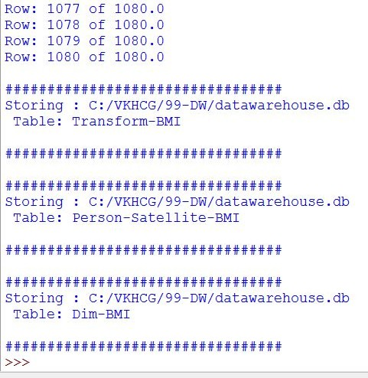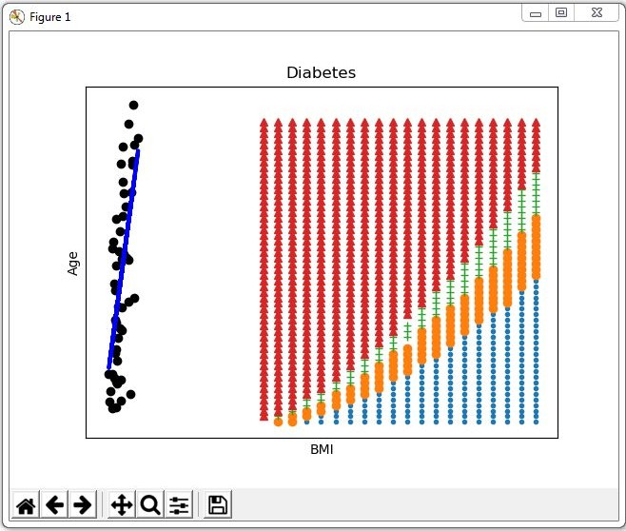

plt.yticks(()) plt.axis('tight') plt.title("Diabetes") plt.xlabel("BMI") plt.ylabel("Age") plt.show()

**Output:**

## Practical 8:

Organize Superstep

**Organizing Data**

The Organize superstep takes the complete data warehouse you built at the end of the Transform superstep and

subsections it into business-specific data marts. A data mart is the access layer of the data warehouse

environment built to expose data to the users. The data mart is a subset of the data warehouse and is generally oriented to a specific business group.

#### Horizontal Style

Performing horizontal-style slicing or subsetting of the data warehouse is achieved by applying a filter

technique that forces the data warehouse to show only the data for a specific preselected set of filtered

outcomes against the data population. The horizontal-style slicing selects the subset of rows from the

population while preserving the columns. That is, the data science tool can see the complete record for the records in the subset of records.

**C:\VKHCG\01-Vermeulen\05-Organise\ Organize-Horizontal.py**

################################################################

# -*- coding: utf-8 -*- ################################################################

import sys import os

import pandas as pd import sqlite3 as sq

################################################################ Base='C:/VKHCG'

print('################################')

print('Working Base :',Base, ' using ', sys.platform) print('################################') ################################################################ ################################################################

Company='01-Vermeulen' ################################################################

sDataWarehouseDir=Base + '/99-DW'

if not os.path.exists(sDataWarehouseDir): os.makedirs(sDataWarehouseDir)

################################################################

sDatabaseName=sDataWarehouseDir + '/datawarehouse.db' conn1 = sq.connect(sDatabaseName)

################################################################

sDatabaseName=sDataWarehouseDir + '/datamart.db' conn2 = sq.connect(sDatabaseName)

################################################################ print('################')

sTable = 'Dim-BMI'

print('Loading :',sDatabaseName,' Table:',sTable) sSQL="SELECT * FROM [Dim-BMI];"

PersonFrame0=pd.read_sql_query(sSQL, conn1) print('################')

sTable = 'Dim-BMI'

print('Loading :',sDatabaseName,' Table:',sTable)

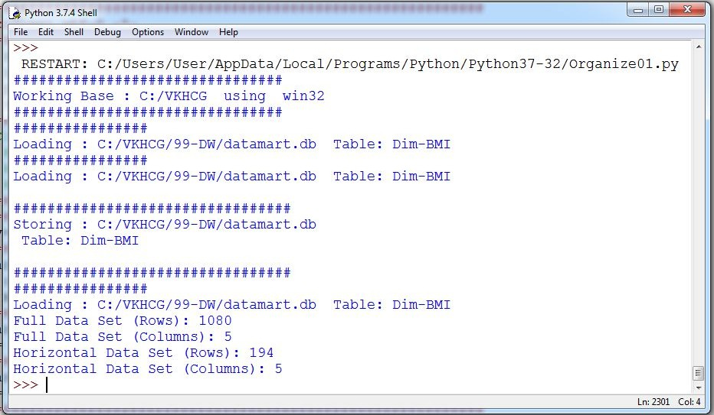

sSQL="SELECT PersonID,\ Height,\

Weight,\ bmi,\ Indicator\

FROM [Dim-BMI]\ WHERE \

Height > 1.5 \ and Indicator = 1\ ORDER BY \

Height,\ Weight;"

PersonFrame1=pd.read_sql_query(sSQL, conn1) ################################################################

DimPerson=PersonFrame1 DimPersonIndex=DimPerson.set_index(['PersonID'],inplace=False) ################################################################

sTable = 'Dim-BMI' print('\n#################################')

print('Storing :',sDatabaseName,'\n Table:',sTable) print('\n#################################')

#DimPersonIndex.to_sql(sTable, conn2, if_exists="replace") ################################################################ print('################')

sTable = 'Dim-BMI'

print('Loading :',sDatabaseName,' Table:',sTable) sSQL="SELECT * FROM [Dim-BMI];"

PersonFrame2=pd.read_sql_query(sSQL, conn2) print('Full Data Set (Rows):', PersonFrame0.shape[0]) print('Full Data Set (Columns):', PersonFrame0.shape[1])

print('Horizontal Data Set (Rows):', PersonFrame2.shape[0]) print('Horizontal Data Set (Columns):', PersonFrame2.shape[1]) **Output:**

The horizontal-style slicing selects the 194 subset of rows from the 1080 rows while preserving the columns.

#### Vertical Style

Performing vertical-style slicing or subsetting of the data warehouse is achieved by applying a filter technique that forces the data warehouse to show only the data for specific preselected filtered outcomes against the data population. The vertical-style slicing selects the subset of columns from the population, while preserving the rows. That is, the data science tool can see only the preselected columns from a record for all the records in the population.

**C:\VKHCG\01-Vermeulen\05-Organise\ Organize-Vertical.py**

################################################################

# -*- coding: utf-8 -*- ################################################################

import sys import os

import pandas as pd import sqlite3 as sq

################################################################ Base='C:/VKHCG'

print('################################')

print('Working Base :',Base, ' using ', sys.platform) print('################################') ################################################################ ################################################################

Company='01-Vermeulen' ################################################################

sDataWarehouseDir=Base + '/99-DW'

if not os.path.exists(sDataWarehouseDir): os.makedirs(sDataWarehouseDir)

################################################################

sDatabaseName=sDataWarehouseDir + '/datawarehouse.db' conn1 = sq.connect(sDatabaseName)

################################################################

sDatabaseName=sDataWarehouseDir + '/datamart.db' conn2 = sq.connect(sDatabaseName)

################################################################ print('################################')

sTable = 'Dim-BMI'

print('Loading :',sDatabaseName,' Table:',sTable) sSQL="SELECT * FROM [Dim-BMI];"

PersonFrame0=pd.read_sql_query(sSQL, conn1) ################################################################ print('################################')

sTable = 'Dim-BMI'

print('Loading :',sDatabaseName,' Table:',sTable) print('################################') sSQL="SELECT \

Height,\ Weight,\ Indicator\

FROM [Dim-BMI];"

PersonFrame1=pd.read_sql_query(sSQL, conn1) ################################################################

DimPerson=PersonFrame1 DimPersonIndex=DimPerson.set_index(['Indicator'],inplace=False)

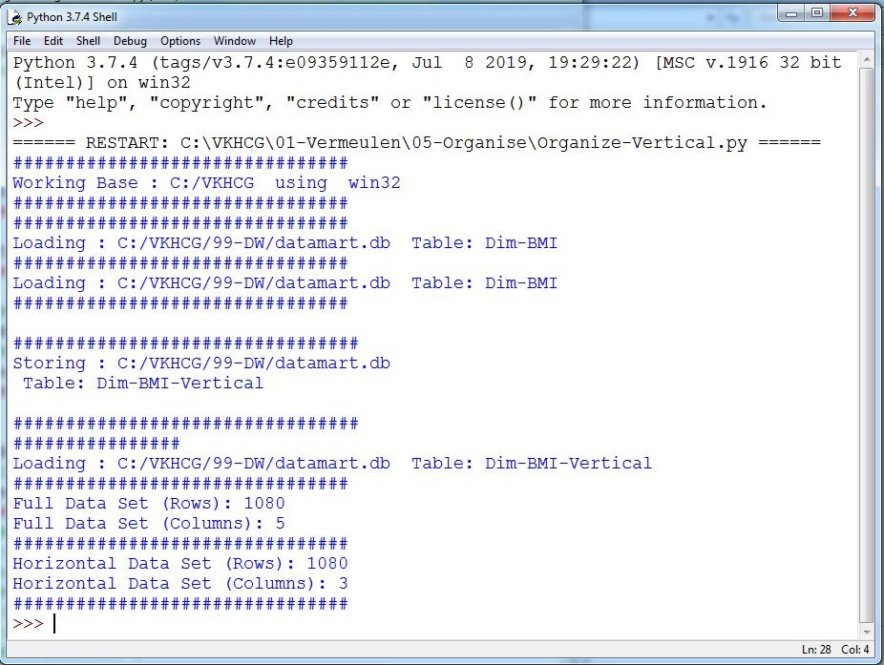

################################################################

sTable = 'Dim-BMI-Vertical' print('\n#################################')

print('Storing :',sDatabaseName,'\n Table:',sTable) print('\n#################################')

DimPersonIndex.to_sql(sTable, conn2, if_exists="replace") ################################################################ print('################')

sTable = 'Dim-BMI-Vertical'

print('Loading :',sDatabaseName,' Table:',sTable) sSQL="SELECT * FROM [Dim-BMI-Vertical];"

PersonFrame2=pd.read_sql_query(sSQL, conn2) ################################################################ print('################################')

print('Full Data Set (Rows):', PersonFrame0.shape[0]) print('Full Data Set (Columns):', PersonFrame0.shape[1]) print('################################')

print('Horizontal Data Set (Rows):', PersonFrame2.shape[0]) print('Horizontal Data Set (Columns):', PersonFrame2.shape[1]) print('################################')

################################################################

**Output:**

The vertical-style slicing selects 3 of 5 from the population, while preserving the rows [1080].

#### Island Style

Performing island-style slicing or subsetting of the data warehouse is achieved by applying a combination of horizontal- and vertical-style slicing. This generates a subset of specific rows and specific columns reduced at the same time.

**C:\VKHCG\01-Vermeulen\05-Organise\ Organize-Island.py**

################################################################

# -*- coding: utf-8 -*- ################################################################

import sys import os

import pandas as pd import sqlite3 as sq

################################################################ Base='C:/VKHCG'

print('################################')

print('Working Base :',Base, ' using ', sys.platform) print('################################') ################################################################ ################################################################

Company='01-Vermeulen' ################################################################

sDataWarehouseDir=Base + '/99-DW'

if not os.path.exists(sDataWarehouseDir): os.makedirs(sDataWarehouseDir)

################################################################

sDatabaseName=sDataWarehouseDir + '/datawarehouse.db' conn1 = sq.connect(sDatabaseName)

################################################################

sDatabaseName=sDataWarehouseDir + '/datamart.db' conn2 = sq.connect(sDatabaseName)

################################################################ print('################')

sTable = 'Dim-BMI'

print('Loading :',sDatabaseName,' Table:',sTable) sSQL="SELECT * FROM [Dim-BMI];"

PersonFrame0=pd.read_sql_query(sSQL, conn1) ################################################################ print('################')

sTable = 'Dim-BMI'

print('Loading :',sDatabaseName,' Table:',sTable)

sSQL="SELECT \

Height,\ Weight,\ Indicator\

FROM [Dim-BMI]\

WHERE Indicator > 2\

ORDER BY \

Height,\ Weight;"

PersonFrame1=pd.read_sql_query(sSQL, conn1) ################################################################

DimPerson=PersonFrame1 DimPersonIndex=DimPerson.set_index(['Indicator'],inplace=False) ################################################################

sTable = 'Dim-BMI-Vertical' print('\n#################################')

print('Storing :',sDatabaseName,'\n Table:',sTable)

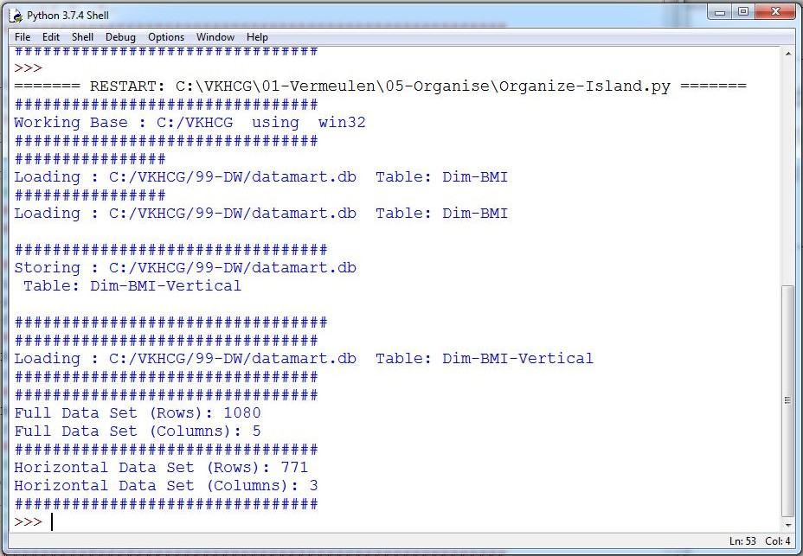

print('\n#################################')

DimPersonIndex.to_sql(sTable, conn2, if_exists="replace") ################################################################ print('################################')

sTable = 'Dim-BMI-Vertical'

print('Loading :',sDatabaseName,' Table:',sTable) print('################################') sSQL="SELECT * FROM [Dim-BMI-Vertical];"

PersonFrame2=pd.read_sql_query(sSQL, conn2) ################################################################ print('################################')

print('Full Data Set (Rows):', PersonFrame0.shape[0]) print('Full Data Set (Columns):', PersonFrame0.shape[1]) print('################################')

print('Horizontal Data Set (Rows):', PersonFrame2.shape[0]) print('Horizontal Data Set (Columns):', PersonFrame2.shape[1]) print('################################')

################################################################

Output:

This generates a subset of 771 rows out of 1080 rows and 3 columns out of 5.

#### Secure Vault Style

The secure vault is a version of one of the horizontal, vertical, or island slicing techniques, but the outcome is also attached to the person who performs the query. This is common in multi-security environments, where different users are allowed to see different data sets.

This process works well, if you use a role-based access control (RBAC) approach to restricting system access to authorized users. The security is applied against the “role,” and a person can then, by the security system, simply be added or removed from the role, to enable or disable access.

**C:\VKHCG\01-Vermeulen\05-Organise\ Organize-Secure-Vault.py**

################################################################

# -*- coding: utf-8 -*- ################################################################

import sys import os

import pandas as pd import sqlite3 as sq

################################################################ Base='C:/VKHCG'

print('################################')

print('Working Base :',Base, ' using ', sys.platform) print('################################') ################################################################ ################################################################

Company='01-Vermeulen' ################################################################

sDataWarehouseDir=Base + '/99-DW'

if not os.path.exists(sDataWarehouseDir): os.makedirs(sDataWarehouseDir)

################################################################

sDatabaseName=sDataWarehouseDir + '/datawarehouse.db' conn1 = sq.connect(sDatabaseName)

################################################################

sDatabaseName=sDataWarehouseDir + '/datamart.db' conn2 = sq.connect(sDatabaseName)

################################################################ print('################')

sTable = 'Dim-BMI'

print('Loading :',sDatabaseName,' Table:',sTable) sSQL="SELECT * FROM [Dim-BMI];"

PersonFrame0=pd.read_sql_query(sSQL, conn1) ################################################################ print('################')

sTable = 'Dim-BMI'

print('Loading :',sDatabaseName,' Table:',sTable)

sSQL="SELECT \

Height,\ Weight,\ Indicator,\ CASE Indicator\

WHEN 1 THEN 'Pip'\

WHEN 2 THEN 'Norman'\ WHEN 3 THEN 'Grant'\ ELSE 'Sam'\

END AS Name\ FROM [Dim-BMI]\

WHERE Indicator > 2\

ORDER BY \

Height,\ Weight;"

PersonFrame1=pd.read_sql_query(sSQL, conn1)

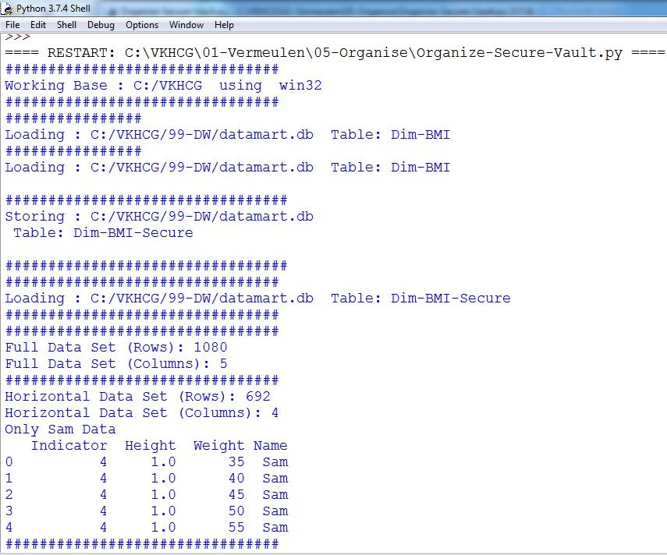

################################################################

DimPerson=PersonFrame1 DimPersonIndex=DimPerson.set_index(['Indicator'],inplace=False) ################################################################

sTable = 'Dim-BMI-Secure' print('\n#################################')

print('Storing :',sDatabaseName,'\n Table:',sTable) print('\n#################################')

DimPersonIndex.to_sql(sTable, conn2, if_exists="replace") ################################################################ print('################################')

sTable = 'Dim-BMI-Secure'

print('Loading :',sDatabaseName,' Table:',sTable) print('################################')

sSQL="SELECT * FROM [Dim-BMI-Secure] WHERE Name = 'Sam';"

PersonFrame2=pd.read_sql_query(sSQL, conn2) ################################################################ print('################################')

print('Full Data Set (Rows):', PersonFrame0.shape[0]) print('Full Data Set (Columns):', PersonFrame0.shape[1]) print('################################')

print('Horizontal Data Set (Rows):', PersonFrame2.shape[0]) print('Horizontal Data Set (Columns):', PersonFrame2.shape[1]) print('Only Sam Data')

print(PersonFrame2.head()) print('################################')

################################################################

**Output:**

#### Association Rule Mining

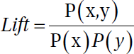

Association rule learning is a rule-based machine-learning method for discoveringinteresting relations between variables in large databases, similar to the data you willfind in a data lake. The technique enables you to investigate the interaction between datawithin the same population. Lift is simply estimatedby the ratio of the joint probability of two items x and y, divided by the product of theirindividual probabilities:

**C:\VKHCG\01-Vermeulen\05-Organise\ Organize-Association-Rule.py**

################################################################

# -*- coding: utf-8 -*- ################################################################

import sys import os

import pandas as pd

from mlxtend.frequent_patterns import apriori

from mlxtend.frequent_patterns import association_rules ################################################################ Base='C:/VKHCG'

print('################################')

print('Working Base :',Base, ' using ', sys.platform) print('################################') ################################################################

Company='01-Vermeulen' InputFileName='Online-Retail-Billboard.xlsx' EDSAssessDir='02-Assess/01-EDS' InputAssessDir=EDSAssessDir + '/02-Python'

################################################################

sFileAssessDir=Base + '/' + Company + '/' + InputAssessDir if not os.path.exists(sFileAssessDir):

os.makedirs(sFileAssessDir) ################################################################

sFileName=Base+'/'+ Company + '/00-RawData/' + InputFileName ################################################################

df = pd.read_excel(sFileName) print(df.shape)

################################################################

df['Description'] = df['Description'].str.strip() df.dropna(axis=0, subset=['InvoiceNo'], inplace=True) df['InvoiceNo'] = df['InvoiceNo'].astype('str')

df = df[~df['InvoiceNo'].str.contains('C')]

basket = (df[df['Country'] =="France"]

.groupby(['InvoiceNo', 'Description'])['Quantity']

.sum().unstack().reset_index().fillna(0)

.set_index('InvoiceNo')) ################################################################

def encode_units(x): if x <= 0:

return 0

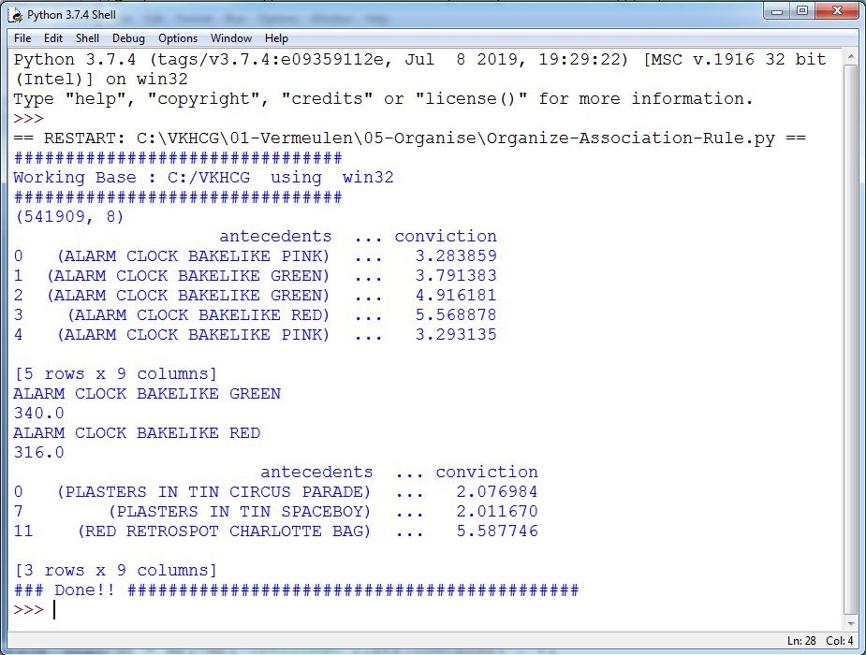

if x >= 1: return 1

################################################################

basket_sets = basket.applymap(encode_units) basket_sets.drop('POSTAGE', inplace=True, axis=1)

frequent_itemsets = apriori(basket_sets, min_support=0.07, use_colnames=True) rules = association_rules(frequent_itemsets, metric="lift", min_threshold=1) print(rules.head())

rules[ (rules['lift'] >= 6) & (rules['confidence'] >= 0.8) ]

################################################################ sProduct1='ALARM CLOCK BAKELIKE GREEN'

print(sProduct1) print(basket[sProduct1].sum())

sProduct2='ALARM CLOCK BAKELIKE RED'

print(sProduct2) print(basket[sProduct2].sum())

################################################################

basket2 = (df[df['Country'] =="Germany"]

.groupby(['InvoiceNo', 'Description'])['Quantity']

.sum().unstack().reset_index().fillna(0)

.set_index('InvoiceNo'))

basket_sets2 = basket2.applymap(encode_units) basket_sets2.drop('POSTAGE', inplace=True, axis=1)

frequent_itemsets2 = apriori(basket_sets2, min_support=0.05, use_colnames=True) rules2 = association_rules(frequent_itemsets2, metric="lift", min_threshold=1)

print(rules2[ (rules2['lift'] >= 4) & (rules2['confidence'] >= 0.5)])

################################################################ print('### Done!! ############################################') ################################################################

**Output:**

Create a Network Routing Diagram

I will guide you through a possible solution for the requirement, by constructing an island-style Organize superstep that uses a graph data model to reduce the records and the columns on the data set.

**C:\VKHCG\01-Vermeulen\05-Organise\ Organise-Network-Routing-Company.py**

################################################################

import sys import os

import pandas as pd import networkx as nx

import matplotlib.pyplot as plt ################################################################

pd.options.mode.chained_assignment = None ################################################################ Base='C:/VKHCG' ################################################################ print('################################')

print('Working Base :',Base, ' using ', sys.platform) print('################################') ################################################################

sInputFileName='02-Assess/01-EDS/02-Python/Assess-Network-Routing-Company.csv' ################################################################

sOutputFileName1='05-Organise/01-EDS/02-Python/Organise-Network-Routing-Company.gml' sOutputFileName2='05-Organise/01-EDS/02-Python/Organise-Network-Routing-Company.png' Company='01-Vermeulen' ################################################################ ################################################################

### Import Country Data ################################################################

sFileName=Base + '/' + Company + '/' + sInputFileName print('################################')

print('Loading :',sFileName) print('################################')

CompanyData=pd.read_csv(sFileName,header=0,low_memory=False, encoding="latin-1") print('################################') ################################################################

print(CompanyData.head()) print(CompanyData.shape)

################################################################

G=nx.Graph()

for i in range(CompanyData.shape[0]): for j in range(CompanyData.shape[0]):

Node0=CompanyData['Company_Country_Name'][i] Node1=CompanyData['Company_Country_Name'][j] if Node0 != Node1:

G.add_edge(Node0,Node1)

for i in range(CompanyData.shape[0]): Node0=CompanyData['Company_Country_Name'][i]

Node1=CompanyData['Company_Place_Name'][i] + '('+ CompanyData['Company_Country_Name'][i] + ')' if Node0 != Node1:

G.add_edge(Node0,Node1)

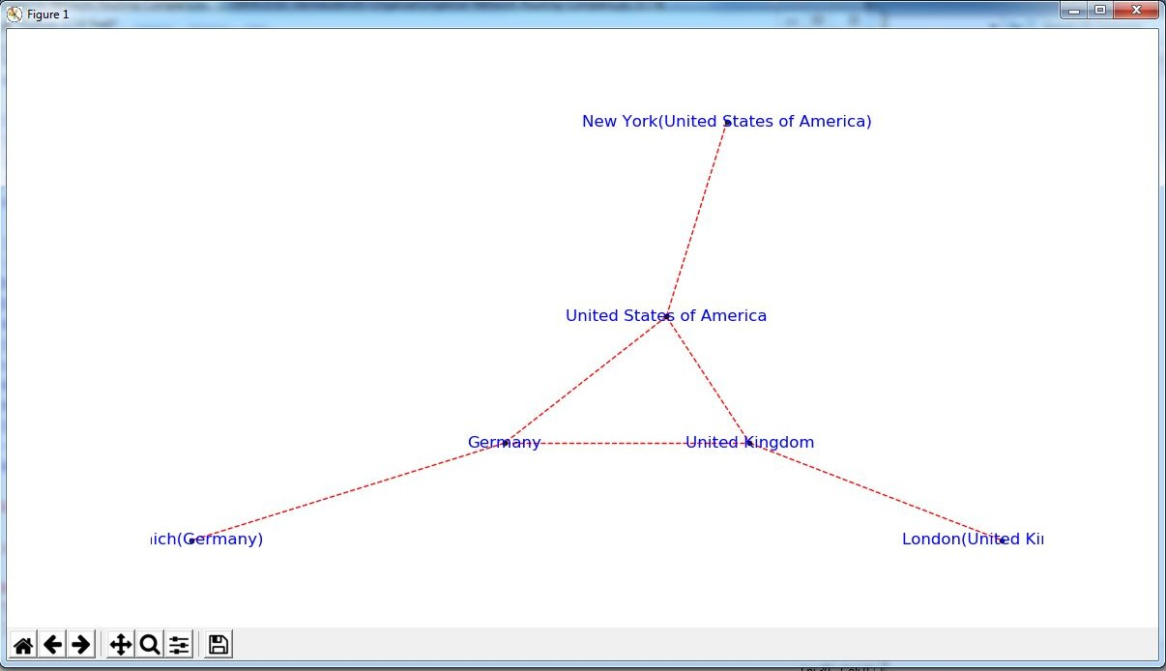

print('Nodes:', G.number_of_nodes()) print('Edges:', G.number_of_edges())

################################################################

sFileName=Base + '/' + Company + '/' + sOutputFileName1 print('################################')

print('Storing :',sFileName) print('################################')

nx.write_gml(G, sFileName) ################################################################

sFileName=Base + '/' + Company + '/' + sOutputFileName2 print('################################')

print('Storing Graph Image:',sFileName) print('################################')

plt.figure(figsize=(15, 15)) pos=nx.spectral_layout(G,dim=2)

nx.draw_networkx_nodes(G,pos, node_color='k', node_size=10, alpha=0.8) nx.draw_networkx_edges(G, pos,edge_color='r', arrows=False, style='dashed') nx.draw_networkx_labels(G,pos,font_size=12,font_family='sans-serif',font_color='b') plt.axis('off')

plt.savefig(sFileName,dpi=600) plt.show()

################################################################ print('################################')

print('### Done!! #####################') print('################################') ################################################################

Picking Content for Billboards

To enable the marketing salespeople to sell billboard content, they will require a diagram to show what billboards connect to which office content publisher. Each of Krennwallner’s billboards has a proximity sensor

that enables the content managers to record when a registered visitor points his/her smartphone at the billboard content or touches the near-field pad with a mobile phone.

Program will assist you in building an organized graph of the billboards’ locations data to help you to gain insights into the billboard locations and content picking process.

**C:\VKHCG\02-Krennwallner\05-Organise\ Organise-billboards.py**

################################################################

import sys import os

import pandas as pd import networkx as nx

import matplotlib.pyplot as plt import numpy as np

################################################################

pd.options.mode.chained_assignment = None ################################################################ Base='C:/VKHCG' ################################################################ print('################################')

print('Working Base :',Base, ' using ', sys.platform) print('################################') ################################################################

sInputFileName='02-Assess/01-EDS/02-Python/Assess-DE-Billboard-Visitor.csv' ################################################################

sOutputFileName1='05-Organise/01-EDS/02-Python/Organise-Billboards.gml' sOutputFileName2='05-Organise/01-EDS/02-Python/Organise-Billboards.png' Company='02-Krennwallner' ################################################################ ################################################################

### Import Company Data ################################################################

sFileName=Base + '/' + Company + '/' + sInputFileName print('################################')

print('Loading :',sFileName) print('################################')

BillboardDataRaw=pd.read_csv(sFileName,header=0,low_memory=False, encoding="latin-1") print('################################') ################################################################

print(BillboardDataRaw.head()) print(BillboardDataRaw.shape) BillboardData=BillboardDataRaw sSample=list(np.random.choice(BillboardData.shape[0],20))

###############################################################

G=nx.Graph() for i in sSample:

for j in sSample:

Node0=BillboardData['BillboardPlaceName'][i] + '('+ BillboardData['BillboardCountry'][i] + ')' Node1=BillboardData['BillboardPlaceName'][j] + '('+ BillboardData['BillboardCountry'][i] + ')' if Node0 != Node1:

G.add_edge(Node0,Node1)

for i in sSample:

Node0=BillboardData['BillboardPlaceName'][i] + '('+ BillboardData['VisitorPlaceName'][i] + ')'

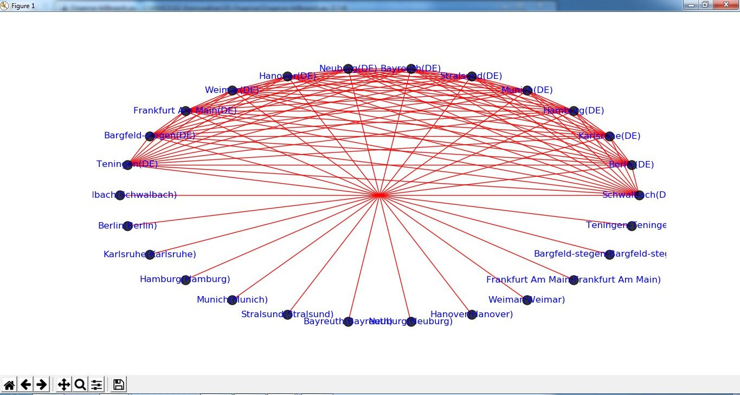

Node1=BillboardData['BillboardPlaceName'][i] + '('+ BillboardData['VisitorCountry'][i] + ')' if Node0 != Node1:

G.add_edge(Node0,Node1)

print('Nodes:', G.number_of_nodes()) print('Edges:', G.number_of_edges())

################################################################

sFileName=Base + '/02-Krennwallner/' + sOutputFileName1 print('################################')

print('Storing :',sFileName) print('################################')

nx.write_gml(G, sFileName) ################################################################

sFileName=Base + '/02-Krennwallner/' + sOutputFileName2 print('################################')

print('Storing Graph Image:',sFileName) print('################################')

plt.figure(figsize=(15, 15)) pos=nx.circular_layout(G,dim=2)

nx.draw_networkx_nodes(G,pos, node_color='k', node_size=150, alpha=0.8) nx.draw_networkx_edges(G, pos,edge_color='r', arrows=False, style='solid') nx.draw_networkx_labels(G,pos,font_size=12,font_family='sans-serif',font_color='b') plt.axis('off')

plt.savefig(sFileName,dpi=600) plt.show()

################################################################ print('################################')

print('### Done!! #####################') print('################################') ################################################################

**Output :**

Create a Delivery Route

Hillman requires a new delivery route plan from HQ-KA13’s delivery region. Themanaging director has to know the following:

* What his most expensive route is, if the cost is £1.50 per mile and twotrips are planned per day
* What the average travel distance in miles is for the region per 30-daymonth

With your newfound knowledge in building the technology stack for turning datalakes into business assets, can you convert the graph stored in the Assess step called

“Assess_Best_Logistics” into the shortest path between the two points?

**C:\VKHCG\03-Hillman\05-Organise\Organise-Routes.py**

# -*- coding: utf-8 -*- ################################################################

import sys import os

import pandas as pd ################################################################ Base='C:/VKHCG' ################################################################ print('################################')

print('Working Base :',Base, ' using ', sys.platform) print('################################') ################################################################

sInputFileName='02-Assess/01-EDS/02-Python/Assess_Shipping_Routes.txt' ################################################################

sOutputFileName='05-Organise/01-EDS/02-Python/Organise-Routes.csv' Company='03-Hillman' ################################################################ ################################################################

### Import Routes Data ################################################################

sFileName=Base + '/' + Company + '/' + sInputFileName print('################################')

print('Loading :',sFileName) print('################################')

RouteDataRaw=pd.read_csv(sFileName,header=0,low_memory=False, sep='|', encoding="latin-1") print('################################') ################################################################

RouteStart=RouteDataRaw[RouteDataRaw['StartAt']=='WH-KA13'] ################################################################

RouteDistance=RouteStart[RouteStart['Cost']=='DistanceMiles'] RouteDistance=RouteDistance.sort_values(by=['Measure'], ascending=False) ################################################################

RouteMax=RouteStart["Measure"].max()

RouteMaxCost=round((((RouteMax/1000)*1.5*2)),2) print('################################')

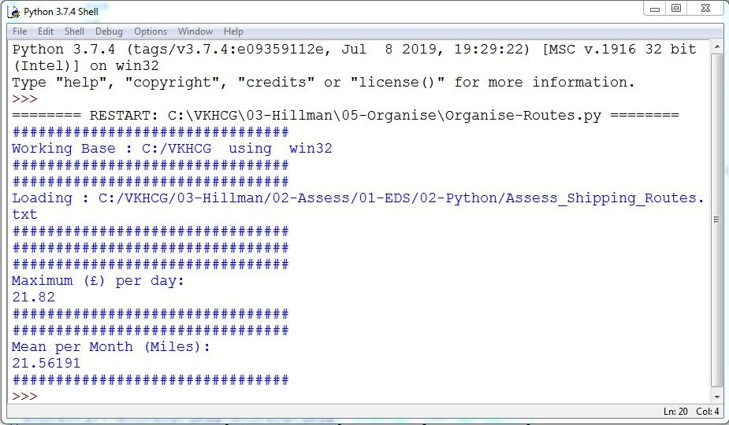

print('Maximum (£) per day:') print(RouteMaxCost) print('################################')

################################################################

RouteMean=RouteStart["Measure"].mean() RouteMeanMonth=round((((RouteMean/1000)*2*30)),6) print('################################')

print('Mean per Month (Miles):') print(RouteMeanMonth) print('################################')

**Output:**

###### Clark Ltd

Our financial services company has been tasked to investigate the options to convert1 million pounds sterling into extra income. Mr. Clark Junior suggests using the simplevariance in the daily rate between the British pound sterling and the US dollar, togenerate extra income from trading. Your chief financial officer wants to know if this isfeasible?

Simple Forex Trading Planner

Your challenge is to take 1 million US dollars or just over six hunderd thou sand pounds sterling and, by simply converting it between pounds sterling and US dollars, achieve a profit. Are you up to this challenge? The Program will help you how to model this problem and achieve a positive outcome. The forex data has been collected on a daily basis by Clark’s accounting department, from previous overseas transactions.

**C:\VKHCG\04-Clark\05-Organise\Organise-Forex.py**

# -*- coding: utf-8 -*- ################################################################

import sys import os

import pandas as pd import sqlite3 as sq import re

################################################################ Base='C:/VKHCG' ################################################################ print('################################')

print('Working Base :',Base, ' using ', sys.platform) print('################################') ################################################################

sInputFileName='03-Process/01-EDS/02-Python/Process_ExchangeRates.csv' ################################################################

sOutputFileName='05-Organise/01-EDS/02-Python/Organise-Forex.csv' Company='04-Clark' ################################################################

sDatabaseName=Base + '/' + Company + '/05-Organise/SQLite/clark.db' conn = sq.connect(sDatabaseName)

#conn = sq.connect(':memory:') ################################################################ ################################################################

### Import Forex Data ################################################################

sFileName=Base + '/' + Company + '/' + sInputFileName print('################################')

print('Loading :',sFileName) print('################################')

ForexDataRaw=pd.read_csv(sFileName,header=0,low_memory=False, encoding="latin-1") print('################################') ################################################################

ForexDataRaw.index.names = ['RowID'] sTable='Forex_All'

print('Storing :',sDatabaseName,' Table:',sTable) ForexDataRaw.to_sql(sTable, conn, if_exists="replace")

################################################################

sSQL="SELECT 1 as Bag\

, CAST(min(Date) AS VARCHAR(10)) as Date \

,CAST(1000000.0000000 as NUMERIC(12,4)) as Money \

,'USD' as Currency \ FROM Forex_All \

;"

sSQL=re.sub("\s\s+", " ", sSQL) nMoney=pd.read_sql_query(sSQL, conn)

################################################################

nMoney.index.names = ['RowID'] sTable='MoneyData'

print('Storing :',sDatabaseName,' Table:',sTable) nMoney.to_sql(sTable, conn, if_exists="replace")

################################################################

sTable='TransactionData'

print('Storing :',sDatabaseName,' Table:',sTable) nMoney.to_sql(sTable, conn, if_exists="replace")

################################################################

ForexDay=pd.read_sql_query("SELECT Date FROM Forex_All GROUP BY Date;", conn) ################################################################

t=0

for i in range(ForexDay.shape[0]): sDay1=ForexDay['Date'][i] sDay=str(sDay1)

sSQL='\

SELECT M.Bag as Bag, \ F.Date as Date, \

round(M.Money * F.Rate,6) AS Money, \ F.CodeIn AS PCurrency, \

F.CodeOut AS Currency \ FROM MoneyData AS M \ JOIN \

( \

SELECT \

CodeIn, CodeOut, Date, Rate \ FROM \

Forex_All \ WHERE\

CodeIn = "USD" AND CodeOut = "GBP" \ UNION \

SELECT \

CodeOut AS CodeIn, CodeIn AS CodeOut, FROM \

Forex_All \ WHERE\

CodeIn = "USD" AND CodeOut = "GBP" \

) AS F \

ON \ M.Currency=F.CodeIn \ AND \

F.Date ="' +sDay + '";'

sSQL=re.sub("\s\s+", " ", sSQL)

Date, (1/Rate) AS Rate \

ForexDayRate=pd.read_sql_query(sSQL, conn) for j in range(ForexDayRate.shape[0]):

sBag=str(ForexDayRate['Bag'][j]) nMoney=str(round(ForexDayRate['Money'][j],2))

sCodeIn=ForexDayRate['PCurrency'][j] sCodeOut=ForexDayRate['Currency'][j]

sSQL='UPDATE MoneyData SET Date= "' + sDay + '", '

sSQL= sSQL + ' Money = ' + nMoney + ', Currency="' + sCodeOut + '"' sSQL= sSQL + ' WHERE Bag=' + sBag + ' AND Currency="' + sCodeIn + '";'

sSQL=re.sub("\s\s+", " ", sSQL) cur = conn.cursor() cur.execute(sSQL) conn.commit()

t+=1

print('Trade :', t, sDay, sCodeOut, nMoney)

sSQL=' \

INSERT INTO TransactionData ( \

RowID, \ Bag, \ Date, \ Money, \ Currency \

) \

SELECT ' + str(t) + ' AS RowID, \

Bag, \ Date, \ Money, \ Currency \

FROM MoneyData \

;'

sSQL=re.sub("\s\s+", " ", sSQL)

cur = conn.cursor() cur.execute(sSQL) conn.commit()

################################################################

sSQL="SELECT RowID, Bag, Date, Money, Currency FROM TransactionData ORDER BY RowID;"

sSQL=re.sub("\s\s+", " ", sSQL) TransactionData=pd.read_sql_query(sSQL, conn)

OutputFile=Base + '/' + Company + '/' + sOutputFileName TransactionData.to_csv(OutputFile, index = False) ################################################################

Output:

Save the Assess-Forex.py file, then compile and execute with your Python compiler. This will produce a set of demonstrated values onscreen.

## Practical 9:

**Generating Data**

## Report Superstep

The Report superstep is the step in the ecosystem that enhances the data science findings with the art of

storytelling

and

data

visualization.

You

can

perform

the

best

data

science, but if

you

cannot

execute a

respectable and trustworthy Report step by turning your data science into actionable business insights, you have achieved no advantage for your business.

###### Vermeulen PLC

Vermeulen requires a map of all their customers’ data links. Can you provide a report to deliver this? I will guide you through an example that delivers this requirement.

**C:\VKHCG\01-Vermeulen\06-Report\Raport-Network-Routing-Customer.py**

################################################################

import sys import os

import pandas as pd import networkx as nx

import matplotlib.pyplot as plt ################################################################

pd.options.mode.chained_assignment = None ################################################################

if sys.platform == 'linux': Base=os.path.expanduser('~') + 'VKHCG'

else:

Base='C:/VKHCG' ################################################################ print('################################')

print('Working Base :',Base, ' using ', sys.platform) print('################################') ################################################################

sInputFileName='02-Assess/01-EDS/02-Python/Assess-Network-Routing-Customer.csv' ################################################################

sOutputFileName1='06-Report/01-EDS/02-Python/Report-Network-Routing-Customer.gml' sOutputFileName2='06-Report/01-EDS/02-Python/Report-Network-Routing-Customer.png' Company='01-Vermeulen' ################################################################ ################################################################

### Import Country Data ################################################################

sFileName=Base + '/' + Company + '/' + sInputFileName print('################################')

print('Loading :',sFileName) print('################################')

CustomerDataRaw=pd.read_csv(sFileName,header=0,low_memory=False, encoding="latin-1") CustomerData=CustomerDataRaw.head(100)

print('Loaded Country:',CustomerData.columns.values) print('################################') ################################################################

print(CustomerData.head())

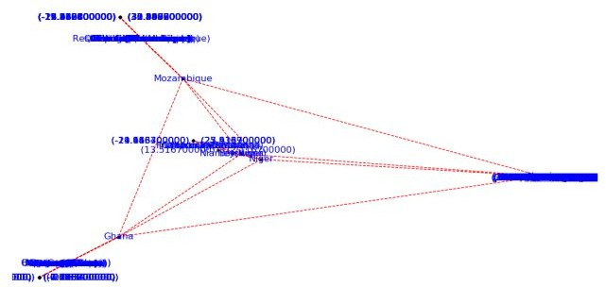

print(CustomerData.shape) ################################################################

G=nx.Graph()

for i in range(CustomerData.shape[0]): for j in range(CustomerData.shape[0]):

Node0=CustomerData['Customer_Country_Name'][i] Node1=CustomerData['Customer_Country_Name'][j] if Node0 != Node1:

G.add_edge(Node0,Node1)

for i in range(CustomerData.shape[0]): Node0=CustomerData['Customer_Country_Name'][i]

Node1=CustomerData['Customer_Place_Name'][i] + '('+ CustomerData['Customer_Country_Name'][i] + ')'

Node2='('+ "{:.9f}".format(CustomerData['Customer_Latitude'][i]) + ')\ ('+ "{:.9f}".format(CustomerData['Customer_Longitude'][i]) + ')'

if Node0 != Node1: G.add_edge(Node0,Node1)

if Node1 != Node2: G.add_edge(Node1,Node2)

print('Nodes:', G.number_of_nodes()) print('Edges:', G.number_of_edges())

################################################################

sFileName=Base + '/' + Company + '/' + sOutputFileName1 print('################################')

print('Storing :',sFileName) print('################################')

nx.write_gml(G, sFileName) ################################################################

sFileName=Base + '/' + Company + '/' + sOutputFileName2 print('################################')

print('Storing Graph Image:',sFileName) print('################################')

plt.figure(figsize=(25, 25)) pos=nx.spectral_layout(G,dim=2)

nx.draw_networkx_nodes(G,pos, node_color='k', node_size=10, alpha=0.8) nx.draw_networkx_edges(G, pos,edge_color='r', arrows=False, style='dashed') nx.draw_networkx_labels(G,pos,font_size=12,font_family='sans-serif',font_color='b') plt.axis('off')

plt.savefig(sFileName,dpi=600) plt.show()

print('################################') print('### Done!! #####################') print('################################')

###### Krennwallner AG

The Krennwallner marketing department wants to deploy the locations of the billboards onto the company web server. Can you prepare three versions of the locations’ web pages?

* Locations clustered into bubbles when you zoom out
* Locations as pins
* Locations as heat map

Picking Content for Billboards

**C:\VKHCG\02-Krennwallner\06-Report\Report_Billboard.py**

################################################################

# -*- coding: utf-8 -*- ################################################################

import sys import os

import pandas as pd

from folium.plugins import FastMarkerCluster, HeatMap from folium import Marker, Map

import webbrowser ################################################################ Base='C:/VKHCG'

print('################################')

print('Working Base :',Base, ' using ', sys.platform) print('################################') ################################################################

sFileName=Base+'/02-Krennwallner/01-Retrieve/01-EDS/02-Python/Retrieve_DE_Billboard_Locations.csv' df = pd.read_csv(sFileName,header=0,low_memory=False, encoding="latin-1")

df.fillna(value=0, inplace=True) print(df.shape)

################################################################

t=0

for i in range(df.shape[0]): try:

sLongitude=df["Longitude"][i] sLongitude=float(sLongitude)

except Exception: sLongitude=float(0.0)

try:

sLatitude=df["Latitude"][i] sLatitude=float(sLatitude)

except Exception: sLatitude=float(0.0)

try:

sDescription=df["Place_Name"][i] + ' (' + df["Country"][i]+')'

except Exception: sDescription='VKHCG'

if sLongitude != 0.0 and sLatitude != 0.0: DataClusterList=list([sLatitude, sLongitude]) DataPointList=list([sLatitude, sLongitude, sDescription]) t+=1

if t==1:

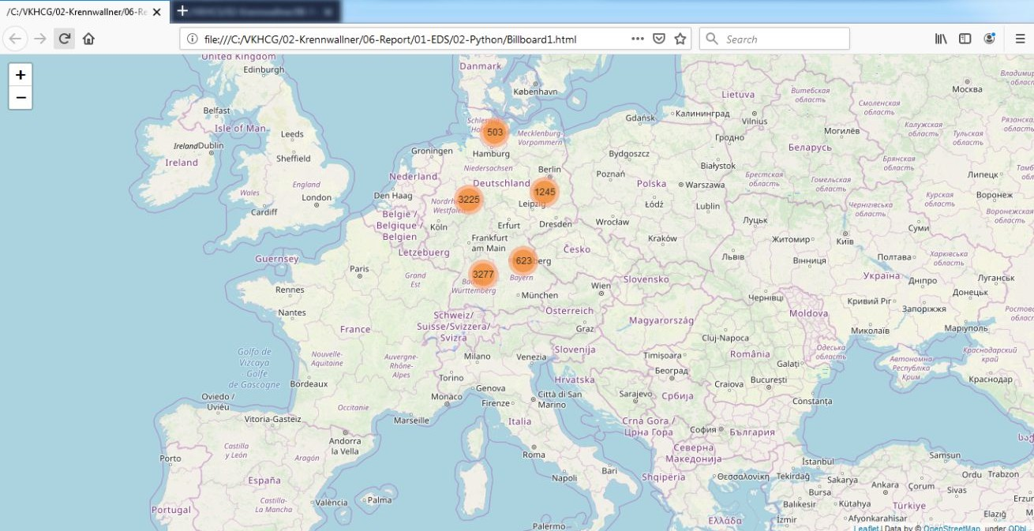

DataCluster=[DataClusterList] DataPoint=[DataPointList]

else:

DataCluster.append(DataClusterList) DataPoint.append(DataPointList)

data=DataCluster pins=pd.DataFrame(DataPoint)

pins.columns = [ 'Latitude','Longitude','Description'] ################################################################

stops_map1 = Map(location=[48.1459806, 11.4985484], zoom_start=5) marker_cluster = FastMarkerCluster(data).add_to(stops_map1)

sFileNameHtml=Base+'/02-Krennwallner/06-Report/01-EDS/02-Python/Billboard1.html' stops_map1.save(sFileNameHtml)

webbrowser.open('file://' + os.path.realpath(sFileNameHtml)) ################################################################

stops_map2 = Map(location=[48.1459806, 11.4985484], zoom_start=5) for name, row in pins.iloc[:100].iterrows():

Marker([row["Latitude"],row["Longitude"]], popup=row["Description"]).add_to(stops_map2) sFileNameHtml=Base+'/02-Krennwallner/06-Report/01-EDS/02-Python/Billboard2.html' stops_map2.save(sFileNameHtml)

webbrowser.open('file://' + os.path.realpath(sFileNameHtml)) ################################################################

stops_heatmap = Map(location=[48.1459806, 11.4985484], zoom_start=5) stops_heatmap.add_child(HeatMap([[row["Latitude"], row["Longitude"]] for name, row in pins.iloc[:100].iterrows()]))

sFileNameHtml=Base+'/02-Krennwallner/06-Report/01-EDS/02-Python/Billboard_heatmap.html' stops_heatmap.save(sFileNameHtml)

webbrowser.open('file://' + os.path.realpath(sFileNameHtml)) ################################################################ print('### Done!! ############################################') ################################################################

**Output:**

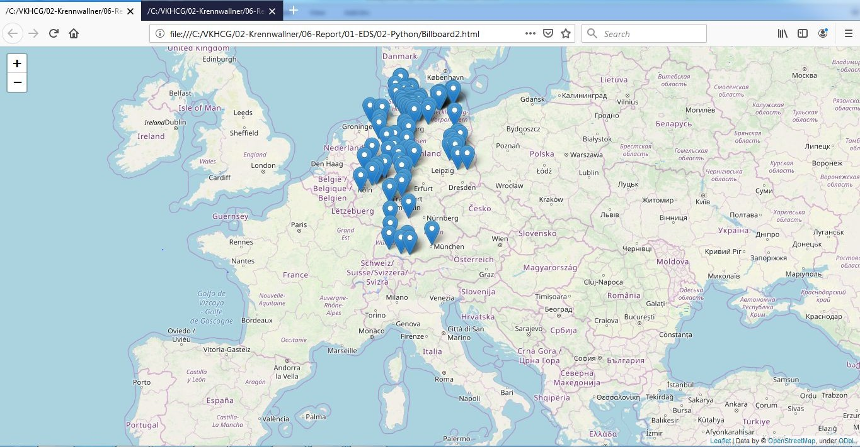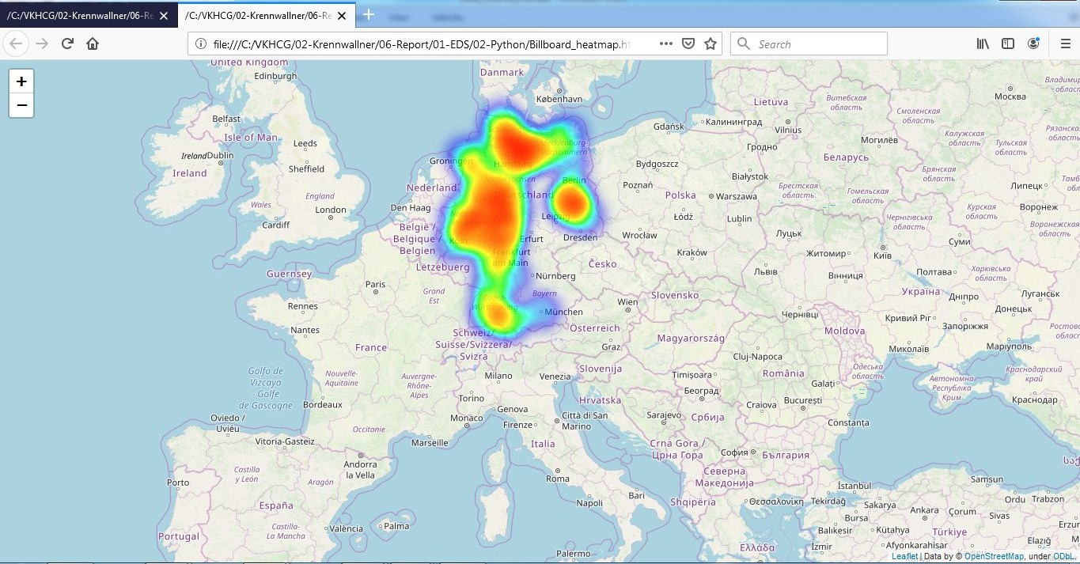

###### Hillman Ltd

Dr. Hillman Sr. has just installed a camera system that enables the company to capture video and, therefore, indirectly, images of all containers that enter or leave the warehouse. Can you convert the number on the side of the containers into digits?

Reading the Containers

**C:\VKHCG\03-Hillman\06-Report\ Report_Reading_Container.py**

from time import time import numpy as np

import matplotlib.pyplot as plt from matplotlib import offsetbox

from sklearn import (manifold, datasets, decomposition, ensemble, discriminant_analysis, random_projection) digits = datasets.load_digits(n_class=6)

X = digits.data y = digits.target

n_samples, n_features = X.shape n_neighbors = 30

def plot_embedding(X, title=None):

x_min, x_max = np.min(X, 0), np.max(X, 0) X = (X - x_min) / (x_max - x_min) plt.figure(figsize=(10, 10))

ax = plt.subplot(111)

for i in range(X.shape[0]):

plt.text(X[i, 0], X[i, 1], str(digits.target[i]),

color=plt.cm.Set1(y[i] / 10.), fontdict={'weight': 'bold', 'size': 9})

if hasattr(offsetbox, 'AnnotationBbox'):

# only print thumbnails with matplotlib > 1.0 shown_images = np.array([[1., 1.]]) # just something big for i in range(digits.data.shape[0]):

dist = np.sum((X[i] - shown_images) ** 2, 1) if np.min(dist) < 4e-3:

# don't show points that are too close continue

shown_images = np.r_[shown_images, [X[i]]]

imagebox = offsetbox.AnnotationBbox(offsetbox.OffsetImage(digits.images[i], cmap=plt.cm.gray_r),X[i])

ax.add_artist(imagebox) plt.xticks([]), plt.yticks([]) if title is not None:

plt.title(title) n_img_per_row = 20

img = np.zeros((10 * n_img_per_row, 10 * n_img_per_row)) for i in range(n_img_per_row):

ix = 10 * i + 1

for j in range(n_img_per_row): iy = 10 * j + 1

img[ix:ix + 8, iy:iy + 8] = X[i * n_img_per_row + j].reshape((8, 8)) plt.figure(figsize=(10, 10))

plt.imshow(img, cmap=plt.cm.binary) plt.xticks([])

plt.yticks([])

plt.title('A selection from the 64-dimensional digits dataset') print("Computing random projection")

rp = random_projection.SparseRandomProjection(n_components=2, random_state=42) X_projected = rp.fit_transform(X)

plot_embedding(X_projected, "Random Projection of the digits") print("Computing PCA projection")

t0 = time()

X_pca = decomposition.TruncatedSVD(n_components=2).fit_transform(X)

plot_embedding(X_pca,"Principal Components projection of the digits (time %.2fs)" %(time() - t0)) print("Computing Linear Discriminant Analysis projection")

X2 = X.copy()

X2.flat[::X.shape[1] + 1] += 0.01 # Make X invertible t0 = time()

X_lda = discriminant_analysis.LinearDiscriminantAnalysis(n_components=2).fit_transform(X2, y) plot_embedding(X_lda,"Linear Discriminant projection of the digits (time %.2fs)" %(time() - t0)) print("Computing Isomap embedding")

t0 = time()

X_iso = manifold.Isomap(n_neighbors, n_components=2).fit_transform(X) print("Done.")

plot_embedding(X_iso,"Isomap projection of the digits (time %.2fs)" %(time() - t0)) print("Computing LLE embedding")

clf = manifold.LocallyLinearEmbedding(n_neighbors, n_components=2,method='standard') t0 = time()

X_lle = clf.fit_transform(X)

print("Done. Reconstruction error: %g" % clf.reconstruction_error_) plot_embedding(X_lle,"Locally Linear Embedding of the digits (time %.2fs)" %(time() - t0)) print("Computing modified LLE embedding")

clf = manifold.LocallyLinearEmbedding(n_neighbors, n_components=2, method='modified')

t0 = time()

X_mlle = clf.fit_transform(X)

print("Done. Reconstruction error: %g" % clf.reconstruction_error_)

plot_embedding(X_mlle,"Modified Locally Linear Embedding of the digits (time %.2fs)" %(time() - t0)) print("Computing Hessian LLE embedding")

clf = manifold.LocallyLinearEmbedding(n_neighbors, n_components=2,method='hessian') t0 = time()

X_hlle = clf.fit_transform(X)

print("Done. Reconstruction error: %g" % clf.reconstruction_error_)

plot_embedding(X_hlle,"Hessian Locally Linear Embedding of the digits (time %.2fs)" %(time() - t0)) print("Computing LTSA embedding")

clf = manifold.LocallyLinearEmbedding(n_neighbors, n_components=2,method='ltsa') t0 = time()

X_ltsa = clf.fit_transform(X)

print("Done. Reconstruction error: %g" % clf.reconstruction_error_) plot_embedding(X_ltsa,"Local Tangent Space Alignment of the digits (time %.2fs)" %(time() - t0)) print("Computing MDS embedding")

clf = manifold.MDS(n_components=2, n_init=1, max_iter=100) t0 = time()

X_mds = clf.fit_transform(X) print("Done. Stress: %f" % clf.stress_)

plot_embedding(X_mds,"MDS embedding of the digits (time %.2fs)" %(time() - t0)) print("Computing Totally Random Trees embedding")

hasher = ensemble.RandomTreesEmbedding(n_estimators=200, random_state=0, max_depth=5)

t0 = time()

X_transformed = hasher.fit_transform(X)

pca = decomposition.TruncatedSVD(n_components=2) X_reduced = pca.fit_transform(X_transformed)

plot_embedding(X_reduced,"Random forest embedding of the digits (time %.2fs)" %(time() - t0)) print("Computing Spectral embedding")

embedder = manifold.SpectralEmbedding(n_components=2, random_state=0,

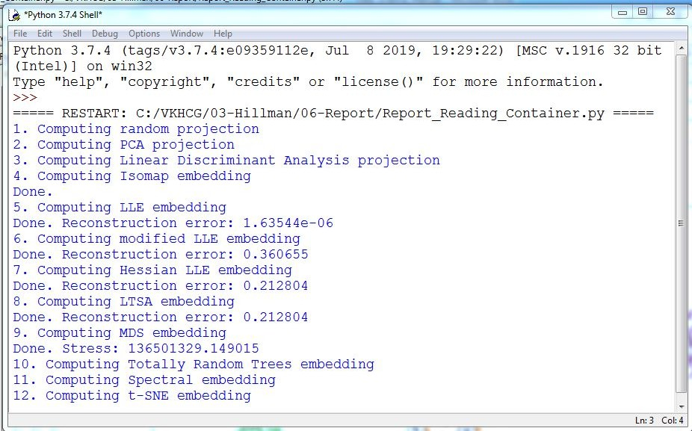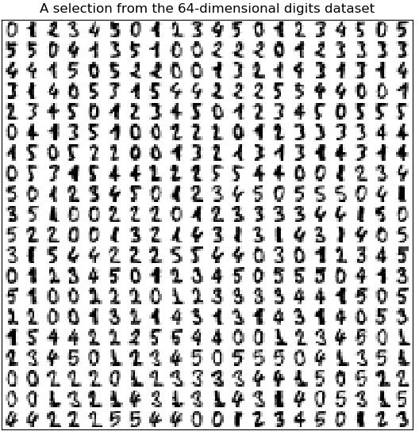

eigen_solver="arpack") t0 = time()

X_se = embedder.fit_transform(X)

plot_embedding(X_se,"Spectral embedding of the digits (time %.2fs)" %(time() - t0)) print("Computing t-SNE embedding")

tsne = manifold.TSNE(n_components=2, init='pca', random_state=0) t0 = time()

X_tsne = tsne.fit_transform(X)

plot_embedding(X_tsne,"t-SNE embedding of the digits (time %.2fs)" %(time() - t0)) plt.show()

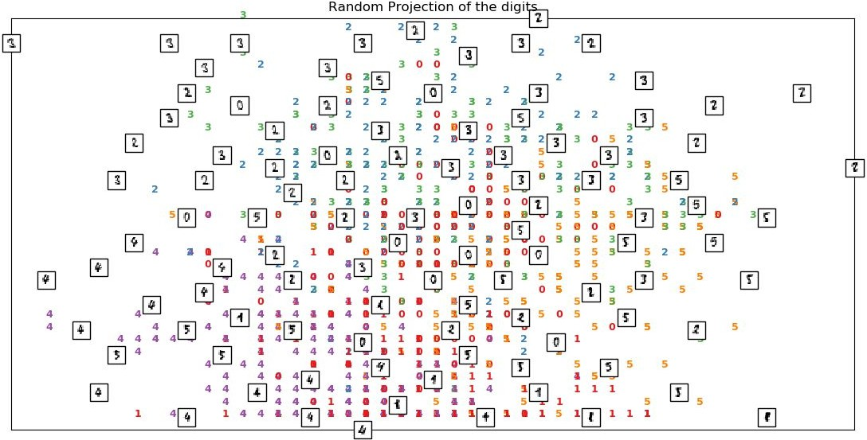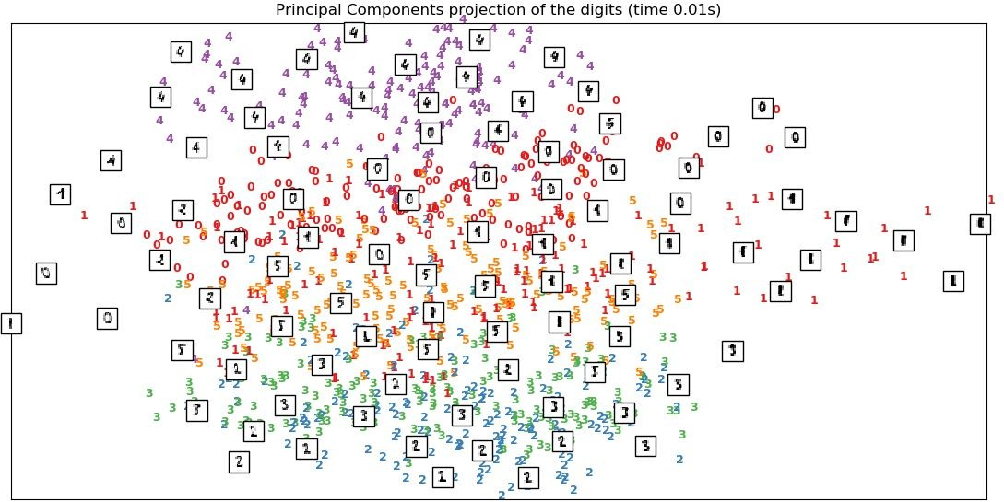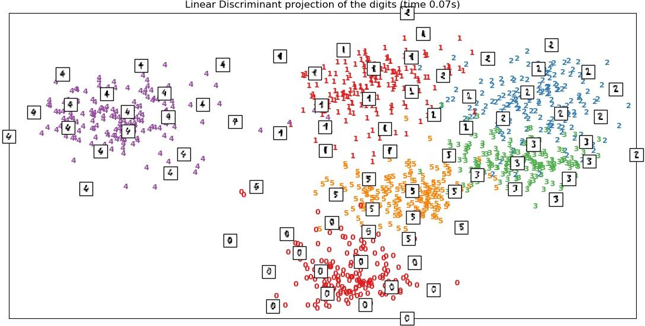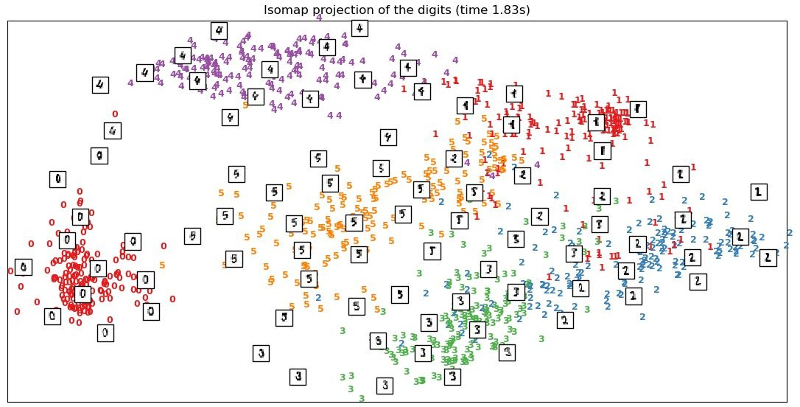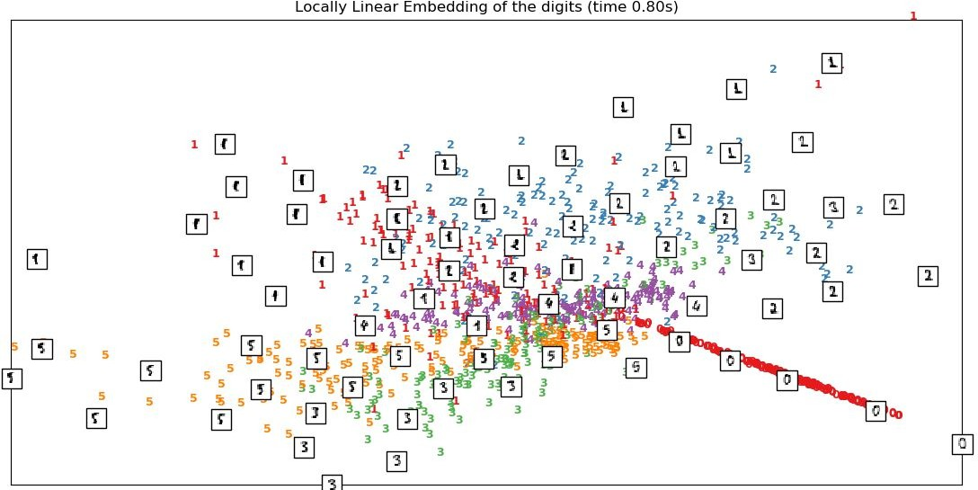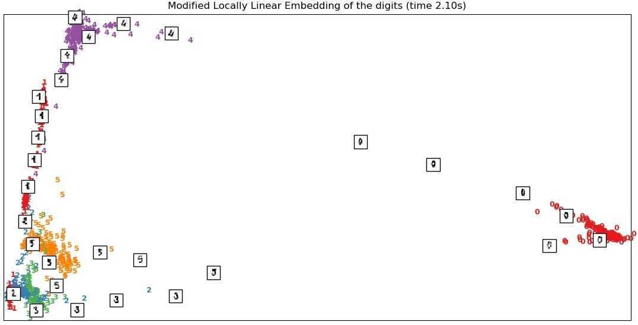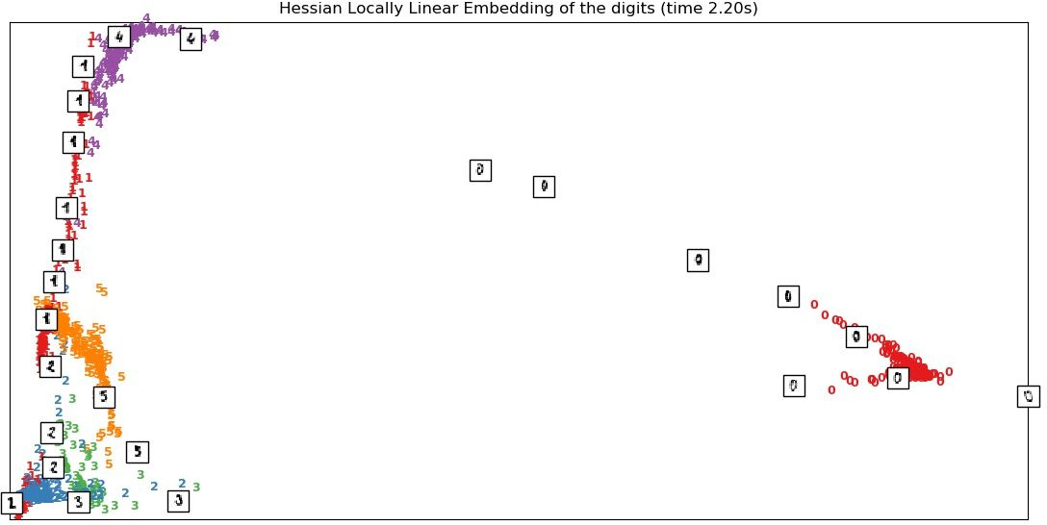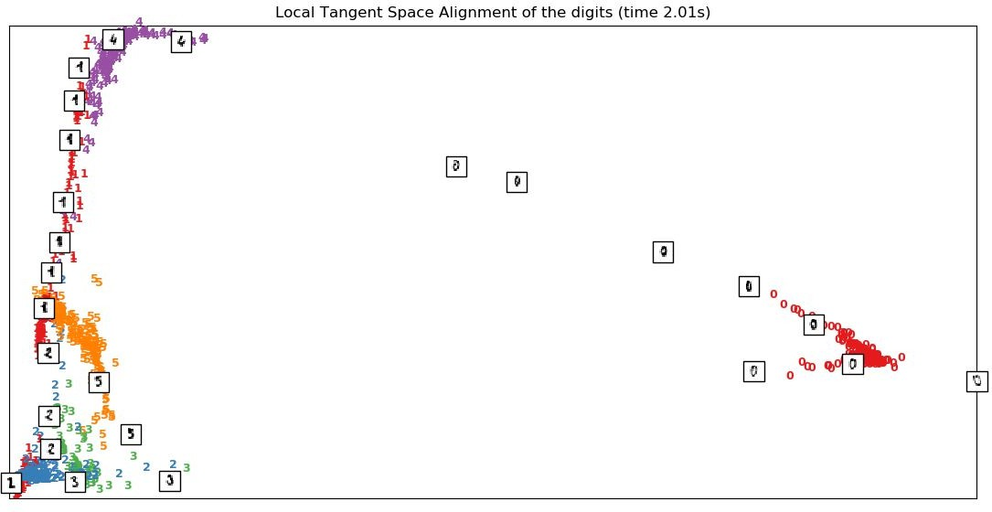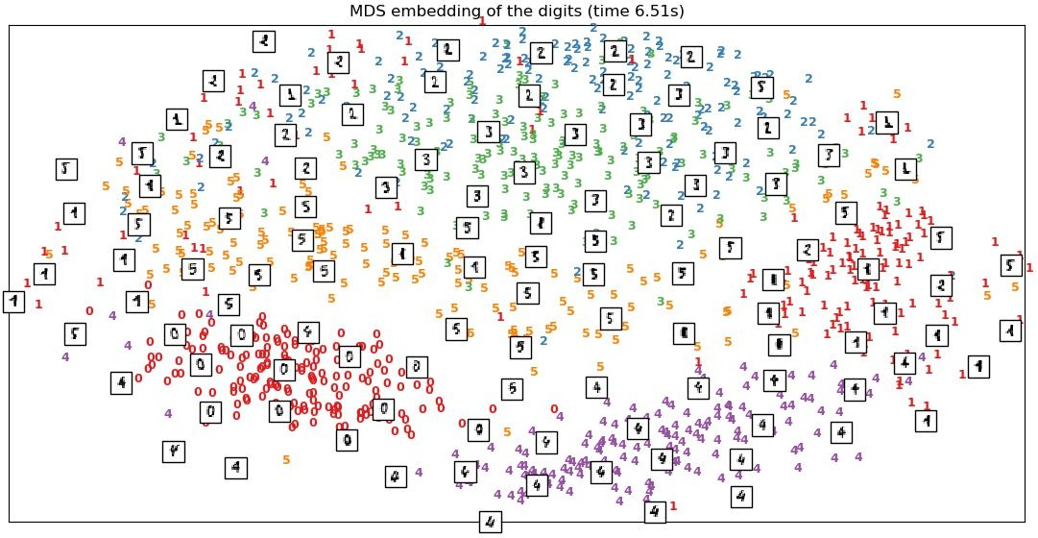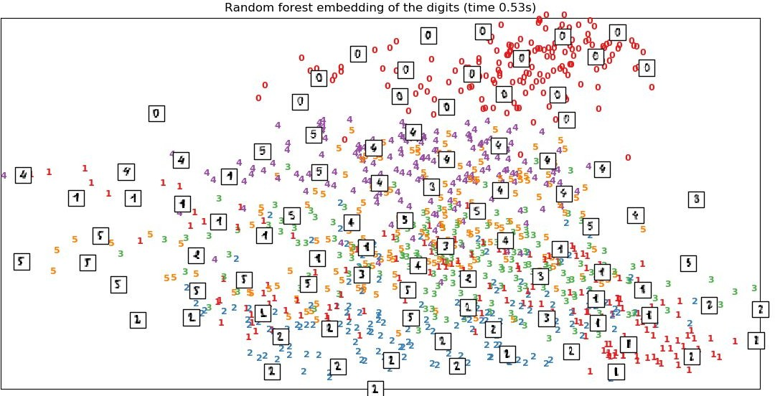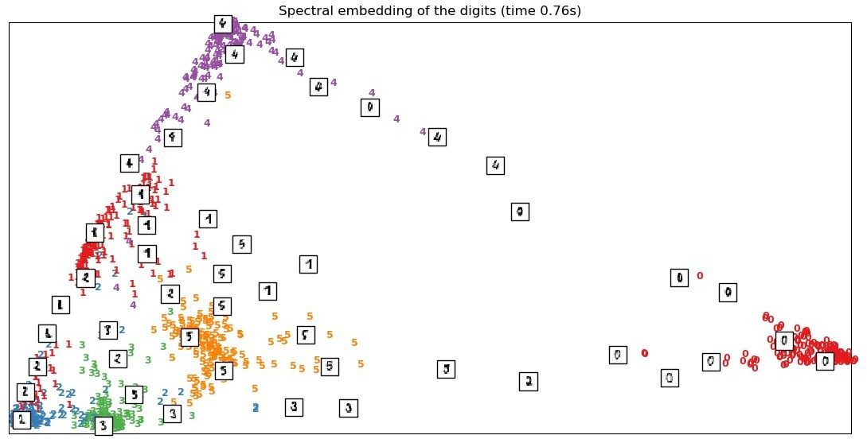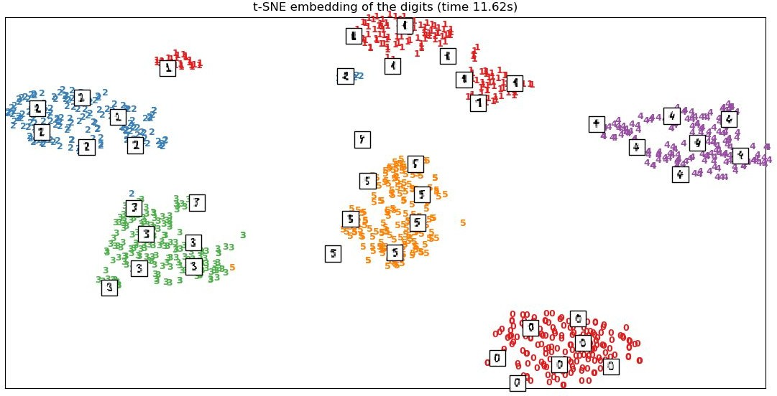

You have successfully completed the container experiment. Which display format do you think is the best? The right answer is your choice, as it has to be the one that matches your own insight into the data, and there is not really a wrong answer.

###### Clark Ltd

The financial company in VKHCG is the Clark accounting firm that VKHCG owns with a 60% stake. The accountants are the financial advisers to the group and handle everything to do with the complex work of international accounting.

Financials

The VKHCG companies did well last year, and the teams at Clark must prepare a balance sheet for each company in the group. The companies require a balance sheet for each company, to be produced using the template (Balance-Sheet-Template.xlsx) that can be found in the example directory (..\VKHCG\04-Clark\00- RawData).

The Program will guide you through a process that will enable you to merge the data science with preformatted Microsoft Excel template, to produce a balance sheet for each of the VKHCG companies.

**C:\VKHCG\04-Clark\06-Report\Report-Balance-Sheet.py**

# -*- coding: utf-8 -*- ################################################################

import sys import os

import pandas as pd import sqlite3 as sq import re

from openpyxl import load_workbook ################################################################ Base='C:/VKHCG' ################################################################ print('################################')

print('Working Base :',Base, ' using ', sys.platform) print('################################') ################################################################

sInputTemplateName='00-RawData/Balance-Sheet-Template.xlsx' ################################################################

sOutputFileName='06-Report/01-EDS/02-Python/Report-Balance-Sheet' Company='04-Clark' ################################################################

sDatabaseName=Base + '/' + Company + '/06-Report/SQLite/clark.db' conn = sq.connect(sDatabaseName)

#conn = sq.connect(':memory:') ################################################################

### Import Balance Sheet Data ################################################################

for y in range(1,13):

sInputFileName='00-RawData/BalanceSheets' + str(y).zfill(2) + '.csv' sFileName=Base + '/' + Company + '/' + sInputFileName print('################################')

print('Loading :',sFileName) print('################################')

ForexDataRaw=pd.read_csv(sFileName,header=0,low_memory=False, encoding="latin-1") print('################################') ################################################################

ForexDataRaw.index.names = ['RowID'] sTable='BalanceSheets'

print('Storing :',sDatabaseName,' Table:',sTable) if y == 1:

print('Load Data')

ForexDataRaw.to_sql(sTable, conn, if_exists="replace") else:

print('Append Data')

ForexDataRaw.to_sql(sTable, conn, if_exists="append") ################################################################ sSQL="SELECT \

Year, \ Quarter, \ Country, \ Company, \

CAST(Year AS INT) || 'Q' || CAST(Quarter AS INT) AS sDate, \ Company || ' (' || Country || ')' AS sCompanyName , \ CAST(Year AS INT) || 'Q' || CAST(Quarter AS INT) || '-' ||\ Company || '-' || Country AS sCompanyFile \

FROM BalanceSheets \ GROUP BY \

Year, \ Quarter, \ Country, \ Company \

HAVING Year is not null \

;"

sSQL=re.sub("\s\s+", " ", sSQL) sDatesRaw=pd.read_sql_query(sSQL, conn) print(sDatesRaw.shape) sDates=sDatesRaw.head(5)

################################################################

## Loop Dates ################################################################

for i in range(sDates.shape[0]):

sFileName=Base + '/' + Company + '/' + sInputTemplateName wb = load_workbook(sFileName) ws=wb.get_sheet_by_name("Balance-Sheet") sYear=sDates['sDate'][i] sCompany=sDates['sCompanyName'][i] sCompanyFile=sDates['sCompanyFile'][i] sCompanyFile=re.sub("\s+", "", sCompanyFile)

ws['D3'] = sYear ws['D5'] = sCompany

sFields = pd.DataFrame( [

['Cash','D16', 1],

['Accounts_Receivable','D17', 1],

['Doubtful_Accounts','D18', 1],

['Inventory','D19', 1],

['Temporary_Investment','D20', 1],

['Prepaid_Expenses','D21', 1],

['Long_Term_Investments','D24', 1],

['Land','D25', 1],

['Buildings','D26', 1],

['Depreciation_Buildings','D27', -1],

['Plant_Equipment','D28', 1],

['Depreciation_Plant_Equipment','D29', -1],

['Furniture_Fixtures','D30', 1],

['Depreciation_Furniture_Fixtures','D31', -1],

['Accounts_Payable','H16', 1],

['Short_Term_Notes','H17', 1],

['Current_Long_Term_Notes','H18', 1],

['Interest_Payable','H19', 1],

['Taxes_Payable','H20', 1],

['Accrued_Payroll','H21', 1],

['Mortgage','H24', 1],

['Other_Long_Term_Liabilities','H25', 1],

['Capital_Stock','H30', 1]

]

)

nYear=str(int(sDates['Year'][i])) nQuarter=str(int(sDates['Quarter'][i])) sCountry=str(sDates['Country'][i]) sCompany=str(sDates['Company'][i])

sFileName=Base + '/' + Company + '/' + sOutputFileName + \ '-' + sCompanyFile + '.xlsx'

print(sFileName)

for j in range(sFields.shape[0]):

sSumField=sFields[0][j] sCellField=sFields[1][j] nSumSign=sFields[2][j]

sSQL="SELECT \

Year, \ Quarter, \ Country, \ Company, \

SUM(" + sSumField + ") AS nSumTotal \ FROM BalanceSheets \

GROUP BY \

Year, \ Quarter, \ Country, \ Company \

HAVING \

Year=" + nYear + " \ AND \

Quarter=" + nQuarter + " \ AND \

Country='" + sCountry + "' \

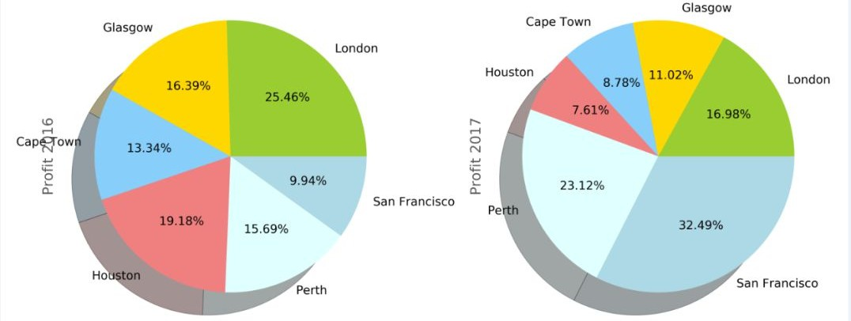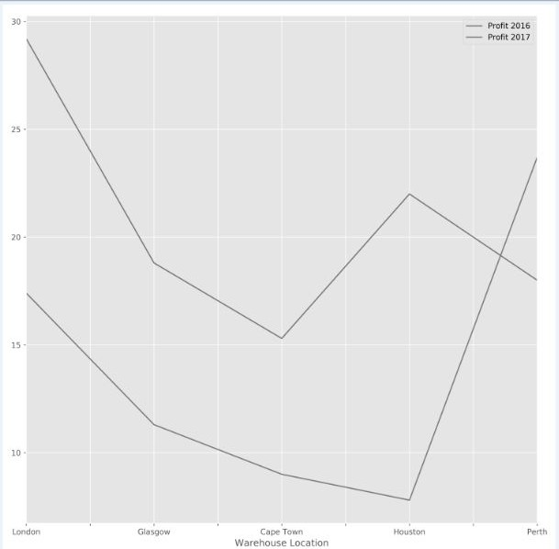

AND \

Company='" + sCompany + "' \

;"

sSQL=re.sub("\s\s+", " ", sSQL) sSumRaw=pd.read_sql_query(sSQL, conn) ws[sCellField] = sSumRaw["nSumTotal"][0] * nSumSign print('Set cell',sCellField,' to ', sSumField,'Total')

wb.save(sFileName)

Output:

**You now have all the reports you need.**

**Check the Following files for generated reports in** C:/VKHCG/04-Clark/06-Report/01-EDS/02-Python/

1. Report-Balance-Sheet-2000Q1-Clark-Afghanistan.xlsx
2. Report-Balance-Sheet-2000Q1-Hillman-Afghanistan.xlsx
3. Report-Balance-Sheet-2000Q1-Krennwallner-Afghanistan.xlsx
4. Report-Balance-Sheet-2000Q1-Vermeulen-Afghanistan.xlsx
5. Report-Balance-Sheet-2000Q1-Clark-AlandIslands.xlsx

## Graphics

This section will now guide you through a number of visualizations that particularly useful in presenting data to my customers.

###### Pie Graph Double Pie

C:\VKHCG\01-Vermeulen\06-Report\Report_Graph_A.py

###### Line Graph

C:/VKHCG/01-Vermeulen/06-Report/Report_Graph_A.py

###### Bar Graph / Horizontal Bar Graph

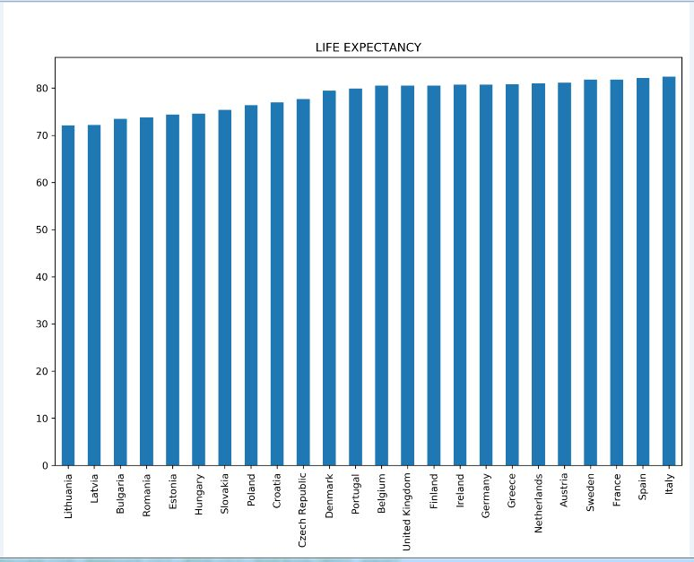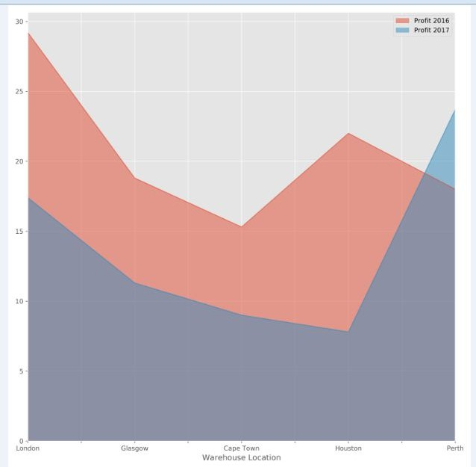

C:/VKHCG/01-Vermeulen/06-Report/Report_Graph_A.py

###### Area Graph

C:/VKHCG/01-Vermeulen/06-Report/Report_Graph_A.py

Scatter Graph : VKHCG/03-Hillman/06-Report/Report-Scatterplot-With-Encircling.r

Scatter Graph : VKHCG/03-Hillman/06-Report/Report-Scatterplot-With-Encircling.r

Scatter Graph : VKHCG/03-Hillman/06-Report/Report-Scatterplot-With-Encircling.r

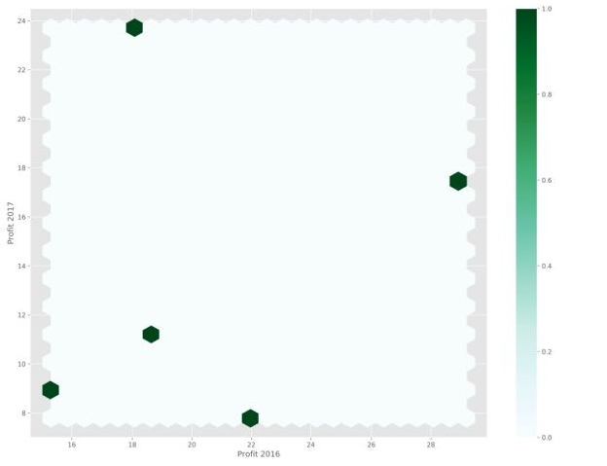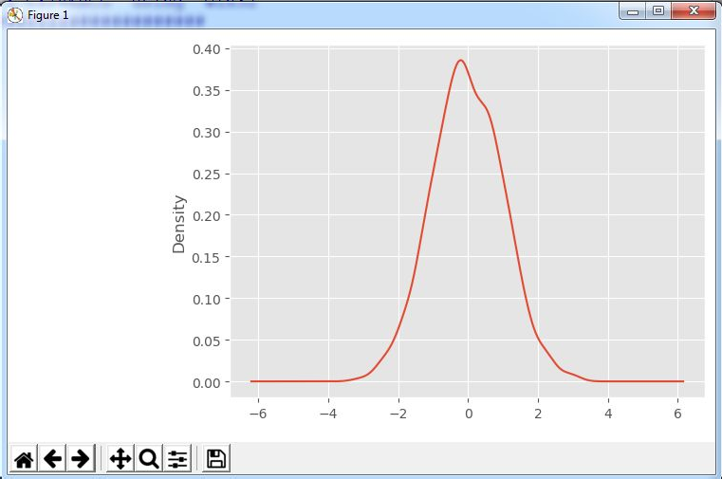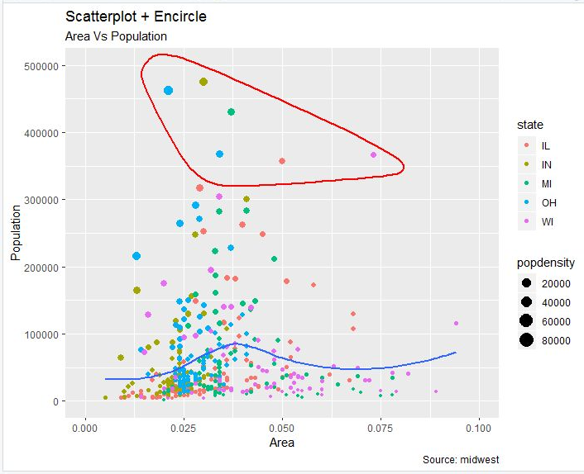

# Hexbin:

**Program : C:\VKHCG\01-Vermeulen\06-Repor**t\Report_Graph_A.py

**Kernel Density Estimatio**n (KDE) Graph

**C:\VKHCG\01-Vermeulen\06-Report\Report_G**raph_B.py

###### Scatter Matrix Graph

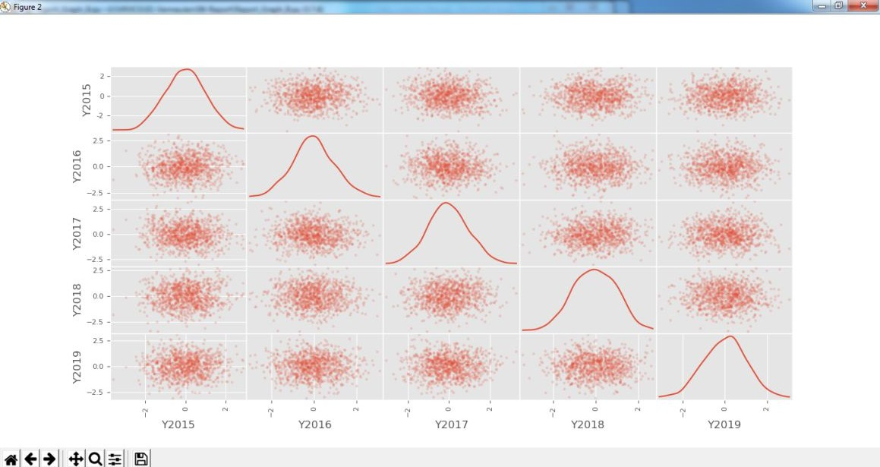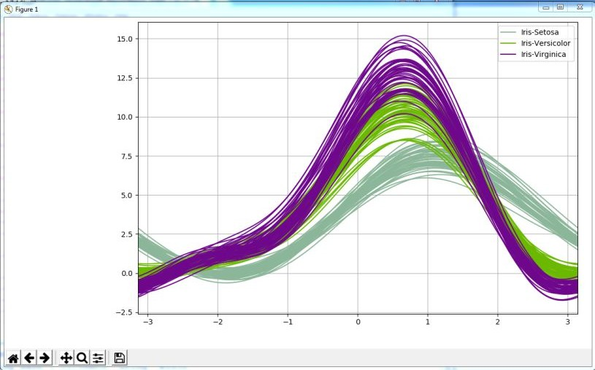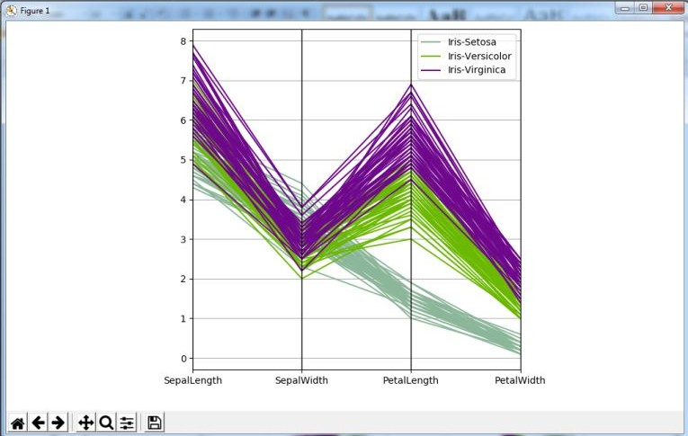

C:\VKHCG\01-Vermeulen\06-Report\Report_Graph_B.py

###### Andrews’ Curves

C:\VKHCG\01-Vermeulen\06-Report\Report_Graph_C.py

###### Parallel Coordinates

C:\VKHCG\01-Vermeulen\06-Report\Report_Graph_C.py

###### RADVIZ Method

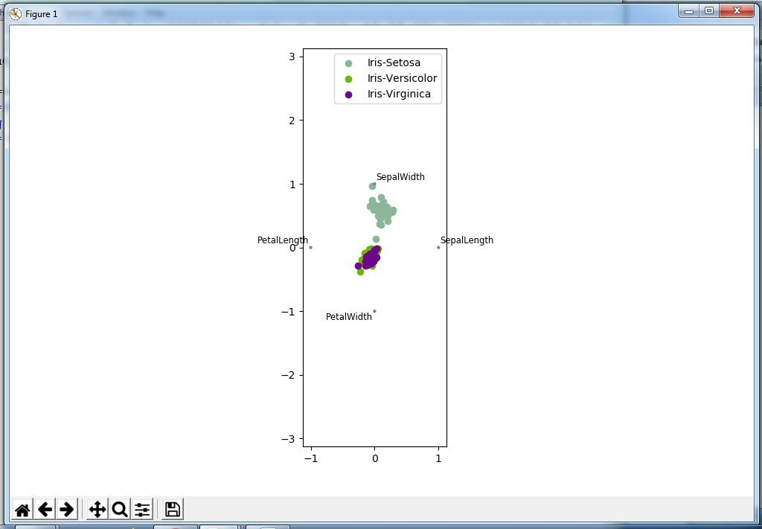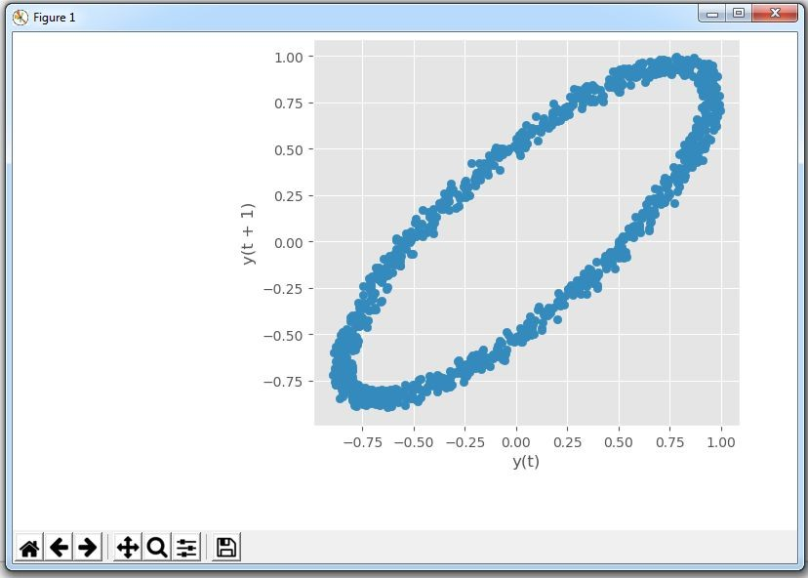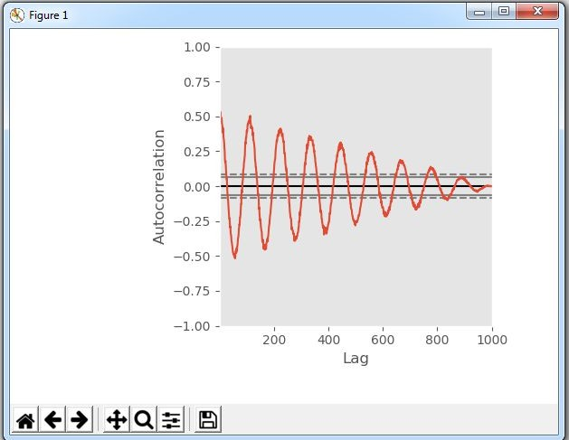

C:\VKHCG\01-Vermeulen\06-Report\Report_Graph_C.py

###### Lag Plot

C:\VKHCG\01-Vermeulen\06-Report\Report_Graph_D.py

###### Autocorrelation Plot

C:\VKHCG\01-Vermeulen\06-Report\Report_Graph_D.py

##### Bootstrap Plot

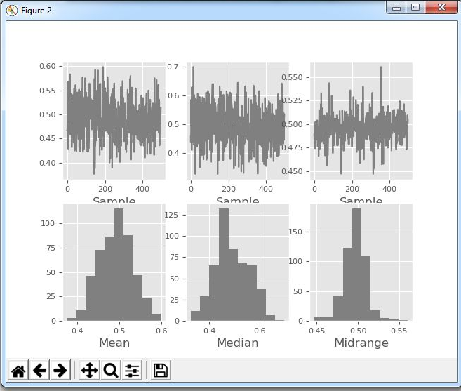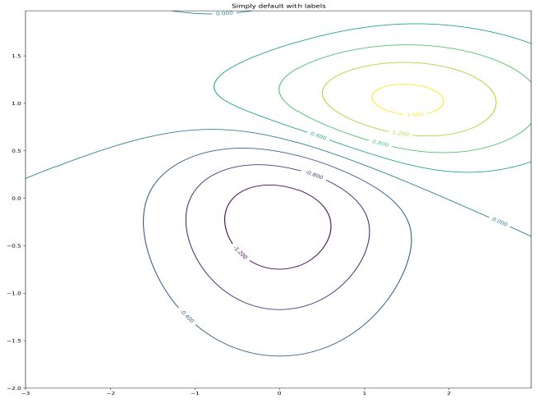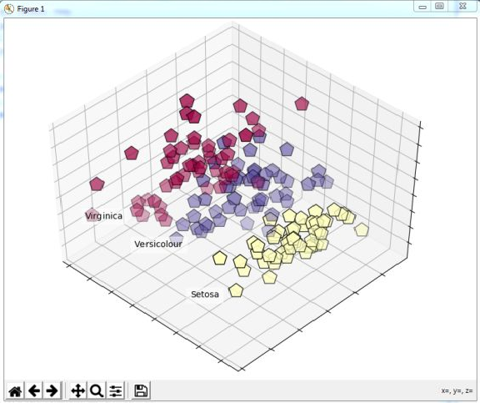

**C:\VKHCG\01-Vermeulen\06-Report\Report_G**raph_D.py

##### Contour Graphs

**C:\VKHCG\01-Vermeulen\06-Report\Report_G**raph_G.py

##### 3D Graphs

**C:\VKHCG\01-Vermeulen\06-Report\Report_P**CA_IRIS.py

(add →import matplotlib.cm as cm& Replace : plt.cm.spectral →cm.get_cmap("Spectral") at Line 44)

(add →import matplotlib.cm as cm& Replace : plt.cm.spectral →cm.get_cmap("Spectral") at Line 44)

(add →import matplotlib.cm as cm& Replace : plt.cm.spectral →cm.get_cmap("Spectral") at Line 44)

## Practical 10:

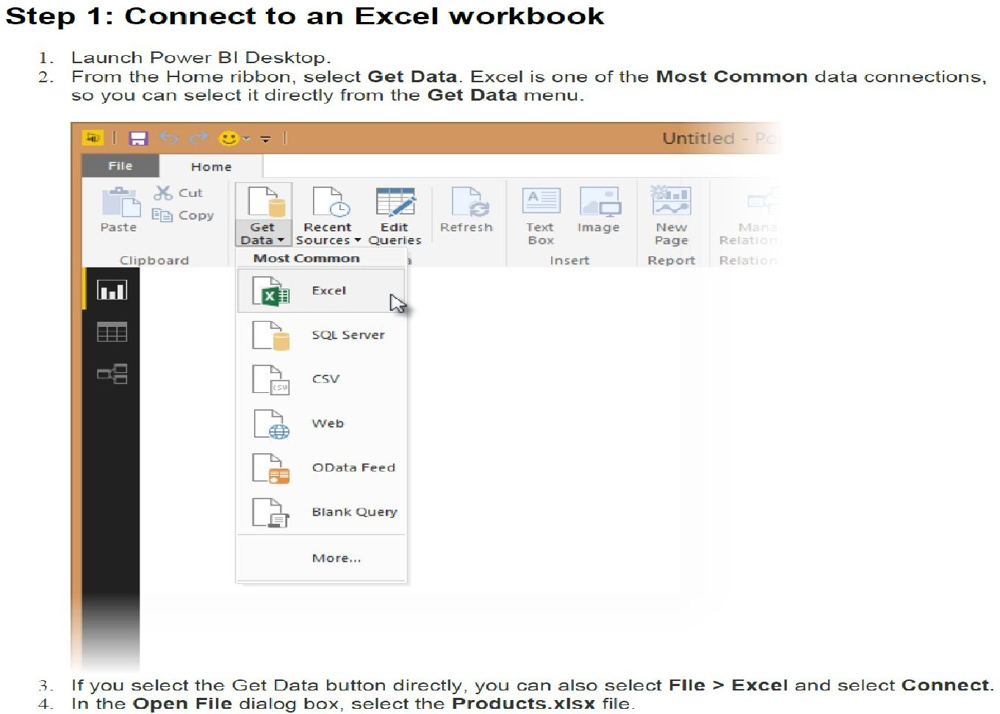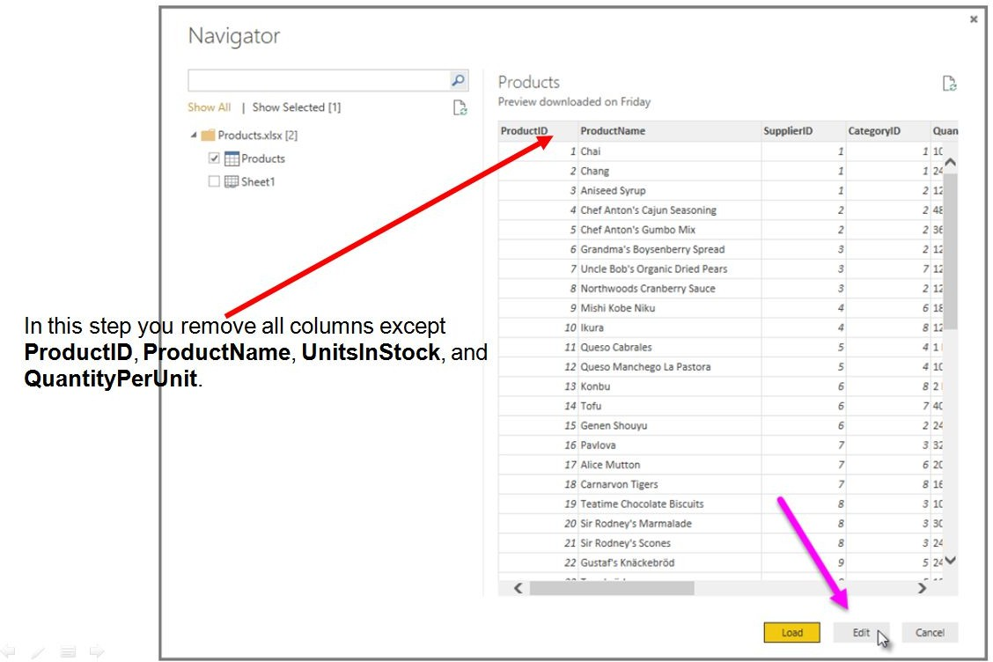

**Data Visualization with Power BI**

**Case Study : Sales Data**

You can also open the Query Editor by selecting Edit Queries from the Home ribbon in Power BI Desktop. The following steps are performed in Query Editor.

1. In Query Editor, select the ProductID, ProductName, QuantityPerUnit, and UnitsInStock columns

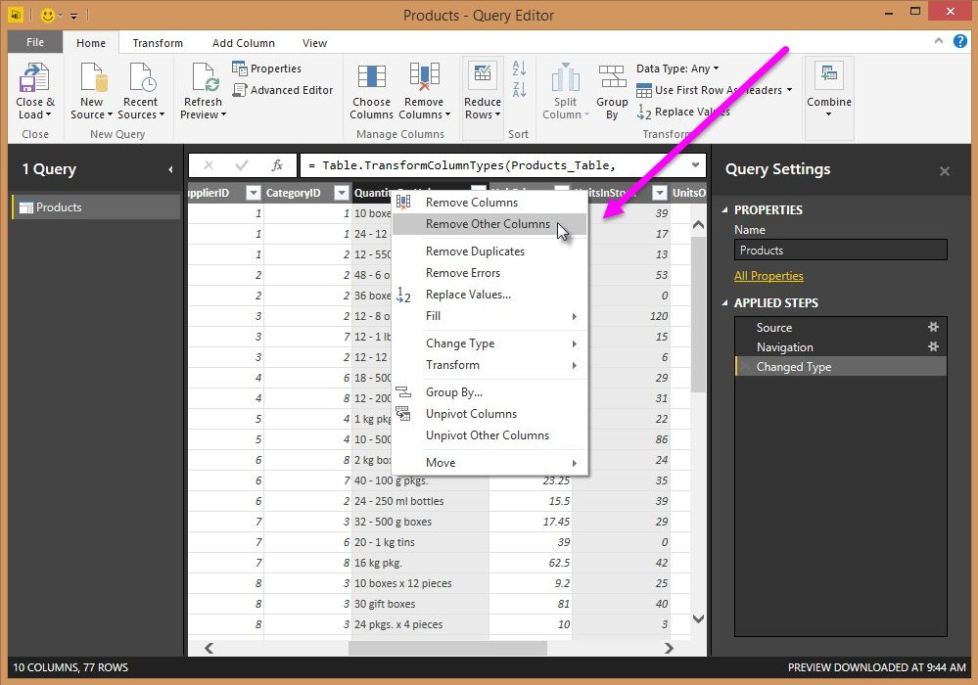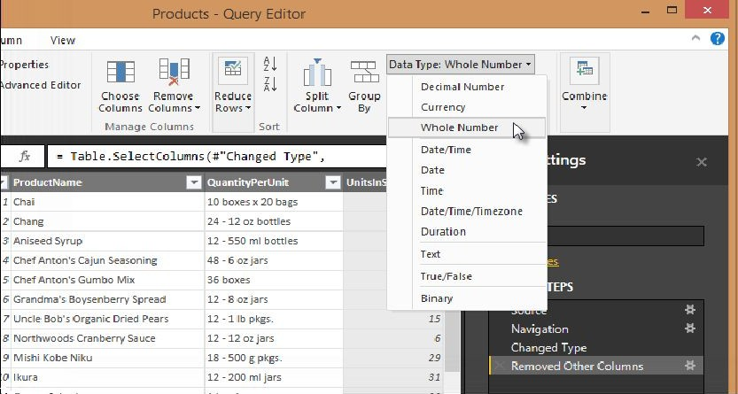

*(use Ctrl+Click to select more than one column, or Shift+Click to select columns that are beside each other)*

1. Select Remove Columns→Remove Other Columns from the ribbon, or right-click on a column header and click Remove Other Columns.

Step 3: Change the data type of the UnitsInStock column

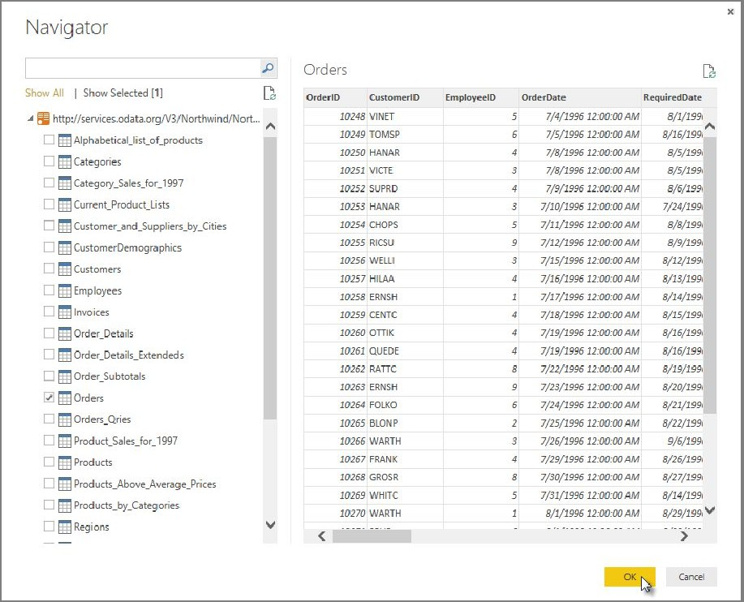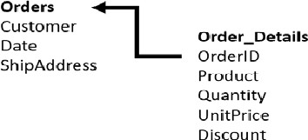

For the Excel workbook, products in stock will always be a whole number, so in this step you confirm the UnitsInStock column’s datatype is Whole Number.

* 1. Select the UnitsInStock column.
  2. 2. Select the Data Type drop-down button in the Home ribbon.
  3. If not already a Whole Number, select Whole Number for data type from the drop down *(the Data Type: button also displays the data type for the current selection).*

### Task 2: Import order data from an OData feed

You import data into Power BI Desktop from the sample Northwind OData feed at the following URL, which you can copy (and then paste) in the steps below: <http://services.odata.org/V3/Northwind/Northwind.svc/>

**Step 1: Connect to an OData feed**

1. From the **Home** ribbon tab in Query Editor, select **Get Data.**
2. Browse to the **OData Feed** data source.
3. In the **OData Feed** dialog box, paste the **URL** for the Northwind OData feed.
4. Select **OK**.

**Step 2: Expand the Order_Details table**

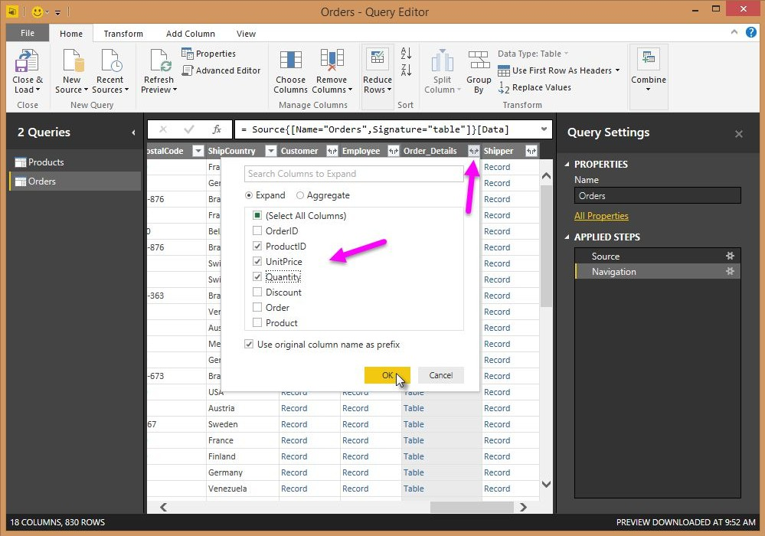

Expand the **Order_Details** table that is related to the **Orders** table, to combine the **ProductID**, **UnitPrice**, and **Quantity** columns from **Order_Details** into the **Orders** table.

The **Expand** operation combines columns from a related table into a subject table. When the query runs, rows from the related table (**Order_Details**) are combined into rows from the subject table (**Orders**).

After you expand the **Order_Details** table, three new columns and additional rows are added to the

**Orders** table, one for each row in the nested or related table.

1. In the **Query View**, scroll to the **Order_Details** column.
2. In the **Order_Details** column, select the expand icon ().
3. In the **Expand** drop-down: a. Select **(Select All Columns)** to clear all columns. Select **ProductID**, **UnitPrice**, and **Quantity**.

click **OK**.

**Step 3: Remove other columns to only display columns of interest**

In this step you remove all columns except **OrderDate, ShipCity**, **ShipCountry**, **Order_Details.ProductID**, **Order_Details.UnitPrice**, and **Order_Details.Quantity** columns. In the previous task, you used **Remove Other Columns**. For this task, you remove selected columns.

In the **Query View**, select all columns by completing a.

* 1. Click the first column (**OrderID**).
  2. Shift+Click the last column (**Shipper**).
  3. Now that all columns are selected, use Ctrl+Click to unselect the following columns: OrderDate, ShipCity, ShipCountry, Order_Details.ProductID, Order_Details.UnitPrice, and Order_Details.Quantity.

Now that only the columns we want to remove are selected, right-click on any selected column header and click Remove Columns.

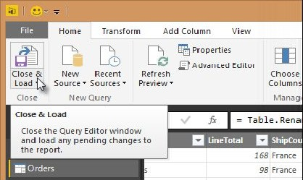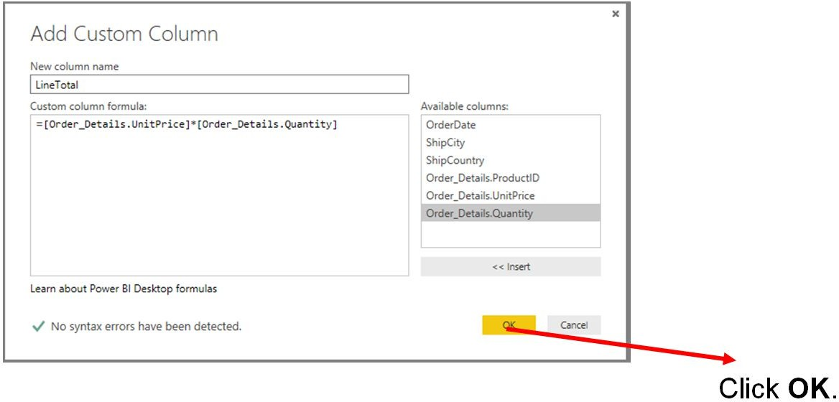

**Step 4: Calculate the line total for each Order_Details row**

Power BI Desktop lets you to create calculations based on the columns you are importing, so you can enrich the data that you connect to. In this step, you create a **Custom Column** to calculate the line total for each **Order_Details** row.

Calculate the line total for each **Order_Details** row:

* + 1. In the **Add Column** ribbon tab, click **Add Custom Column**.
    2. In the Add Custom Column dialog box, in the Custom Column Formula textbox, enter

**[Order_Details.UnitPrice] * [Order_Details.Quantity].**

* + 1. In the New column name textbox, enter LineTotal.

**Step 5: Set the datatype of the LineTotal field**

1. Right click the **LineTotal** column.
2. Select **Change Type** and choose **Decimal Number.**

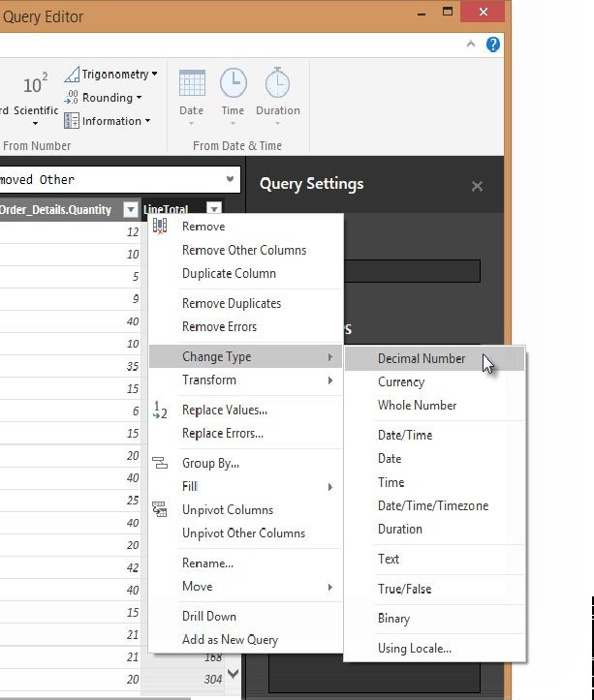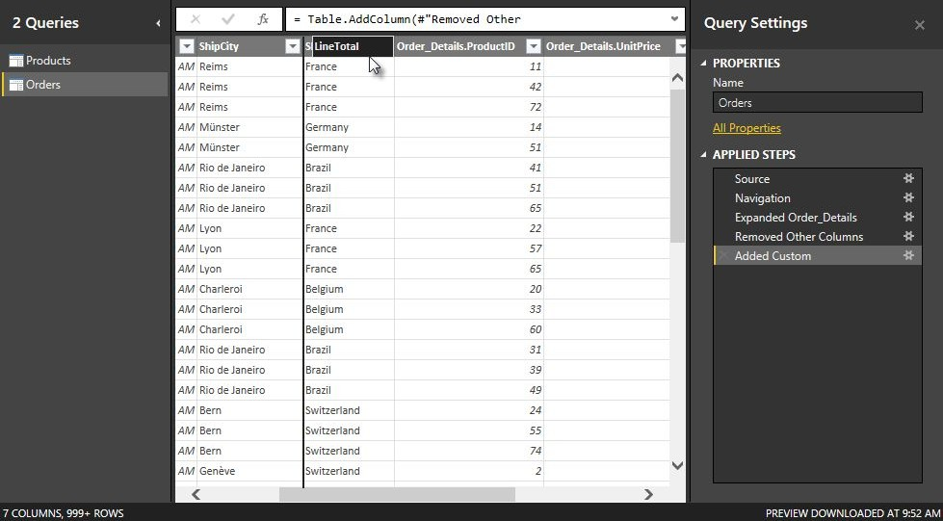

**Step 6: Rename and reorder columns in the query**

1. In **Query Editor**, drag the **LineTotal** column to the left, after **ShipCountry**.
2. Remove
3. Remove the *Order_Details.* prefix from the **Order_Details.ProductID**, **Order_Details.UnitPrice** and **Order_Details.Quantity** columns, by double-clicking on each column header, and then deleting that text from the column name.

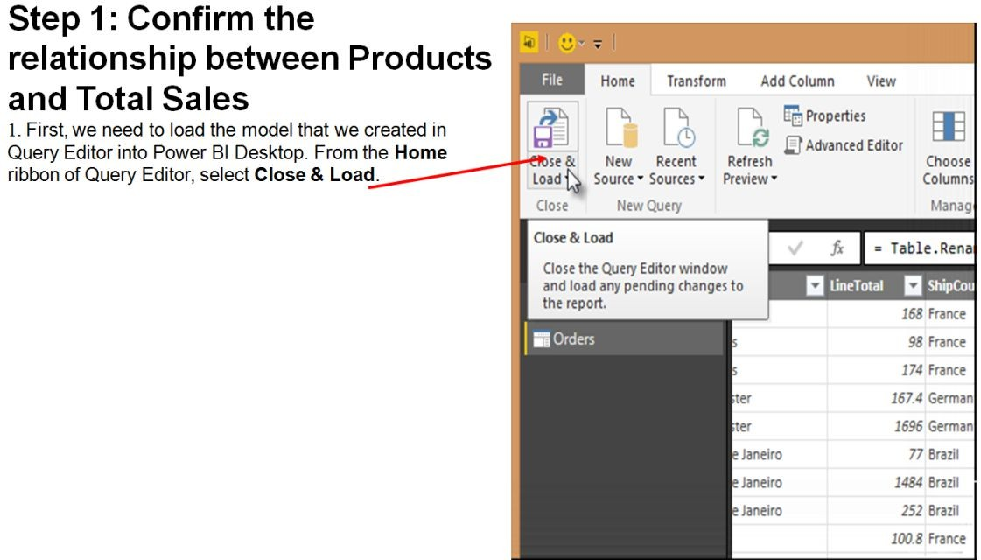

**Task 3: Combine the Products and Total Sales queries**

* 1. Power BI Desktop loads the data from the two queries
  2. Once the data is loaded, select the Manage Relationships button Home ribbon
  3. Select the New… button
  4. When we attempt to create the relationship, we see that one already exists! As shown in the Create Relationship dialog (by the shaded columns), the ProductsID fields in each query already have an established relationship.

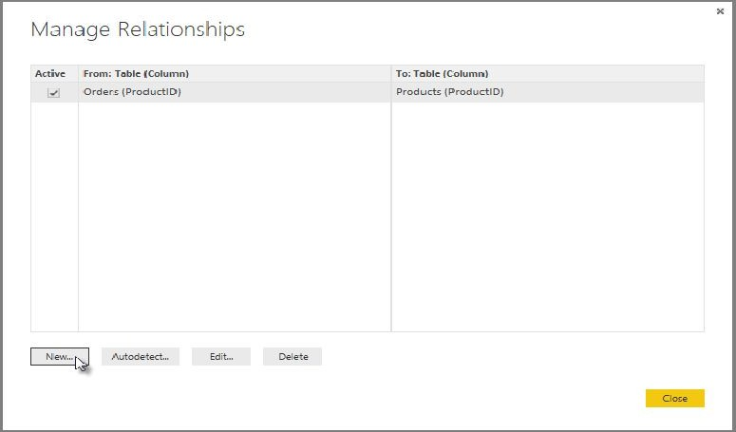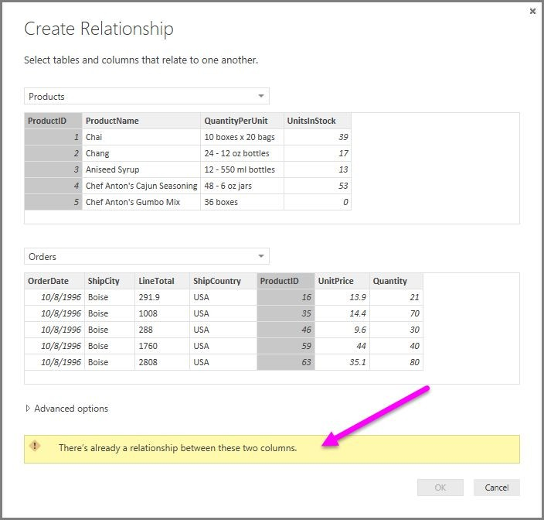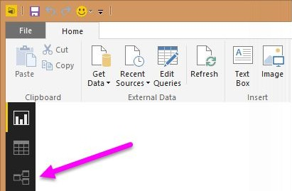

* 1. **Select Cancel, and then select Relationship view in Power BI Desktop.**

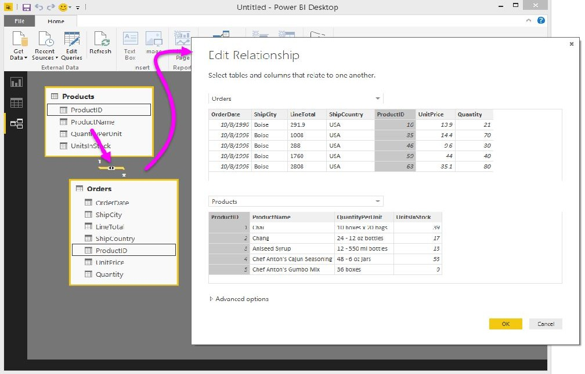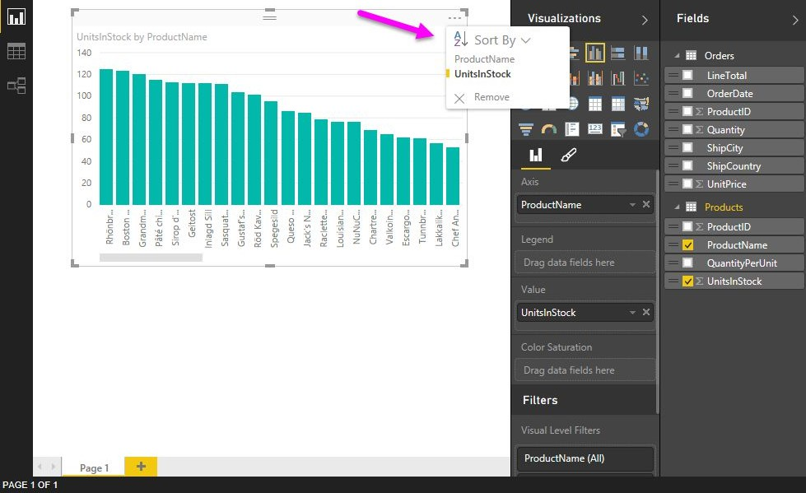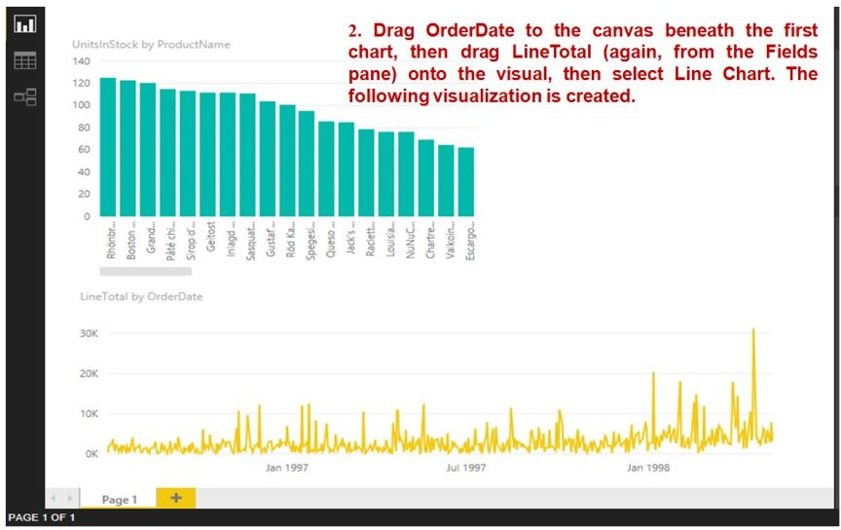

### Task 4: Build visuals using your data

**Step 1: Create charts showing Units in Stock by Product and Total Sales by Year**

1. **Next, drag ShipCountry to a space on the canvas in the top right. Because you selected a geographic field, a map was created automatically. Now drag LineTotal to the Values field; the circles on the map for each country are now relative in size to the LineTotal for orders shipped to that country.**

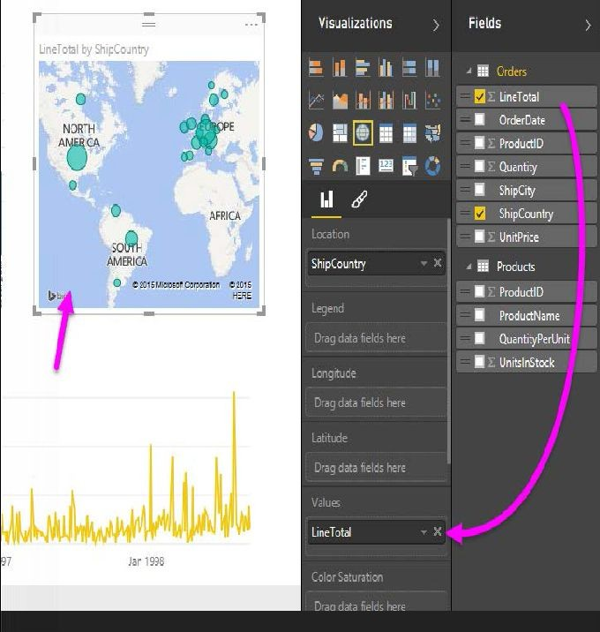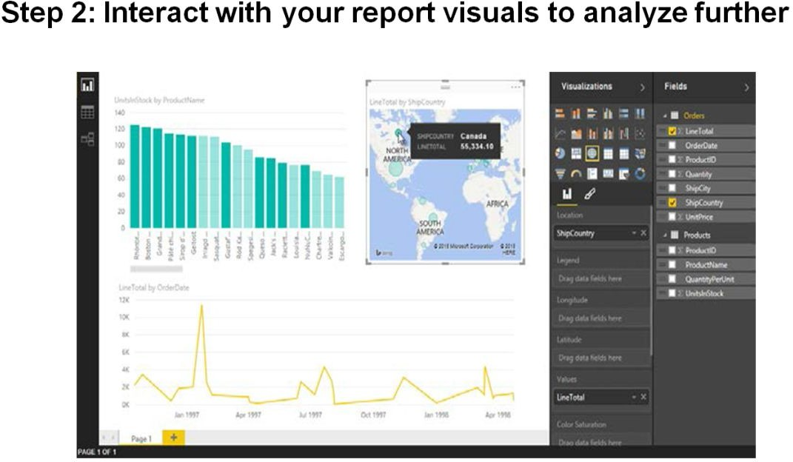

**~~~~~*****~~~~~**



**Dear Teacher,**

**Please send your valuable feedback and contribution to make this manual more effective.**

**Feel Free to connect us on …….** [dandhiren@yahoo.co.in](mailto:dandhiren@yahoo.co.in) [patilrajendrab@gmail.com](mailto:patilrajendrab@gmail.com) [ahtesham.shaikh@apcollege.edu.in](mailto:ahtesham.shaikh@apcollege.edu.in)

Also join the M. Sc. IT Semester 1 - **Data Science Teacher’s Group** on WhatsApp: https://chat.whatsapp.com/BgllrrcbT3Q4SthOwqW0Uq